Log Horizon Volume 8

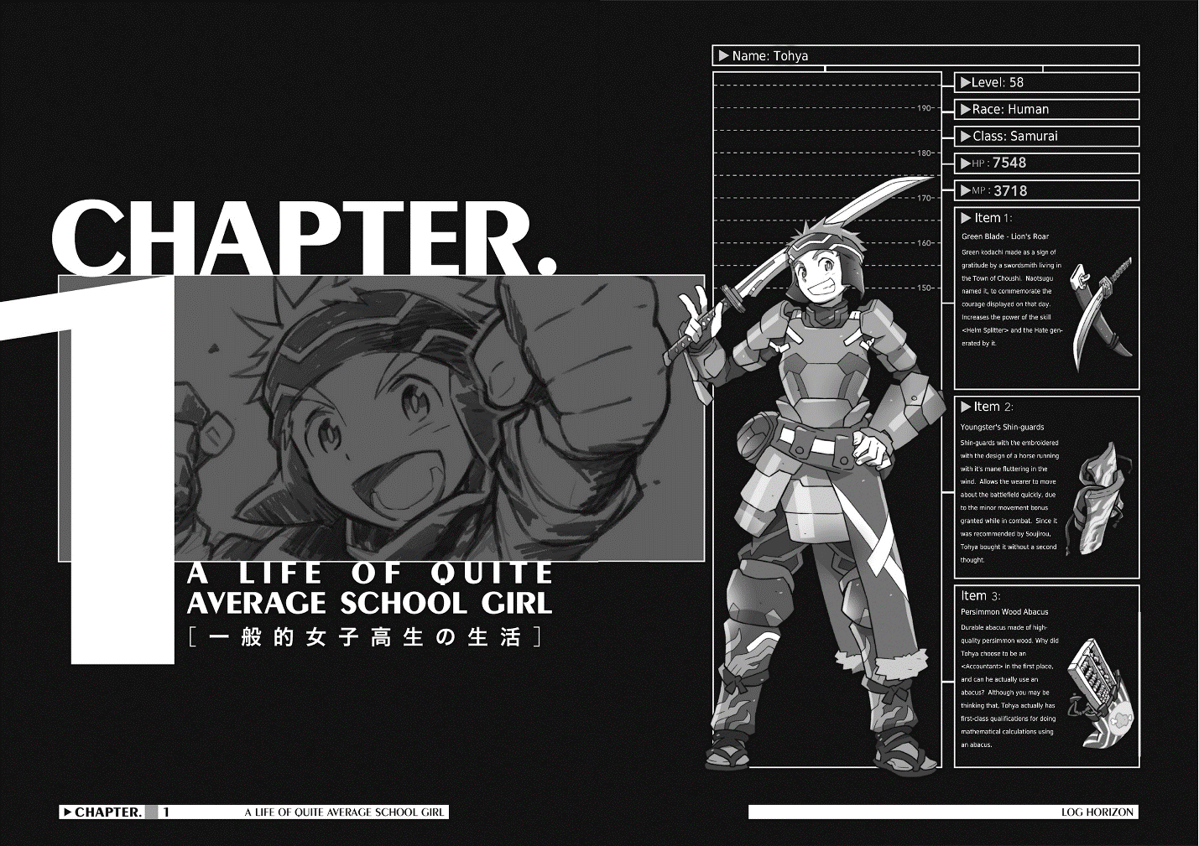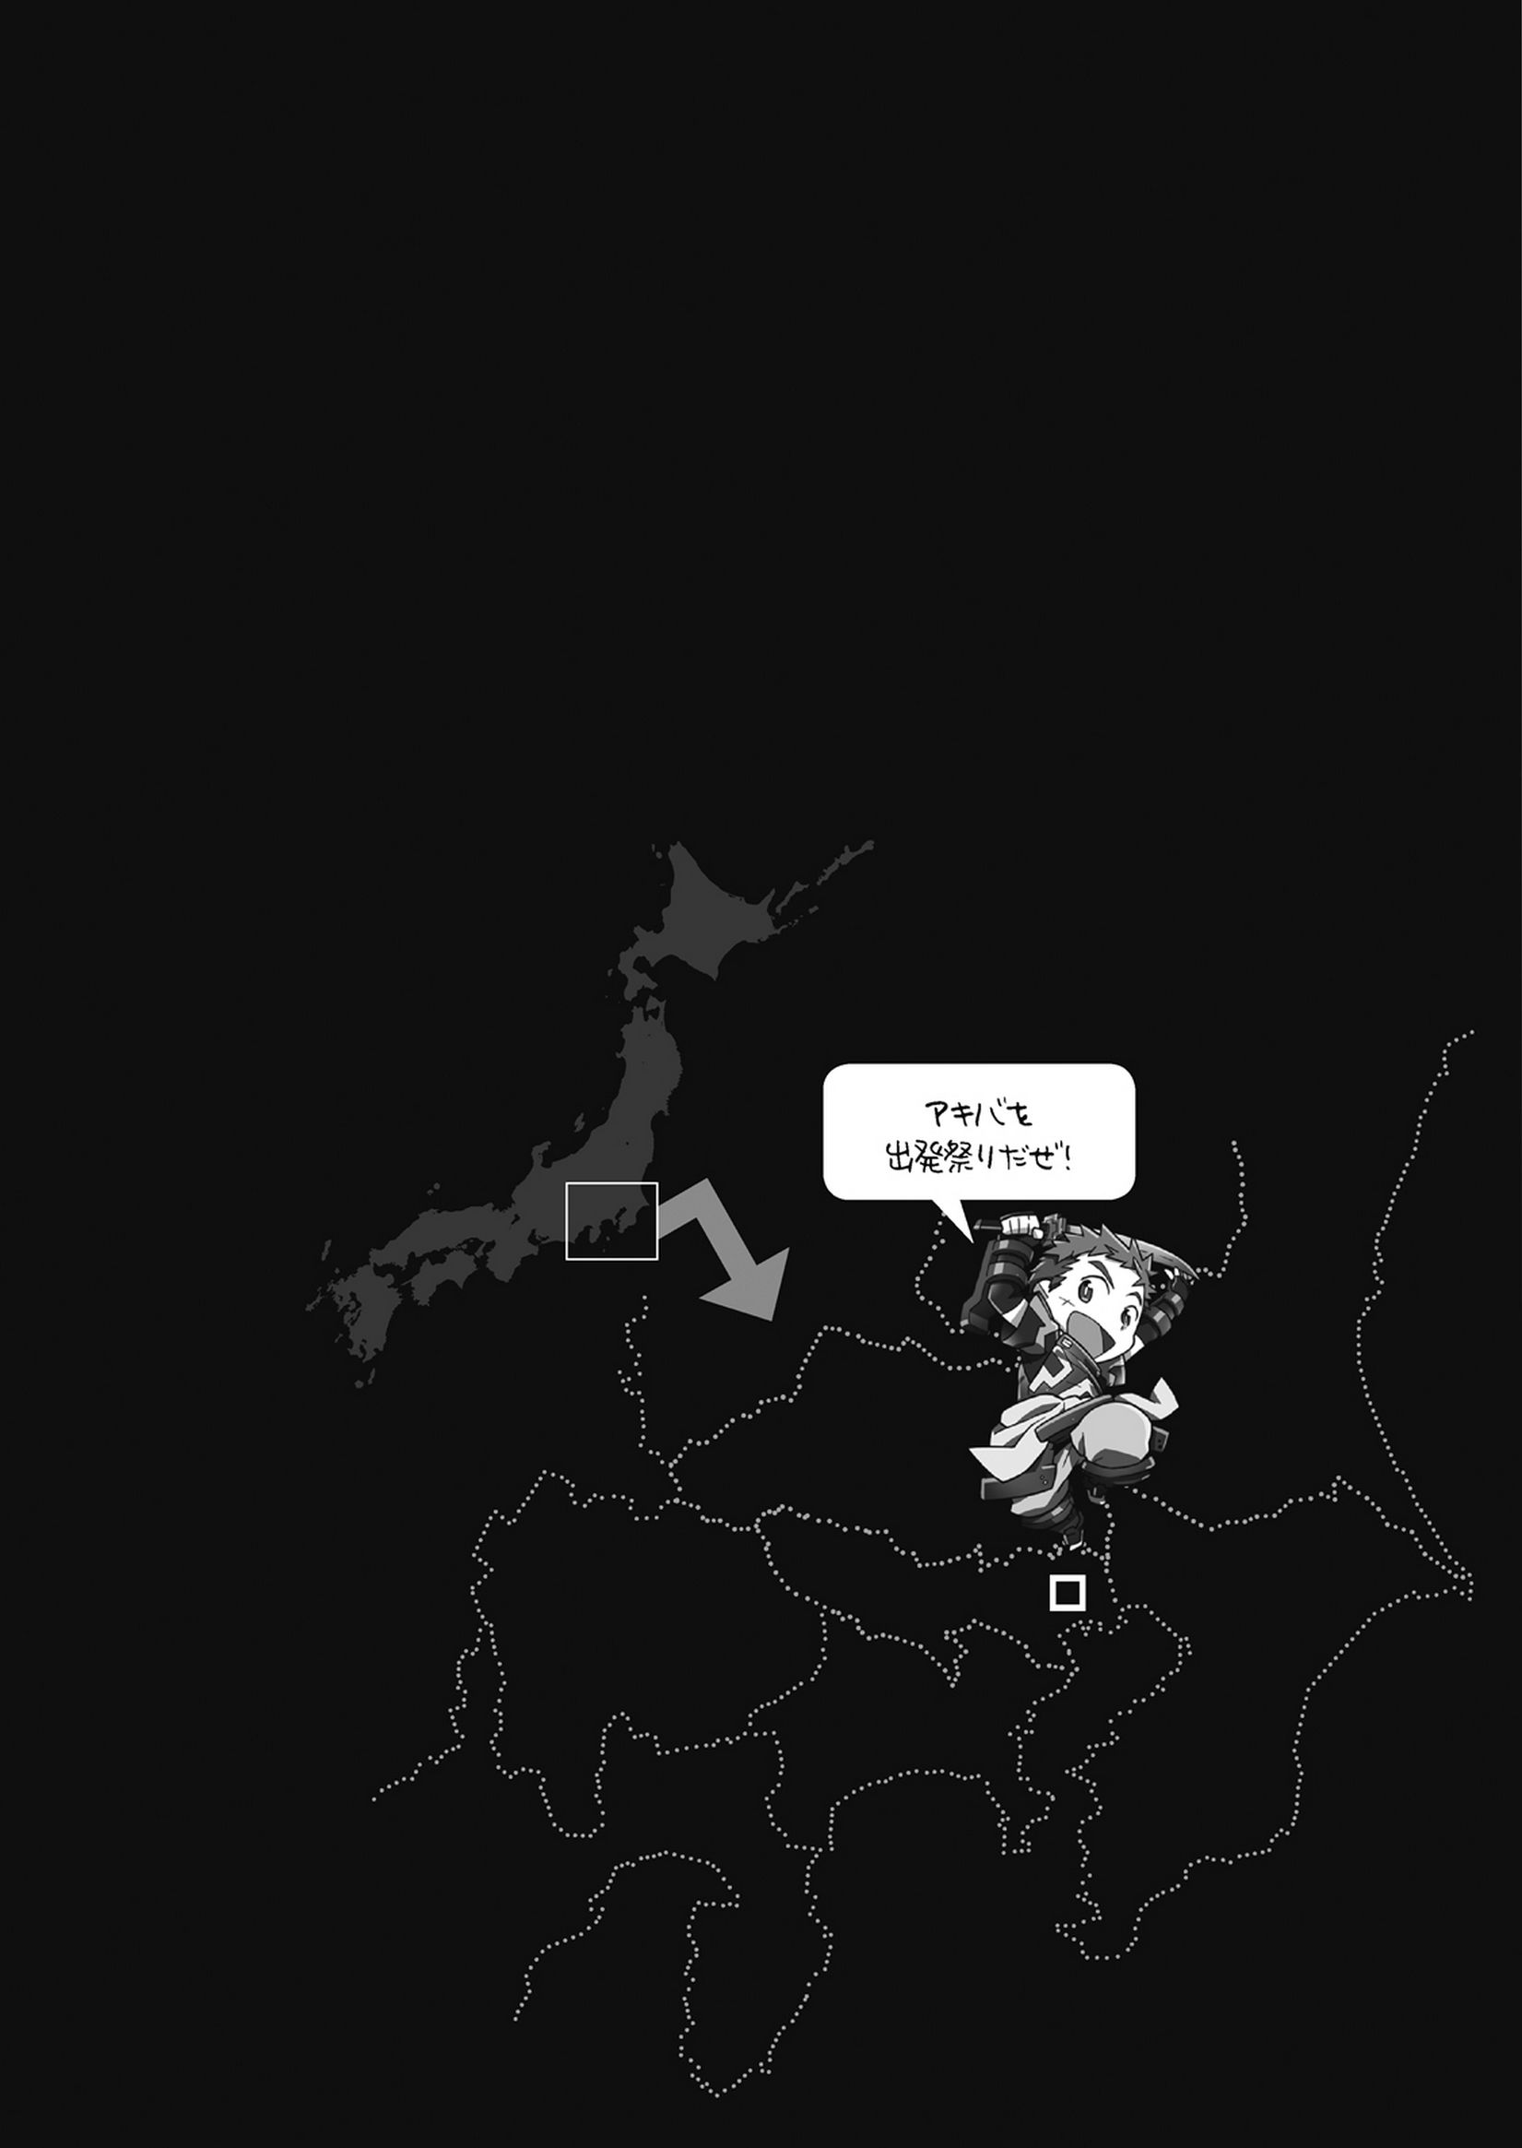
Chapter 1 – Part 1
Isuzu clutched a lute to her pounding chest and stepped onto the twenty centimetre high stage. Although she felt like she’d burst, her consciousness slowed and she met the eyes of her partner for the day, Tohya. He grinned and lightly kicked his impromptu drum set made of cans and boxes lashed together.

Isuzu herself gave a bold seeming smile and lifted her lute slightly higher, the An Die Freude that Maryelle had made and the Roderick Firm had remodelled.
The stage was tiny, if you looked over it from right in the middle, it went about ten metres in each direction. The café was one of the many in Akiba’s centre streets, The Broom Hole.
Originally, it was nothing more than an abandoned building but it became part of Oceanic Systems’ experimental reform project and passed into the Adventurers’ hands. After that, the store received many repairs and was now owned by The Seventh Drum and Fife Band.
From the beginning, much of the management of the shop itself was done by People of The Land because the Adventurers were too busy to have time for managing a shop and business work. In Akiba, dual managed establishments were the current style, almost like symbiosis.
The country style shop was lit extravagantly with Magic Lights.
And in that light stood Isuzu with her head bowed as she clapped her hands loudly.
There were about seventy seats, and all of them were filled.
There were canvas covered sofas around amber tables, and hanging on the wall with the menus were hand written event schedules.
The Adventurers and People of The Land gathered together in Akiba had, with some back and forth, built a store together. It wasn’t focussed on building efficiency or safe interior design, the individual guild halls, houses and shops, all had to be hand built.
The shop was a mish-mash of moods, there was a small veranda like stage and it resembled a mix of a restaurant, a fast food joint, and a live house. In a fantasy novel, it would be called a tavern; but Akiba’s adventurers weren’t like the adventurers in those novels, bathing themselves in alcohol, if pushed, they’d say that eating was more important than drinking, the store reflected this way of thinking too, it had a bright and cheery atmosphere.

Looking over the store, Isuzu relaxed slightly. In the audience, she could see many unfamiliar faces, and firmed her resolve.
It was fine to be nervous.
If she could enjoy herself at the same time, she’d be able to become more skilled.
Isuzu stopped thinking, and strummed the first note.
Before the performance, her head had been full of thoughts, and she understood what bursting with emotion felt like.
They’d been given time for six songs. Those thirty minutes were long enough to grant any wish, but short enough to blink three times and miss.
Isuzu’s joy and hope burst from her throat as sound, Tohya matching the rhythm, kicking the drums with a smile floating on his face as Isuzu scattered notes into the air.
The Amber Dragon’s Claw she was given by Shiroe glided down the strings, it wasn’t the usual way to play, but it made for a showy performance. In the corner of her head, she thought it sounded like the roar of the sea at the beach.
Happiness pressed upon her like waves.
Strumming the taught strings, the vibrations reverberated through her fingers, up to her wrist.
Hundreds of times stronger than carbonated water, Isuzu’s happiness bubbled.
She had an instrument in her hands, just from that, her cheeks slackened. The instrument responded to Isuzu’s wishes, giving the first cry of a baby, the first cry was a beautiful riff, it was Isuzu’s duty to nurture it.
Like birthday wishes, Isuzu’s words hung upon her lips.
It was her plain, ordinary voice, but it filled the room.
In this world with no electrical amplification, it was her natural voice, but it was still plenty to fill the small store.
Isuzu always felt strange doing this. Could a common country high school girl’s voice echo like this?
Isuzu had been playing here for a month, but if she counted on her fingers, how many times she’d been on stage, she wouldn’t need more than one hand. Of course, before the catastrophe, living in the outskirts of her hometown, she’d never done anything like this. Where there was mainly empty land and fields around where she lived, the closest she’d come was a box like karaoke room.
That was why, every time her voice was so sweet and carefree, she couldn’t help being surprised.
However, that was only for a breath.
Her reverie only lasted a moment before it was swallowed up in the flood of sound.
A burning shiver ran through her arms, and she strained her voice through her quivering throat.
It wasn’t anything special, on earth it was just a common rock number, a song Isuzu remembered from her childhood, hearing it in her father’s collection. Isuzu played and sung the song that brought such a desperate heat to her.
Wrapped in Isuzu’s troubadour aura, Tohya took care of the drums, but there were no other instruments.
By the old world’s common sense, this wasn’t a bad, it was a small scale group, just breaking onto the stage.
But even that, in front of Isuzu’s happiness which was boiling like the air above the pavement in the summer, was meaningless.

Isuzu was singing on her stage.
It was a much more vividly moving experience than she had imagined.
In the light from the magic lights, Isuzu was no longer Isuzu, she had become someone else, the thin, freckled, curveless high school girl had vanished. She had become the lute-strumming troubadour Isuzu, who was full of confidence, wearing a shining smile.
The overwhelming happiness cleared her sight.
Many people were watching Isuzu from the filled seats.
They were all smiling.
The dwarf shop manager’s mouth was drawn together in a line, but even they were enjoying the rhythm. Isuzu’s feelings were pushed out through the lute like an arch of F notes.
Nyanta and Serara sat by the counter, Serara shivering with red cheeks, and Nyanta smiling whilst watching over her. Serara holding her shaking fist in front of her chest was really cute. She was the girliest girl that Isuzu knew. The calm gentleman Nyanta’s silver whiskers twitched as he enjoyed the performance.
Their calm aura flowed into Isuzu and gave her lute even more brilliance.

The first song ended. Most of the room were hitting the tables in time with the drums, like they were percussion instruments. It felt like she had a bass drum in her stomach. Her braid swinging in front of her eyes, she spun on her foot and started preparing for the next song.
It was irritating.
Had her happiness been received by everyone?
Even in her giddy dizziness, she still managed to properly thank her lute. The lute was her partner.
After being rescued from Hamelin, she didn’t know what to do, and found this lute in the Crescent Moon Alliance. The guild master Maryelle was a carpenter, and had made it a long time ago. It had been added to and upgraded here and there, and barely looked like it had originally, even so, it had healed her feelings of loneliness from this alternate world.
Isuzu and the lute were already of one mind and body.
In this world without school or clubs, she didn’t just play her lute, she did housework for the guild and hunted with her friends.
But in this world with no TV, web, cable or films, if she wanted to hear music, she had to play it herself.
At the end of a ribbon like cable from her trusty partner, there was a shell with a globe inside that raised her voice. An artificial spirit that magnified sound from the trunk of the lute. It was because the Roderick Firm had remodelled it with the low-level follower summon item Siren’s Shell. It was originally a lute for old style music, but the remodelling gave it more width and feeling and evolved it into a deluxe mystery instrument. Even so, Isuzu loved her partner.
The Magic Light met her eyes and smiled brightly.
I forgot. Thank you.
Filled with those feelings, Isuzu nodded.
What song was it now? She was dizzy and didn’t know. She thought it was the third or fourth.
She felt like she was about to fly away, like she had grown wings and blown away the fragments of fatigue.
Was this also part of the stamina of an adventurer?
That wasn’t right.
Rather, it was like a cable had attached to her back and was pouring energy into her. The store was filled with the sounds of clapping and stomping, it was like a furious avalanche of happiness. Isuzu cheerfully sang an absurd rock number, one of the oldies from her father’s collection.
She didn’t think it was a good performance.
At any rate, Isuzu had no musical talent, she’d been told that time and again by her father. She was a country high school girl, the only things musical that she’d done were school festival type things, and after school karaoke. She hadn’t received any instruction in those things, and was no match for her musician father.
However, or perhaps because of that, it had nothing to do with this wondrous moment.
That emotion wasn’t happiness.
It wasn’t anything so vague, it was the clear energy of the moment.
The invisible, intangible, colourless power that slept inside everyone. In Isuzu, in Tohya, in Nyanta and Serara, in everyone in that store.
It was overflowing and raining down upon the stage, the lute was connected to Isuzu and performing, so talent had nothing to do with it. This enjoyment, and everyone’s joy were proof of that.
Next to the entrance furthest from her, Isuzu saw a glint of gold.
It was the dog-prince, his face full of excitement, waving both arms at Isuzu. Just from seeing that, Isuzu’s lute broke past its limits. Isuzu was filled with feelings she didn’t understand, her face relaxed and she broke into a big smile, waving the neck of the lute in reply. It was embarrassing and awkward, and she didn’t know what to do. The notes around her turned pink and overflowed.
She needed to put her all into the next number too.
It was Isuzu’s sworn friend, her colleague, her designated bag carrier and her guard when walking, the dog-prince, Rundelhous Code’s favourite slow ballad.
It couldn’t be helped, this next song would be a prize for Rudy.
Isuzu thought that and took a deep breath.
Reading the mood of the soft light from the Magic Lights, Isuzu started singing the next song.
It would be today’s most important performance.

Part 2

“It’s a little warm tonight isn’t it ~nya”

“It is, Nyanta-san”

If you walked a little from the store, the streets were deserted.

In this alternate world with no electronic media, trains or cars, the noise of city life was non-existent. There were festivals like the Libra Festival, but that was different, and the mornings and evenings were getting colder, so the streets were deserted at night.

Isuzu, Rundelhous, Tohya, Nyanta and Serara were in good spirits, smiling as they went back from The Broom Hole.

On the main streets, there were Firefly Lights dotted here and there, and the party had Rundelhous’ Magic Light to guide them as well.

Rundelhous and Tohya were talking excitedly ahead of everyone, Serara and Nyanta were enjoying themselves too, and Isuzu followed behind, wrapped in a fluffy aura of joy.

Tohya and Rundelhous were carrying large amounts of luggage, but Isuzu only had her lute, cradled against her chest. Because they were only walking through the town, they were all in casual wear and didn’t have their weapons with them. Around the time they’d joined Log Horizon, their lives hadn’t calmed down at all, so they had few personal belongings, but now, because they had their own rooms in the guild house, they had more casual wear. Now that they thought of it, it had been half a year since the defensive battle at Choushi.

<;/br>

Rundelhous looked back at Isuzu, walking slowly behind them, and asked

“Miss Isuzu, are you okay, are you tired?”

“Not at all, I’m full of energy!”

He misunderstood, Isuzu was just satisfied with watching everyone else.

“We should go back to the guild house before we get too cold ~nya.”

“To eat too!”

Whilst Nyanta and Tohya were having that back and forth, they crossed a small intersection.

They were all walking down the night roads with happy faces.

Isuzu and Rundelhous were used to Log Horizon now.

Log Horizon was a kind and comfy guild. Isuzu had become good friends with Minori, she felt like she had known the diligent younger girl for years now, Serara too. Isuzu really liked the girl standing next to Nyanta, with a melty smile on her face.

Isuzu’s sworn friend, Rundelhous, had also relaxed since when they were in the Forest of Lagranda. Rundelhous and Tohya had become friends as “the boys’ group”, when they were together, it was really noisy. Isuzu would say that their mental age fell when they were together.

They also gradually got to know the senior group of Shiroe, Nyanta, Naotsugu and Akatsuki. The eldest in the guild, Nyanta, was an easy to get along with, calm dandy. The guild’s kitchen was his domain. The young group had been caught by their stomachs and fallen in love with his cooking.

Tohya and Rundelhous had come to understand Naotsugu by talking with him. He always was the life of the party in their banter, but Isuzu thought he was a surprisingly considerate person. If there was a problem with the decoration or facilities in the guild, Naotsugu was the first one to talk to.

Recently, Naotsugu, Tohya, Rundelhous, and sometimes Nyanta had some male bonding time. They said it was special training, they’re sometimes a bit childish, but Isuzu and Minori pretend not to see. According to Naotsugu, they went out here and there, but they came back with silly grins and mud clinging to them. Minori and Isuzu would smile wryly and go to prepare the bath.

Akatsuki was a quiet and sharp woman. She seemed shy but still replied somewhat curtly when addressed. When Isuzu first joined the guild, she disliked her a little, but she was really a kind person with a hidden sense of humour. She enjoyed washing and cleaning and, without any help would stealthily implement large scale cleans. In the blink of an eye the sheets would be airing on the veranda.

Since the New Year, Tetora had joined and was their free healthcare. She certainly wasn’t a shy person, the first time they’d met, she’d grabbed Isuzu in a hug, not just Isuzu, everyone apart from Akatsuki, who had quickly side-stepped.

On the other hand, there was the guild master, Shiroe, who they didn’t understand for a long time. At mealtimes he’d absentmindedly pass out the seasonings and plates, not anything special. He’d nap in the afternoons on the sofa in the living room, seeming exhausted. When it was time for cleaning or shopping he’d say something like

“I’m no good at this, so I’m going to my room.” And hard-heartedly leave it to Naotsugu and Akatsuki.

If you listened to the rumours in the town, you’d hear all sorts of things, like ‘His eyes are sharp.’ Or, ‘He’s a wicked schemer.’ Or, ‘He’s playing with Akiba’s fate.’ Or, ‘He’s the mastermind behind the Round Table.’ Or, ‘He’s not good enough’. Isuzu would agree with the sharp eyes, but many of the others she thought “Is that really true?”

Aside from the rumours, Isuzu also had her long-time friend Minori, according to her, Shiroe was a “really upstanding young man, kind, good at taking care of people, wise, gentlemanly, the one I want to-”

It was like there were three types of Shiroe, inconsistent like daily specials for lunch.

The one that Isuzu thought of was when he stood at the cross-roads in Choushi with his strict face, asking for secrecy, she thought (even though she hadn’t seen a real one) that he was almost like a judge.

She thought that saving Rundelhous wasn’t a matter of chance, but a foregone conclusion, he really was an amazing person.

One day, after she knew him better, she’d asked Nyanta who had just said

“Shiroecchi has eldest-son-syndrome.”

To Isuzu, Shiroe was someone who tried so hard it defied common sense. He was someone who had such amazing talents, but also unexpected bad points.

She could understand Shiroe a little better now, so felt like she could help Minori.

Like that, Isuzu got along with Log Horizon as time passed.

She thought everyday was busy, even if there was nothing that needed to be done, people still got hungry through the day, and if people got hungry, they needed food, so the food needed preparing. Log Horizon had Nyanta who had a sub-class of Chef, but that didn’t mean that everything to do with food should be pushed on to him.

In the first place, in this world, there weren’t any conveniences like pre-cut vegetables, seasonings, and instant meals, so cooking was hard labour.

If you wanted to cook something fancy, those preparations could easily take an entire day. On top of that, there weren’t net-supermarkets that would do home delivery, you had to go and buy the food yourself.

Delegating all of that work to Nyanta would be unfair. Even if there wasn’t anything cooked in the mornings, there was always something left out for breakfast, on top of that, two days of the week were set as “Chief Nyanta’s rest days.”

The preparation of food was on everyone’s minds, so the most noticeable stores in Akiba were the food and drink stores. Places were you could just decide to go and eat on a whim, set meal and soup stalls were very common. As could be expected from a place where gamers gathered, there were many stores which sold food which was simple and filling, but there were also bakeries, take outs and other stalls. And even a few fashionable restaurants for dates.

From the beginning there were many shops which sold food and drink, but the 8th Shopping District had led the way, opening a shopping mall under the guard rails by the abandoned Akiba Station, where you could find familiar flavours.

On “Chief Nyanta’s rest days” the guild members would eat out at one of these shops.

The range on offer had changed a little around the end of year celebration of Snowfell.

Isuzu had been scouted at an open stage night at The Broom Hole, and about once a week after that, she’d done small life concerts like today.

Being a bard didn’t increase your singing or musical ability, but adventurers who didn’t have bard as their class, or a similar sub-class had limits placed on their musical abilities.

If they had the Diva sub-class or similar, then, depending on their practice, they could sing well, the limitations wouldn’t drag at their feet. Bards however, could remove the limitations from people around them, so when Isuzu was on the stage, Tohya, Minori and Serara could use backing instruments and keep a rhythm. Unfortunately, the dog prince himself had no musical talent so was mainly there for support.

“Minori-chan would have liked to do this too.”

“She would have ~nya.”

“She couldn’t, she had work.”

“With Charashin-san, right?”

“Miss Minori is a working woman.”

“Ahahahaha.”

“But, she should be finished now.”

“Isn’t she going home with Shiroe-niichan?”

Her heart was pounding in her ears, but listening to her friends’ conversation in front was slowly soothing her. It was like the loneliness as a dream leaves you, but even so, the indelible happiness still followed her.

(She wasn’t a pro like her father, but she sometimes played the lute to make herself feel better.)

She didn’t think she’d ever go on stage.

But more than those worries, she loved music; she gently caressed the lute in her arms. Like a hanging fruit, the trunk hung from the neck. She was more accustomed to the wooden bass, but the lute had a more delicate, old sounding tone.

(Uehehe.)

The wooden bass she used to use was a mass produced model (though still ridiculously expensive for a student like Isuzu) but this lute was a one of a kind item made by Maryelle. It was decorated with two strings of elegant rainbow-coloured mother of pearl down either side. Compared to when she received it, it had been remodelled here and there, but it still had the resemblance to a dolphin that Isuzu liked so much.

“Rockers have to have a favourite instrument!” That was what Isuzu fervently believed, and her lute, the Flying Dolphin was hers.

“What’s up, Isuzu-neechan?”

“Fueh?”

“Isuzu-san?”

Before she knew it, everyone was gathered around her

“Eh? Eh?”

“You were grinning, nee-chan.”

“I was not!”

“You were, you were smiling.”

She put a hand against her cheek, to check for herself, and sure enough, her cheeks were drawn into a smile.

“Miss Isuzu is still excited.”

“That’s not it, Rudy!”

Isuzu’s voice got louder as she moved towards him, Rundelhous looked around with an amazed face and a kind smile, looking for support. Tohya answered his plea with.

“Isuzu-neechan really is amazing.”

“That’s not true at all, it’s just because I had instruments in the house when I was a kid, so I can sort of play them.”

“That’s not it ~nya. It made everyone happy ~nyaa.”

With a smiling Serara agreeing at his side, Nyanta praised her too. Her face went bright red, and the one who struck the final blow was the one who was supposed to be her ally, Rundelhous.

“Miss Isuzu is like a spirit of music, her enchanting melody enriches the night. Next week we’re going on a trip after all, I’m sure the people there will enjoy it…. Uh, what is it, Miss Isuzu?”

“I. Told. You. Rudy. Why do you say things like that with such a serious face!?”

Isuzu’s embarrassment overwhelmed her patience and she started chasing Rundelhous around.

She was happy, but couldn’t look at them in the face. The chase through the cold night continued until they reached they guild house.

Part 3
It had been six months since the apocalypse, within all the ruined and abandoned buildings in Akiba, the one that had received the most improvements was the Guild Hall.
On the first floor there was the Guild Information Desk, the bank and hallways. From the second floor, there were six floors of transfer doors to individual guildhalls, lined up along the corridors like a hotel. On the fourteenth floor, the Luquenje conference hall used when the Round Table Conference was formed.
The seventh floor and up were originally like tenantless buildings for rent, when Elder Tale was a game and immediately after the Catastrophe, it was just space without a purpose. When the Round Table Conference was formed, the space became very valuable as it could be repurposed for many uses.
The Manufacturing Guild Liaison Office and other sub-divisions of the round Table Conference had spaces set up for them during the Libra Festival. For all that the Round Table Conference was a self-governing organisation, it had little power in a political sense, and their ability to flatter couldn’t be said to be high.
Even though the Round Table Conference was imperfect, they governed well. As the major guilds that made up the conference formed a not insignificant proportion of the citizens, the city had confidence in them. There weren’t many of the original citizens from when it was a game that opposed the rule, there were altruistic players which made voluntary events and such.
In the first place, Akiba was founded on freedom, whether you wanted to just carry on with your life, fight, or do something related to economics, the difficulty level wasn’t too high. People in Akiba just went about life as they pleased, those who wanted to hunt lived went to the outskirts, people who wanted to manufacture shut themselves in workshops, and those who wanted to sell things or interact with people, managed stores.
There was the self-governing organisation, but as long as they didn’t get in the way of what people wanted to do, that was fine. That’s how the general populace felt, but the Round Table Conference actually had far more to do than the citizens thought. If only they could let people just do what they wanted, but things needed doing, like determining priority for usage of buildings as stores because of course several people would want the same area.
One by one, these issues weren’t important, but dealing with masses of administration was the fate of any self-governing organisation, the Round Table Conference was no exception.
“Phew, I’m finished here, Black Heart.”
“Over here too, Isaac-san.”
In the corner of a large cafeteria on the first basement floor of the Guild Hall, the two of them spoke to each other. Log Horizon’s guild master Shiroe, and The Black Sword Knight’s guild master Isaac.
It was called an underground cafeteria, but it was really just a space where you could eat and drink.
Light from the firefly lights around the ceiling streamed down onto tables which would seat two or four people, with geometric lines drawn on them. The space was split into many areas, further in there were private rooms and small conference rooms.
There were also two communal kitchens which could be used by cooking groups to sell food, the buyers took their food to the tables themselves under a self-service system.
Shiroe’s group had taken up positions around an eight person table far into the area, maps, documents and writing tools lined up on top of it. Various tools and measuring devices had been added from the bag at his feet. It was the sort of table hogging that shouldn’t be seen somewhere where you eat, but they’d already finished using it for food.
“What are you talking about? I’m the one that handles most of the admin for the Black Sword.”
Said Isaac’s second-in-command Rezarick, slumping with an aghast look on his face. Isaac just gave a smirk that said “don’t sweat the small stuff.”
Isaac was naturally not wearing his armour today, instead he was clad in the Round Table Conference’s uniform with an ash coloured trailing coat draped over his shoulders.
It seemed like Isaac like the uniform, though Shiroe.
Shiroe however, was in his everyday turtleneck. The best kind of clothing for carrying papers around and doing office work.
Recently he’d been working a lot with Isaac, but office work didn’t suit Isaac, every time he tried to have a meeting and draw up papers, they’d end up going for food and drink.
Staying in the bustling Akiba wouldn’t work so he was grateful for the underground shared space.
“I don’t really get it, but is this fine?”
“Yes, that’s fine, sorry for letting you take the lead.”
“I don’t care about that.”
“Isaac-kun was looking forward to be able to see this.”
“Shut it you. And don’t call me ‘-kun’.
Shiroe smiled at their conversation and began packing away the surplus equipment.
“But you know, since we came to this word, The Knights have been doing a lot of drills.”
“It’s The Black Swords, not The Knights.”
He said that, but Isaac didn’t seem to be too serious about it, he was more focussed on the documents in front of him. Titled “The first people of the land training outline.”
“Like I said the other meeting, it sounds friendlier.”
“And like I said, we don’t need that kind of thing. How many levels do we want to raise them?”
“By two or three would be good – no, even a single level.”
Shiroe answered without looking up from his papers.
The request to The Black Sword Knights was to go to Maihama and hold training. The target of course was the people of the land knights, not just those from Maihama, but for the other feudal lords’ knights as well. It was for all the League of Free Cities Eastal’s people of the land.
“I don’t want to spend ages on them.”
“They’re people of the land remember, don’t push them too hard.”
“Is that so? Oi.” Isaac turned to Rezarick who was standing behind him and asked “weren’t we going to power level them?”
Power levelling was a term used in gaming, it essentially half forced levelling up. A high level leader would farm monsters that gave lots of experience, the low level members of the party stay a safe distance away gain a large amount of experience. It raised levels efficiently in a short time, so it was common to see in MMO type games.
“Power levelling would be a problem. They won’t be able to use their actual power.”
On the other hand, as with Shiroe’s reply, there were many who opposed that way of thinking. Whilst it raised levels and physical ability, you wouldn’t be able to use the suddenly increased abilities correctly. Even though attack power and stamina would increase, there would be the adverse effect of not knowing how to fight properly or what tactics to use.
Isaac let out a big laugh and said
“You’re hard-headed, Black Heart. If we do power levelling and actual training, it’ll be fine. Probably more training than levelling, what a pain.”
Even Shiroe thought there was no helping it when it was put like that. In the first place, even he didn’t completely oppose power levelling. For example, if a player already had a high level character, using that kind of method on a second or third character was fine.
Besides, Shiroe was working overtime in Akiba at the moment. Although it would take less than an hour to get to Maihama by Griffon, the one in charge of the plan was Isaac, so he couldn’t just pick holes in it.
“That area is fairly open, so don’t go all out please.”
“Ah, leave it to me… But still, guarding.”
Isaac’s face fell into a thinking expression as he ran a hand through his hair and fell silent for a while.

It was just past dinner time.
If you were to think of restaurant type places, this should be their busiest time, but the space was less than ten percent full.
That was to be expected though, this space was like a cafeteria for the Adventurers and People of the Land that worked for the Round Table Conference. Many of the adventurers had their own guild halls, and would work there normally, Shiroe, Michitaka and Charasin all did this.
The only people that would still be here at this time, were exceptions like Shiroe and Isaac who were discussing things over arranged documents, people who lived in the guild building itself, or people who did little else but work. That number of people was by no means large.
“You haven’t been able to contact that idiot Krusty yet?”
“No, the friend list isn’t reacting either.”
“What’s he thinking, leaving his guild like that, it’s going to fall apart.”
“It doesn’t look like it will go that far.”
Answered Shiroe.
Close to three months had passed since Krusty had gone missing in the mountains. Isaac said “going to fall apart.” But there had already been plenty of time for the guild to collapse.
In general, MMORPG guilds were fragile things, they weren’t jobs with contracts, it was simply “let’s play together”. People who lived close, classmates or just people who wanted to communicate without the limits of a physical body, it was something more pure than friendship from physical meetings, but that itself was why they were so easy to break.
It only took someone saying “I don’t want to be here anymore.” And they could fall apart, guilds like Hamelin which interfered with the withdrawal process were the exception.
In many cases, the core of the guild was its leader.
The leader was the one who chose where the guild would go, the one who set the mood. If some trouble appeared within the guild, it would be up to them to solve it. For a guild to be a guild, a leader was needed.
After Krusty had vanished, there had been people leaving D.D.D, they probably felt uneasy being in an organisation with no leader, and they couldn’t be faulted for that, especially when this world becoming real meant that a mutual-aid organisation was needed for survival. The fact that in three months with no leader, the number of people who had left the guild hadn’t reached fifty was a quiet miracle.
Shiroe had received the report from the grave-faced sorcerer Rieze, her management skills weren’t just praised to keep the Round Table running expediently. Shiroe truly thought that it was an amazing guild.
“You worried, Black Heart?”
“What about you, Isaac-san?”
“No way would I be worried about him, he’s a Berserker, he’s just off playing or fighting somewhere.”
“Hmm.”
Shiroe nodded vaguely in assent, he couldn’t quite deny Isaac’s words. He thought that Krusty had probably been launched into another server, or possibly a zone where telepathy didn’t function, events with those zones had existed when Elder Tale was a game. Of course, all that aside, it was still a serious incident, the possibility that Krusty himself was in trouble wasn’t small, but as Isaac said, if he were asked to choose who out of the Round Table personnel would be most likely to come back alive from some unpredictable issue, it would be Krusty. Even so, he couldn’t help but worry.
“He’ll probably just appear back here suddenly.” Declared the one who Shiroe thought would be the second most likely to come back.
“What I’m worried about isn’t Krusty-san, but D.D.D and the Round Table Conference.” Revealed Shiroe.
D.D.D was certainly a self-sufficient group who could continue their administration even without Krusty. But being able to continue the administration and being able to alleviate their member’s worries were different. Already a small number had been driven by those feelings to leave the guild. The possibility of D.D.D collapsing was not small enough to neglect.
D.D.D was the biggest combat guild, and also one of the most rigorously organised. For example, if you were to judge by their achievements in raids and battle quests, there were many shining stars in Akiba. Isaac’s Black Sword Knights and Soujirou’s West Wind Brigade were two of them. However, as the scope of the battles increased so did the need for a highly ordered structure and chain of command due to the needed tactics. In this, there was no guild to substitute for D.D.D.
If D.D.D were to fall, not only would it weaken the Round Table, it would weaken Akiba as well, that couldn’t be avoided.
Shiroe felt that the Round Table was a good self-governing organisation, but that didn’t mean he thought it was faultless. If a parliament of influential guilds was to temporarily show discord, it would show its unexpected fragility.
(Eins-san probably can’t be stopped…)
Honesty’s investigation of the Fairy Rings was proceeding well, but the amount of attention paid to it within the town was low because of the constant technological breakthroughs within the city. Those breakthroughs were slowly eroding the measure known as levels. The period where high levels meant prosperity were passing away.
The formation of the Round Table Conference, and these breakthroughs were changing the world. Now, new ideas and the ability to carry them out amassed wealth.
Many adventurers hunted, but left a wide safety margin, for example, level ninety adventurers would hunt in level eighty five areas. Of course, they earned money and items, but their levels wouldn’t go up. Some guilds continued with extreme challenges, but it was safe to say they were the exception. They were the only ones with levels above ninety, but casual hunting could no longer make a large profit. There were people showing irritation with the current situation, to unite them, Krusty was important, Shiroe was having some difficulty handling the fallout.
He thought that he’d finished with securing financing from the Kunie clan, but yet another headache was added to his pile, so even Shiroe felt like crying. He at least had help from Nyanta and Roderick, but they could only appeal to people’s self-control with dangerous flavour text items. On top of that, it wasn’t only cursed items which could cause disasters, even items with no clear curse in the flavour text could cause issues, with their tactics, the list of dangerous items should be finished soon, but that was no guarantee that nothing would happen.
“Shiroe-san!”
“Yo yo, Shiroe-dono, Isaac-dono, are you finished? We bought food.”
Charasin and Minori, who had been helping the head of the manufacturing guilds’ liaison committee appeared. Charasin was dressed as normal, but Minori was wearing civilian clothes for in the city. She looked like a student coming back from lessons as she looked happily at Shiroe.
Isaac gestured at a sofa and said. “Hey, go ahead and sit.”
Whilst the gesture was forceful and could cause others to get cold feet, Charasin just said “Thank you, thank you.” And cordially took the seat. His amiable nature was Charsin’s weapon, as Shiroe thought this, Minori had stood next to him and skilfully cleared the documents and set down sandwiches and a drink.
“Shiroe-san, have some ginger ale.”
“Thank you, Minori, you didn’t have any problems at work?”
Looking at Minori with a despicable smile as she shook her head, Charasin said.
“Hey hey, Shiroe-dono, how about this, why don’t you give Minori-chan to us, she’s really skilled.”
Isaac came to Shiroe’s rescue as he searched for a reply.
“Oi, Charasin, you’re making passes at middle schoolers now? Been too long since you had a woman?”
Charasin frantically replied with things like “That’s not it, Isaac-dono, it’s about work!”
To the giggling Minori, Charasin’s talkativeness was an everyday thing. Shiroe relaxed in relief and took a sip of his ginger ale and smiled. All of the drinks in Akiba were homemade, the ginger ale with a light hint of honey felt good.

There were a mountain of things to do, and the future looked tough. The capture of Seventh Fall where the Goblin King reigned wasn’t complete, and the round table wanted to raise everyone’s levels to at least thirty.
But Shiroe had another plan riding on that, and for that, he had to lay the groundwork. That was why Shiroe had more things to ask of Charasin and Isaac regarding the People of the Land’s knights’ training plan.
Part 4
Rieze was being worked to death.
Her original work, the supervision of the training squads, hadn’t changed since Krusty had disappeared, but, along with the spreading uneasiness within the guild, the amount of trivial things that needed attending to had increased. The hand over hadn’t gone smoothly, there were things which needed checking on one by one, and the amount of counselling and comforting that was needed had also increased.
Above all, what was wearing on her was knowing what was important and what wasn’t. What to do and where to do it, Rieze had no idea. With the unease within the guild, and trying to understand and oversee the majority of the administration, the information volume was beating her down.
It would be fine to give up, but her worries and working right up to her limits were causing trouble for others.
She didn’t know what to do or where to go and felt like everything she had done and everything she should do had failed, and continued through the night feeling like she was getting in the way of the administration.
Her sleep was light and there were many times she’d shot up in bed through the nights.
Her feelings about what had happened were swirling in confusion, little troubles seemed like they were big problems standing in the guild’s way made fear sink in to her teeth.
On the other hand, there were things which absolutely had to be done which were underestimated, widening the scope of the damage even more.
Even without Rieze’s regard for Krusty, she’d had the pride to say she had seen his guild management the closest, it’s wasn’t just Rieze, but all of the Drei Klauen that had that kind of managerial role.
But now that he’d vanished, it felt like they didn’t understand the management, the division of work, or even the report system.
The individual divisions autonomous management systems were still functioning as well as they had under Krusty, if there had been a problem there whilst Takayama Misa hadn’t been able to act for a month, D.D.D would have disintegrated.
That the guild had been able to struggle through the month was no doubt thanks to the organisation structure that Krusty had made.
However, after Snowfell was over, like invisible metal fatigue, the guild was slowly crumbling and there was no end to the darkness in sight.
The thing that saved them from those days was Henrietta and the others.

“You’re looking pale again.”
“Oh, am I?”
Rieze had been abducted by Henrietta again to the Crescent Moon Alliance’s guild hall.
The dining room wasn’t confined and had decorative plants dotted around the room, and in between them were strange stuffed animals. It should have been a disorderly mess, but instead it gave off a welcoming feeling. The table was a simple beige wood, and sitting under the orange tinted light, brought about a cheerful harmony.
Rieze thought that the room gave a warm familial feeling.

She’d been invited under the pretext of a late lunch, a cream stew made by their chef, Girov. As it was still early February, the days were still cold, so it was a welcome meal.
It had become a quiet meal, the members of the Crescent Moon Alliance had already finished their midday meal, and about half of them had taken out lunchboxes with them to nearby areas.
Silence flowed through the afternoon guild hall, with only the occasional small voice, or the sounds of the kitchen being cleared.
It was the sound of life in a mid-sized guild, Rieze felt a sense of assurance from the sounds.

“You’re glaring too, Rieze. You look like my lord.”
Another person who had been invited, Akatsuki, told Rieze. She had black hair and a small build, and was staring at Rieze motionlessly with hints of worry flickering around her round eyes. Rieze had become friends with her and could see the worry on her face.
“I’m okay, I’m not exhausted yet.”
“Don’t push yourself too hard.”
Henrietta chided Rieze with a soft expression. Akatsuki was held tight in her arms where she’d grabbed her from behind.
“Akatsuki-san is twenty, right?”
“Hmm? Yes.”
“And Henrietta-san is twenty e-”
“Ahem, and I’m twenty.”
After the interruption, Rieze let it go quickly, there were some things in the world it was better not to investigate too much.
“Yes.”
Rieze could see Akatsuki’s displeasure, and wanted to draw her out of it.
She still took exception to the difference in her appearance and age, but if pushed Rieze would say there were some advantages to looking young, of course, she wouldn’t have thought so in high school.
Rieze surprised everyone after having been thinking for a while by saying.
“It’s sort of strange.”
Akatsuki was a twenty year old student, Henrietta worked as an office lady for a big company, Mikakage was going to a technical school for chefs, aiming to become a confectioner, Minori was a middle school student, and Nazuna was a dentist’s assistant.
“Our ages?”
“No, in the original world, I’m sure we wouldn’t have become friends.”
“You might be right.”
Answered Akatsuki with a puzzled face. Seeing her friend being teased by Henrietta, the first smile in a long time found its way onto her face.
Rieze was surprised at feeling her face go loose, she’d been under more stress than she’d thought.

“No, that’s not true! It’s said that the cute are drawn together, we would have met no matter what!”
“We don’t need that kind of assurance.”
“But recently, when I rub against you, you haven’t been getting angry, I’m so happy.”
And like that, Henrietta and Akatsuki’s normal playful fight unfolded. Henrietta with hearts flying off of her and Akatsuki with a resigned face but not actually hating it. She didn’t like it, but had given up resisting. Rieze was sure it was because before the incident last year Akatsuki still felt inferior, but she didn’t hold out a hand to help.
Akatsuki needed the warmth from being hugged closely.

At any rate, the time Rieze passed with her close friends was peaceful.
She naturally relaxed, the tension leaving her spine and the numbing weariness slowly melted away.
Akatsuki quietly bore Henrietta’s assault with a small shrug of the shoulders and asked Rieze a small question, it was what was worrying her.
“…Is it hard without the scary glasses guy?”
“It is, I really relied on Krusty-sama a lot.”
“My lord is also troubled.”
“Shiroe-sama too, I suppose he would be, Krusty-sama had become the face of the round table’s diplomacy. It’s fine now, but when you take into account what might happen, it’s obvious.”
“The round table’s affairs can’t be ignored, but I can’t take any more.”
The Round Table Conference too was part of Krusty’s responsibilities, but of course, Rieze couldn’t handle that as well. She couldn’t handle it and had finally admitted it.
As the commanding officer of the training squads, she could direct large scale battles, and write strategy progress charts, however, in the end that was a game’s strategy. If she could praise herself a little, she was proud of applying those game tactics to the current real life Akiba.
After the Catastrophe, Krusty constantly said things like “Nothing has changed” and “How we have managed the guild, and how we will manage the guild, won’t change. Life won’t change whether we’re here or there.” Many members thought it was just Krusty giving false promises, but Rieze knew, that was, without exaggeration, what he truly believed.
On the contrary, people who said “The world after the Catastrophe is the same as reality, there’s little stimulation.” Probably also truly thought that. Krusty followed his words and unswervingly supported D.D.D.
The youth that Akatsuki called ‘my lord’ was also someone to look up to. Log Horizon’s guild master also put his skills from conquering the game into conquering the Catastrophe.
If their plans and techniques were explained, then they could be understood. MMO-RPGs were communication games, so when those words were coming from the depths of your heart in a risky situation, the experience in the game could be transfered to reality. She could understand the logic, but couldn’t believe it worked in reality.
But was it really that strange?
Krusty and Shiroe were certainly special, but Oceanic Systems’ Michitaka, Roderick Firm’s Roderick, 8th Shopping District’s Charasin and Soujirou, Isaac, Eins, Maryelle, Kushi Yatama, Henrietta right in front of her, and many others. Had they too, in some sense, not changed through the Catastrophe?
Had they continued to fight as themselves in this world which was changing completely, minute by minute?
Krusty and Shiroe had meshed with the situation, and without being shaken had used their experience up until now to solve the problems in front of them, but there wasn’t one of the others who hadn’t felt inferior to them.
In short, last year’s Akatsuki, and the current Rieze were the same.
Focusing on the tactics and manual from when it was a game, was that right or wrong? Was it enough or not? If you looked at it from that perspective, whether you won or lost, you didn’t win, you had an uneasy feeling every day. It was like Akatsuki worrying about her levels or lack of Phantasmal equipment.
Rather than that, focus on your own will and decisions, and how you wanted to live. That’s what Rieze thought. Krusty was like that from the beginning, Michitaka and Isaac were like that as well, so they were strong.
――She didn’t suddenly gain self confidence, but.

“I’m sure I’m causing a lot of trouble, and I’ll probably cause more.”
“You don’t need to worry. We know it’s tough, and I’m sure Shiroe-sama will do something.”
“…My lord won’t think of it as a bother. Besides, even if he did, I’d help.”
Henrietta’s unconcerned face gave reassurance, and the small girl clasped to her chest had a resolute smile dyeing her cheeks.
The always expressionless girl’s smile was like flower petals becoming visible.
After that battle, Akatsuki had changed. And she too needed to change.
She needed to take a step forward and stop hesitating due to impatience or unease. The self-condemning Takayama and Rieze weren’t the only ones trying to improve the situation.
Now that Krusty was gone, D.D.D needed its Drei Klauen.

Part 5
In this world, many magic items exist of many different types, weapons and armour, equipment, books, furniture.
After the Catastrophe, the amount of magic goods available explosively increased, since before that, one of the most convenient items for an adventurer was a ‘bag’.
To be precise, in Elder Tale it was a ‘container’, an item which held other items, from convenient carryables like pouches and bags, to larger things like boxes, strongboxes and chests of drawers.
Generally, the container items could hold various things inside, if the container was big enough, you could put it inside. Magic container items however, could ignore the physical dimensions, reduce the weight and transform specific items, the amount of variation was hard to grasp.
Dazanegg’s Magic Bag was a magic container item which could be equipped at level 45. There were other magic container items around the same equip level, but they couldn’t compete in terms of storage capacity and ease of obtaining.
Moreover, if you procured items you couldn’t sell for a while, the base level of the bag would hold plenty of materials, 200 kilograms in fact, and there were also higher level quests to raise the bag’s abilities, so for many adventurers, it was an eternal companion.
Dazanegg’s Magic Bag was a must have item for mid-levellers in Elder Tale, the gateway to magic bags.

“Are you all ready?” asked Naotsugu, poking his head into the living room.
“Definitely, Master!” Answered Tohya, puffing his chest out.
The younger group of Tohya, Minori, Isuzu and Rundelhous were preparing for a journey in the big room.
If they had a magic bag, the preparations would have been simple, unfortunately they didn’t have one yet, rather, the journey was to obtain one. The quest for Dazanegg’s Magic Bag, ‘Get the Magic Bag’ was a quest you could take at level 45. Until now it was a mostly meaningless restriction, but even after the Catastrophe, equip levels were a binding force.
They were going to leave Kanto for the first time to obtain the raw materials needed to make the bag.
“The carriage is ready too, Naotsugu-san.” Added Minori, concentrating on her notebook with the preparations in one hand.

The destination is the Redstone Mountains.
The trip is about 180 kilometres, using a horse drawn cart, that should take about twenty days for a round trip?
Tohya had never seen mountains before so he was daydreaming and being fidgety.
“Ahh, but the Redstone Mountains right, that’s around Nagano? There’s mountains, rivers, forests! And even villages we’ve never seen!”
“Hmm, It’s been a while since I travelled, but if you need any information, just ask me, Rundelhous Code.”
“Oh yeah, you travelled here, didn’t you, Rudy-nii?”
“Yes, until halfway I was with Adventurers, but I came here from Bogport alone, so I have plenty of experience.”
“Good, make sure you put a barrel of water on the carriage too.”
“We know!”
“Tohya, make sure you put another two pairs of underwear in.”
“I’ve already got enough, Minori.”

image9Tohya was uncontainably excited. He hadn’t been travelling in the old world for a long time, and travelling far away was rarer still. On top of that, this time, it was just the young friends going on a trip, so it was much more exciting than a school trip, and using a horse drawn carriage just stirred a sense of romanticism.
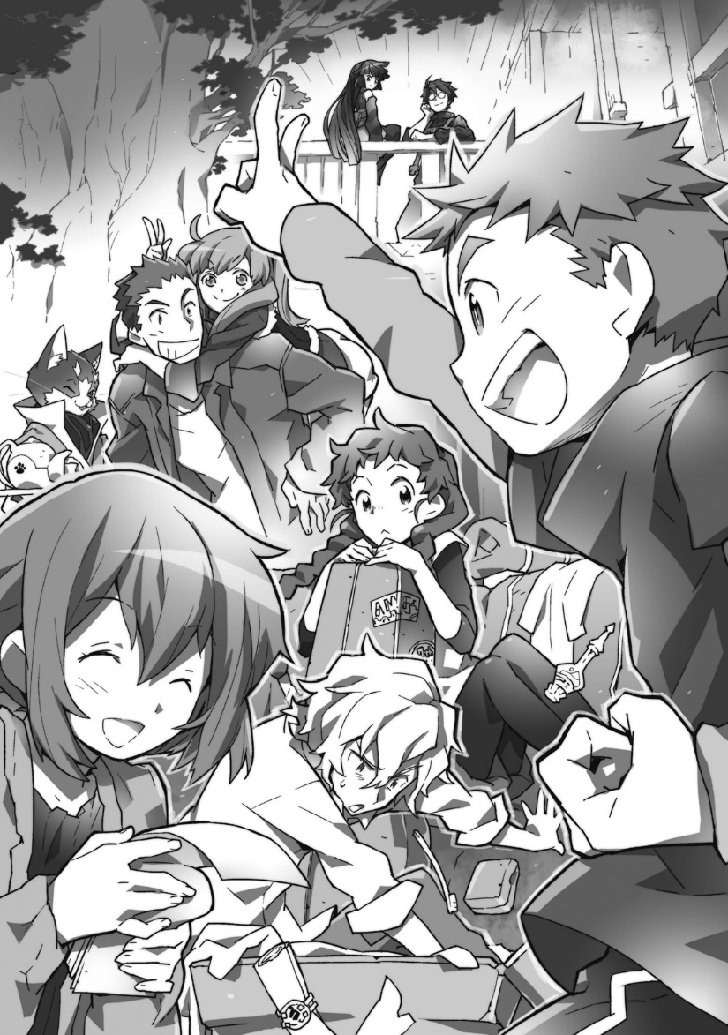
They had belongings strewn across the floor.
After being checked by Minori, changes of clothes, preserved foods and first aid kits were packed away. Tohya thought they probably didn’t need to be as thorough as Minori was being. For the clothes, in the first place, the equipment from when Elder Tale was a game had a high enough endurance, and dirt and tears would automatically disappear, so even for a long time, it was fine to wear armour and just change your underwear. For rations, if you weren’t after enjoyment, there were plenty of simple things available in this world.
Even so, he didn’t voice his thoughts, he knew Minori tried so hard, and to be worthy of being called an older brother (though Minori called herself the elder sibling) he had to look after his younger sister.
“Mugh.”
With that, Rundelhous fell to his knees and began scrabbling through the things on the floor.
“What’s wrong, Rudy?”
“My brush is gone. I need it to keep my appearance as an elegant adventurer.”
“Eh?”
Ignoring Naotsugu’s quip of “Really?” Rundelhous continued searching.
“Oh no, my precious item, it must be worth at least a hundred gold.”
“Rudy.”
Isuzu called to Rundelhous and stopped packing her self made bag of ethnic fabric to deftly pick out a smoke blue pouch from the things he’d strewn around. “It’s in your toiletries right? You’d better clean your mess up, Rudy.”
“It is, thank you for finding it, Miss Isuzu.”
Seeing the two of them start tidying away, Tohya felt happy too; Rudy and Isuzu were both precious members of Log Horizon and felt like they’d become older siblings.
When he was young, Tohya loved football, looking back on it now he didn’t know why he loved it so much, but for the energetic Tohya, running about with his friends after school, kicking a ball around was plenty.
After his legs stopped working, he showed up to their gatherings a few time, but stopped after about two months.
It wasn’t through jealousy or hate, but he didn’t want them to stop playing because of him, so he put some distance between them, making sure they were all smiling was very important to Tohya.
Tohya’s family, when he had to rely on the folding wheelchair hadn’t made upset faces. Tohya knew they’d placed him above them, but that wasn’t why, he’d seen the moments their faces tightened, or their lips pursed, so he smiled for himself because others were there, Tohya understood that pain.
So seeing Rundelhous, Isuzu and Minori happy relieved him.
And he respected Shiroe.
What he’d protected wasn’t Rundelhous’ life, but everyone’s smiles, and all the time they’d been able to spend together. It was amazing to an extent Tohya had never imagined before.
“Nfufuu~”
After finally gathering everything into a small mountain, she gently stroked the lute case she was carrying under her arm.
When they were planning the quest to gather materials for Dazanegg’s Magic Bag the one most excited was Tohya, but he thought Isuzu wouldn’t lose in happiness, though he didn’t really understand why.
“Isuzu-neechan, are you excited for the trip too?”
“Of course I am, travelling with everyone is fun, and it’s sort of like a tour, isn’t it?”
A tour? Everyone in the room, Naotsugu included, didn’t know what the word meant.
“It’s like ‘jakajakajaan’ on a carriage.”
Isuzu stood up and strummed a hand across the case, her braids swung back and forth showing her happiness.
“A tour is when musicians go on a trip to play music nyaa. Famous artists travel the world and indies pay for trips out of their own pocket nyaa.” Explained Nyanta as he carried a tea set from the kitchen to the table next to the sofa where Naotsugu was sitting.
“That sounds awesome, let’s do a tour of the galaxy!”
“You’re just going past Izu.”
Tetora appeared, followed by Akatsuki scolding her. If Shiroe came in, Log Horizon’s members would be out in full force.

When it was explained like that, Tohya had heard of it.
He’d never been to a live house or stadium, but he’d seen video clips on the web.
He’d not thought of going on a tour with the five of them (himself, Minori, Isuzu, Rundelhous and Serara who had been invited from the Crescent Moon Alliance.) but it was an exciting idea.
“That’s right, a tour! Like dododon.”
Tohya drummed on his rucksack, Isuzu looked a little surprised, but soon broke into a smile and imitated an instrument.
“A tour?…It’s the first time I’ve heard the word, but it sounds amazing, are you going to go around the villages with the forty two?”
“No, there aren’t that many villages around, right, Minori?”
“On the way to the Redstone Mountains, there are four or five villages, according to Shiroe-san’s map.”
“Then it’s fine, let’s go, we need to go to a few anyway, for water and supplies.” Tohya proposed immediately.
Climbing mountains and hunting small wyverns might be fun, but visiting the People of the Land’s villages and performing sounded equally as fun, and getting somewhere to stay for a night was even better.
Hearing everyone’s agreement, Isuzu’s face light up and she said “Yeah! A tour will be great!”
“Alright, leave the locations and negotiations to me.”
Rundelhous declared, standing up with a sunny expression.
Tohya didn’t really get music, but he could keep a rhythm on a drum, Serara could play on a simple keyboard, and Minori had been learning the lute from Isuzu, they might not catch up with ‘artists’ but just helping Isuzu should be plenty of fun.

“This is going to be brilliant!” shouted Isuzu, grabbing a confused Rundelhous’ head. Rundelhous was the eldest among them, and the tallest, but he was still powerless to resist in the face of Isuzu’s skinship.
Hehehe, Rudy-nii is cool
Tohya swallowed the words with a smile, realising he was the same when trying to go against Minori.
We have to show a man’s dignity through this trip. He thought, remembering Naotsugu crossing his arms and proclaiming.
“Men show what they’re made of when it counts.”
Of course they were reliable friends, but three of them would be girls, what would he be as a man if he (and his friend Rundelhous) couldn’t protect the others.
“Minori, Minori! I need to go buy some more strings!”
“Mou, Isuzu-san!”
These were Tohya’s thoughts as he watched the laughing guild members.

Part 6
In Elder Tale, there were several types of carriages, but there had been innovation even there since the Round Table Conference was formed. Originally, the first high-class carriages used leaf springs, but new, lightweight materials for suspension and spring systems were being introduced.

With liberal use of abnormal techniques, The Roderick Firm amazed the citizens of Akiba with their goods. There was no clear meaning to adding aerodynamic tail wings, but the incessant addition of those parts was causing the market to be slowly saturated with cheap products.

In Akiba there were many products being manufactured, but carriages were the thing with the highest demand amongst the people of the land.

Among the items produced in Akiba, many used magic, so the people of the land with their low mana couldn’t use them, and the items to bring the comforts of modern day earth mainly made them wonder why the adventurers would go that far.

Items that were pocket change to adventurers were harder to buy for people of the land. Of course, nobles form the League of Freedom Cities Eastal could easily buy expensive items, but they didn’t bring the needed demand.

For that, the new forms of carriage were ideal.

There were of course those which used magic, but there were also mechanical carriages to provide convenience for people of the land. If the capabilities were raised too much, it would also raised the required driver level, but for the majority of lucky coachmen and tradesmen, this wasn’t a major problem.

The price was high of course, but carriages weren’t consumables. If a trader bought one, when considering the increase in trading efficiency, the carriage would pay for itself before long, and for farmers to buy one, the whole village could contribute and buy one jointly. Because of this, the high price wasn’t an issue.

Along with chrome molybdenum steel farm tools, carriages were the items most sought after from Akiba by people of the land.

The carriage Isuzu and the others had bought was one of these.

There were high end carriages for adventurers, but they had a basic carriage, the carriages with rank eighty elemental resistances were too much for their pockets.

A robust, easy to handle carriage which could carry plenty of luggage and five or six people was enough. They considered dedicated luggage carts, but settled on a covered wagon, and splurged on water repellent cloth for the covering. It could be used as a tent for camping, but comfort in rain wasn’t a main priority.

It was a relatively lightweight carriage.

The group were still in the mid-levels, and the road to their destination had lots of uneven sections, so the weight of the carriage should be less; that was they advice they’d received from Nyanta and Roderick.

They’d divided the price evenly between the five of them so the carriage was genuinely theirs. Serara and Minori bought quilted cushions in the market place to put under the canopy. Because the luggage was made waterproof, even if they became submerged temporarily, they should be safe. Tohya suggested adding “LOG HORIZON” to the canopy, which was unanimously supported.

After that Isuzu remembered having to pin Minori’s arms behind her back to stop her from drawing a picture on the side that she didn’t want to remember.

They finished everything off with adventurer like summon flutes.

Summon flutes were a type of magic item which summoned a working beast. High levelled ones could summon Griffons, Flying mounts and phantasmal beasts. This was an item type with a huge variation, there were a fair number which just summoned horses even. The type of horse and their strength, how long they would help from a single summon, the cooldown time, how many times they could be used all varied. All these elements caused the price to also vary wildly.

In this world there were also ordinary horses that weren’t summoned with a flute, that didn’t run away when a time limit was reached and always stayed by their owner’s side.

However, those had to be fed and looked after properly, and may not be able to do what an adventurer needed. The safer choice was definitely using a summoning flute.

They’d bought the Twin Horse Flute of Lyman. To pull the cart, they’d need two horses, and rather than buy two flutes, they’d gone for the cheaper option of a flute which summoned two horses. But, if pushed, they’d admit the fell in love with the name and horses. The name “The Twin Horse Flute” made Tohya and Minori imagine pack horses with a sturdy toughness.

“Wafaaa. Wafaaa!” Serara fed the horses cabbage while letting out meaningless crys of happiness. They were summoned horses, so didn’t need feeding, but that had nothing to do with it.

Rundelhous was wiping their back with an old rag and Isuzu whispered to him.

“Hey, Rudy?”

“What is it? You don’t need to be that quiet.”

“Can I touch them?”

“It should be fine, they’re obedient, and not too irritated now.”

The horse glanced at Isuzu before losing interest and focussing on Serara’s cabbage. Isuzu still had doubts they weren’t being more greedy than obedient, but her curiosity won out.

Swallowing, she timidly stroked it.

They’d ridden borrowed horses to the summer training camp at Choushi, but she could feel the sinew under her hand again. Even with no special reason, touching a large animal conveyed a sense of awe.

From just the small movements of it shifting foot to foot, the horse’s strength could be understood. That undeniable vigour made Isuzu think. “Ah! It’s really alive!”

She couldn’t really explain it, but Isuzu hadn’t touched other living things skin. Isuzu felt that ordinary high school girls wouldn’t get the chance to touch large animals and high school students were past the age where they were spoilt by their parents. She’d hugged friends, but in the end, it was clothes she touched, not direct contact with the body.

“Mm mm, living things really are amazing” She thought with a nod.

“Huh? Miss Isuzu, what’s wrong? Are you scared of horses?” asked Rundelhous, looking at her with concern.

“No,” Isuzu shook her head back and forth “They’re not scary, they’re cute.”

It was fine if it was like that, she would stroke Rudy’s hair freely. When she did that, Rundelhous would draw his mouth up in a line and make a dissatisfied expression, but it scrambled her shy feelings.

“It’s fine, it’s just like stroking a puppy” Isuzu thought to herself.

The moment she touched the horse, she was suddenly embarrassed and felt surprised, and grabbed hold of Rundelhous. She felt bad for Rundelhous resisting, but some things couldn’t be helped.

Isuzu wasn’t good with boys. If she was still the original high schooler, she would probably be bad with animals too. She couldn’t understand what other living things were feeling, they were big, and a little scary.

But Rundelhous was fine.

He was her morning escort, her golden retriever.

“Isuzu-san, would you like to feed them too?”

Serara’s question dragged Isuzu out of her thoughts.

“I will, I will! Hey, you too, Rudy!”

“I’m fine.”

“You can’t ignore your friends, They’re your friends on this tour too.”

Isuzu cried out, her awkwardness blown away.

Her voice startled the horses, making them snort, and Rundelhous scolded her.

“Horses are shy, so you can’t be that loud.”

“Shy?” She asked with her eyes as the horses looked away and flicked their ears backwards and forwards.

“I’m sorry, I’m sorry.” She apologised to the ill-tempered horses.

These big, beautiful companions couldn’t hate her.

“You need to apologise better.”

It was difficult, apologising to horses wasn’t in Isuzu’s repertoire. She could only cling on to Rundelhous’ peaceful puppy aura.

“I’m sorry, you too, Rudy!”

“Wha- Honestly… Forgive me, horsey.”

The horse that was originally in a bad mood with them accepted their tribute of four carrots and opened its heart as the sun sank.

Rundelhous’ unwilling mood also gave way to good humour. Serara and the others took care of the horses together, leading them back to the guild house, and gave them names (Sweet and tasty ones!).

And just like that, the day of their journey arrived.

