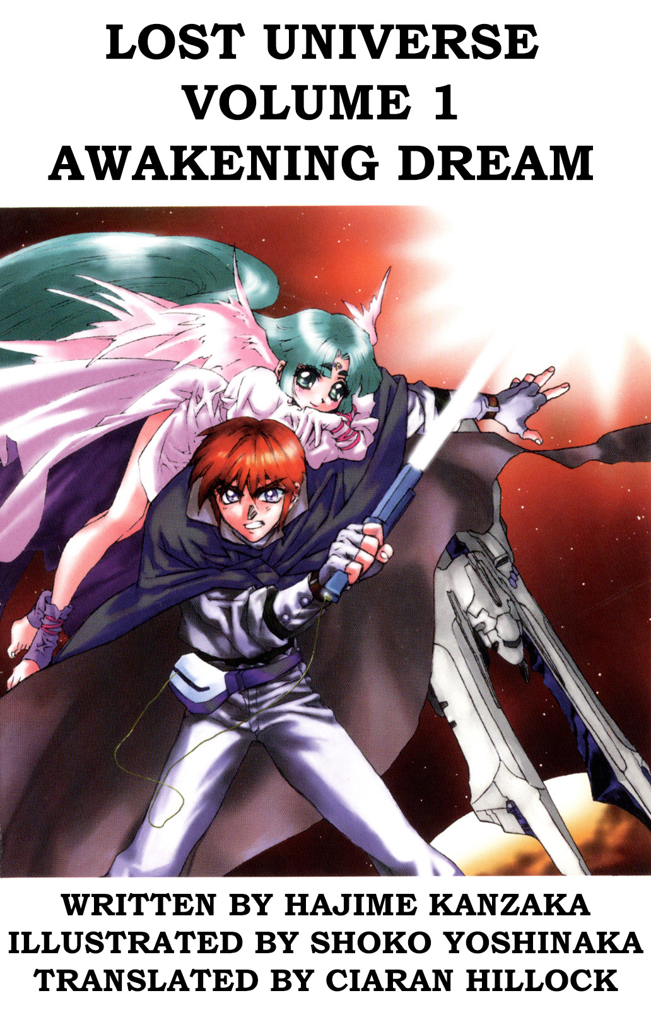
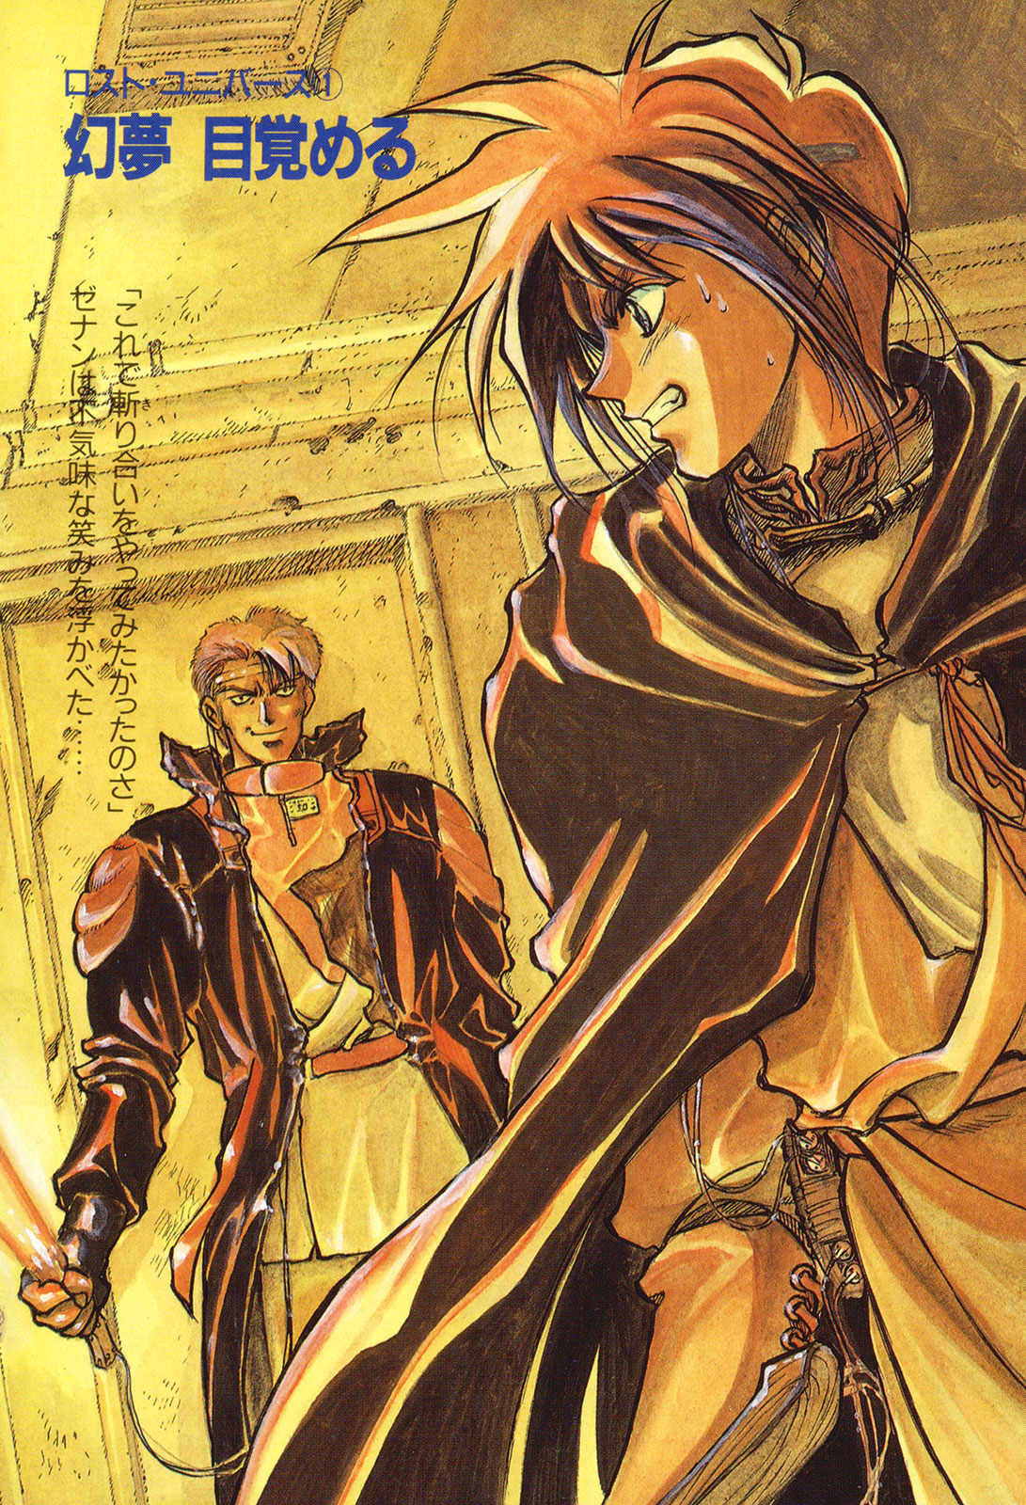
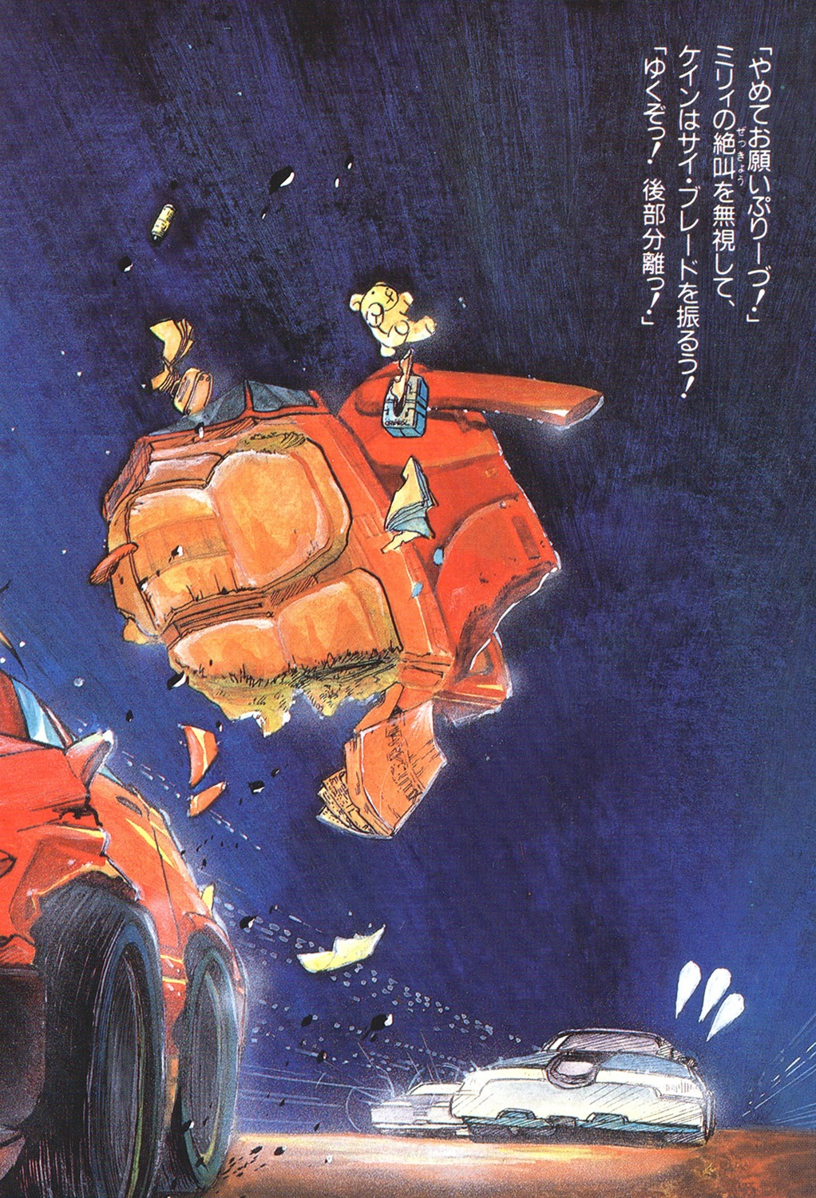
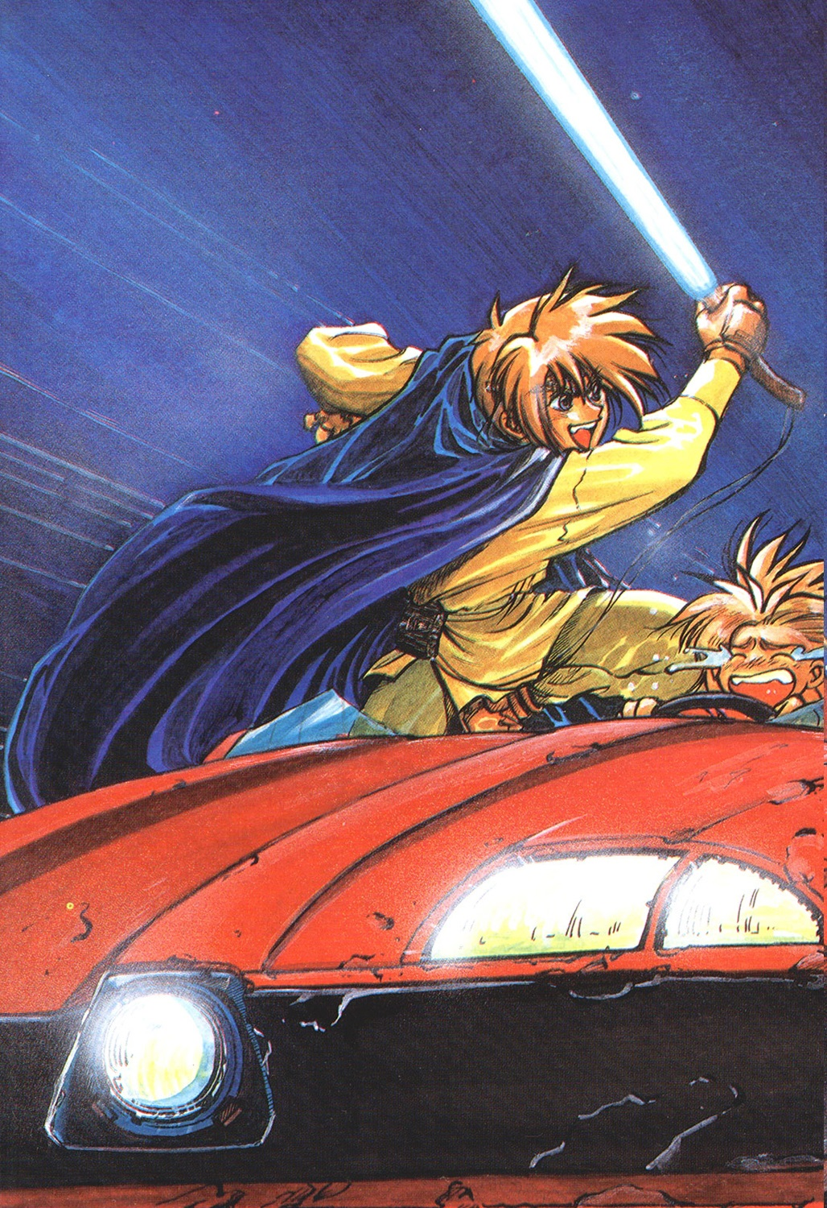

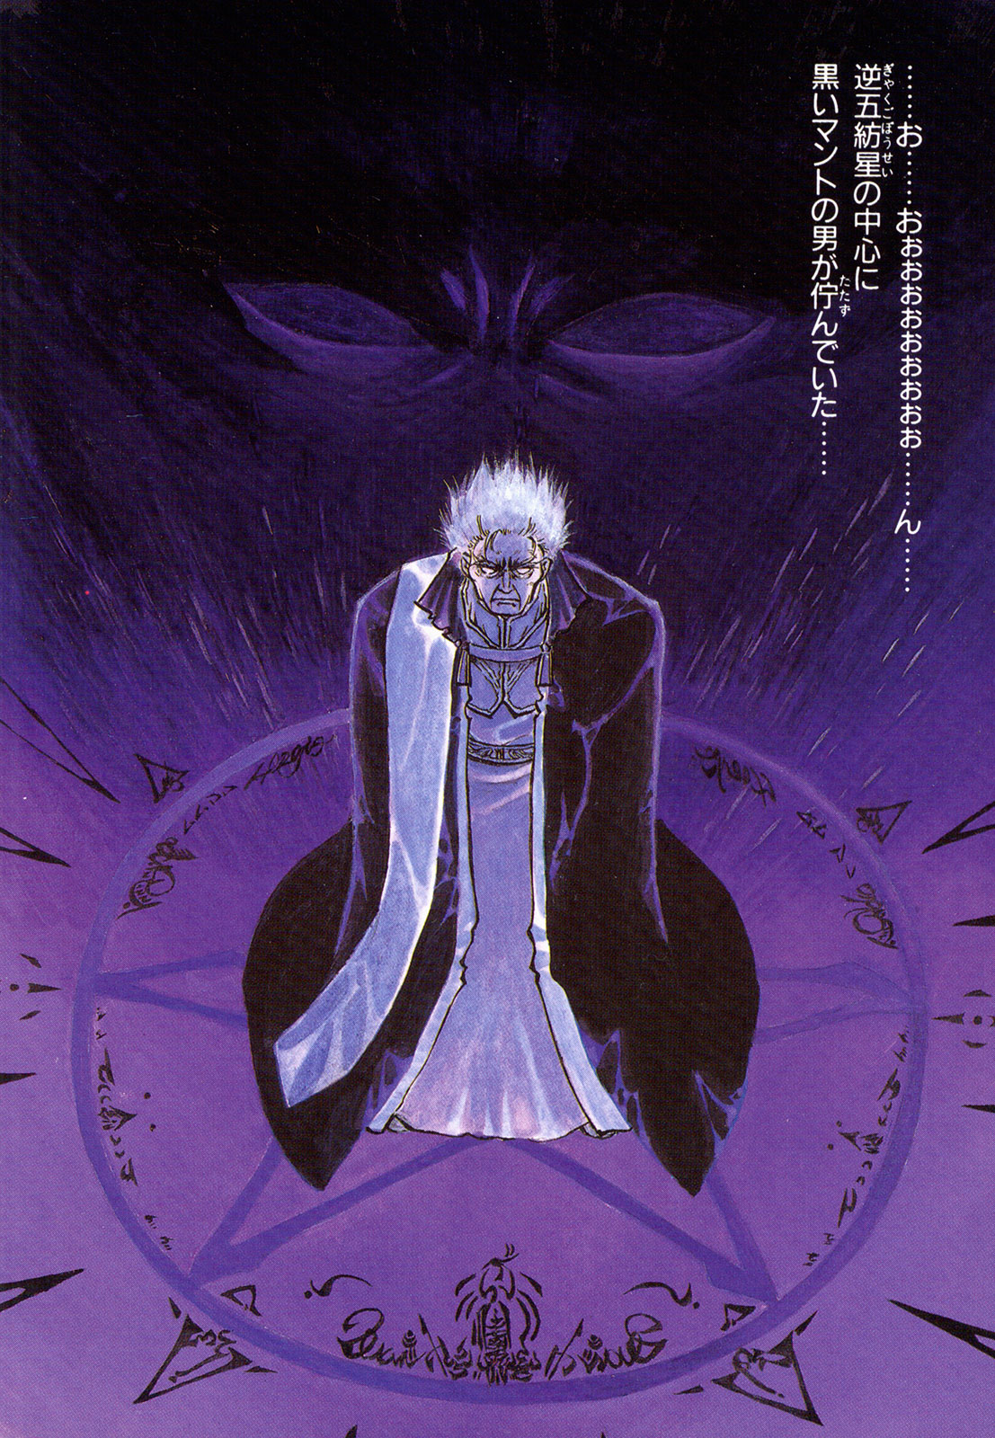

Chapter 0 – Prologue

“Sorry, could you repeat that?”
Kane got up from the bar stool and took a fighting posture.
“Looks like this guy didn’t hear me.”
“Okay, then say it again.”
A contrived smile appeared on the guys face while the other’s moved in unison.
There was a total of four people, all of which looking for trouble.
One of them was taller than Kane, the guy was facing him was 1.8 meters tall.
They were in a small bar on a frontier world, located near a spaceport.
Kane usually wasn’t the type who would pick fights with punks in a bar.
He was that kind of guy.
“You said, a baby-faced guy shouldn’t drink such a watered down drink in front of adults. It's insulting!”
The guy who was the tallest said those exact words, he was currently looking down on Kane.
“And then, this guy had something to say?”
Kane looked over at another one of the guys——the fattest of the four.
“This guy...”
A little man with a loud shrill voice spoke up.
“He dresses so strange, kind of like a woman, he’s definitely not straight——”
Bang!
Kane kicked one of the men in the face.
A cheer rang out across the bar.
“You punk!”
The older man was kicked to the ground, the remaining three started to panic.
“That guy wears some funky clothes.”
Kane smartly shook his coat, he was wondering if they had a problem with the way he dressed. They did, though it just hadn’t dawned on him yet.
“On another point. I don’t know what kind of planet this is, but I don’t agree with people infringing upon the rights of gays. Understand?”
Kane said rather bluntly.
He had been drinking, though he wasn’t as drunk as many of the bar’s patrons. Kane wasn’t that type of person.
“Do you guys think you can take me on?”
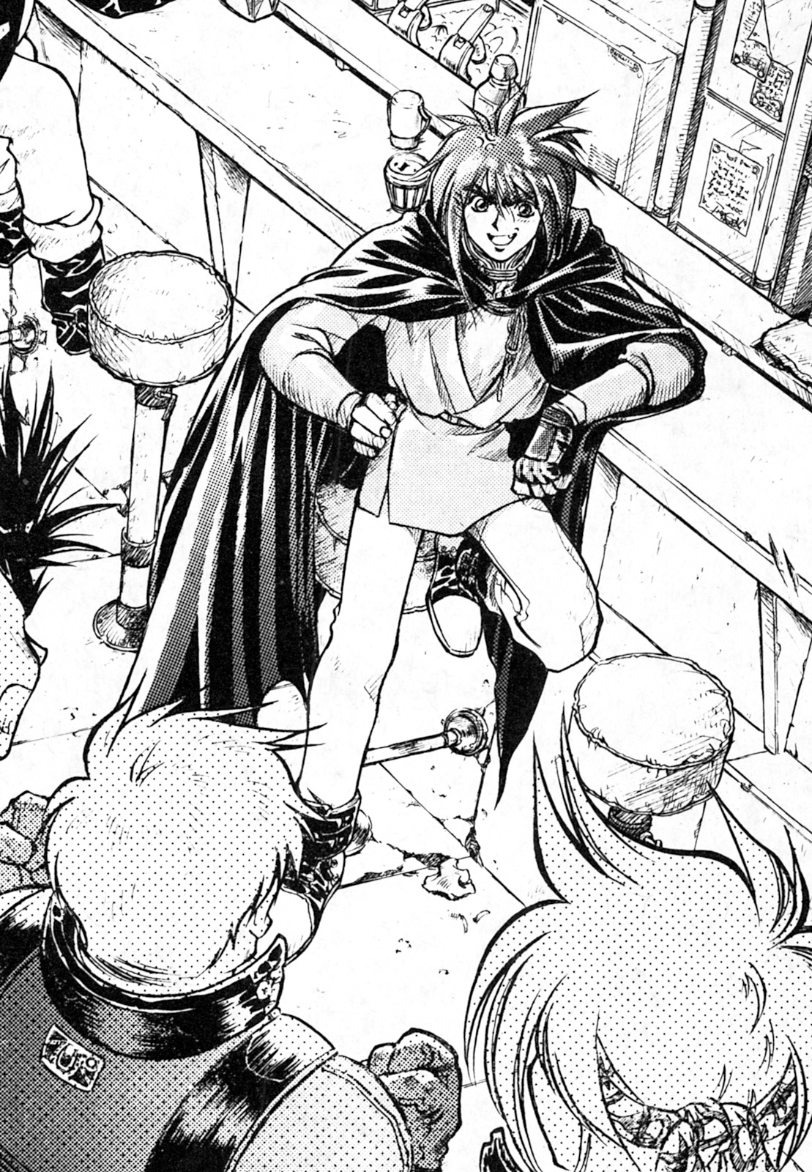
He was getting impatient with their pointless complaining, so Kane——
“You little punk!”
“You’ve got to be kidding me!”
While he was busy arguing, they were also stepping forward.
Everyone on both sides were acting irresponsible.
“Honourable guests——”
The bartender tried to settle both parties down, but just as he opened his mouth——
Kane kicked the big man in the chin.
He was sent to the ground.
“Ooohh!”
The patrons in the bar were cheering louder now.
“You bastard!”
“How dare you!”
They knew they couldn’t win using their bare fists, so the remaining two pulled out knives from their hip pockets.
——Meanwhile, the bartender secretly pressed an alarm.
“Hehe, you really want to do this?”
A fearless smile appeared on Kane’s face.
“We don’t need your mercy. Let’s get him!”
“If this is what you want, then I’ll cut you into pieces.”
The men screamed as they charged him.
However, Kane calmly moved out of the way.
With Kane’s cape standing where he once was, the man rushed into it.
“Huh?”
“What do you mean “huh”?”
From above came a kick. And then another, and then another.
…...Eventually……
The man inside the cape remained motionless, having received many kicks.
“Why you…”
“I’ve had enough of your nonsense!”
Kane said as he spun around, with his cape now behind him.
“Since you brought a knife to a bar fight with the intent of killing, I won’t show mercy.”
He now faced the last man.
“——Well, so you're the last one.”
“Bring it on!”
The man said as he moved to knife from one hand to another, Kane maintained his distance.
“......Hmm……”
Kane sighed.
“So, that useless guy was your leader, I thought your technology was meant to be good.”
“Want to see it with your own eyes?”
The man suddenly stopped. He was aware of Kane’s superior strength.
“Well, at least let me pay for the dry cleaning for your cape.”
Kane then took half a step forward, but then suddenly stopped——
Both of them continued to stare at each other. The room was filled with murderous intent.
The bar’s patrons continued to cheer them on, both of them men didn’t know if they wanted to be swallowed up in the bar’s rather bleak atmosphere.
But then suddenly, the bar went quiet.
Nobody knew who would strike first.
Kane took a step forward, but it was too late before he noticed.
Tap tap tap.
“Don’t move! It’s the Police!”
The establishments doors were kicked wide open, and a number of Policemen rushed inside.
“......Oh, you’re finally here.”
Kane felt relieved.
However.
“Office, it was that man.”
The bartender pointed directly at Kane.
“Hey!”
Kane raised his voice.
The policemen rushed over to Kane and grabbed him.
“So, it was you!”
“Hey…...I can explain.”
“Knock it off, now be quiet.”
“Stop! I'm innocent! You’ve got to believe me!”
Kane could only scream in vain, as he was dragged out of the bar by the police officers.
He was threw into a detention centre, he really stood out among the regulars.
The lighting was barely operational, there was a sticky substance all over the walls and bed. In the corner of the room was a toilet, but there was no toilet paper. He then checked the bedsheets, and they were covered in stains and the sheets were grey.
He wanted to ask them if this place hasn’t been cleaned in years, but was afraid of the answer, so he put it out of mind.
Breakfast and lunch in this place was no better than dog food.
“Really…...in this day and age, I can’t believe there are lice here.”
He scratched his head, not knowing if the itching sensation was real or not.
“......I wonder what the police here eat, why did they have to stick an ordinary person like me in this place?”
Kane’s complaining was suddenly interrupted as the door opened.
He could hear two different sets of footsteps approaching him.
“So this is where you are taking your leave, Kane. It really suits you.”
Standing at the railing outside was two people. One of them was the police officer who brought him in and the other man was wearing a coat.
He was slightly older than Kane, and had a handsome face with black hair. You could tell right away this wasn’t his kind of place.
“......What brings you to this place, Officer Rail?”
Kane humoured the man.
“Why do you think the Interstellar police have come here? I don’t have time for your games.”
He said bluntly.
Rail Claymore. A young officer in the Interstellar police.
Kane is what you would call a trouble contractor, and Rail delegates his orders. Although none of these dealings are illegal, they do bring you within an inch of death.
You wouldn't call the two friends, but rather acquaintances.
“......Well it seems you just can’t stay away from the Interstellar Police.”
Rail said, smiling.
“It that a hint of sarcasm I detect in your voice?”
“And so what if it is?”
After listening to his words, Rail continued smiling.
“When I come down to a place like this to see a trouble contractor, it’s purely business.”
Rail turned his attention to the other police officer.
“Sorry, could you leave us for a moment.”
“Yes, sir.”
Hearing his words, the police officer saluted and left.
“......Wow, you must have some authority.”
“Yes, and you should learn to fear it.”
Rail leaned against the prison cells wall.
“I know the warden here.”
“Is that so……”
“Listen Kane, you’re in big trouble this time. You sent three people to the hospital, this is a serious offense.”
“It was self-defence!”
Kane shouted.
“They said you hit first.”
“That was so I could get the upper hand.”
“......Hey.”
“In the twentieth century on Earth, some publications have clearly stated that human beings have rights.”
“Enough!”
Rail said impatiently.
“I didn’t come here to listen to your nonsense. Let’s get straight to the point, you want to get out of here, don’t you?
Kane stared at him with displeasure.
“What’s the matter, would you rather rot in here?”
“Of course I want out of here.”
“Don’t’ expect my help for nothing. In return for my generosity, I’ll need you to complete a job for me.”
“What about a reward?”
“Your freedom is the reward.”
Rail said, as he pulled a cigarette from his pocket and put it in between his fingers.
“I talked it over with the warden and he said that bar fights are a trivial matter, though I’ve got to keep an eye on you.”
“......I can’t do it.”
Kane hummed for a bit.
“I don’t even know what the job is, and I wouldn’t be in this mess if the police didn’t interrupt that fight. Which I would have won.”
“Hahaha. Well there’s a first time for everything.”
“I can’t do the job for nothing, I’ve got bills to pay.”
“Well, if you are found guilty you will have to pay even more. From my point of view, it’s a good deal.”
“Why you……”
Rail completely ignored Kane’s angry gaze.
“So, what will it be?”
Kane really had no alternative.
“It’s a relatively easy job.”
Rail smiled as he pulled out a photo from his breast pocket.
“......Just find this person.”

Mankind officially entered the Milky Way 400 years ago.
In the twenty first century, humanity began to study on how to convert spiritual power into physical energy.
Faced with the problem of overpopulation, humanity spread to every corner of the galaxy.
Planets such as Mars were terraformed with newly acquired technologies, turning it into a habitable planet.
As humanity expanded, Earth’s newly formed colonies sought independence one after another.
Thus, humanity entered the galaxy and the calendar was changed to the cosmic calendar.
…...But even as humanity expanded into the galaxy, they could not throw away their old habits. Pollution, crime and so on, these problems would plague humanity forever.
This new universe resulted in the Interstellar Police and Trouble Contractors being created.
Trouble Contractors generally deal with matters that are deemed too dangerous for the Interstellar Police to handle.
They have to rely on their own abilities and spacecraft.
Kane’s spacecraft the “Sword Breaker” was parked in the local port.
He generally rides a smaller shuttle that is instrumental in transferring supplies to the ship.
“Welcome back, Kane.”
A sweet voice greeted him as he arrived.
In the central control room stood a young girl.
She looked around 16 or 17 years old. With silver hair and an adorable look on her face, her clothes were the first thing you’d notice.
She had a complex pattern on her cloak and chains, as well as a variety of decorations. If you saw her, should would look like a witch from a fantasy story.
“Let’s cast off.”
Kane spoke in a rude voice as he sat down on the control seat.
“Rail from the Interstellar Police has sent us a message. However, I don’t have a good feeling about this one.”
“We’ve just got to look for someone.”
“......Obviously it’s got something to do with organized crime.”
“............”
Kane fell silent.
“......Ah?”
She made a silly sound towards Kane.
“We’ve already been sent the relevant information about the mission.”
“What!!!!”
Kane unconsciously asked Canal.
“Look, here.”
Kane put his finger on the screen, he was pointing at the last line of text——
“——Look.”
“……”
Kane was speechless.
“I’ve had it printed out too.”
“That, that bastard……the Dugole Connection……”
“……What’s wrong, didn’t you ask beforehand?”
“No, I didn’t ask! That guy, he wants us to bring back the son of a wealthy merchant. What nonsense!”
“……Strange, why didn’t you?”
“Well, I……”
Canal stared at him with contempt, Kane flew into a panic and tried to defend himself.
“Even though this child ran away from home, this is a job for the police……not people like us.”
Canal sighed.
“……No matter, we’ve already accepted it……the only thing we can do is complete the mission, and then raise the commission fee.”
“……But……But……we…”
Kane couldn’t find the words.
Although he didn’t want to say it, the truth would eventually be revealed.
“Is there anything else?”
“There is no……commission fee……”
“………What?”
Canal couldn’t believe what he said.
The room went quiet for a moment, Kane closed his eyes, waited to be berated.
“Idiot!”
“It’s not my fault…….”
“Come here!”

Canal then found out that Kane was involved in a fight, and that he was to blame for their current situation.
“Why the hell did you start a fight?”
“……No, it didn’t happen like that.”
Kane was like a spoiled child defending himself, Canal then pointed at him.
“Is there nothing you won’t do to justify your actions? You said you’d stop that kind of behaviour!”
“Well……I……”
“No ifs, no buts!”
She didn’t give him the time to think, she continued her assault:
“You can’t worm your way out of this one. You messed up big time, and now you owe me!”
“Okay, I understand.”
Kane reluctantly agreed.
“Good, and you better not forget about this favour.”
A wave of nausea came over Kane.
“Actually, I want to buy something.”
“……You want to buy something?”
“Yup. The Heckler agency is selling new equipment: an intensive particle cannon, it’s weapon design and performance are great. We could install them all over the ship, I think four should be enough. Here’s the catalogue.”
(A weapons catalogue, this will be the end of me!)
“What!”
Kane was speechless, he just looked at the price.
“I know, it’s amazing, isn’t it?”

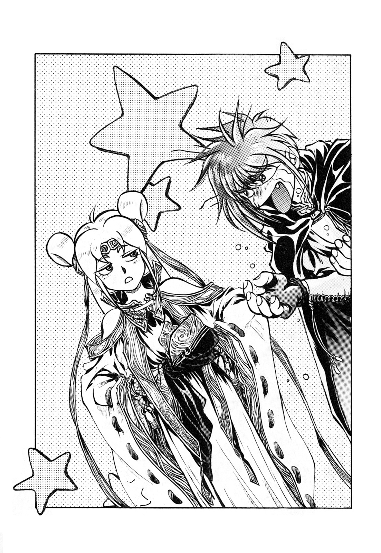
“I can’t believe you……we haven’t even received any money, how are we meant to afford one expensive cannon never mind four……”
“Wont’ you buy it for me?”
Canal’s cheeks were swollen.
“Come on, buy it! Pretty please, I’m begging you, aren’t you my friend? If you don’t buy it I’ll be forced to shut off life support!”
(……I ought to spill some coffee on her motherboard……)
While Kane cursed inside himself, he nodded to her.
“I know, I know! After we complete this mission, just head toward the nearest planet where we can buy it!”
“Thank you, thank you. I think we can regard this deal, sealed.”
Canal smiled, then.
“Alright! Destination——the solar system!”
“I know it’s where humanity came from, but……it’s on the frontier.”
When humanity established themselves in the Galaxy, humanity’s original solar system suffered serious damage.
Before faster than light travel was invented, humanity lived in this crowded solar system. Valuable resources had long since been depleted, and natural hazards and public dissent only increased. Under these conditions, Earth needed a transfer hub between itself and her colonies, it failed in this regard.
Without the resources from its outer colonies, and their independence, Earth became a backwater system and not much people paid any attention to it.
Out of all the planets in the solar system, only two of have human life: Earth and Mars, though there are several space colonies.
“No abnormalities detected system wide, our destination is Galactic region 1-3-A, the solar system.”
“Okay. Departure formalities are complete, Sword Breaker has been given clearance to leave dock 11.”
At the same time the control rooms communications sounded off, the hull lock on the ship was detached, the docking bay doors then slowly opened.
Outside, a pale-coloured planet could be seen to the left, and countless stars stretching into nothingness——
Their spaceship “Sword Breaker”, a total length of 210 meters slowly crawled out of the space dock. “This is Sword Breaker calling the control room, departure from the dock has been completed. Thank you for your assistance.”
“Understood. Have a safe voyage.”
The dock control operator said to Kane.
“Sword Breaker——”
Kane ran his fingers across the control interface, as his voice echoed across the room.
A faint vibration came from the engines.
“GO!”
Just then——
Sword Breaker set out, into the universe.

Chapter 1 – Mars

“Finally completed——”
Kane finished with his operations, he stretched immensely. Then he turned to Canal, who was standing behind him.
“Phase drive has been implemented, do we still have some time?”
She asked.
Phase drive——a device which allows space ships to go faster than the speed of light.
“Yes. According to our present rate, and taking in standard time calculations, we’ve got eight hours to go.”
Standard time refers to the flow of time relevant to that of Earths, since mankind’s home world became a backwater planet, people commonly use it as a reference.
“Okay. Easy as she goes. During this time, we should gather information relevant to our mission……what was that organisation called again?”
“The Dugole Connection.”
“Alright, let’s get that relevant information.”
“Prior to proceeding, I recommend you get yourself some coffee. And don’t spill it this time.”
“Okay.”
Kane got up from the operator seat, and moved to a small bench behind him.
A mini table appeared out of a hole in front of the seat, it was filled with steaming cups of coffee.
Naturally, they were filled with sugar, Kane loves sugar and super-hot coffee.
He rested for a while, he then suddenly found himself alone, Canal had disappeared somewhere.
“……I really hope we don’t get dragged into something.”
Kane whispered while holding a mug in one hand.
(Hopefully we’ll be able to bring that smelly kid back without much trouble……and get paid.)
Kane thought.
By the time he had finished half of his cup of coffee, Canal appeared again.
“For more information on the Dugole Connection, I’ll need access to a police computer. It’ll take a while.”
“Okay.”
It seemed his causal tone offended her, mostly because she detected that he didn’t care.
“Done. Would you like to hear the relevant information?”
“Sure.”
“Understood. The Dugole Connection was founded on the solar systems fourth planet, Mars is used as their base of operations, and their influence spreads throughout the solar system. The founder of the organization Duras Dugole died twelve years ago, it’s now ruled by his son Derleth. And——”
Reading, Canal began to frown.
“——Now, they are considered ready to enter the criminal organization Nightmare——”
“Nightmare!?”
Kane unconsciously said out loud.
There are few people in the Milky way Galaxy that don’t know the name, some say they don’t exist. But nevertheless, they are: the galaxy’s largest criminal organization.
On the surface, they used a organization called Gazer Concern as a front.
It seems to be a fairly common business, dating back forty or fifty years. The head of the company is a man by the name of Albert von Stargazer.
“……Nightmare……could they be behind this?”
Canal whispered.
“Although they are a force to be reckoned with, they are still afraid of the interstellar police”
“We best keep out wits about us then.”
A moment of silence filled the room.
Kane then sipped the rest of his coffee, and spoke:
“Please give me a printed copy of all the relevant information.”
Having said that, Kane got up.
“Where are you going?”
“Back to my room. I’ll wash then get some sleep. Yesterday, I didn’t sleep too well in detention. Wake me up when we gone out of phase shift.”
“Understood. Sweet dreams.”
Kane then left for the residential zone of the ship.
“……Now.”
Canal opened up a communications channel.
“Rail, there’s an interstellar communication for you.”
He received the phone call in his hotel room.
It wasn’t an ordinary business hotel, it was without a doubt, a first class hotel.
“……An interstellar communication?”
The front desk attendant on the phone said to him, he frowned slightly.
“Okay. I’ll accept the call.”
“Incoming transmission from Sword Breaker accepted.”
The front desk attendant’s voice soon faded.
The video phone on the wall started ringing, he looked at the screen and saw a static image of Kane’s face.
“……Kane……”
Seeing who it was, he unconsciously moaned.
“……Well……”
A smile appeared on his face.
“Long time no see. Canal of Sword Breaker.”
As he envisioned the contrary, a picture of an adorable smiling girl appeared.
In the past he usually met her face to face with her, he always found it more difficult talking through a phone.
“…You’re not…Kane.”
Rail quietly mumbled.
“Well, Kane is indisposed at the moment……anyway, about our commission fee, there’s something we need to talk about.”
“Didn’t Kane tell you?”
“He did say something, but he wasn’t entirely clear. He said he got caught up in a bar fight and you helped him out, and he accepted a job, right?”
“That’s the gist of it.”
“……Is there enough to charge him for a crime?”
“Well, he did send some people to the hospital.”
Rail answered calmly, Canal looked slightly worried.
“——Hey!!!”
Just then, Canal’s attitude changed. With a cheerful voice, she said:
“To put it bluntly, you used your relationship with the local police to get a criminal off scot-free.”
“Where are you going with this?”
“This is the truth! You intimidated and belittled a criminal to benefit yourself, this is unbecoming of an office of the interstellar police. These charges should be enough to get your dismissed, right?”
“You have no evidence!”
Rail’s face was full of panic, Canal smiled.
“But I’ll be willing to let this slide if you do be a favour.”
“A favour?”
He knew he wouldn’t get out of this situation easily.
“What about our original commission fee and some hush money, that should be around 10,000 credits.”
(Currency in space, the author stated that the ratio is 1:1000 when compared to Japanese Yen.)
“What!!!!”
“Alright, I’ll admit that Kane messed up, but you could us 5000 credits now.”
“That’s far too much!”
“……Alright, 4000.”
“I’ll give you 2000.”
Canal smiled, both of them nodded in agreement.
“Understood. 2000 credits it is. I’ll send you my account number, thank you for your patronage.”
A smiling blur was left on the screen, as the picture disappeared.
“——2000 credits……that’s nearly double the market rate……”
Rail said, while staring at the screen.

“We’re almost there.”
Kane returned to the control room just in time.
“5 minutes until arrival.”
Canal said in a cheerful voice.
Naturally, she mentioned the conversation she had with Rail.
“Route setting and system check is complete. Awaiting orders.”
“Alright, let’s get this part started! Onward, to Galactic coordinate 1-3-A, the solar system!”
“Aye aye, phase transfer system is starting up!”
The control was filled with a low-frequency vibration, the main display emitted a blue light. And then, the stars began to shine, and space started to distort.
Boom!
For a moment, all the stars that were reflected on the screen started to fade away, this moment made Kane feel wonderful.
A dark blue picture reflected in his mind.
“We care currently in FTL. Proceeding without error. We’ll reach the target in 30 standard time.”
She spoke in a directing like voice.
“One day……”
Kane left his seat, and headed towards the door leading to the residential zone.
“Later, I’m off to have something to eat and then sleep.”
“Sleeping again?”
Canal said in surprise.
Kane’s face then went serious.
“Sleeping during the day is nothing but a man’s dream!”
“A man needs to keep his mind fresh!”
“If that’s the case then why don’t we play chess, I think level 2 should be enough.”
“Don’t do that……”
Kane openly frowned.
“I’m always concerned when I play chess, I know I’ll probably lose, do you secretly raise the difficulty be chance? Sometimes it suddenly gets harder.”
If she was a human, then surely cold sweat would be flowing down her forehead, but she was very calm.
“I don’t do that. The second half of a level 2 game is slightly harder than the first half.”
“……Really? Anyway, I’m off to have some food before getting some sleep.”
“Understood.”
Canal watched him disappear behind the door, Meanwhile Kane thought——
(Wonderful……looks like she doesn’t think I know that she’s a cheat.”
Hum…
Along with a low-frequency vibration, the main display went dark.
Then, the stars slowly started to appear.
“We’ve successfully entered normal space, the whole system is operating normally. Interstellar coordinates, we’ve arrived at the outer solar system.”
“This is……the birthplace of humanity.”
Kane muttered.
“——Kane.”
Canal interrupted him.
“The radar has picked something up. There’s two spacecraft at eleven o clock, they’re heading right for us.”
“Just give them the standard greeting.”
Kane said calmly, but Canal shook her head.
“……This seems strange, based on its registration and license it’s a transport vessel. However, there’s an unusually high energy reaction.”
“What’s going on?”
Said Kane, as he straightened his posture.
“Maybe it’s just transporting energy……”
“Highly unlikely, it’s most likely a combat ship.”
“Can you put it on the screen?”
“Putting it on screen.”
Canal said right away, as a two space ships side by side appeared on the screen.
“The first one looks like a frigate.”
It was obviously very far away, but the picture was very clear.
“A two hundred meter class frigate manufactured by Leclerc Corporation. Armament, very strong.”
The screen switched to the second ship. It was a four-hundred meter transport of the same class, but they couldn’t find this model in the database.
As she spoke, a foreboding feeling came over her.
“Should we investigate?”
“……I guess.”
Kane’s answer was a little ambiguous.
“The Leclerc Corporation is affiliated with Dugole Connection, I don’t think this is just a coincidence.”
“……Hmm……”
Kane folded his arms.
“——Wait a minute, we’ve got a voice communication, patching it through.”
After a moment’s delay, a voice could be heard, it sounded cold.
“This is the frigate Uranus of the Leclerc Corporation. We wish you a safe voyage.”
The voice echoed throughout the room, Kane then opened a communications channel.
“——This is trouble-Contractor Kane Blueriver of Sword Breaker, I wish your vessel a safe journey.”
After the transmission had been sent, he closed communications.
“……What are you doing, Kane? We only have sixty seconds until they reach us……”
“……I’m not afraid of them.”
Kane whispered to himself.
“……Anyway, we both know this isn’t a casual greeting. Prepare to expand the barrier. Continuously monitor the frigate and the transport ship, put them on the screen too.”
“Understood. Preparing to expand the electromagnetic barrier——“
“——Wait!”
Kane interrupted Canal.
“Expand spirit (PSI) barrier.”
She was surprised for a moment, she could tell by looking at his face that he was thinking of something.
“——Understood. Ready to expand spirit barrier. Range of distance from the frigate is five seconds——“
Kane had been watching the screen. The frigate kept moving.
“We’ve entered within range of the frigate. It’s taken no action.”
Canal said, then sighed.
“This seems suspicious……”
“——We’re not done yet.”
Kane said suddenly.
“——Huh?”
“Maintain current status. From the very start I’ve had a bad feeling.”
“Understood. Ten seconds until the transport ship arrives.”
Kane kept staring at the screen.
At his point. The transport ship started to change.
Looking a flowing in full bloom, boom, the exterior of the transport was blown away.
(An explosion?)
Kane thought to himself, but he was wrong.
From the insides of the ship emerged ten large combat ships!
All of their guns swung around to target their ship.
“Expand barrier!”
Kane yelled.
(Damn it, they hid combat ships inside a transport ship.)
“Understood. Expanding barrier!”
As soon as Canal finished speaking ——
The ship shook as it was impacted by full gun salvo. Everyone monitors were full of bright white light.
“Target have been eliminated.”
After hearing the crews report, Captain of the Uranus smacked his lips and smiled.
Particle Cannons, missiles and rail guns. All of them hit the target at such a close distance. Regardless of how powerful their magnetic barriers are, they cannot resist.
“Hmm. Excellent work, though I didn’t expect it to be over so quick.”
He said with a sneer on his face.
But——
“The enemy is still alive!”
Upon hearing the report, his smile disappeared.
“——Impossible!”
On the screen, the light faded to the background of stars, Swordbreaker could clearly be seen.
“What! This can’t be!”
According to his understanding, nothing should have been able to withstand that attack.
“What……What do we do? Captain……?”
There was no way he could prevent the crew from panicking.
“Did we sustain any damage?”
Canal answered the question almost instantly.
“——We’re intact, no abnormalities......but ......]
“What’s wrong?”
“That attack was stronger than my shock absorbers could handle, a lot of the cutlery may have been smashed.”
“……Those bastards……what the hell! Have they no mercy!”
“Who knows……anyway, what next? Should we retaliate?”
Kane thought for a moment. He then saw the hostile ships preparing to run away.
“——They mustn’t be allowed to escape.”
“Understood. Lifting barriers! Increasing engine output!”
“Looks like they don’t want to get caught by the police!”
“Enemy fleet is turning, ready to give chase!”
Kane thought to himself for a moment, he had completely neglected the presence of the frigate!
“Shut off the engine! Expand spirit barrier!”
“Understood!”
At the same time she said that, they could hear the ship being hit. It wasn’t just projectiles, but a spacecraft too, the electromagnetic barrier didn’t stop it, it was sinking through it.
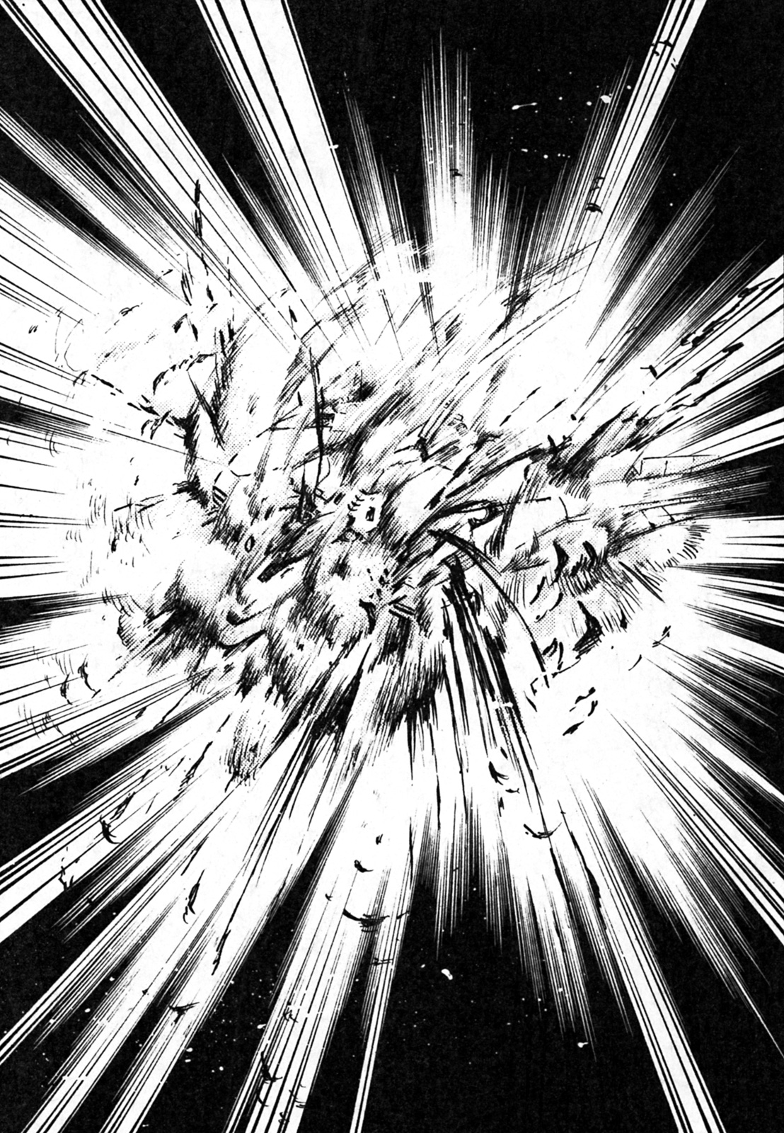
But——
This powerful defence force known as a spirit barrier also has its weaknesses.
When expanding the barrier to meet an oncoming attack, the engine cannot be used. Though the energy from the barrier can be used to move the ship a little.
“Canal! On my orders, eject the barrier particles from the YZ axis in any direction, then close the barrier! At the same time start give the engines all you’ve got, and commence Evasive maneuvers!”
“Understood! I hope you know what you’re doing!”
Kane remained silent for a moment.
“GO!”
Kane cried out.
The barrier around Sworbreaker disappeared, at the same time, the engine emitted a dazzling white light.
“The enemy fleet is shooting……”

Boom!

Canal’s voice was interrupted by the sound of the hull being impacted.
“——We’re hit! Damage report?”
“Upper port side! A particle gun was graved by the attack! Minor damage!”
“Understood. Accelerate progress!”
The light from the universe started to turn into a blur, Sword Breaker continued to accelerate. The distance between them and the enemy fleet started to widen, although the shelling continued.
“The enemy is still in range……the shelling is continuing.”
“Don’t worry about them, onward to Mars.”

Sixteen hours later, they arrived at a port near Phobos, a satellite of Mars.
When they entered the port, the young male control operator on their display screen couldn’t hide his curiosity.
“All your paperwork is in order. ……What’s with all the marks on the hull? It looks like you were in a battle.”
Kane instantly muttered something.
“We were in the neighbour and got caught up in a fleet battle near Pluto! We were lucky.”
After a moment of brief silence, Canal calmly spoke.
“……It really is eye-catching!”
She said with a smile.
“Six months ago, in the Lubasi star field. The interstellar police and some organizations have a little dispute, remember?”
“Yeah. Anyway……”
Canal tried to distract the control operator from looking at the screen.
“It was careless of you to get involved……you should contact your insurance company because we might need to do an investigation.”
“……Right……an insurance company!”
“Would you like us to repair the damage? We’ve got some premium plans.”
“Hey, Kane, is that alright?”
“……Yeah……sure.”
Kane nodded.
“……Also, you’ve only applied for one person heading to the surface of Mars. Mr. Kane Blueriver, is that right?”
“Yeah, I’m not going, I’m ship keeping.”
Canal winked at him.
The control operator’s serious expression disappeared, as he fell backwards.
“I don’t……I……I understand. If there’s anything you need, just contact the control room and ask for Thomas.”
Communications were then closed.
“That control operator……I think he’s interested in you.”
Kane said angrily.
“Obviously, it’s because of my appearance……but in this case, I really feel sorry for the guy.”
“Then why didn’t you do anything? There’s probably going to be an investigation now!”
“It’s alright……I’ll get them to categorize it under a theft report.”
“Theft report?”
Kane said.
“……It’s not like they stole anything.”
“The investigation will progress much smoother if we just do that.”
“Would you rather say that we were attacked over a personal grudge?”
Kane remained quiet.
“Anyway, be careful when you get planeside. Try not to get into any trouble, and make sure you take the appropriate weaponry with you. Take a communicator and a handkerchief too.”
“……What am I in, primary school?”
“Just hurry up and depart.”
“Alright.”
He said as he raised one hand, he then left the control room.
Kane went through the residential area to get to the shuttle hatch.
“Mars……”
He softly murmured, as he opened the hatch.
Aruba City, this was the first base built on Mars after it had been terraformed, now it has become a city.
Kane had just docked in the port.
“——Ah——”
Thud, thud, he heard this a couple of times.
“……Seems a little different.”
The gravity on the Swordbreaker was 1g——basically it was the same gravity as on Earth, in contrast to Mars which is only half of that. Suddenly Kane felt like he had lost half his weight.
The first thing he did was find a cheap hotel.
He locked the door to his room, he was ready for anything. Although he did bring a credit card with him, he thought it was better to bring a little cash. He also got a map from Canal.
And also——
His opponent is a dangerous organization, he couldn’t forget to bring a weapon.
Hidden in his hair was a thin strip, and a little box. Inside was a small metal tube about twenty centimetres.
A spirit (PSI) lightsabre.
It saps on the human spirit through the amplifier on his wrist, this results in energy being pushed out of the end of the metal cylinder.
It’s a great anti-personnel weapon but it does have its drawbacks. First of all, if your opponent has a gun it’s obviously a better weapon than a sword.
This is the biggest reason why the lightsabre isn’t a popular weapon——not to mention people don’t like that fact that lit saps on your mental energy.

Therefore, due to various reasons, the lightsabre is only use by in close quarters by military and by military enthusiasts.
“Now……”
Kane said as he checked his watch.
“First……I’ll check out the local bar. It’s still early.”
He took a seat at the hotel bar, he got sandwiched between two women, when he went to take a drink of his watered down wink, Kane finally remembered his original purpose.
(——Ah! Now isn’t the time to be drinking!)
“I hope you don’t mind if I ask a silly question, but do you know this guy?”
Kane deliberately spoke in a frivolous tone, he reached for one of his chest pockets, and pulled out a picture.
Clay Roberts.
The guy looked around twenty years old, he had a grim look on his face, and his eyes glared at you from the picture.
“Yeah, this guy owes me 100 dollars.”
He showed the picture to both girls, to his right and to his left.
“He ran away from home after he couldn’t pay the debt.”
“……No, I don’t know him.”
“What a guy! Come on, let’s drink in peace.”
“Yeah, back off.”
Kane had just been triggered.
——The result——
He left the store with three bottles of wine, two of which were empty.
“……Next……I’ll head to another bar.”
While Kane looked up at the dark sky, before entering into another bar.
“……Do you know this man?”
The fifty year old bartender looked at the picture as he cleaned some glasses.
“——Kid, are you some kind of student?”
His expression didn’t change one bit.
“No, but I’m not a local.”
Kane said, as he handed out some banknotes.
The bartender’s expression didn’t change, even when he took his money.
“That guy does come in here sometimes, where can I contact you if he does come in?”
“…At the——”
Kane almost blurted out the name of his hotel.
It wasn’t clear whether the bartender was friend or foe. He couldn’t afford to tell him his place of residence.
“Sorry, I’m just passing through.”
Kane put his drink and a tip down on the table, he then stood up from the bar stool.
“At least tell me your name.”
Kane heard as he went towards the exit, he then stopped and turned around.
“Kane, Kane Blueriver.”
Then, Kane pushed open the bar’s door.
As he left, the door swung open for a moment.
Kane didn’t know this, but one of the bars patrons was watching him the entire time.
After he finished his drink, he ran over and used the phone.
The next night, Kane checked out another bar, it stank of alcohol and cigarettes, and so did its patrons. The music was loud and bombastic.
“I heard you were looking for someone.”
This place didn’t look very friendly, but then again these places were the best places to get information.
The man looked like he was in his mid-thirties. His face was bearded and he wore dark glasses. He was wearing a dirty coat, his hair was unkempt, this guy was anything but clean.
“……And you are?”
“Who I am is not important. But then again, I might be able to help you, if you’re willing to talk to your wallet.”
The man exposed a vulgar smile.
——He was an information broker.
“I’m looking for someone, this is my second day on the search.”
“Well, that’s quite the outfit. It makes you stand out.”
“Stand out? How so?”
Kane looked at the man in amazement.
“……Listen here……every day all kinds of shady characters walk around town, how am I any different?”
Kane said, he had an angry look on his face.
“That goes without saying, your walking around with a freaking cape——but then again, that shows that you have a wild personality.”
“Yeah. I’m a wild cat, okay? ……Come on, let’s head to the bar.”
“His name is Clay Roberts, do you know this man?”
After a moment of silence, the bearded man spoke.
“……Alright, 50 dollars.”
“…Oh…”
Kane sighed.
He didn’t want to pay the commission fee, it was too high.
“I’ll find him myself.”
Kane then turned to leave.
“……Hey, don’t do that.”
The man thought for a moment.
“What about forty?”
That’s still expensive.
“……I just can’t afford to spend that much.”
“Wait! We’ll settle at thirty!”
Kane ignored him.
“Twenty!”
“……That’s still too high……”
Kane said with a tired face.
“What about fifteen? Then we’ve got a deal!”
Kane stood still for a moment.
“I still don’t think it’s worth that much.”
Kane then pulled up his sleeves, and took out ten dollars.
“What! Ten dollars, you’ve got to be fucking kidding me!!”
The information broker cried.
“Fine. You’ve got yourself a deal.”
“Okay, where is he?”
“He usually wanders around this area, I’ll help you find him.”
The man took the bills from Kane’s hands.
“Come on, let’s get going.”
Kane and the man walked around for ten minutes.
The man then lead Kane down a small street, it seemed that the hustle and bustle of the city’s streets had disappeared. This place was somewhere normal people didn’t go, and even if they did enter, they probably wouldn’t leave alive.
“Ah……there’s another bar, maybe he drinks in there.”
The man didn’t even turn his head back, he just continued walking.
“……Oh?”
Kane didn’t ask any questions, he quietly followed the man.
“We’ll be there soon.”
They walked for a few more minutes.
In the dirty little road, the man stopped in his tracks.
In the distance, there was one operational street light among darkened buildings.
“……Hmm.”
Kane looked around with a bored expression.
“……Is this it?”
“Yeah. This is it.”
A voice came from somewhere.
Several men came out of the shadows near the buildings.
Three in front of him, and three behind him.
“……Hey.”
The informant walked towards the three in front of them.
“……I can’t blame him, this is part of the job.”
Kane revealed a fearless smile.
“Oh, is that so?”
One of the three men in front of Kane said in a husky voice. He stood into the light, he was far taller than Kane.
“I was under the assumption that I would be getting the information I paid for.”
“You were foolish to come……you may act confident, but……”
The man tried to pull something out with his right hand.
“In that case——”
Hum!
Before the man could finish, a bright white light cut into the night.
Bang!
The blunt sound of a shot rang out.
Something fell onto the ground——it was a shiny black pistol.
Just as Kane saw the pistol fall onto the ground, all the muscles in his arm that was holding the lightsabre tensed up.
(Everyone will understand who I am, Kane!)
“Ahhh!!!!”
One of the men was aware what was happening, so he screamed.
But before the others realize the same, Kane had already sprang into action.
Thud…
He chopped the second man’s wrist off, he fell onto the ground.
Kane then struck the other man in the gut and the back of his foot.
He fell to his knees, he couldn’t feel a thing anymore. The information broker watched in horror.
“I’ll let the rest of you guys go.”
“Sure…we won’t hold a grudge.”
Kane then carved a V-shape into the man’s chest.
Since Kane was used to heavier gravity, he did this action in a flash.
The three men behind him turned away in a panic.
But one of them turned around with a pistol, he wasn’t that far away.
Kane aligned his lightsabre in the man’s direction, he then thought of a dazzling bright light.
Hum!
The light which was emitted shot through the man’s wrist.
“Ahh!”
“W-What the…”
“That guy has a laser gun!”
One of them shouted, then he ran away from Kane. The other two people followed after him.
“…...You’re really unprofessional……leaving your comrade like that……”
Kane wasn’t prepared to run after them.
“Next.”
Kane turned around to the man who had his wrist cut, it wasn’t bleeding, but he was in severe pain.
“Hey!”
“Ahhh!”
He pressed down on his wrist, a dying man like him wouldn’t lie.
“I’m begging you……please, call a doctor……an ambulance.”
Kane sighed loudly.
“……Don’t worry. If you don’t want to die, then you’ll answer me question. Then maybe I’ll send you to the hospital.”
“G-Good.”
The man said, Kane sighed again.
“Answer me, why did you attack me?”
The man shook his head.
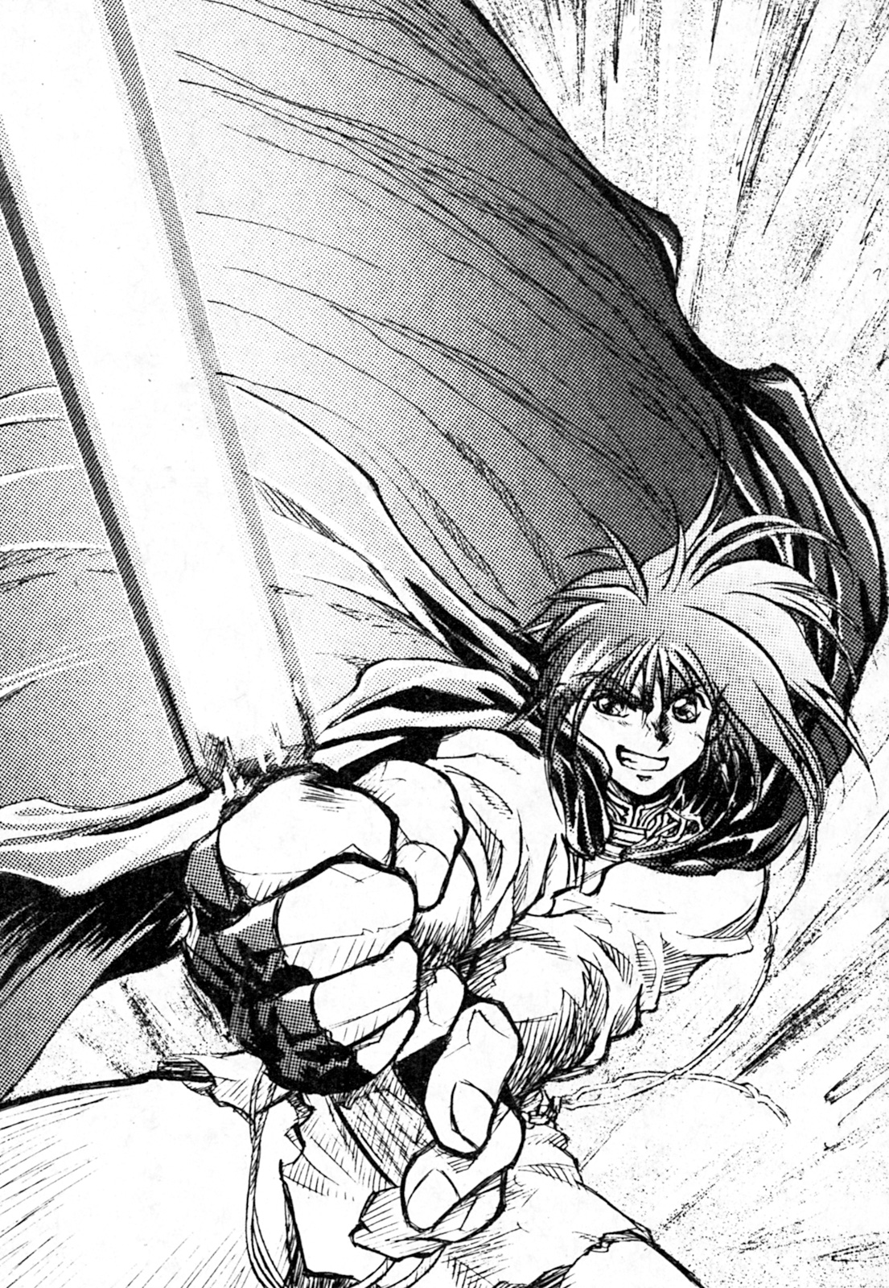
“I don’t know……I just do as I’m told, the guy you were with told us to get rid of you.”
“So that guy……”
Kane grabbed the man’s collar.
“Tell me! What else do you know?”
“……I……don’t know.”
“You don’t know? Then I might as well cut your head off!”
“I’m serious! I just run errands!”
“For who?”
“An organization.”
“——Dugole Connection?”
Kane said quietly.
(But why?)
“Why do they want to get rid of me?”
“I don’t know! They tell us to do errands and we do them! If we are ordered to kill a guy, we do it without question. If we ask any questions or refuse to do the job we’d be killed.”
“Oh……”
Kane stared into the man’s eyes.
He saw a look of terror in his eyes.
(Even if that guy was selling information, it’s not like this one knows much about the organization he works for.)
No matter how many times Kane questioned him, he would never reveal a name.
Kane gave up.
“What else do you know? Anything about Dugole Connection will do.”
“I don’t know! ……A small fry like me never meets the big man!
“Okay. But one more thing……”
Kane said, as he let go of the information broker.
“That information costed ten dollars, give it back!”

Chapter 2 – Millennium

“Man, how did we get stuck with such a crappy job?”
Kane sighed in the bathtub.
After the completion of today’s search, Kane submitted his report to the Sword Breaker and took a nice bubble bath in the hotel.
“However, what kind of people have I got myself mixed up with?”
He then took a drink from his ice-cold cola.
Kane likes to take warm bubble baths while drinking ice-cold cola.
As Canal would always say, “Kane, you’re old-fashioned”.
Clay Roberts.
According to the information Rail gave to him, his father is one of the planet’s local councillors. Although he didn’t have the right to do so, Kane still wanted to make some more profit.
——Could it be that this Clay and that organization are tied together by money somehow?
Although he thought about it for a little while, Kane didn’t think this was true.
“Hmm……”
He loudly sighed.
……Ring, Ring……
Kane suddenly became aware that the phone was ringing.
“Ah!”
He ignored it for a moment, but the phone continued to ring, forcing him to leave the bathtub.
He was naked and his body was soaking wet, Kane then put on a bathrobe and anxiously went to pick up the phone in the hallway.
“Who’s calling?”
“Reception services.” (Front Desk)
Kane heard a fat little man’s voice.
He thought about this fat man sitting at the reception desk, for some reason he had an indifferent look on his face. Every time he would check in he would show his business-like smile, but this time he had a cold expression.
However, even from the old man’s point of view, there was no reason to suspect that the guy he was talking to was the one who was running around in a black cape.
“You have an inbound call.”
“——Who is it?”
“It’s a woman. She never left a name. When she tried to call you I heard some commotion in the background, do you want to take the call?”
Kane didn’t give an answer right away, he directly switched the telephone lines himself.
“——I’ll patch the call through myself.”
Kane straightened his back and prepared himself for whatever may happen next.
“If this is another pyramid scheme or some weirdo trying to persuade me to join their religion, then you can count me out.”
And with that came a young woman’s voice.
“You are a suspicious one, I presume you’ve been looking for Clay Roberts?”
“Talk about changing the subject, you’re the suspicious one here.”
“Never mind about that, listen here……”
For a moment the woman’s voice was very low, Kane listened closely.
“Stop looking for him.”
“Hey……”
Kane’s tone instantly changed, it became harsh.
“Are you one of those guys who attacked me today?”
“……Ah.”
The only reply Kane got was silence, after a while the woman answered back.
“No, not at all. Why would you suspect that I was?”
“Alright, then who are you?”
“Although I don’t know why you want to find Clay Roberts, you aren’t helping me by going around and talking about him.”
(Helping you?)
“I’ve been entrusted to return him safety, he’s run away from home.”
“If it was up to me, I wouldn’t let him suffer.”
(Is he currently suffering?)
“Are you some kind of detective hired by Clay’s father or something?”
——On the other side of the phone was silence.
“……Why would you want to know that?”
(——I’m looking for an honest answer, or should I play around for a while.)
Many thoughts ran through Kane’s mind.
“You don’t sound like you could be a detective anyway, are you?”
“Oh, shut up!”
Kane struck a nerve.
“Outsiders like you have no right sticking your nose into our business. I’m hanging up now!”
After such a declaration, she hung up.
“……You sound more like an outsider than me, lady.”
Kane watched the phone make all kinds of beeping noises, he wondered who it really was.
“Clay Roberts? I’ll check out more places to find his whereabouts.”
Kane got the answered he desired on the fifth night.
“Minos?”
Kane got a straightforward answer, he didn’t know if it was legit or a trap.
“Yes. It’s the 11th Street bar, it’s a relatively small place.”
The man around twenty years said, as he exposed a wretched smile.
“Here, thanks.”
Kane handed the man a few bills, however the man had no intention of accepting them.
“Compared to that sort of thing……young lad……I think I’ll need a closer feel of your personality before I accept any kind of payment.”
The man said as he reached out and groped Kane’s ass.
——He was gay.
In an instant, Kane’s elbow smashed the man’s jaw.
“——Thank you for your assistance.”
Kane thanked the fallen man before leaving for the bar.
After he opened the door, a wave of smoke and alcohol bombarded him.
The bar’s odour was quite intense.
As soon as the bar’s patrons saw him, they immediately moved away from the bar to the tables.
It seemed the bar’s patrons were wary of Kane.
——Of course, you wouldn’t say a guy walking around in a black cape was normal.
“……I wonder……”
Kane whispered as he observed the bar and its patrons.
He took a look, but he didn’t find who he was looking for.
“——Hey, you going to order something?”
The bartender asked Kane.
Before sitting down, Kane ordered a bottle of beer that wasn’t watered down.
“I’ve heard of a guy called Clay Roberts, do you know the guy?”
Kane thought the bartender would complain before answering, but he silently gazed towards a corner of the bar.
There was four punks in the corner.
“Hey?”
Kane couldn’t help but call out to them.
One of them turned around, it was the man he had been looking for——Clay Roberts, although he looked a lot different from his photo.
He gave Kane a hundred yard stare.
Kane took his drink and walked towards him.
“Hey, Clay! Why the long face, are you imitating a stray dog or something?”
After listening to Kane, Clay’s face changed instantly.
“——Who do you think you are?”
The other three punks stood up.
“……Don’t get angry.”
Clay stopped them from taking further action.
“I’ll need a moment alone with this guy.”
The three punks looked at each other.
“If that’s what you want, then so be it.”
Clay nodded at them and they left him alone with Kane.
“Interesting friends you’ve got.”
Kane said with a smirk.
“Clay! If anything happens, we’ll rush right over!”
The three punks shouted.
While this might have not been the smartest choice, this made talking to Clay less troublesome. In addition, two of the three punks were standing outside.
“——Why are you looking for me?”
Clay spoke first.
Kane could see fear in his eyes.
“What does nightmare want with me?”
A moment of silence enveloped the bar.
“......What?”
Kane said in a high pitched voice.
“……What are you saying?”
“Why must you still play the fool?”
Clay issued a sigh.
“They’ve been looking for me everywhere, to be honest I thought they’d find me sooner. This bar is usually a place you hide before the spies of nightmare find you.”
Clay began panting.
Kane silently scratched his head.
“When will the people from nightmare arrive?”
“Shouldn’t you already know that?”
“What?”
Kane was dumbfounded.
“Hey, wait a minute. Why are nightmare after you?”
“Everyone knows why!”
“I am an acquaintance of your fathers, let me take you back to him.”
“Don’t touch me!”
“Listen to me!”
“If you are who you say you are, then prove it.”
“Proof, what kind of proof?”
“Anything, otherwise I’ll think you’re from nightmare.”
Both of them debated for a moment like two children, until Clay realized it was useless.
“I doesn’t matter anyway……”
“Listen, I’m here to bring you back and that’s what I’m going to do.”
“I’m not going!”
(What a troublesome guy!)
Kane couldn’t help himself, he wanted to hit Clay.
Even though he might have to overcome the three punks guarding Clay, he didn’t hesitate to strike him with his elbow.
“Do what you have to do, but I’m not going back to my worried father?”
“Oh? Why?”
Kane revealed a faint smile.
“Because I’m the son of his wife, he doesn’t really care about me.”
“It seems your future was already set in stone……”
Kane guessed that Clay’s father already has his life planned out for him, he would impose his values upon him whether he liked it or not. His life would be on a fixed route, a high class school and education would allow him to enter a high level business. Clay Roberts was more or less a gear in the wheel of economics.
“Is there anything else?”
Kane spoke in a cold tone.
“Well, got any advice?”
Clay tapped his shoulder, Kane brushed his hand off.
“Nope, fools don’t get advice.”
“Asshole, have you no compassion.”
“Of course I do, but you’re a fool.”
Both of them argued like children.
“You were the one who ran away from home! You must have some confidence if you think you can live in a bar like this, just what were you thinking? I’m the one who had to travel to Mars to rescue your ass, you should show me compassion.”
Clay went silent for a moment.
Kane then continued talking.
“Regardless if you argue with your parents or not, this kind of revenge on them isn’t right.”
Although Kane didn’t really know what he was talking about, but with Clay’s silence, he knew he was right.
“Anyway, I’m sure you relied on your parent’s money, and now you’ve had to rely on that organization. Can’t you see how foolish getting mixed up with them was?”
“……I……”
It seems like he wanted to say something, but was obviously holding it back.
“I’m entrusted to bring you back home, anything else you’ve got yourself into is your own fault and none of my business.”
Kane was blunt.
Someone then entered through the bar’s front door.
“……I……”
Thud…
A voice interrupted them.
“Sorry for the interruption.”
After they heard the guy talking, both of them turned their attention to him. Clay’s body instantly went stiff.
“Mr Zenan.”
The man stood in the doorway like a general of an army, tall and proud. He was a little more handsome than the average male, but his cold dead like eyes would naturally make him inaccessible to others.
Kane’s attention then turned to something else, a small box was tied to his belt.
It was a lightsabre amplifier, the same type used by Kane.
“Well, well. Besides the stink coming from the bathroom, this bar is pretty cool.”
Zenan completely ignored Kane.
“The vessel called Sword Breaker, it belongs to nightmare.”
He spoke in a suave tone.
“You got the name of the ship right, but not its owner.”
Zenan then pulled a lightsabre out from beneath his cloak, Kane did the same.
It became apparent that this man was a professional killer, it was unclear whether this battle was winnable.
This slowly dawned on Kane.
“Mr Zenan……I……”
Clay tried to speak, but Zenan raised his hand to silence him.
“You must be that guy nightmare sent to assassinate the boss, Kane Blueriver and the Sword Breaker.”
“You must be mistaken!”
Zenan ignored Kane’s plea.
“What’s going on?”
“Either way, suspicion of being a member of nightmare is reason enough for me to kill you.”
“So, after the first guy tried to kill me they sent another. Where’s your buddies? Last time there was more of you.”
“A large group of people isn’t necessary to eliminate you.”
Kane took a defensive posture.
Zenan calmly took out a metal tube from his pocket.
Whoosh…
It generated a 70-80cm blade of light.
“I think I’ll play with you for a while.”
Then, Zenan laughed.
At that moment…
Kane took out his own lightsabre.
He dashed towards the pipes near the bathroom and slashed them.
The pipes were cut, water was sent flying everywhere.
Zenan’s view was obscured, he retreated back towards the door.
Kane took this opportunity to run to the other side of the room.
There was no exit on his side of the room, naturally he thought of creating his own exit.
He stuck his lightsabre into the wall, carving an oval shaped door.
However, he knew he had to get Clay out of here too.
But, he knew that if he started fighting in the bar that Clay would probably get hurt.
Nevertheless, Kane kicked the hole he cut and looked through it.
It was night outside.
He didn’t hesitate to jump outside.
In that moment, someone with scorching murderous intent was behind him.
“——!——”
Kane looked behind himself, it was Zenan with his glowing lightsabre.
It seemed he fired an energy projectile from his lightsabre, scorching Kane’s cloak.
“He went outside!”
Zenan shouted behind himself, it seemed he wasn’t alone.
But Kane didn’t stop to find out, he just ran without knowing where he was going.
(Damn it, that bastard has men with him! He even left a hole in my cloak! I doubt much places on Mars even sell cloaks, if at all.)
Tap! Click!
He didn’t have time to complain, a series of noises came from behind him.
(——A pistol?)
If they’re guns fired normal bullets and lasers it would prove troublesome if Kane took a hit, mostly because bullets are more lethal.
Bang!
(Asshole! I’m the one who delivers the opening attack!)
Fortunately the shot missed, but he wouldn’t be so lucky next time.
Though he wanted to fight back he couldn’t, because he didn’t know how many people he was up against or their firepower.
All he knew was the he had to blindly go forward.
Bathed in the light of the night, numerous men with murderous intent continued their pursuit.
(……These guys just won’t give up……)
Kane felt that he could only run for a few minutes more. Although if he stopped right now he would risk being shot while turning to face his pursuers.
He knew that he couldn’t run forever, but finding a hiding place wasn’t an option right now, because if he was found it would be over for him.
(If I bring them into an open street they might give up.)
Kane opted for an open street instead of being chased through alleys and the back streets.
“Ah!”
Kane yelled as he rushed onto an open road.
The road he ran onto had numerous dazzling lights——they were cars.
“Damn it!”
Among the noises of the cars Kane heard a familiar voice.
“Come on, get in!”
After hesitating for a moment, Kane got into the car.
Kane sat in the passenger seat, she then started the car.
The men chasing after Kane were catching up with them.
“Friends of yours?”
“Just drive!”
“He’s getting away!”
Behind them they heard numerous shouts and gunfire being directed in their direction.
Even if they were to drive after them, it would be impossible to catch up.
“——It’s you. Thanks anyway.”
Kane said to the female driver.
“The name’s Millennium, but you call me Millie.”
It was the same person who Kane had a phone call with earlier, he could tell from her voice.
She was almost the same age as Kane, she was wearing a red jacket and her blonde hair was shoulder length.
“——It isn’t over yet!”
She shouted while turning the wheel.
“Didn’t I tell you to back off?”
“Whatever, it doesn’t matter now because he’s not here. Hopefully he was able to escape.”
As they were driving, a familiar looking car was parked on the side of the road——it was Zenan and his cronies.
“Ah! You’re going the wrong way!”
“You idiot! Why didn’t you tell me earlier!?”
Millie panicked as she operated the steering wheel.
“Huh, then which way is the right one?”
“Go right, right!”
“Are you sure?”
“Who knows, ah!”
The car went into another lane, this time it was a relatively large road with very little vehicles.
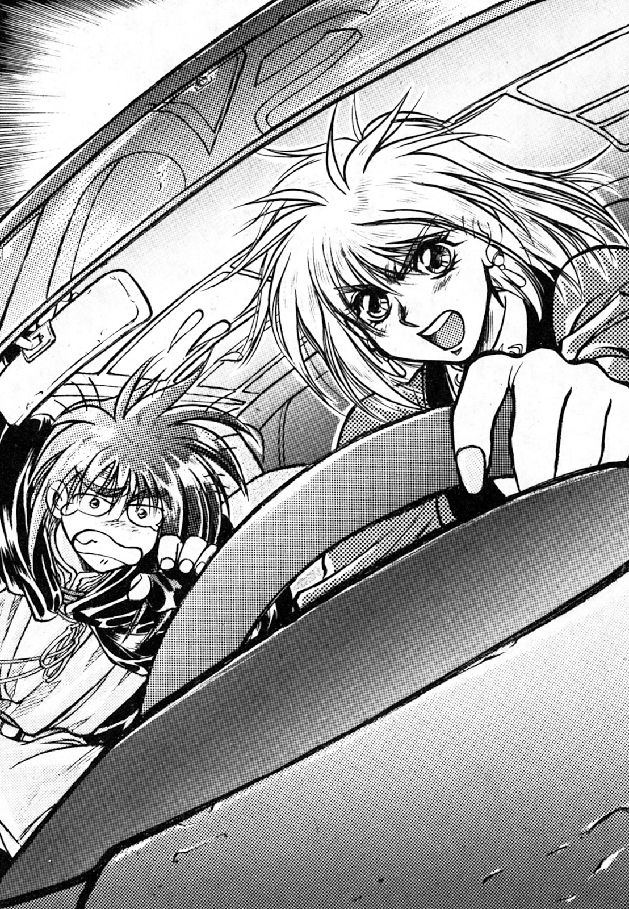

Looking into the rear mirror, Millie spotted two vehicles gaining on them.
“This isn’t the time to play hide and seek.”
Millie quietly muttered.
Pop!
It was a sharp sound, a small hole appeared in the front and rear window of the car.
“They shot at us!”
“Those bastards! They must really want to kill us!”
“Damn it, this car is a rental!”
“Don’t worry about such a thing, just accelerate and get us out of here.”
“If you say so!”
Millie put her foot down on the accelerator.
But——
The reflection in the car mirror was getting closer.
It wasn’t a technical problem, it was because Zenan’s car’s had better engines.
“No, we can’t go any faster!”
“......Forget it! We’ll just have to fight back!”
“Ah!”
Millie desperately screamed as bullets flew overhead.
They were being pursued by floating vehicles, it was a specific type that was powered by electricity. It affected their aiming since it vibrates when moving, no matter how good their aiming was it would be difficult to fire an accurate shot.
“How are you going to fight them, do you even have a gun?”
“No, but I’ve thought of something.”
Kane said as he took out his lightsabre, he then began cutting the passenger’s seat door.
Rattle! Rattle!
After a loud thud, the car door came off. It went flying towards the cars pursuing them, whacking one of the cars.
“My goodness! You used the car door against them!”
“Ah ha ha ha! At least it stopped one of them!”
Millie couldn’t help but feel angry.
“Didn’t you hear me, this is a rental car!”
“So, it’s not like it’s worth much.”
“You better be paying for the damages.”
“Oh, please.”
“……Argh……”
She stepped on the accelerator with tears in her eyes.
Although it wasn’t obvious to them, the distance between them and the remaining car was closing.
Kane thought for a moment.
“……It doesn’t make sense to use the back seats. However, I could use the trunk against them.”
“——H-Hey, stop! Please!”
Millie cried out.
Kane ignored her pleas and began to cut off the trunk.
The driver tried to avoid the impact but was struck dead centre.
“——Bullseye! Hopefully he’ll die in a fiery inferno.”
“Asshole!”
She shouted from the bottom of her heart.

It was very dark, the scene shifted to a large room.
Painted on the floor was a huge inverse pentagram.
In the centre of the room was a mysterious man.
Albert Von Stargazer.
The leader of the galaxy’s largest criminal organization, Nightmare.
He stood in silence in the middle of the room, there wasn’t even a table in sight.
It was almost as if he was meditating.
His white hair was like a silver flame. He had a lean face which was reminiscent of a bird. His entire body was covered in a large black cloak.
It was an ancient sorcerers dress.
“Stargazer.”
He didn’t know where the voice came from, he slowly opened his eyes.
“Come.”
His words reacted with the door, which made no sound as it opened.
A man dressed in black entered.
“We are now planning an invasion against system 1-3-A, the solar system, Dugole Connection among other things……”
The man said as he stood near the entrance, his voice trembled a little as he spoke.
“We pulled some strings inside the interstellar police and have caused some friction between them and the Dugole Connection.”
“And?”
His expression didn’t change.
“According to the staff report, they would seem to have a great deal of trouble if they tried to topple them. We have the opportunity to either support or destroy one side.”
No matter how much trouble nightmare was causing, it wasn’t enough to push the balance in anyone’s favour without getting directly involved.
“Is there any information relating to that trouble contractor?”
“Yes, here it is.”
The man in black slowly walked towards Stargazer.
He handed him the information, regardless of how much his hand shook.
Then he went back to the door, the man in black couldn’t help but shed a cold sweat.
Every single time.
Every time he was near the old man a wave of nausea or some strange type of pressure came over him.
Normal humans cannot withstand it for long.
If this man was a realist, he might describe it as——miasma.
The old man began to turn over the report.
“——Is the content of this report correct?.”
“Yes, five pirate ships were sunk by……”
The old man interrupted the man in black with a rough tone.
“The Sword Breaker, I’ve had my eye on this spaceship and its central control system……”
“You are referring to Canal Volfield.”
“Obviously.”
The old man whispered.
The man in black couldn’t help but flinch.
Not because he was shocked, but because the miasma in the room had become more intense.
“What are the energy supply levels on docks 1-5?”
Although the topic of conversation had changed, the man in black didn’t panic.
“They haven’t changed much, they average around thirty percent. Dock is at thirty seven percent though.”
He replied.
After a moment of silence, Stargazer slowly spoke.
“——Open the doors to dock number two.”
“Yes, sir. I’ll hand the orders down personally.”
He then saluted Stargazer.
“——Is there anything I should know?”
He reluctantly asked.
“It’s a spaceship.”
Stargazer said in an emotionless voice.
“Who’s the pilot?”
“A pilot isn’t necessary.”
When travelling through outer space, a human spirit is necessary.
If no one was aboard the ship, then it would be impossible to enter superluminal navigation.
He knew better than to ask any more questions.
“Understood. But what about the Dugole Connection?”
“Use your contact in the Interstellar Police to apply pressure on them, eventually it will escalate and they will be forced to intervene. Then we’ll force them into submission.”
“Understood.”
He saluted and left the room.
Stargazer was left alone once more.
“This must come to pass, nightmare will spread across the universe……”

Millie walked alone in the night, neon lights lighted up the area.
The night wind was cold, very cold.
Regardless of how much of a bargain the rental car was, she didn’t have the money to pay for the damages.
She had to contact the Director of her department to get the necessary funds, but this resulted in a pay cut as punishment.
For a new recruit on the job for less than a year, it was a mighty blow.
“Helping that guy was a mistake……he walks around in the street with a cape of all things, I should have knew he was trouble."
Millie said, but she needed his help to find Clay because her Director kept telling her to hurry up and find him.
If her information is correct, he should be in this bar.
The place was noisy and full of smoke, a drunken man approached her.
“Yo, foxy lady. How you doin’?
She ignored him and went straight to the bar, hoping to find Clay.
“He’s not here, right?”
“He’s here alright.”
“You are……”
It was the man she was looking for——Clay Roberts.
“Why do you want to help me?”
“——It doesn’t matter.”
Clay said, he then waved over the bartender and ordered some cocktails.
He gave one to Millie.
“Because……I wouldn’t be able to sleep at night if I just let you disappear.”
“Is that right?”
Clay said, as he sipped her cocktail.
“Anyway, how can we bring you back home? You’re not interested in your father’s cause, you just want to escape from reality. Maybe there’s some way we can get both of you to come to terms with one another?”
Millie stopped preaching.
“Although, I think it might be a bit too late for the unpromising son to return home.”
Clay said in a sombre tone.
For a while they were silent, both of them stared at their glasses.
“I’ve…..thought about it a lot.”
He whispered, then fell silent.
Mille wasn’t in a hurry to ask.
“——I.”
“——Your ideals are simply irrelevant.”
A voice came suddenly from the side.
(——Crap!)
Millie instantly stood up.
They hadn’t realized it, but they were surrounded by five or six men.
Although Millie didn’t know, one of the men was Zenan.
“I’d like to hear more from this lady.”
Zenan smiled and ordered his men to grab Millie.
“……Wait a second! You must be joking?!”
Clay revealed a look of desperation, however he didn’t have the courage to help.
Millie was pulled out of the bar, eventually she was taken to an underground parking lot.
The lights of a car lit up the parking lot, she was being held down on the car.
“Where is Kane?”
“I don’t know.”
Each time Zenan asked, Millie let out a cry.
“You are his associate! What are nightmare planning?”
“Nightmare……I’m not……”
“This isn’t working.”
Zenan coldly looked at her.
“If you won’t give me the answer, then I’ll have to force it out of you. How does 1.5 volts sound?”
One of the men revealed a wicked smile, as he moved close to Millie.
“Wait! Wait! Ah!”
Her voice was strained.
“I’m just a detective! I was commissioned by Clay’s father to bring him back!”
The man slowly climbed on top of her.
“I called Kane and nightmare has nothing to do with this!”
The man grabbed Millie’s’ clothes.
“I have proof! Please, listen to me!”
“…Proof?”
Zenan whispered, and then the man stopped in his tracks.
“——Well, we’ll see about that.”
As he spoke, the man reluctantly got off of Millie.
However, the crisis wasn’t over, she was still strapped to the car.
“Well, where’s this proof?”
“There’s proof that I’m a detective in my wallet.”
“You do realize people can fake that kind of stuff.”
Millie went silent.
“……Well, you can call the detective agency and give them my number.”
“Hmm……”
Zenan thought for a moment.
“Okay, but you’ll be doing a video call——there’s a device in the car.”
The car was equipped with a small video camera.
“No funny business, or you’ll get it.”
Millie started dialling the agency.
Although her hands were free, she had a gun pointed at her back.
Even if she had an opportunity to escape, the odds of her escaping alive were very low.
After a considerable amount of time, the agency finally picked up.
A woman appeared on the video screen.
“Hi, Cynthia.”
“Millie? What’s wrong? Your calling of a sudden, is it about the case?”
“Yeah, but first I’ve got to speak to the director.”
“Understood.”
A moment passed.
Then a silver haired middle aged man appeared on the screen.
“What is it this time, Millie?”
“You don’t want me renting a car since I trashed the last one, right?”
The man revealed a bulldog like expression.
“Get to the point!”
“Remember how I was going to bring back Clay Roberts to his father on Mars?”
The director frowned. He then carefully looked at Millie’s face.
“Have you lost the relevant information?”
“No, I still have it.”
The man behind Millie suddenly pushed her out of the way.
“Who is that man?”
“Well……”
Millie pondered for a moment.
“He’s a member of a local organization.”
“What?”
“Ah, you see I am part of a local organization that does odd jobs. We suspect this woman to be part of a hostile organization.”
“And?”
The director said in a rude manner.
“They were wondering if you could verify my identity as a detective.”
“Can’t you do anything right? Since you can’t man detailed in your assignment, I think it’s best that you don’t phone back here again.”
“No, wait!”
“Goodbye, Miss Millennium Feria Nocturne.”
The connection on the other side was cut.
Millie was speechless.
“……Ahhhhhhh!!!”
Screams could clearly be heard in the vehicle.
“My life! My new life! I haven’t paid off that five month loan on my VCD machine yet!”
“……This woman is still worried about her loan……”
Millie couldn’t help but shed tears.
“It’s clear that she’s not from nightmare.”
“Mr Zenan, what do we do with her?”
One man said in a disgruntled voice.
“The director saw my face. If this woman’s corpse is found, naturally the first suspect will be me.”
Zenan sighed.
“I guess we’ll have to do this the hard way. Whether you are from nightmare or not, you did disturb our work. Dumping your body into a bathtub full of dissolution acid should do the trick, there won’t be anything left of you to find.”
“No!”
“——Get her!”
Whack, Millie hit one of the men and tried to make a break for it.
However, Zenan’s men were closing in on her.
“Stop……please!”
One grabbed Millie by the wrist, it was impossible for her to resist.
Whoosh!
Then suddenly——a beam of light flew out of the darkness and struck the hand hold Millie, she was free.
“Run for it!”
By the time the voice reached Zenan, it was too late.
At that very moment, a bright light shone in the darkness.
“Ahh…”
“Ohh…”
Two of Zenan’s goons fell to the ground, both of them had been struck by something.
“——Nobody move!”
The voice came from the darkness.
“It’s that guy……”
Zenan whispered.
“Move and you get shot!”
Millie didn’t understand what was happening.
Then——
Out of the darkness appeared Kane, with his cape and lightsabre in tow.
“Millie, you okay?”
“——Yes, thank you.”
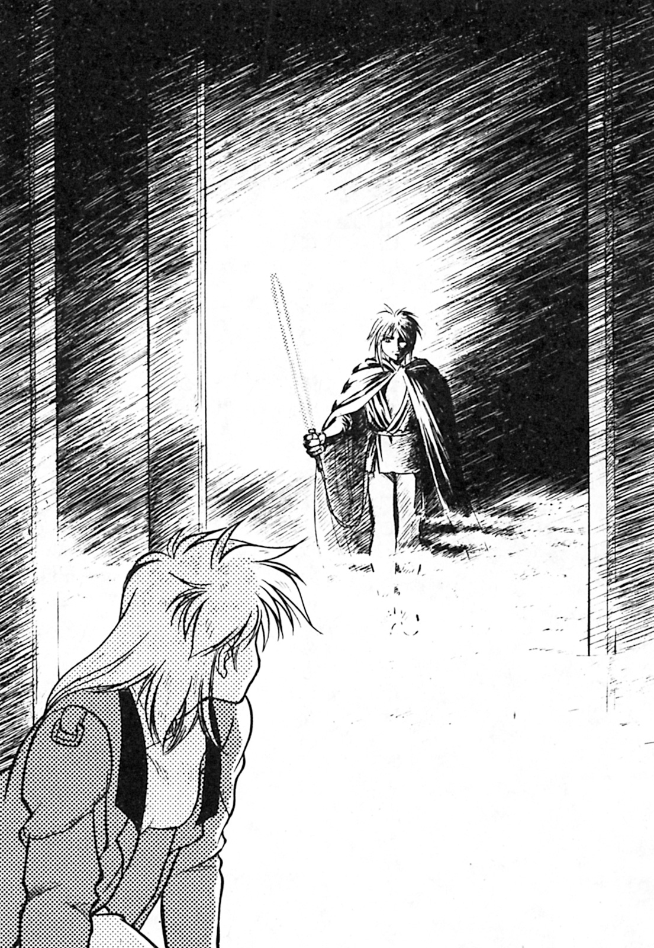

“I know where you’re hiding, Zenan!”
Kane motioned for Millie to move closer to him, she moved accordingly.
“We’ll get in the car and go.”
He said, while watching for any signs of movement.
Zenan was in no hurry to attack.
He had seen what Kane did to his men.
From the way he had shot at his men’s joints, he could easily tell that Kane was a skilled shooter.
If he casually walked out from behind the stone pillar, death was certain. But if he could use the other men as a distraction, then he might have a chance to move.
Just as Zenan had been thinking about what to do, he hear a car driving away.
“Damn!”
Him and his remaining men rushed out from behind the pillars.
“Mr Zenan……”
He ignored his men and rushed straight towards the car.
Running past the injured men on the ground he rushed towards the parking lot entrance.
“Shit!”
Zenan shouted.
But——
After a moment of silence, he smiled.
“……Well, this isn’t over one bit……”
“You saved me, thanks a lot.”
Millie said, as she sat in the passenger seat.
“We’re not friends anyway, so I don’t owe you a favour.”
“Why do you say that?”
Kane revealed an unhappy look.
“Don’t be so narrow-minded. Men, they should be more open-minded.”
“All in all, you only escaped because of me. If I was narrow-minded I wouldn’t have saved you.”
Millie ignored the irony of his words.
“So! You were the one who got me into this mess.”
“And you were the one who told me to get into the car!”
“You argue like a child.”
“Just shut up, where do you want me to take you? To your hotel or to Clay?”
“……I just remembered something……”
Millie quietly murmured.
“……What is it?”
“……The detective agency I worked for fired me……”
“Damn. Why were you fired?”
“The director scolded me for not being able to find Clay, he said not to phone back.”
“Well, that sucks.”
“……What will I do now?”
Millie though about what to do. Meanwhile Kane kept driving on the road, ever watchful for signs of someone following them.

Chapter 3 – Zenan

“Yo!”
Clay became startled after hearing a loud sound, he came to a full stop.
He was right in front of the cheap apartment where he lived.
“Jack……”
Clay softly cried out.
“Is something wrong? You look frustrated.”
Kane came to find him that night, naturally this was the start of his problems.
“Yeah, maybe a little…”
Clay revealed a cowardly smile.
He remembered how he let Zenan take Millie away.
Although he saw the entire thing, there was nothing he could do.
This weighed on his mind heavily, he knew that it wouldn’t have ended well for her.
“You seem like you have something on your mind?”
Jack watched Clay closely.
“……It’s nothing, I’m fine.”
Clay made a forced smile.
“Clay, are you free right now?”
“I guess so……”
He nodded without thinking.
“——Okay, so what’s up?””
Jack told Clay that he needed help cleaning his fridge of beer.
“……And that’s what happened.”
Clay lifelessly replied as he sat down on a mouldy couch.
Jack was sitting on the couch opposite of him.
“……Do you remember this sofa?”
Jack patted his couch and pointed at Clay.
“It was back in my early days on Mars, a couple of my buddies went to steal some stuff at a local store……”
“Of course I remember, it was when Bobby and a guy were getting chased by a dog”
“And both of them got their ass bit.”
Both of them laughed.
“……Those were happy times.”
After listening to the words of Jack, Clay began to smile, but he still couldn’t hide the sadness.
Just over two months ago, Bobby was caught by the police for selling marijuana for an organization.
“Although in the beginning things looked promising, now I regret introducing everyone to the organization……”
Jack took another sip of beer.
“……I never expected things ever get like this.”
“I know.”
“You should have just stayed home.”
Jack suddenly whispered something.
“……What?”
Clay immediately said.
“——I didn’t want to say this. But recently there’s been a guy pestering you——his names Kane, right? There are rumours going around that he is with nightmare, you know associating with those people is taboo.”
“……”
Clay went silent for a moment.
“Yeah, I know the guy. He just wanted to take me back home, though I will admit trouble seems to follow him.”
“But……”
Knock, knock.
A knocking sound came from the door.
“Seriously, who’s knocking at this time of the night?”
“Don’t worry, I’ll get it.”
Clay said as he made his way towards the door, he opened it.
He stood there for a moment.
“Why are you so surprised to see me?”
Zenan said in a calm voice.
“Mr Zenan.”
Subconsciously he stepped backwards.
Zenan took this opportunity and entered the room.
“Mr Zenan!”
Zenan ignored Jack and looked directly at Clay.
“Kill Kane Blueriver.”
He unilaterally declared.
“This requires your assistance.”
“My assistance?”
“You do realize that you and that guy are both suspected of being spies for nightmare, this is an excellent opportunity to set the record straight.”
“I……”
An unbearable wave of pressure came upon Clay
“What, were you going to say something?”
“Mr Zenan!”
Jack suddenly interrupted them.
This was the first time Zenan had met him.
“……Are you sure you want to do this?”
“Please, just let him go.”
Zenan watched in silence.
“……That guy Kane isn’t from nightmare and neither is Clay, leave him out of this.”
“——Enough, shut up!”
Zenan coldly said to Jack, he then turned his attention back to Clay.
“I have no time to waste with you!”
“However, Mr Zenan!”
But Jack still went on.
“The real reason that guy Kane came……”
“Didn’t I tell you to shut up?”
Zenan said without turning around to face him.
“……Was to just bring clay back home!”
Zenan silently waved his arm.
Whoosh.
A light sabre waved through the air.
The sound of something heavy hit the ground.
“——Ahhhhhh!”
Clay started screaming.
Jacks decapitated body hit the ground.
“Don’t make me repeat myself.”
Zenan stared coldly at Clay.
“I’ll ask again. Will you lend your assistance?”
Zenan said as he waved his light sabre through the air.
Clay took a deep breath, with his trembling voice he gave a resolute answer.
“I won’t!”
“……Strange……”

The next night.
Millie and Kane had been searching different nightclubs trying to find Clay, they had searched five but with no luck.
“He’s not here, certainly he should be in one of these bars……”
She said to herself as she turned a page in her notebook.
“Is sharing intelligence a problem?”
Kane casually asked.
“No, that shouldn’t be a problem.”
“Do you think he’s at home?”
“Probably not, I rung his apartment several times and got no answer.”
“Hmm……”
Kane mused to himself.
“Where can are investigation go from here? We’ve only got his phone number.”
“I’ve still got my business secrets.”
“Obviously you’ve been fired, right?”
“……Argh……”
“Then we’ve got to move faster with our investigation.”
Kane muttered to himself.
“Why?”
Millie asked in a casual tone.
“Because we are being watched. Behind you.”
“……Huh?”
“He’s in the corner.”
“Right.”
After whispering to each other, both of them headed for the exit.
A moment later, something touched Kane’s back.
“Ahhhhh!”
Kane panicked as a man grabbed him by the collar.
“——Oh, it’s you.”
Kane said with a smirk on his face.
It was an informant that Kane knew.
“Is he an acquaintance of yours?”
“Yeah, I met him a few days ago.”
Kane answered Millie’s question.
“About your prior statement, you know you can buy intelligence.”
“Is this alright?”
“I guess so, as long as we don’t regret it in the future……”
Kane then gave the informant a punch in the gut.
“W-Why?”
The informant groaned.
“Because I know you weren’t following us for no reason, some fat ass much have put you up to it……”
“Listen man, you know I can’t say anything.”
Kane punched the man in the face.
“I’m running out of patience.”
Kane was about to punch him again when
“Zenan! It was Zenan! He wanted me to deliver a message to you. Clay called me and wanted you to meet him at this address.”
Kane pulled a note with the address from the man’s hands, then both him and Millie slowly left the bar.
He knew where the place was, it was only two blocks away.
Even though he knew it was most likely a trap, he had to defeat Zenan and rescue Clay somehow.
(If only I could get a plan of the building……)
Of course Kane could get Canal on the Sword Breaker to get the plans, but that would take hours, they just didn’t have that kind of time.
“——Hey, you wait in the car.”
Kane couldn’t remember how many times he’s said this.
“No, I’m coming too!”
Millie shook her head.
Kane sighed.
(……Man, what a drag.)
This disturbed Kane.
He knew that Millie wouldn’t be able to handle herself if a firefight ensued.
“……It seems to be an abandoned building.”
Millie whispered as she looked around the place.
It was an old office building leftover from the Great Depression on Mars, it was obviously not being maintained anymore. The only light was that from the stars above, the streetlights near the building weren’t operational.
Both of them decided to go around and enter from the back of the building.
At the end of the rear alley they found an iron gate.
It had lost a lot of its original paint, there was considerable rust on it.
They glanced around again and saw no sign of the enemy.
“——It’s locked.”
Kane said, he was fiddling with the doorknob.
“That’s for sure, it’s an abandoned building after all……”
“I guess I’ll just have to cut open the door.”
“Stop!”
Millie panicked and stopped Kane from pulling out his light sabre.
“……Why did you stop me?”
“Don’t you realize that people could notice us? Didn’t you even stop to think of the consequences?”
“Well……”
“Exactly, now leave it to a professional.”
Millie took a hairpin from her head, and fitted it into the keyhole.
“A hairpin?”
“Yeah, I think common sense is more convenient in this situation……”
Click, a moment later Millie pressed the door handle and it opened.
“We’re in.”
Both of them entered the building, they saw a faint light emanating from down the hallway.
“……It’s a hall.”
Millie whispered to Kane.
They could see a faint figure in the hall.
“…This is bad, we can’t just foolishly enter the hall.”
Kane was right, for there’s nowhere to hide in a hall, and if Zenan’s men were hiding in the corners of the hall they would descend upon them like locusts.
“……Listen, Millie. I’ll go in first, if it’s safe I’ll give you the signal to enter.”
“Come on, you can’t get rid of me that easily.”
Millie revealed an angry expression.
“Fine, but remember my financial situation is relying on this job.”
Kane nodded to Millie, then he entered the room with his light sabre at the ready.
He took a few steps forward, then——
He stopped moving, the room went dead quiet.
Millie could clearly see Kane standing in the hall.
“What’s wrong?”
Millie couldn’t help but break the silence, she opened the door.
“——Don’t come in.”
Kane calmly said.
“…...What happened? Is it the enemy?”
“——It’s not the enemy.”
“So, what is it then?”
“Just shut up, don’t come over here!”
“Up yours!”
Then, Millie rushed over to Kane.
“Millie!”
Ignoring Kane, she went to see what Kane was looking at.
“5F.”
This text was in front of them.
It was spray painted in white and red,
“……Ah!”
There was something below the writing.
It took Millie a while to realize what it was, it wasn’t a mannequin——it was a real person.
“It’s Clay……”
Kane mumbled.
There wasn’t even a scar on his face, his head was cut off from the rest of his body, it was lying not far away from his head.
His face had the expression of terror and despair.
There wasn’t even any blood, the light sabre made sure of that, it was so unreal.
“——This is——”
An intense wave of nausea came upon them.
Millie then spoke in a weak voice.
“……They want us to go to the fifth floor, that’s where the final battle will be fought.”
“Probably.”
Kane then left the room and silently walked up to the second floor, Millie followed behind him.
On the second floor they found an elevator, the power was still working.
Kane pressed the elevator button.
After the doors opened, he pressed the button for the fifth floor.
Both of them then went towards the emergency stairs and climbed to the fifth floor, Millie struggled to keep up.
After a while, they reached the fifth floor.
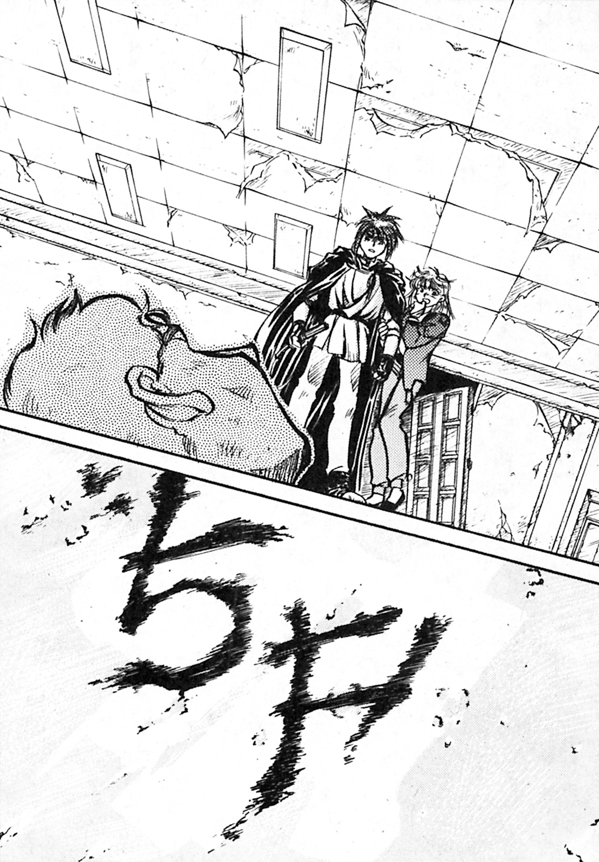

It was a spacious room, most of the curtains were closed and there was only one working light in the room.
“——Took you long enough.”
Zenan was waiting for Kane.
“——You bastard!”
Kane shouted.
Millie immediately pulled out her gun.
“What are you thinking?”
Zenan sneered.
“At this point I don’t care if you are with nightmare or not, I just want to kill you.”
“I’m not with nightmare!”
“…Maybe…but I don’t care.”
“You monster, you killed Clay!”
Millie shouted.
“And?”
Millie raised her tranquilizer gun, she was dead set on shooting him.
Kane stopped her.
“Why?”
Zenan laughed.
“Come on, let’s fight.”
“How do I know that all the guys you have back there will not interfere?”
“Don’t worry, this fight will be a one on one.”
Kane looked back at Millie.
“Millie, you wait outside.”
“Not going to happen, she stays here. We need a witness.”
Zenan calmly raised his right hand.
“Enough talk!”
Whoosh!
Zenan’s light sabre lit up the room.
Kane powered up his light sabre too, he slowly walked towards Zenan.
Zenan made the first move.
Both of their sabre’s clashed, a crackling sound could be heard around the room.
Meanwhile, Zenan kicked Kane’s right leg.
“Ahh!”
Kane jumped backwards and regained his footing.
Zenan instantly came after him.
Kane dodged his attack and struck back, but Zenan’s defence was too strong.
Zenan was even stronger than Kane expected.
However, Kane had speed and technique on his side, though he knew that wouldn’t win the battle alone.
Kane and Zenan continued to clash sabres.
This time Zenan used his elbow to hit Kane in the face, naturally Kane regained his balance fairly quickly.
Zenan dashed towards him again.
After several repeated attempts, anxiety was starting to show on his face.
“Well, Kane! I didn’t expect much of a fight from you!”
Kane smiled back at him.
“——Looks like you can’t handle me, you ready to die yet?”
“Shut your mouth!”
Zenan roared.
Kane saw Zenan trying to rush him again.
“Are you ready to die?!”
Zenan shouted, that was followed by the room going dark.
“What?!”
Kane had struck the only working light in the room.
“No!”
“Ah!”
Screams sounded out across the room.
After Kane had turned off the lights he had killed the guys hiding behind the curtain.
“Ah! Turn on the lights!”
Zenan screamed.
“Kane!”
Millie said, just as someone pushed by her.
“He’s making a break for it!”
“Come on, let’s go after him!”
Kane shouted, making his way to the exit.
“I can’t see him.”
Millie looked down the staircase, there wasn’t a trace of Zenan.
“Then he’s gone up! Come on!”
“No, he definitely went downstairs.”
Millie said as she shook her head.
“The bastard couldn’t win so he ran, figures.”
Click, click.
They heard a sound transmission.
Millie was startled.
“Don’t worry, it’s mine.”
Kane pulled out his communicator.
“——Kane, I……”
It was Canal from the Sword Breaker.
“What’s up? I’m kind of busy here!”
“I was eavesdropping in the Martian communication system, apparently the Dugole Connection is marshalling their fleet.”
“I don’t think that’s something we should be concerned about!”
Kane unhappily replied back.
“I haven’t got the time to worry about that, right now we’ve got to go after Zenan!”
“Zenan?”
Canal said.
“That’s the assassin you mentioned before, right? Someone from his organization called him just as he left the building.”
“What was it about?”
“He was told to immediately go to the spaceport, he also received some other information……”
“Spaceport?”
He repeated her like a parrot.
“What else did they tell him?”
Canal replied in a low voice.
“Nightmare has declared war on the Dugole Connection.”

Chapter 4 – Galveira

“……I can’t believe this is happening.”
Millie said to Kane as they were preparing to leave.
“……What?”
Kane stopped entering information into his keypad for a moment.
“Could you be quiet, I’m trying to track Zenan.”
“Oh, alright.”
Millie sulked like a child.
“You can either stay here or come with me, whatever’s safer for you.”
“……There’s going to be fighting all over the airspace, no where’s going to be safe. Know anywhere safe?”
Kane didn’t answer her question, he just handed her the keypad.
“Put your information into it, your ID and retinal data too.”
“……I have to ask, but……”
Millie said as she slid her ID card into the machine.
“You do know who Nightmare are, right?”
Kane didn’t look at Millie as he replied.
“Albert Von Stargazer, that damn old man.”
“……I see.”
Millie agreed with him.
They filled out the forms, then got onto a shuttle.
“……This ship looks pretty cheap.”
“Enough nonsense.”
Millie complained about almost everything in the ship, from the instruments to the equipment. Kane just grunted, then started the space shuttle.
Although he was very impatient to arrive at the station’s harbour, he could only think about Zenan.
Then——the universe.
They docked in the port of Phobos.
Both Millie and Kane made their way onto the Sword Breaker.
“Hmm……”
Upon arriving on the Sword Breaker, Millie wondered what the gravity setting was on. She gently hopped a couple of times to test it.
“……1G…...it’s amazing that you can perfectly simulate gravity on your ship.”
The control room door opened.
“Welcome back.”
Canal smiled and greeted the two.
Millie’s eyes widened.
“……What a strange dress.”
Although Canal heard Millie whisper this, she didn’t have the time to be concerned about this.
“Canal, this is Millie. I mentioned her in the report, she’s also on the case.”
After being introduced, Millie stretched out her right hand.
“My full name’s Millennium Feria Nocturne, Millie for short.”
“Nice to meet you, Millie. I’m Canal Volfield. I am the central control system of this ship. By the way, I’m a three dimensional image. A hologram.”
“Oh, okay……”
After a casual introduction, Millie retracted her right hand.
“Kane……did you tell her beforehand?”
“No.”
Millie was a little disappointed, she thought they were a team now.
“Anyway, have you prepared for departure?”
“Almost. You just need to sign and pay before we can leave.”
“Millie, you can sit on that seat.”
He pointed to a seat on the right hand side.
After Kane finished the standard procedure before departure, the doors of the dock opened.
“Canal, did anyone come looking for trouble?”
“Yeah.”
She seemed to be a little out of breath.
“When the exterior was being repaired someone tried to plant some explosives.”
“Ah!”
After listening to their conversation, Millie couldn’t help but cry out.
“Don’t worry, they’ve been removed.”
“Okay......though, can I change seat? I can’t see anything with Canal’s ass in the way.”
“Please sit where you are for now. Although you might not be able to see much, you can use the user interface by touching it.”
After several exchanges, the Sword Breaker left the dock.
“Canal, do you know where the staging ground is?”
“They are gathering at stellar coordinates 8-5, they are also manoeuvring near spatial coordinates F-0-0.”
“That’s a little far away, but——”
Before Kane could finish——
Rumble!
Multiple shocks and vibrations went through the Sword Breaker.
“What?”
“What happened?!”
“We’re being bombarded by a beam cannon! Damage is minimal……damn it, I just fixed the exterior!”
All three of them cried out.
“Ships incoming at fifteen o’clock! It’s the Dugole Connection.”
“Get us in the shadow of Phobos.”
“Understood!”
The Sword Breaker had used Phobos to shield itself in the past, hiding was a good way to stay out of trouble.
“——Kane. They’ve sent a communication.”
“Put it through.”
Kane answered, it was a video call.
On the screen appeared——
“……Zenan.”
“Kane Blueriver……if you think returning right now is a good thing, then you’ll be the next blood sacrifice.”
“You’re mad!”
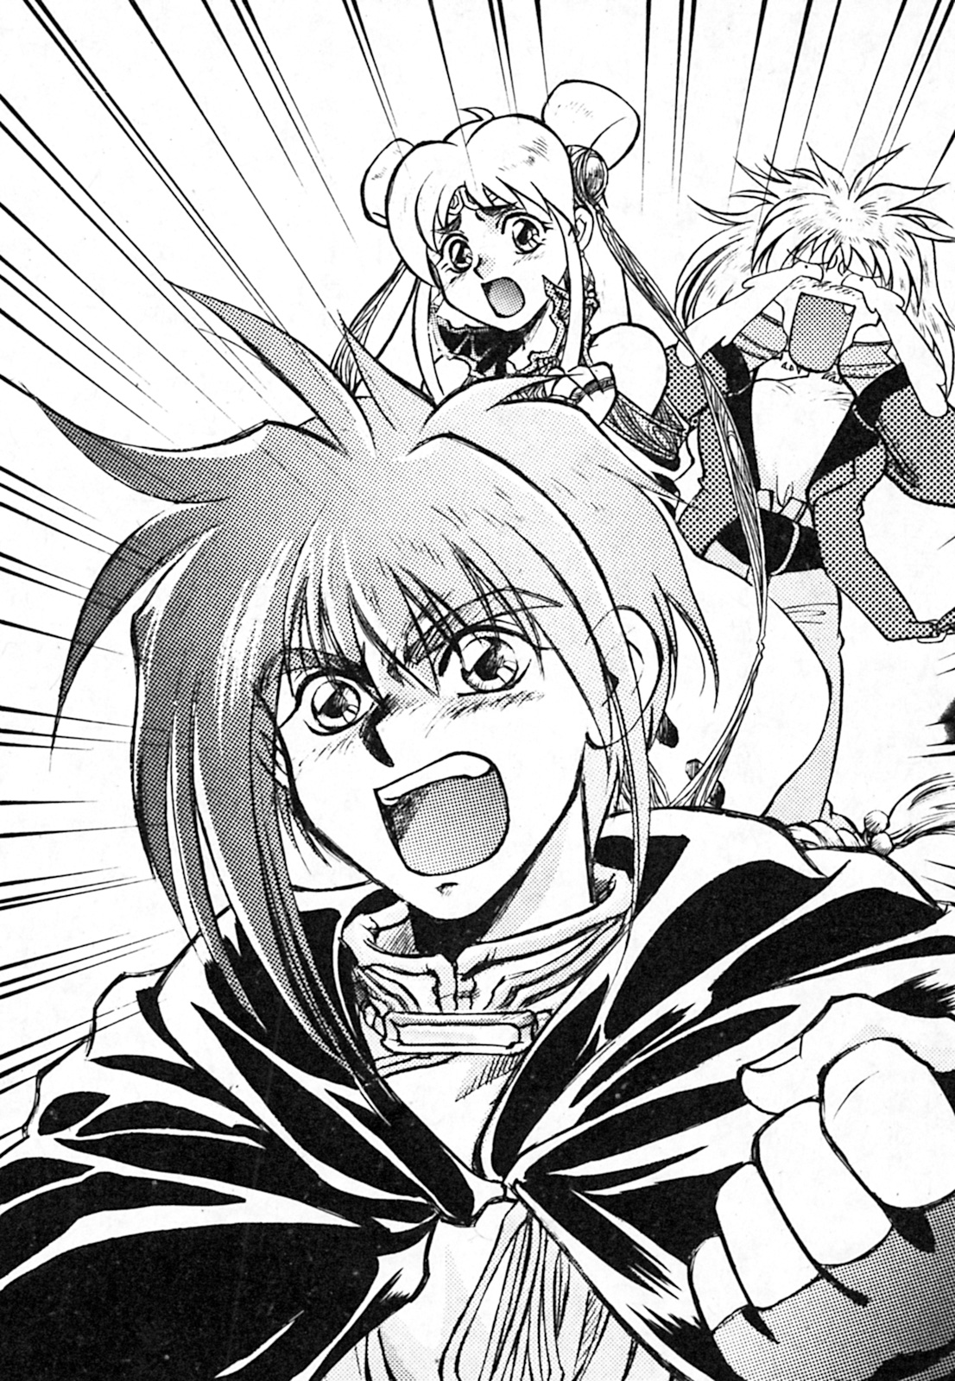

Kane couldn’t help but shout.
“I’m going to kill you……”
Zenan closed his mouth, then he shut down the communication.
“Kane, the enemy is moving! They’re coming for us!”
The enemy ships were bypassing Phobos and coming at them from the side.
“Get us out of here, I don’t want Phobos to get caught in the crossfire.”
“Understood!”
Hmm…
A loud humming sound came from the engines, the Sword Breaker began to accelerate.
“This bucket of bolts of yours better be safe.”
Millie cried out, but Kane and Canal were too preoccupied with the matter at hand.
“The front of a fleet is nearing us! There’s ten ships in total!”
“Local patrol ships?”
Kane had a habit of asking questions when he knew the answer, Canal simply shook her head.
“——No, they’re Dugole!”
“Jesus!”
Millie desperately said.
“——Zenan, this is his doing!”
Zenan opened up the communication channel, and immediately asked for the patrol ships leader.
Although Zenan didn’t know, when Kane came to the Solar System, he was responsible for the attack on the Sword Breaker.
“You want the fight to last longer, right? Haven’t you thought of the consequences!?”
He said in a straight tone, noticing their arrival.
“Do you know that the Sword Breaker is a nightmare vessel?”
Zenan was talking even though he didn’t believe the lies.
“……Of course I know.”
The man replied.
“I am afraid that the Sword Breaker is willing to take advantage of Phobos to pressure us, or to appear behind us and wait for an opportunity to attack us.”
“I understand. What’s your orders?”
“Surround Phobos.”
After the communication channel turned off, Zenan cursed under his breath.
“——The fleet in front of us is slowly backing away.”
“So that’s how it is?”
“……This ship is going to be wrecked, they have fifteen ships.”
“Wrecked! What is the meaning of this?”
Canal couldn’t stand that Millie called her ship a “wreck”.
“Well, from the exterior that’s what it looks like. Although I didn’t really get a good look either……”
“Hey! Canal!”
Kane interrupted her.
“Where do you find the time to chat? We’ve got a situation over here!”
“Oh, if the patrol ships come, they’ll be easier to handle. Don’t worry.”
Needless to say, the patrol ships were in the satellite Phobos’ harbour, though they were still something to worry about.
“The enemy fleet is slowly surrounding Phobos”
“What a dirty move.”
Phobos is one of Mars’ moons, based on the amount of ships they had around it, it was obviously more than enough.
“I’ve got it in full view.”
Canal said.
“They really aren’t giving us much options. Move out!”
“Understood.”
She instantly answered, the Sword Breaker began to accelerate.
“Incoming!”
Numerous enemy ships began shelling them.
Kane began to move his control stick, avoiding all of the enemy shots.
“——This is fun!”
Zenan couldn’t help but shout out loud.
“How could they avoid all those shots? It’s impossible!”
“——A lost ship——”
Millie whispered, Kane and Canal didn’t hear her.
“The enemy has launched small attack craft!”
“We can cope with them, use our auto guns on them.”
“Understood!”
Numerous ships were annihilated within a couple seconds, some of them had avoided being destroyed. However this is mostly due to Kane not having the time to aim at them himself, since he was too busy driving.
“Good hit!”
Millie’s operator interface suddenly lit up in front of her.
“Do you know how to operate that?”
“Of course, it’s as easy as 1-2-3!”
Millie put her hand just above the interface.
Then——
Boom!
A cosmic flower bloomed in the light.
An arrow of light impacted almost all the attack ships.
“Oh, yeah!”
Kane couldn’t help but shout in joy.
“……Where did you learn to operate that kind of system?”
“Weekend practice.”
While answering Kane’s questions, Millie continued to use the gun.
Then, the darkness of space lit up with more explosions.
The rest of the incoming ships started to panic.
“The attack forces are taking evasive action.”
“That’s good, head straight through the middle of them.”
“There’s movement from the fleet at Phobos! They are heading this way!”
“Engage!”
Millie didn’t know why, but she seemed to think all of what was happening was an illusion.
“Anti-ship weapons?”
Millie asked.
“……From my point of view the beam guns should be used……”
“There’s also rail guns, but forget it. Let me take control!”
Millie didn’t reply, she let Canal take control of the system. She started firing wildly.
But——
The instant before the target was hit, a dazzling light dissipated in the darkness.
“An electromagnetic barrier!”
“No way! Damn conventional weapons.”
Canal shouted.
They all watched the Patrol ships head towards them.
However——
In an instant, the screen was suddenly filled with white light——it was the patrol ships.
“Someone sank the patrol ships!”
Canal was dumbfounded.
“Okay, Canal. I think it’s time to get serious.”
“…………”
But Canal didn’t answer.
“Canal?”
She stood there motionless, her eyes never once moving from the screen.
“——It’s coming——”
She whispered.
Suddenly there was a flash in the distance.
“What?”
Kane shouted as he looked at the screen.
“After they left Phobos, the Dugole Connection……they were silenced.”
“What is it?”
Without looking back, Canal spoke in a sombre tone.
“Nightmare……”
“——They’re here?”
Zenan’s fleet had stopped shelling them.
“——Kane.”
He sighed.
“——I understand. Unlock all weapons! We’ll use everything to defeat them!”
“Understood!”
After Millie heard the name Nightmare, she sat there silently.
“Enemy recognition complete! It’s a 300 meter class assault ship, it’s name is Galveira.”
A triangular pyramid shape was reflected in the screen, it looked like a biological spaceship.
“Long time no see, Volfield.”
A deep voice came through the speakers.
“That guy must have forced his communication through.”
Canal said to Millie and Kane.
There was no picture, only sound.
“Long time no see, Galveira. I didn’t think you’d use that language to speak to me.”
“At my master’s request, I must destroy you.”
“Do you think you can?”
“I will destroy you.”
The communication ceased.
“Kane! Watch out!”
A blast of light galloped across space.
It split into several beams and struck Phobos.
In an instant——
With a large flash, the Martian moon of Phobos began to break apart.
“What the……”
Kane and Millie said.
“Shockwave incoming!”
A moment later, the Sword Breaker shook violently.
Needless to say, the Dugole Connection fleet was also hit by the shockwave and debris.
“We were lucky, he attacked with less than half of his total power.”
Canal said.
“……Less than half?”
A cold sweat went down Kane’s spine.
“Yeah, and Kane……this is a battle between me and him.”
Due to the blast and electromagnetic waves, the sensors were not operational for a moment.
“Okay, but——”
Before he could finish.
“Expand mental barrier! Full strength!”
Kane raised his voice.
There was no reason behind this, it was his intuition dictating things now.
“Understood!”
Canal quickly answered back.
An attack came afterwards.
The ship rocked side to side.
“It’s him!”
Galveira took advantage of the moons destruction to move his ship, the Sword Breaker never knew because their sensors were down.
“Turn off the barrier! Prepare for high speed manoeuvring, and get ready to fire the railguns!”
“Turn off the barrier?”
“The enemy has done the same, we’ll get close real fast and wish for luck.”
“Understood!”
She complied with his orders. Just a dozen kilometres away, Galveira continued to fire at them.
“Fire the rail guns!”
Both ships were within fifty meters of one another, dealing all sorts of damage.
Galveira sought to escape from such close quarters combat.
“Canal! Give the PSI Blaster handle to Millie! Let it rip!”
“Ah! Understood!”
Millie suddenly panicked.
After listening to Canal’s instructions, Millie would fire at the Galveira.
A moment later, they were ready to fire.
Countless rays of light then flew from the Sword Breaker.
“Barrier!
“Understood!”
“Volfield, I hope you don’t have any regrets.”
The voice went straight to Canal’s ears.
“Expand mental barrier, switch railguns to manual mode!”
Kane ordered.
A moment later.
Strong shockwaves shook the Sword Breaker.
Galveira’s and Sword Breakers mental barriers both impacted each other, pale plasma lit up the nearby vicinity.
Image of ships hitting each other
Kane readied the ships railguns.
“No! Kane!”
“You can’t fire when we are this close!”
Both barriers were crackling against one another.
Their intense shocks seemed to be cancelling each other out.
Both ships slowly backed off, Kane wanted to seize the opportunity.
“If the timing is wrong, this could be the end……”
Kane said as he gripped the rail gun’s trigger.
A fearless smile appeared on his face.
Bzzzzz!
Their barriers disappeared.
Galveira opened fire.
“——Now!”
Kane pushed down on the trigger.
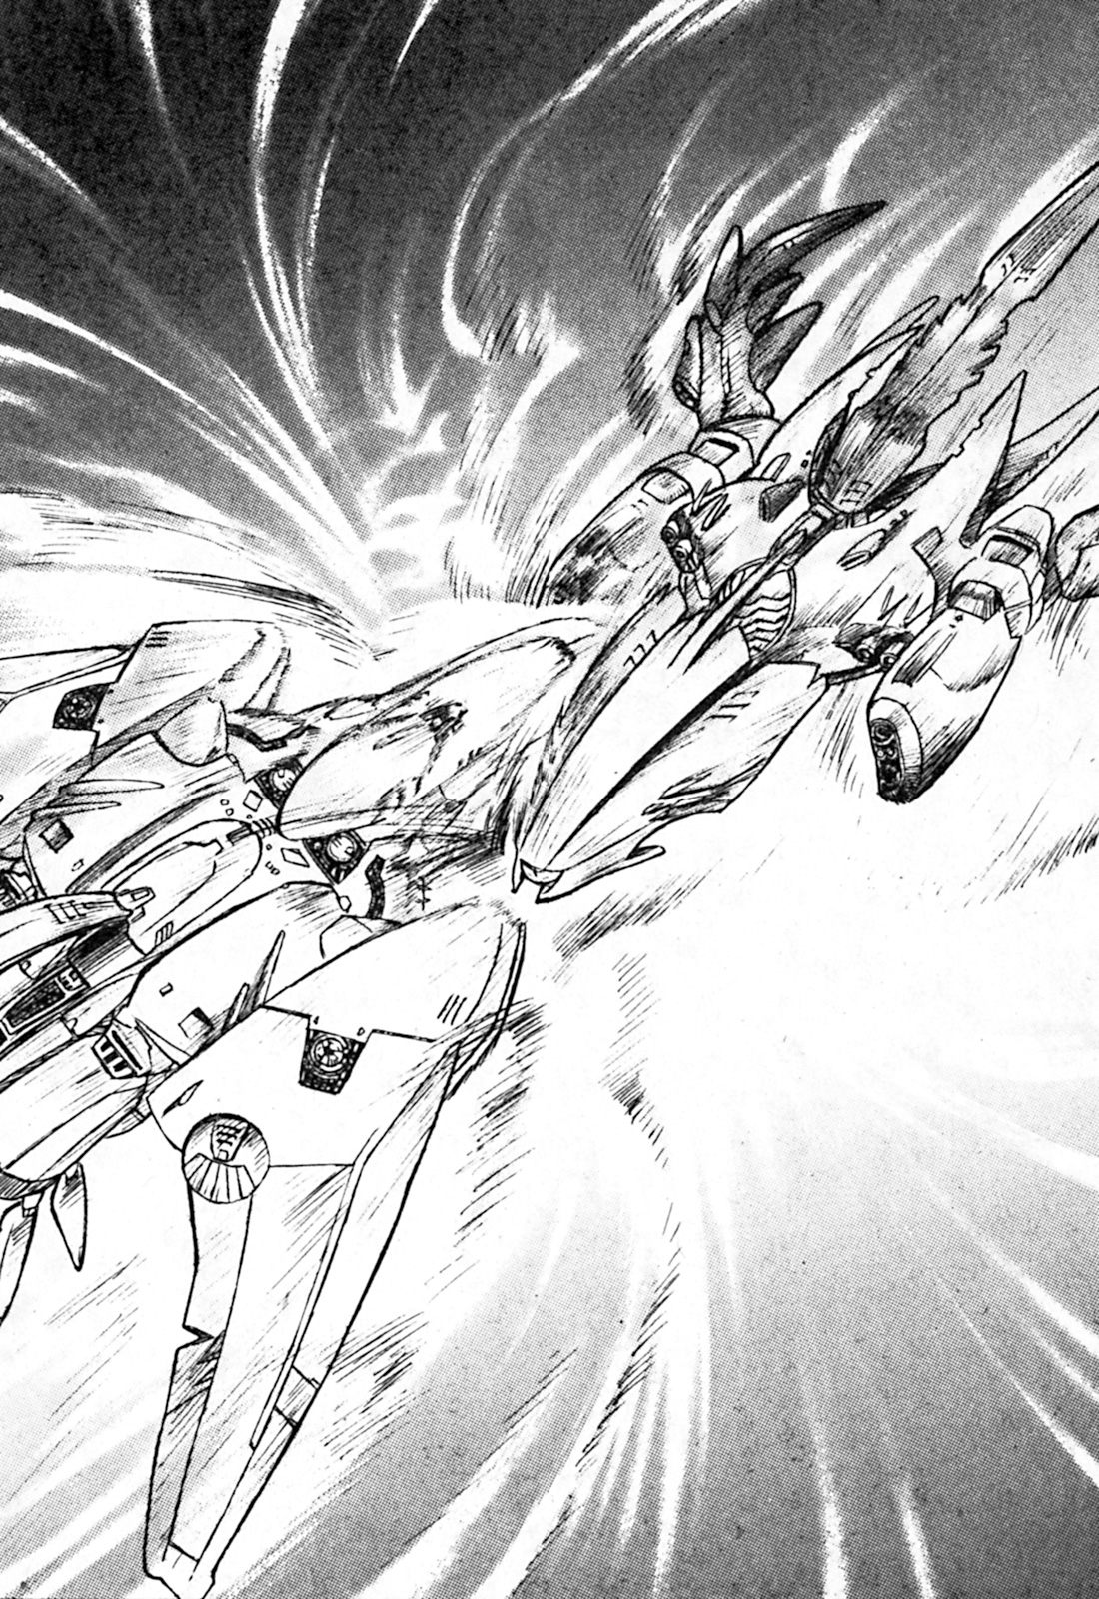

A moment later.
Rumbling!
The enemy ship was turned into a ball of light,
At that moment, Kane prepared to fire another barrage.
“Get ready to launch the plasma blaster!”
An array of light flew from the Sword Breaker, heading straight towards Galveira.
“Gahhhhhhhh!!”
“That’s a scream of someone on his deathbed——”
Canal muttered.
Then——
A dazzling light appeared in front of them, spreading out into the universe.
It was as if Galveira had seemly disappeared.
“——Well, I think I deserve an explanation.”
Millie broke the silence in the control room.
“Oh, in fact, Millie……”
Kane coughed.
“This ship is part of a new military project, we are completing the ongoing tests of new weapons.”
“Liar!”
It was obvious to anyone that this wasn’t an ordinary ship.
“This ship is truly a lost ship……”
The secret had been revealed.
A Lost Ship——
After mankind had entered the galaxy, they had no direct contact with aliens, but they did discover lots of relics.
In the destroyed remains of ancient civilizations, there was proof that life existed outside of the Solar System.
They were——Lost Ships.
However, this information was not formally disclosed.
The reasons were that because the ships had fighting abilities outside of humanities imagination.
It’s been impossible for humans to achieve such technology and weapons, thus people have sought them for personal gain.
If someone got their hands on a lost ship, and the galaxy knew, the militaries of the universe and weapons merchants would not sit idly by. Therefore, information on lost ships were not disclosed.
Everyone simply believed that these lost ships were exactly that, lost.
In conclusion, in the eyes of the general public, these lost ships were only rumours.
“……Please, don’t make fun of us. Lost ships are only legends, legends!”
Canal was ready to play the fool.
“Besides, you are a detective. You should know better.”
“Former detective.”
Millie said solemnly.
“But how do you explain all those ridiculous weapons……mental barrier? Railgun? And that monster of a ship that destroyed Phobos, what kind of weapons was that packing?”
They talked for a while about what happened.
“Please, just don’t tell anyone……”
Kane said with a troubled expression.
“Indeed……this is a lost ship——I inherited it when my grandmother died, it’s one among lots of things I didn’t know about. Isn’t that right, Canal?”
Canal seemed like she was in a daze, a moment later she replied.
“It’s nothing.”
“Was it what that guy said?”
“…………”
Canal thought for a moment.
“No, don’t worry.”
“Anyway, I intend to stay on this ship.”
“What?”
“Wait a minute!”
Kane and Canal both simultaneously shouted.
“How can you made that decision without us?”
“Because it’ll be fun. And I lost my job because of you……this is the least you could do, since you didn’t pay me for the damages.”
“Why you little minx!”
“I think it’s a great idea, as long as she wants to help stop the planned domination of the entire Milky Way Galaxy from the other lost ships.”
“Wait!”
Kane said.
“There’s more of them?”
“There are five.”
“Canal……”
“What?”
“That’s bad conduct.”
Canal giggled.
She then took a look at the main screen, and cried.
A large blue space fleet had appeared.
“……It’s the Interstellar Police and the military.”
“……Things just keep getting better……”
Kane sighed deeply.
Because of the battle with nightmare and the Dugole Connection, the interstellar police have decided to intervene.
The interstellar police didn’t believe the survivors of the Dugole Connection when they told them about the ships with magnificent fighting abilities, therefore the blame for the destruction of Phobos was put on them.
Although the Sword Breaker had begun to delete their records of the battle, Kane didn’t want to help the Dugole Connection by proving their innocence in the moons destruction.
Kane and Millie only accepted a simple investigation, afterwards they were released.
Canal and the Sword Breaker didn’t want to be investigated, they disguised themselves as an ordinary spaceship in one of Mars’ space docks.
“……Put it in there.”
Kane said. He had gone back to his hotel to retrieve his luggage, it wasn’t much to carry.
Today, they were ready to leave Mars.
——The results, there was no way they could bring Clay Roberts back.
Kane gently shook his head.
“Well, all that’s left is Millie……”
With the keys in his hand and a suitcase in the other, he headed down to Millie’s room on the first floor.

Thud. Thud.
Someone knocked on the door.
“——I’m coming!.”
Millie replied, she was still wrestling with all her clothes, trying to get them packed away.
Thud. Thud.
“Come on! Maybe he didn’t hear me……Kane sure is impatient.”
Thud.
“——I said I’m coming!”
Millie said as she opened the door.
She saw someone she didn’t expect standing outside.
Bzzz!
An electric shock went through her body.
(——A stun gun——)
In an instant, Millie fell unconsciousness.

Kane stopped in front of Millie’s room, the door was half open.
He dropped his suitcase gently on the ground.
Kane reached for his lightsabre.
He had a foreboding feeling.
Then he proceeded to look around the room, luggage and clothes were scattered everywhere. The walls were spray painted in red paint, it said: “Go to the roof. I’ll be waiting for five minutes.”
“Millie.”
Kane rushed out the door without thinking.

“——I knew you would come. Kane.”
Zenan wore a crazy smile.
In his hands was an exhausted Millie.
He had a lightsabre right against her throat.
“……Sadly, she’s still alive, but she won’t be for long……”
“What do you want?”
“Since Phobos was destroyed along with our forces, I’ve got nothing to lose. I’ve also got some unfinished business with you.”
“How did you survive?”
“Well, let’s just say that I’m hard to kill.”
“You want to kill me, isn’t that right?”
“No——just throw away that weapon of yours. Afterwards I’ll let her go.”
Kane didn’t know whether he was telling the truth or not, he closely examined Zenan’s lightsabre near Millie’s throat.
He knew what had to be done. Kane pulled the amplifier off his belt, throwing it onto the floor along with his headband and communicator.
“——Good……now your cloak, then turn around.”
“……There!”
Kane said as he took off his cloak.
“……There you go, I’m unarmed……”
At that moment.
Kane spun around, rushing towards Zenan.
“What!”
Zenan quickly threw Millie to the side, shooting his lightsabre right after.
“Ah!”
Kane cried.
The shot went through his shoulder.
In order to block Kane’s escape route, Zenan rushed towards the stairs.
“……What happens now?”
Kane and Zenan had merely swapped positions.
Kane first confirmed Millie’s condition.
She had lost consciousness.
He then looked at Zenan.
“You bastard……if I did as you said both of us would be dead.”
“Wow, you catch on quick.”
“……It was obvious.”
Kane placed Millie on the ground, making sure she wouldn’t be caught in his fight. He then closed the distance between him and Zenan, kicking his lightsabre as he ran.
——It was time.
“Let’s go! Zenan!”
He roared, rushing towards Zenan with all his might.
“Idiot……what are you going to do?”
Zenan’s lightsabre became fully erect.
Kane lowered his posture as he ran, pretending to aim for Zenan’s feet.
Zenan clipped Kane in the shoulder.
Kane whipped out his lightsabre in an instant, barely pulling it out after rolling on the ground.
“It’s over! Kane!”
Flash!
The lightsabre went through his heart.
——Zenan’s heart.
“How can this be?”
Zenan’s lips would move for the last time.
——It was the end for him.
“……Ah……”
His body slumped to the ground, never to move again.
“What a pity.”
Kane said, looking down upon Zenan.
“……You see, even without an amplifier……it’s still usable, all you need is spirit……”
Finally, the battle was over.

“Welcome back, Kane.”
Canal greeted the two with a smile.
They stood in Sword Breakers control room, it was currently docked in a port on Deimos.
“……Ah. That Zenan guy was still alive……although we did get rid of him.”
Kane told Canal what happened.
Millie sat down on the gunner’s seat.
“……Kane, where to next?”
“To Millie’s home planet.”
“Aren’t you going to hire me?”
Millie chimed in from the side.
“When did we say that we were?”
“What!?”
“I did a very detailed investigation into you, Millie.”
“Hey!”
Canal smiled, Millie was speechless.
“——Other than that she’s cool with me, she’s also a great shot, something you aren’t Kane.”
“Haha, very funny.”
“Ahahahahaha!”
Millie giggled.
“What are you hiding, Canal?”
“Nothing, it’s a secret between us girls. Right, Millie?”
“Haha, yeah.”
Millie’s smile became stiffer.
Kane sighed.
“Never mind, I’m probably better off not knowing. Sword Breaker, go!”
“Understood!”
Canal and Millie both smiled at each other.

Chapter 5 – Epilogue

“This is——”
Rail whispered, after receiving Kane’s report.
“Sorry……it was my mistake.”
“Enough……I’m hanging up.”
“Okay……”
After Kane had finished answering, he turned off the communicator.
Rail pulled himself out a bottle of brandy and a glass.
He poured himself a generous amount.
“——That hit the spot.”
He smiled.
“I can’t believe it……Kane messed up.”
Of course, he didn’t really care about Clay Roberts——nor did he care about who killed him.
He just happened to find a missing persons case, one which had the Dugole Connection involved. Or rather, he had gotten them involved. For Rail was the one who had anonymously told the Dugole Connection that a certain man by the name of Kane was an assassin from nightmare coming to cause trouble for them.
Everything was orchestrated by him.
“Now that the Dugole Connection is out of the way……I wonder how much Nightmare will pay.”
Rail took a second glass.
This time he had not just changed the fate of Kane Blueriver, but the fate of Nightmare.

“Ahhhhh……”
The room filled with an ominous sound, it was similar to that of moaning.
Of course, it was just the sound of the machines.
The man in black prepared to submit the final report.
“——The assassination of the Dugole Connection was a success, the leader had an unfortunate traffic accident.”
Albert Von Stargazer listened quietly to the man in black.
There wasn’t a change in his expression.
“Most of the Dugole Connection has been destroyed, those that are left are too disorganized to oppose us. Although there are some other small organizations left, they are puny in the grand scale of things. Effectively, we hold the real power in the Solar System.”
“Understood.”
Albert Von Stargazer spoke softly.
“Is there anything else to report?”
“That’s all for today.”
“You may go.”
The man in black left the room.
After a while——
“As you have heard……”
He said in the empty room.
“We are one step closer to your desire.”
“But there is a problem at the same time.”
A voice came out of nowhere.
The room itself seemed to shake.
“Volfied……your old nemesis has destroyed Galveira. What shall we do next, Dark Star?”
“For now……”
It was a groan like voice.
“We’ll bide out time until everything is ready.”
The dark room got even darker, and soon miasma filled the air——

End of Lost Universe Volume 1
Translated by Ciaran Hillock/Dirk Diggler
https://chillock-amt.blogspot.co.uk/

