Rune Soldier Louie Book 01




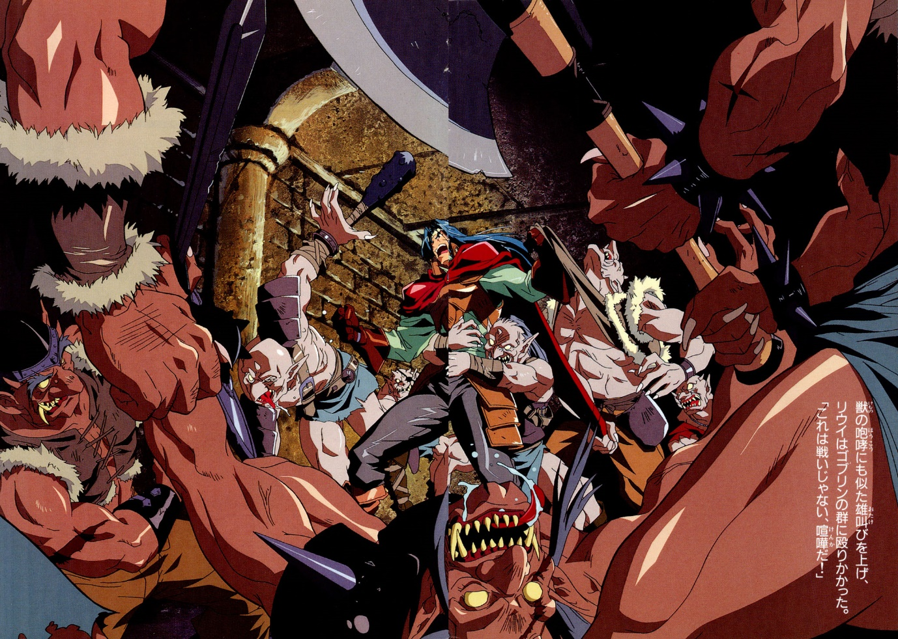

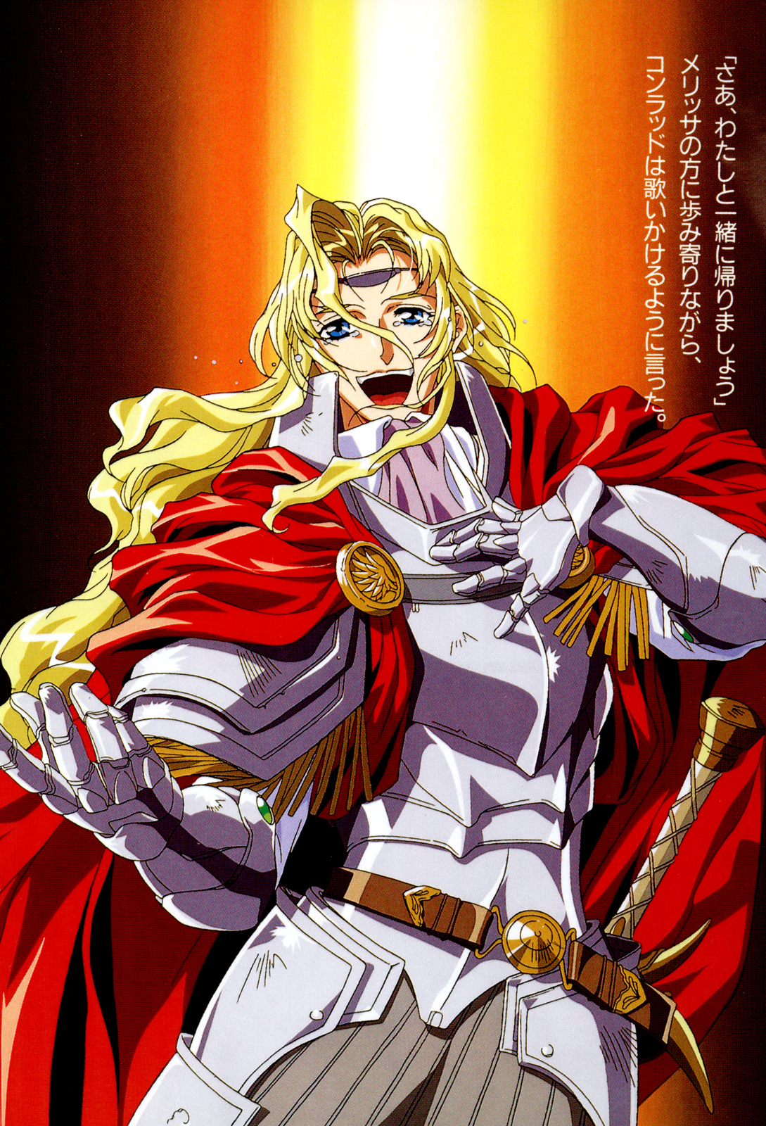

Chapter 1 – The beginning of the story

With the demise of the Old Kingdom of Kastuul, the age of magic came to an end. That was five hundred years ago. Then came the “New Kingdom Period”, it was also called the “age of swords”. It was an age unlike any other, it was full of sorcery and barbarians as all tried to use their swords to forge new kingdoms. In between these five centuries, a lot of kingdoms rose and fell.
On the Alecrast continent, a new kingdom was born, the Kingdom of Ohfun. A hero called Rijarl slayed a powerful dragon using his sword, this kingdom is also known as the “Kingdom of the sword”. However, in this age of swords, it seems the ancient kingdom of magic didn’t disappear, they were called “magicians”, and they have been spreading their magic ever since their incarnation. Among all these magicians, there are some who have excellent fighting skills. These good natured people who fight using magic, they are called “Magical Soldiers”.

***

“Congratulations.”
With these blessing words, four ceramic cups were held high in the air.
“Thank you.”
A strong young man gently lifted the glass, in response to the four blessings. Then, a thin layer of foam was floating in the cup, the young man took one breath and swallowed the red liquid. It was beer, a wave of bitter taste spread throughout his mouth.
“You haven’t changed.”
Another young man who was sitting to the right hand side spoke, he didn’t know whether the others were in a daze from god, or their emotions.
“With a physique like that, you should be able to gulp more than a barrel.”
Five of them sat at a table, a female sitting next to the young man said this. In order to prevent her little brown hair from falling into the glass, she licked the glass clean with her mouth.
“Drinking a barrel is far too much, a couple of glasses will do me.”
Said the youth, while waving to the barkeep to give him another glass of beer.
“Another glass, though I’m afraid it might not quench my thirst.”
The young man said with a confident smile. This young man’s name is Louie.
This summer, he had just turned nineteen, in the world he currently lives in, he is considered an adult. Louie lives in Ohfun, the capital of the kingdom, where he studies at the Magician's Guild. However, even though he is a qualified magician, he is still a disciple in the world when it comes to his standing in the world of magic.
This young man is sitting in the presence of legit magicians.
He entered the magician’s guild a decade ago as a student, where he began to learn under his mentor. Subjects varied from learning about the ancient magical kingdom, the heritage of magical texts and magical words. During this time, there was about one hundred student’s studying at the Magician’s Guild. Today, there is only five students.
“Don’t worry, this will be the last one.”
Louie said, while looking at the barmaid.
Now, there are almost five fully fledged magicians.
The only thing they have to do is chant the “magical ancient language” and say the ancient magical words, only then will they be regarded as real magician. Then they will be granted the use of a “magical wand” to cast magic.
After learning basic magic, they will have to study the ancient texts from the ancient magical kingdom. Afterwards, they attend an awards ceremony where they will receive a formal qualification as proof of them being a magician. Benefits of this qualification include becoming a mentor and carrying out research activities.
Three days ago, Louie received a book of ancient magic at the ceremony, there was five people in total who received an ancient book of magic.
After the ceremony, the five magicians went to a local tavern to celebrate.
“We were the last ones……”
The woman called IIa said. She was two years older the Louie, the oldest of the last five.
“You shouldn’t worry too much, we were just slower than the others.”
That didn’t do much to improve her spirits.
“You know, every day I struggle to even use magic!”
Louie said, in a trance like state.
“That’s because you don’t focus on your magic studies, I’m not even sure if you want to become a magician.”
“Is that so?”
Louie replied with a wry smile, he then mumbled something as he gulped down on his beer.
“I’m not cut out for it……”
Louie looked disappointed as he finished looked into his empty glass, IIa then patted him on the shoulder and spoke.
“With the amount of beer you drink and your physique, not many people would even suspect you of being a magician.”
IIa said, Louie also certainly didn’t dress like a magician.
If Louie had become a Knight, he’d probably be one of the best considering the size of his body.
“Aren’t you and Mr. Carwes related?”
Mr. Carwes is a court magician of the kingdom, he is also the headmaster of the magician's guild. It’s said that he’s one of the most powerful magicians on the continent. Louie was a relative of this great magician, but his parents died when he was a child and he was adopted.
“I and my grandfather aren’t the same.”
Louie said decisively.
Though, Carwes could be consider his father, he was too old at the time and Louie just called him grandfather throughout his childhood.
“If you really are related to him, then you should become a magician.”
Daryl said, as he laughed.
“I heard that people who become magicians inherited the blue blood from the ancient kingdom.”
“That legend is too far-fetched.”
Daryl said, Louie jokingly replied.
In fact, Louie also thought that, he was related to the great magician Carwes after all.
The great Carwes never married, and nobody knows if he has any siblings.
Louie didn’t really care about whether he had the blue blood or not, because it wouldn’t affect his relationship with his adoptive father.
To him, you can become a magician whether you have blue blood or not.
“What kind of aspect do you like the most?”
Louie didn’t hear her, he was lost in his thoughts, and it seemed what Daryl said changed his mood, so he quickly changed the topic.
“Basic magic, specifically the part where you stick out your hand and say the incantation.”
When Louie replied, he looked really lonely.
“Mr Carwes always does make sure you learn the basics.”
Ila smiled.
“I’m working on expanding my magical talents.”
She was referring to using the ancient magical language to enhance her field of magic, like teleport or clairvoyance, etc.
“Aren’t you satisfied with your body?”
Ila looked surprised.
“I’d like to be just like Louie.”
Daryl easily said.
“Since you work out so often, you’re better suited to be an adventurer, you could go out and explore ancient ruins.”
“That gives me an idea, if Louie actually found something, then we could carry out some research, it would give us a boost in our studies.”
Two men sitting opposite of Louie said, while laughing.
“An adventurer?”
The two men were just joking. However, Louie was taking this seriously.
Adventurer——
On the continent of Alecrast, abandoned ruins can be found all over the place.
It’s been five hundred years since the collapse of the ancient kingdom, inside the ruins left behind it was said that untold amounts of treasure, precious metals and stones, works of art, magical treasures, etc. These so called adventurers sneak into these relics and plunder them, this is how they make a living.
Though, sometimes these adventurers commit heroic deeds such as fending off monster infestations, bandits, pirates, etc.
However, not all adventures have such high achievements. Most adventurers become caravan guards or guard a rich noble’s mansion, or they do menial tasks for clients in exchange for food. In other words, they’ll pretty much any job.
Being an adventure is the ultimate form of freedom, but the public doesn’t generally trust in their abilities or the wealth they desire.
Louie thought about this considerably.
“If I can gain the trust of the people……”
Louie murmured.
At that time, the others were more concentrated on other things, no one noticed Louie.
Louie reached to eat some of the food, he then chatted to some of the others.
And thus, the celebration continued into the night.

2 – The first meeting

After the celebration, they returned to the magician's guild, and then to their rooms.
The other four were pretty wasted, it didn’t seem like they would be practicing magic tomorrow.
However, Louie didn’t drink enough. Knowing him, once he starts drinking, he only continues if he’s having fun, but his mood became sour halfway through the celebration.
Louie changed his clothes and went onto the street, he headed towards a small alley.
In the south-western part of the city lies Joy Street, it’s still bustling with activity even though it’s the middle of the night. Though most of the public stay away from this part of the city.
Louie frequently visit’s this area.
He wants to be a magician——
Throughout his childhood, this was the only thing he wanted to be.
However, Louie always doubts himself whenever it comes to his life decision. This doubt prevents him from progressing, and whenever he is in a bad mood, he simply cannot concentrate on reading about magic.
It’s this strange impulse that brings him to Joy Street, drinking, gambling, women, fights, all of these things, they give him a temporary moment of joy and improve his mood.
However, this place doesn’t always satisfy him.

***

He turned the corner and headed down a dimly lit street.
The air was filled with the smell of garbage, rats were feeding on whatever rubbish they could find, a dog barked. He didn’t know where it was coming from, this was a particularly lonely night.
Then suddenly——
He heard someone shouting, followed by the sound of something being broken, then came a barrage of cheering.
In this place, these sounds were quite common.
“It’s a fight!”
Louie picked up his pace and headed towards the sounds.
His emotions were high, then he thought, that tonight might be a good night after all.
His destination was a lively bar just up the street, Louie had never been inside because he thought the place looked boring——but this time he just had to check it out.
Gathered at the entrance was about twenty people, parts of the bar were damaged or torn down, Louie could tell that this fight was intense.
He tried to worm his way through the crowd and get a better look. However, he wasn’t prepared for what he saw inside, in fact, he was speechless.
There was two men and three women, it was clear that the women has prevailed.
These three women, it was the first time he had seen them.
While the two men, they seemed to be trainee Ohfun knights, or at least that was the impression Louie got from them.
Previously, Louie overheard a conversation they were having in the same bar where his graduation celebration was held. Although they didn’t explicitly mention their profession, Louie was able to learn that they were knights in training from their conversations.
However, these two trainee knights didn’t pose a threat to the three women.
One of the women had a sturdy physique, like Louie. If not for her red hair and large breasts, she was have been mistaken for a man. Her upper torso was half covered in leather armour, parts of her wrists and ankles were covered in white cloth, though most of her body was uncovered and her light dark skin was clearly visible, on her cheeks, thighs and arms was a piece of text or a logo.
As far as Louie can recall, it looked like a mark similar to that of the Arido tribe that live in the northern Yasugarun mountains, for some reason she must have left her tribe.
They are brave mountain nation, when the Kingdom of Ohfun was created they sent many people to help in its construction. Ever since, the tribes have retained their autonomy and continue to live in their ancient tradition.
One of the other women was blonde and was wearing less revealing clothing, there was a charming smile on her face, but she didn’t seem to be helping her companions out. However, if she joined, her efforts would probably be fruitless.
Then one of the men, a freckled faced man, tried to slap her in the face, but she slapped his hand away and sent him crashing to the floor.
On her plump chest, there was a pattern of a Warhammer embroiled.
It was the symbol of Mylee, the God of War.
Louie didn’t know if she was a simple believer of Mylee, or a holy magical priestess, the only thing that was certain, was that she believed in the God of War.
And the last woman, she looked like a little girl.
Her face was like a cat playing with a mouse, as was her agility, she easily kicked the trainee knights away.
Her body was that of a teenager, and it was obvious that her chest wasn’t developed, though her waist looked soft and curvy. However, in the light of the bar, Louie found her sparkling black eyes particularly moving. If she wasn’t in a fight, she was probably a lovely girl.
Together, the three girls didn’t look that big when compared to Louie.
However, they were causing serious harm to the trainee knights.
Onlookers gathered inside and outside the bar to watch the ongoing fight, these people seemed to find the fight interesting. However, none of them intended to stop it, even though the trainee knights were taking a beating.
“If this continues, they’ll most likely die……”
A stranger holding a glass said to Louie.
Louie thought this too, he and this man were different, none of them wanted to see someone lose their life.
(Someone should stop this.)
Louie thought to himself.
However, it seemed no one in the crowd was willing to step forward, they were happy to see the three girls humiliate the trainee knights.
(What should I do?)
Louie was wondering if he should end this farce, but then he saw one of the trainee knights put his hand on his sword handle.
Then, the entire room was filled with cheers and booing.
“The guards are coming!”
Someone outside the bar cried out.
It was probably some guards out on patrol, they were aware of the commotion and heading it this way. Ohfun, among other emerging countries, had very good security. And if anyone was caught by the guards, they would be subjected to severely punished.
“If you draw your sword, then I cannot guarantee your life!”
A smile appeared on the red-haired female warriors face, the trainee knight just started her down.
Even though Louie was watching from the side-lines, he could help but shiver, his whole body was wrought with goose bumps.
Seeing the female warrior’s superior strength, the trainee knight hesitated for a moment, but then he remembered that he was a knight of honour, so he pulled out his sword. His silver blade dazzled in the light of the bar.
His comrade followed suit and pulled out his blade.
“It seems you can’t wait to die!”
The female warrior leisurely said, as she pulled out her sword.
Her little companion pulled out a small thin blade, seemingly from nowhere.
The blonde women didn’t pull out any weapon, she just concentrated and preformed magical gestures. It seemed, that she could use the holy priestess magic of Mylee, which means she also received combat training.
Both men looked at each other, they couldn’t decide if they would be victorious.
(I can’t sit idly by.)
Louie decided.
He liked fighting, and wasn’t afraid to fight to the death!
The guards were getting closer, if they saw this situation, then the trainee knight would be in trouble. But if they saw him lose the fight to a woman, he would be shamed for the rest of his life.
And the women, they would probably be expelled from the city. Perhaps they are already accustomed to a wandering lifestyle, however, they would probably like to avoid trouble with the authorities whenever possible.
“That’s it, stop the fight!”
After careful consideration, Louie loudly shouted this to the two parties.
Discontent rang out throughout the crowd. Among them, some were cheering, they were looking forward to seeing Louie get in on the action. However, that was not Louie’s intention.
Usually, he wouldn’t be the sort of guy who would stop a fight, but today was different.
Louie had been drinking, but he had enough faith in his abilities, he then quickly sprang into action to stop the fight.
First, he extended his fists, and knocked the two trainee knight’s weapons to the ground, then he turned around and punched the female warrior in the face.
This sudden blow sent the female warrior flying against the wall.
“Who do you think you are?!”
The little girl’s voice was lovely, even though she was angry, she lifted her leg and tried to kick Louie.
But he didn’t dodge, he met her kick with a kick of his own.
The girl was as fast as the crack of a whip, she kicked Louie’s left thigh.
“That hurt!”
However, this is what the little girl said.
“This guy’s leg is made out of wood!”
Her face was full of pain and anger, as the little girl held her sore foot.
“You actually hit a woman in the face……”
The blonde woman angrily said to Louie.
She stopped right in front of him, and was going to slap Louie’s cheek. He caught her hand midway and pulled her body close to his. The priestess was surprised by his sudden movements, Louie could tell that she wasn’t a bad person from looking into her blue eyes.
“What do you think you’re doing?”
Louie said to her. A moment of silence followed thereafter.
“The guards are coming here, if you stay here, you’ll most likely end up in prison.”
“The guards are coming!?”
The blonde girl said in amazement, as she stared at the bars entrance.
It seemed, that she was too busy with the fight that she didn’t hear them coming.
The guards finally arrived outside the bar. Everyone outside the bar hated the guards, so they prevented the guards from entering right away.
“Get out of here!”
Louie let go of the blonde haired woman’s hand.
Just then, the female warrior stood up, she glared at Louie with murderous intent.
“Don’t you understand? The fight is over.”

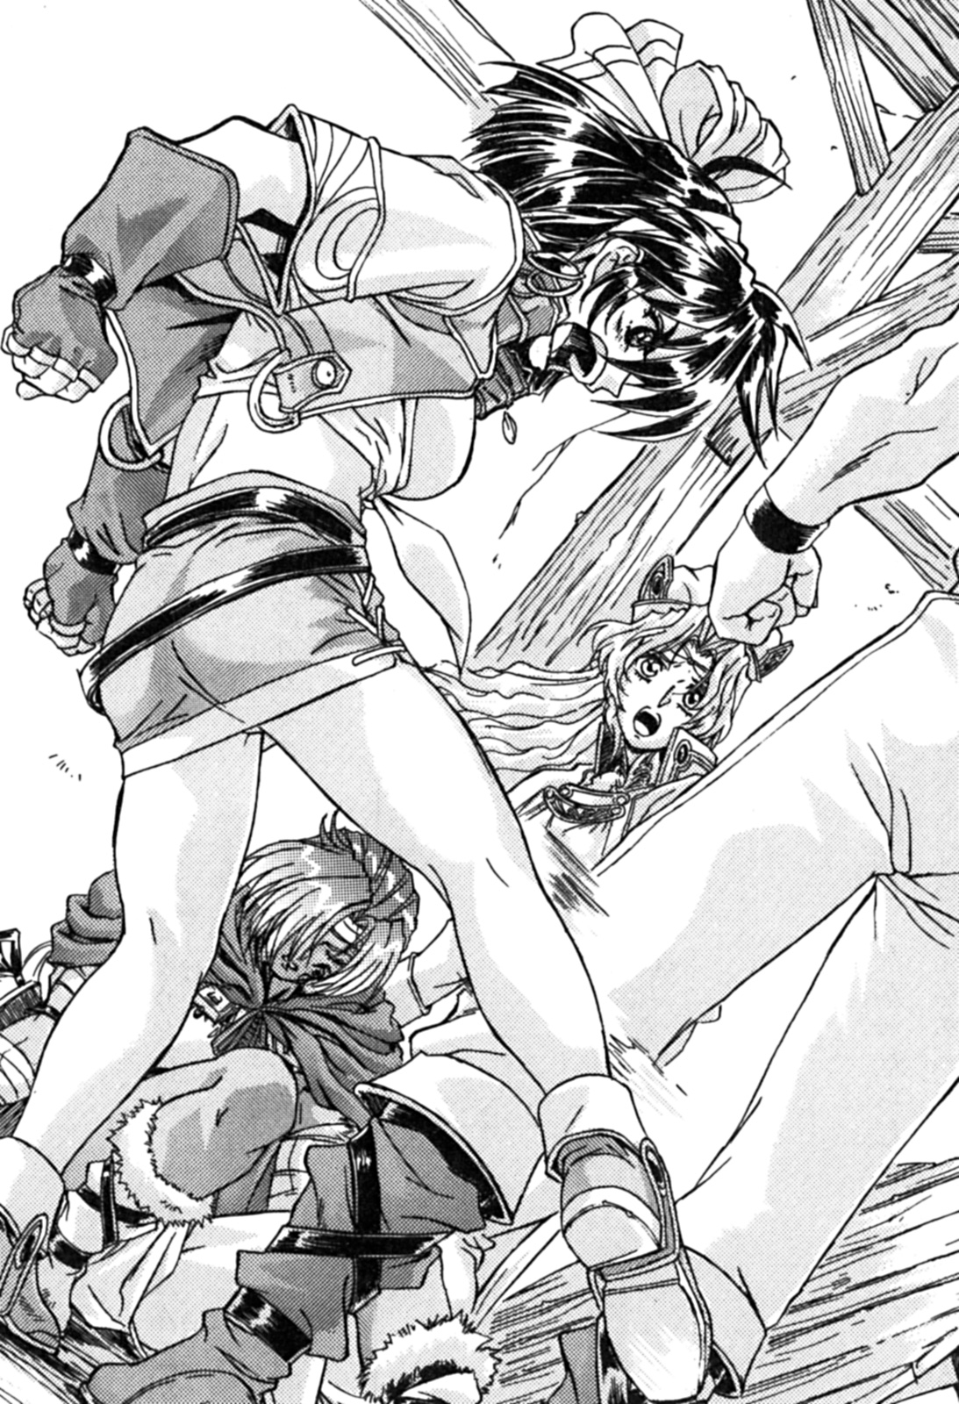

Although he didn’t convince the, the three women left through the back door. Louie felt relived.
But it seemed his intervention caused the opposite effect, if they wanted to get back at Louie, he probably wouldn’t be able to win against all three of them.
Then, he turned around and looked at the two trainee knights.
They stood up, thoroughly embarrassed.
Louie calmly walked towards them——
“Listen, the fight is over.”
He said to the two trainee knights.
They lifted their heads and stared at him, even though the fight was over, they just kept breathing.
Louie repeated himself again.
“Next time, remember to take better care of that honour of yours.”
At that time, the guards broke through the crowd and entered the bar.
“What happened?!”
Louie had his back to the guards, so he turned around to face them.
“There was a fight. I was just watching……”
Louie answered, he then picked up a bottle of wine from a table, and muttered something as he drank.
“You’re drunk!”
One of the guards threw a punch at Louie. It wasn’t a strong punch, though Louie pretended to stagger backwards.
Of course the guards noticed the two trainee knights, however, they winked at each other, realizing what Louie was doing.
Even though this was unfair to Louie, he knew this was the best outcome. He saved the two trainee knights from dishonour, and prevented the three women from being expelled from the kingdom.
Louie’s hands were tied behind his back, he was then taken to Ohfun City’s dungeon.
Although some thought he made a stupid move, Louie thought that tonight was quite stimulating. Though, he regretted that he didn’t drink enough wine.

3 – Hero

Louie was released the following morning.
When he was thrown into palace’s prison, the guards found out that his father’s name was Headmaster Carwes. Knowing this, the guards released Louie.
“I heard that you were drunk and got into a fight.”
Carwes said, as the cell door closed behind Louie.
Upon finding out, Carwes wasn’t angry, he just gave Louie another speech about not getting into trouble, Louie found this very boring.
“Have you seen the king?”
At the end of the sermon, Carwes said to Louie.
“Does the King often come to the dungeon?”
Louie was confused by his father’s question.
If the King found out that Carwes adopted son was thrown in the dungeon, it would probably cause him some misfortune.
“Oh, I didn’t see him.”
After Louie told him what happened, they went to leave the dungeon.
Louie’s clothes were all dirty, so the prison guard washed them after he returned his prison garb. Then they left.
It was now noon, Louie’s stomach was empty. So, he planned on finding someplace to eat and return to the Magician’s Guild.
Louie walked around the streets, looking for a restaurant to appease his belly. Suddenly, he saw three figures walking out of an alley.
Standing in front of him, it was the three girls from last night.
“You……”
Louie took a combat stance, because he sensed murderous intent from the women.
(I bet they’re here to take revenge.)
All three girls were armed. The female warrior was holding a large sword with both arms, the priestess was holding a small war hammer, and the little girl was holding a small knife.
Louie only had a small dagger on him, he had no chance winning against them. Though if this was a fist fight, he might have stood a chance of winning.
No matter how you look at it, Louie’s only option was to run away, otherwise he might lose his life. However, he wasn’t afraid at all, he was excited.
(I must be crazy.)
Louie said inside himself.
These girls looked very accustomed to combat. The large red-haired woman looked like a mercenary, she must have experience a real war.
The blonde woman was a warrior priestess of Mylee, the god of war. Not only was she combat trained, she could also use divine magic.
As for the little girl, she could be a thief, considering her fast movements.
If these three women acted together, in co-ordinated actions, nobody would stand a chance.
They are: adventurers, seasoned adventures.
However, that doesn’t mean they’re any good.
Louie just stared at them in silence.
“Your name’s Louie, right?”
The little girl looked at Louie from head to toe.
Louie didn’t want to respond to her. However, he was convince that she was a thief, only a member of the thieves guild wold be able to obtain personal information so easily.
“I heard that you’re the son of Headmaster Carwes from the Magicians Guild.”
The blonde priestess said slowly.
It was the tone of inquiry, but rather the tone of confirmation.
Louie remained silent.
“I was surprised that a magician……”
The red-haired women spat a mouthful of saliva onto the ground. Her right eye was significantly bruised, there was still traces of Louie’s punch from yesterday.
“Actually dared to punch me.”
“If it wasn’t for that trick you pulled, you would be dead several times over.”
Listening to her words, Louie thought that she was overconfident.
However, Louie was confident that he could beat her in a fist fight, although he’d never dare to fight her since she was armed. Most of the time, Louie would settle his battles with a punch, but this time was different.
“You came to me, okay. The time for talk is over.”
It appears a fight was inevitable.
Louie was prepared for a fight, he closely monitored the three women’s movements.
“Yesterday, I was tempted to tell you……”
The female warrior said, the priestess patted her on the shoulder.
The blonde priestess took a step forward.
“My name is Melissa, I was born in Ramliearth.”
The girl called Melissa said, as she elegantly bowed to Louie.
Louie thought, that she came from a noble background.
The Kingdom of Ramliearth is the continents oldest kingdom, their etiquette courses are quite rigorous.
“The God of War, Mylee, has given me a revelation, you are a hero, this is why I q have come to you today.”
“What?”
Upon hearing this, Louie cried out in surprise.
“I’m a hero……”
Louie was speechless for a moment, the priestess stared blankly at his face.
“Since the God of War told me that you are my chosen hero, I must follow my beliefs.”
Melissa avoided eye contact with Louie, she deliberately turned her head to the side.
“So, you want to worship me as a hero……”
Louie mused.
“Although I’ve done a lot of wicked things in my life, I don’t intend on giving up my dream of becoming a magician. Moreover, I’ve never heard of a magician becoming a hero, the only person I can think of is my grandfather.”
Louie doubted their honesty.
“This is confusing! God must have given a wrong revelation.”
Melissa clenched her fist, and reluctantly looked up at Louie.
“I’m sorry, I can’t be you’re hero. Nor do I want to become one.”
“No, you are a hero.”
Melissa said firmly.
This was related to her beliefs, there was no changing this fact.
"We are adventurers."
The female warriors said with a sigh, Louie wore a puzzled look. She then told Louie that her name was Genie.
“As you can see, I am a warrior. Melissa is a warrior priest to the god Mylee, and Merrill is a thief.”
The little girl called Merrill nodded, she was clearly unhappy.
“We are looking for a companion to join us, a magician would be the perfect choice.”
Adventurers face all kind of unexpected situations, therefore, it’s essential to have a magician as a companion. Although warrior priests can use magic, they can only use a basic healing spell, that’s why they need a magician.
“We would prefer a female magician to join our party.”
The little girl called Merrill said with disdain.
Upon hearing this, the female warrior Genie immediately signalled to Merrill to stop talking.
“In short, the God Mylee gave Melissa a revelation that you are a hero, she’s got to follow you. She doesn’t have a choice……”
When she said this, Louie began to understand.
“So, will you let me join you?”
“Although we’re reluctant……”
The warrior priestess Melissa looked directly at Louie.
“You want me to be an adventurer?”
Becoming an adventurer could mean only one thing, setting out to explore the ruins of the ancient kingdom. At least, this is what Louie thought.
Of course Louie was attracted to the ruins, but not because of the treasure, but for the encounters with dangerous monsters. Though, he think it was unbecoming for a magician to participate adventuring outside of a research expedition.
Even though these three women came to Louie because of a revelation, Louie didn’t believe in fate.
But sometimes mysterious events do happen. Like today……
Louie carefully considered his options, as the three women stared at him.
From the moment Louie was born, he knew he was destined for great things.
“Well, I……”
After thinking for a moment, Louie reluctantly agreed
He didn’t know whether he was doing them a favour, however, he had nothing to lose.
The three women looked at each other with odd expressions.
They felt relieved when he said that, but they weren’t showing their true feelings, they didn’t’ want Louie was their companion.
Women, adventuring, wine, Louie knew his satisfaction from fighting couldn’t be replaced……the only thing he could do was give it a shot.

Chapter 2 – Behind closed doors

1 – Training

An able bodied man stumbled to the ground.
It was Louie, a magician of the “Kingdom of the Sword” from Ohfun.
“You simply can’t do anything.”
A series of rebukes were mercilessly directed at Louie.
The red-haired female warrior was evaluating Louie. Genie and Louie were about the same height, both of them had burly physiques. Both of them worked up quite the sweat, their tanned skin was shining under the bright sun.
“Try harder next time!”
Louie spat onto the ground, he then quickly stood up.
“You think you can resist my attacks?”
Genie said with a sarcastic smile, but it was actually a provocation.
“Are you saying you want to teach me how to use a sword?”
Louie said.
It’s been ten days since Louie joined the three female adventurers.
During this time, Louie has fulfilled his usual obligations to the Magician's Guild, Genie is looking forward to taking him on an adventurer.
Yesterday, they received some good news. They found information about an undiscovered ancient ruin.
Louie and the others were currently staying at a cottage on the outskirts of the city. This cottage seems to be their hiding place and rendezvous point, all the items they take on adventures are stored here.
Louie was waiting, Melissa and Genie were also here, but apparently the little thief Merrill hasn’t arrived yet. During this period of waiting, no one said a word.
Genie was swinging her large sword, while Melissa was kneeling and meditating.
They girls didn’t really get along with Louie due to his personality and unfriendly attitude, but nevertheless they endured him. Moreover, Louie was watching Genie swing her huge sword, he really wanted to test himself against her strength and skills.
(As an adventurer, you have to have the ability to save people’s lives.)
Louie thought about this, this is why he wanted to learn how to use a sword.
Indeed, Louie was pleased when she agreed to train him. But for the moment, she simply said “You’re going to regret this”.
From the moment he heard her say this, Louie knew he made a big mistake.
Genie didn’t sincerely want to train him in swordsmanship, she simply wanted the opportunity to teach him a lesson.
“Remember to keep your eyes on your opponent!”
Genie shouted, and then she mercilessly brought her large sword down upon Louie.
Although Genie let Louie borrow a sword, it really wasn’t a good sword, Louie was unable to resist her attack.
But this didn’t stop Louie, he went three rounds with Genie. Louie came out battered and bruised, the tip of his head was cracked, and blood trickled down his forehead.
“An injury like this is simply nothing.”
Genie laughed, she tightly griped her sword again.
This time she didn’t strike Louie with her sword, instead she kicked him to the ground.
(It can’t be helped.)
Louie stood up, he then spat on his palm.
He concentrated, and held the sword firmly in his right hand. Meanwhile, he clenched his left hand into a fist.
He then swung his sword towards Genie, but she easily blocked it.
“Your sword is like a stick!”
Genie laughed at him, as she retaliated.
However, Louie suddenly stuck out his left fist.
Genie saw this coming and naturally retracted herself, but this wasn’t enough, she was punched in the eye by Louie.
(Why couldn’t I escape that guy’s fist?)
She fell to the ground, shaking the earth itself, dust went up into the air.
“Since you attacked me with your feet, there’s nothing wrong with me using my fists.”
Louie wore a proud smile on his face, he was teasing her.
Melissa cover her face with her hands, she sighed deeply.
(He’s just like a boxer.)
Melissa couldn’t help but feel shame.
(He can’t even use a sword properly, he spits on his hands, he’s simply a rogue. His behaviour is so despicable, why did God select him as my hero?)
Melissa secretly asked the God of War this question.
This is because she got a revelation from her God, Mylee, she was told that her hero was a magician.
Melissa and her hero are from completely different worlds, however, she can’t go against a revelation from her God.
Genie and Merrill were against this from the start, but she couldn’t accept the advice of her friends. She was committed, and both of her friends supported her decision due to their strong friendship. That’s why they let Louie join their group.
However, she doubted if Louie was truly her destined hero.
Melissa raised her head, she looked into the spring sky.
“God of War, give me the strength to endure……”
Melissa prayed quietly.
“This is against my will.”

2 – Thieves

It was the mid-afternoon, the little thief Merrill was just done gathering intelligence.
“That darn broker, I can’t believe he tried to sell me second hand information!”
Merrill cursed under her breath angrily, it seems the information broker had sold the same information to other people.
Generally, when adventurers need to find information they head to an “adventuring shop”. This is how the adventuring industry works, the information brokers find information and they sell it to adventurers, usually to the highest bidder. However, most of the time the information is only sold to one person.
Merrill then headed back to their hideout on the outskirts of the city, she wanted to discuss buying the information with the others.
They discussed it for a while, but decided that they’ll work it out tomorrow. The girls stayed at the cottage while Louie went back to the magician’s guild.
“That woman……”
Louie went back to his room, he took off his clothes and inspected the scars on his body.
There was cuts, abrasions, and numerous bruises. He was annoyed by this, but the average person would probably die of fright.
Fortunately, Louie isn’t an average person. Even if he couldn’t stand these injuries, he would still be able to dominate the alley in Joy Street.
Louie skilfully treated the numerous wounds on his body. Originally, the warrior priest of Mylee offered to heal him with her healing magic, but Louie said he could handle it himself.
He had no reason not to refuse treatment from the warrior priestess Melissa. However, Melissa isn’t fully confident in her abilities, especially when it comes to attending to her hero.
This is most likely due to her doubting herself, she tried three times in a row practicing her healing magic, but every time it ended in failure.
Luckily for Louie, he choose the rather primitive way of healing himself.
He was pretty good at tending to his wounds, mostly because he was always fighting. One time he was stabbed in the stomach, he tended to his wounds and went to class the next day as usual.
“You’ve come back?”
When he was almost finished tending to his wounds, the door suddenly opened, it was Ila.
The door was opened by his friend from the same class, Ila.
“Why are you wearing no clothes?”
Ila saw him naked, but she wasn’t really bothered by this.
She approached him, only to find his body covered in scars.
Because she reads books excessively, her eyesight has declined, so her vision is always blurry.
“Does it hurt?”
Ila stretched out her hand, and touched his wounds.
“Of course it hurts, since you touched it!”
“Oh, is that right?”
Ila smiled happily.
“Anyway, you should put on some clothes. You can’t remain naked in front of a lady.”
“A lady shouldn’t recklessly enter a room with a naked man.”
“You’re missing the point, Louie.”
Just as Ila responded, she pulled something out of her hand bag.
“What’s that?”
It was a two pieces of transparent crystal being held with metal strips, it looked more like a pair of glasses than a magical treasure.
“Oh, it’s a magical treasure.”
Ila said diligently.
She specializes in “endow magic”. This type of magic makes objects produce magical effects.
For a woman such as Ila, this magical treasure will probably be used as a research subject.
“It obviously has two lenses, why don’t you call it four eyes?”
“Because the glasses contain four kinds of magic.”
Louie looked at it more closely, Ila looked very pleased.
“It has the ability to improve the wearer’s vision. You know, my eyesight is very bad, so this thing will help me out a lot.”
Then, she sang an ancient mantra.
The lens on the glasses turned black.
“When the colour of the lens changes, it has a different effect on your vision. For example, I could see people naked with these……”
“Don’t get any funny ideas.”
Louie protested, he didn’t like the idea of someone watching him while he was naked.
“You know, you could sell them and make some money.”
If she wanted to sell it, she wouldn’t have a problem, since her father owns __, one of the largest businesses in the Kingdom of Ohfun. Though she would never do that, since she doesn’t have any money problems.
Also, Louie’s father is the court magician of the Kingdom, and a teacher at the Magicians Guild at the same time, money isn’t a problem for him either.
To learn magic at the Magicians Guild you have to pay a sizeable fee, most of the students come from wealthy families.
Ila smiled, then she sang another incantation.
This time, the colour of the lens changed from black to red.
“This colour gives you night vision, the night practically becomes clear as day……”
“What’s the fourth magic?”
This time, Ila remained silent.
Then, she took off the glasses.
“I can’t use the last kind of magic. It’s the evil eye……”
“The evil eye?”
Louie stood up.
“That’s dangerous, you must bring it to the Forbidden treasure storehouse right now!”
Louie exclaimed.
Most people fear magicians and the power they could hold. Furthermore, if magicians were left to exist in the world, people fear they would resurrect the ancient magical kingdom and rule once again.
Thus, magical artefact deemed too powerful is stored in the library among the forbidden treasures, to prevent them being used for illicit purposes, the room is always sealed.
Ila held up the pair of glasses, it may be deemed to dangerous because of the evil eye, if she let her teachers know this, she would probably be expelled from the magicians guild.
“You’re too loud.”
A flirtatious smile appeared on Ila’s face, as she moved her fingers along Louie’s lips to keep his mouth shut.
“Suffice to say, the fourth magic contained within the glasses must not be used.”
Ila once again put on the glasses, and became signing another mantra.
Louie’s body became stiff as he watched Ila, he had never heard of this mantra before, he also didn’t know if she was actually activing the fourth type of magic.
However, the glasses returned to their original transparent look.
“I won’t use the evil eye. However, you better not make me angry or I’ll……”
Behind the lens of the glasses, for an instant, Louie thought the saw a pair of evil eyes.
“Scare you to death……”
Louie put a hand on his chest, his whole body was covered in sweat.
“Oh, I heard you became an adventurer.”
Ila suddenly changed the topic, and leaned forward towards Louie.
Because her eyesight has always been so bad, she always leans closer to people when she talks to them, this is a habit of hers. But now she has the magical glasses, after getting a good look at Louie, she leaned backwards.
“Oh, these are pretty good.”
After she carefully measured the distance between herself and Louie, Ila revealed a satisfied smile.
Her expression was like a joyful girl. Even though Louie was much larger than her, she was actually 20 years old, 2 years older than Louie.
“You know, you can always find good companions.”
Ila said to herself, while holding her right hand out.
“Huh?”
“All you have to do is ask. Even though I’m not the type of person who’d search ruins, but when it comes to relics, I’m really interested in what magical treasure could be inside.”
“I don’t think I’m in any position to be arguing about anything with my travelling companions. It’s also really dangerous to search ruins, it’ll be too much for you.”
“Yeah, death is a possibility, but you do get paid for whatever treasure you find, especially when it comes to magical treasures. You know, the magician’s guild separates magical treasures into two different categories, powerful treasures that are sealed in the library of forbidden treasures……”
Ila began to dream, she wanted to manage the library of forbidden treasures in the future. To her, that place was like heaven.
“Alright! I’ll do my best.”
Even though Louie wasn’t fully confident, he wanted to try his best.
“I’ll also be on the lookout for anything interesting.”
“Yeah, it would be great if you find something.”
Ila smiled at him, then left the room.
“I can’t wait……”
After Ila left the room, a wry smile appeared on Louie’s face.
Ever since both of them had entered the magician’s guild, Louie and Ila treated each other like brother and sister, that’s why she can come in and out of Louie’s room at will.
However, compared to the three women, Ila was like a little girl.
Genie, Melissa, Merrill, and little Merrill, Louie didn’t know why, but he didn’t know why they didn’t want him to journey with them.
“Who cares what they think, I’ll show them.”
Louie murmured, he then sat down at the table.
In front of him was a book given to him by his father Carwes, he started flicking through the pages.
“I’m looking forward to using some magic……”
Louie said to himself, as he closed the book of magic.
“Anyway, this should be enough.”
With his fists and hands, he left the room with a smile.

3 – The Sword Princess

“You don’t look too happy.”
Melissa was praying devoutly in the chapel of the God of War, Mylee. Suddenly, a voice came from behind her, she stood up.
“High Priestess Jenny……”
Melissa saluted as she approached. Standing in front of her was one of the highest ranking priestess in all of Ohfun.
“I can see you aren’t smiling anymore. I know this temple can get lonely sometimes, but rest assured, I am here if you ever want to talk about your troubles.”
High Priestess Jenny is a very old woman.
Melissa nodded her head, she then knelt in front of her and confessed.
High Priestess Jenny was the one who told Melissa her revelation from God, and that she must serve her chosen hero.
“My chosen hero is not a hero. In fact, he’s a magician, a magician who would strike a woman with his bare hand.”
Melissa said to the High Priestess.
Not long ago, before she was given a revelation from God, she was told to wait for her chosen hero. She was cheerful back then, but now she couldn’t stand the fact that her hero was a magician, and a woman beater.
Jenny couldn’t help but wonder about her hero.
Melissa went to tell her how she failed a healing chant three times. And thus, she repented in front of the God of War.
“When I look at his face, I just can’t stand him……”
Jenny thought that she hated him, she felt sorry for her fellow priestess.
“Even so, he is still a hero, God has entrusted him to you. You must learn to understand him, and in turn he will understand you.
She didn’t know whether Melissa hated men entirely, or just her hero.
“I don’t think I can do this……”
“I know you can do it, you just have to give him a chance.”
Jenny said, as she smiled at her. Though, Jenny was giving this matter serious thought, she knew that if Melissa took this too hard, she may commit suicide. If anything happened to her, it would be a big loss to the church, and to her friends. Though Jenny would never let it come to that, she cared deeply about all her peers.
“You have a mission, you must follow your hero no matter what he may be.
“God gave me this revelation, could it have been wrong?”
Melissa asked Jenny, her face looked very lonely.
“At that time, you clearly heard the voice of God......”
Among the clergy, whenever you hear the voice of God, it’s usually through another person.

“God doesn’t lie, stick to your beliefs.”
This is all Jenny could say to Melissa, this is because it’s taboo to say that you doubt God’s revelation.
In fact, if anyone other than Jenny heard Melissa doubt God’s revelation, they would probably have her expelled from the Church.
“I know I’m being naïve. I wish I was as strong as you, Jenny.”
When she heard those words, her expression changed dramatically.
Jenny was far from an ordinary person, she helped found the Kingdom when the evil dragon was slain.
(True, I am strong……)
Jenny looked into the distance, thinking of times long gone by.
Back when she went on adventures with Carwes, she was a young lady, full of confidence.
“You and I are different, I didn’t get a revelation from God.”
Jenny had finished reminiscing, Melissa was quiet.
“……Why?”
The few other priestess that were nearby gasped.
(No surprise there.)
Jenny was a special case.
Jenny, who used to be called the "Sword Princess," was asked by Rijarl, who was a simple wandering mercenary at the time, and later king of Ohfun, to accompany him upon a battle-filled journey. During all this time, Carwes and Jenny were by his side. All sorts of enemies appeared before the three, trying to obstruct their way.
The last enemy that stood before them was the evil dragon, Crish. They helped Rijarl and defeated Crish after a fierce battle. They would all gladly go to the gates of hell and back for Rijarl.
Though, that’s not to say that Rijarl didn’t have any bad attributes. For one he was arrogant, he liked to drink, was a womanizer, if most people knew this about them they wouldn’t think he was a man who committed heroic deeds.
Jenny naturally developed feelings for Rijarl.
One night after a fierce battle, both of them were mentally and physically fatigued. Even though they spent some time together that night, nothing happened afterwards.
As a result, Jenny never married, nor did she have any children. Because when she learned more about Rijarl’s personality, in her eyes, men are just mortals.
Jenny never forgot about him, nor did she regret meeting him.
After the Kingdom of Ohfun was founded, Rijarl and Princess Melete got married. However, he couldn’t’ beat his old habits, he stayed a womanizer and reportedly cheated on his wide on numerous occasions, usually with the maids.
Fortunately, the princess was a very smart woman, after a few years, she finally suppressed his lecherous habits.
Even so, his many mistresses still bore children, but these matters were swept under the rug as to keep the true successor to the throne a secret.
As far as Jenny knew, the true prince was born from one of Rijarl’s concubines.
“High priestess……”
Melissa called out to Jenny, obviously worried.
“I’m fine. Only those pure of heart can hear the voice of God.”
Jenny smiled, but she didn’t tell Melissa the truth.
“Didn’t God give you any hints?”
Melissa timidly asked Jenny.
“No, nothing.”
“To get a revelation from God is considered a great honour, it is also said God gives you many trials to overcome in order to pass the test. I will help you in any way possible, Melissa.”
“Thank you.”
Melissa said in a weak voice, her eyes full of tears.
“Take him to the temple. Maybe if you can get him to pray, he could become a hero.”
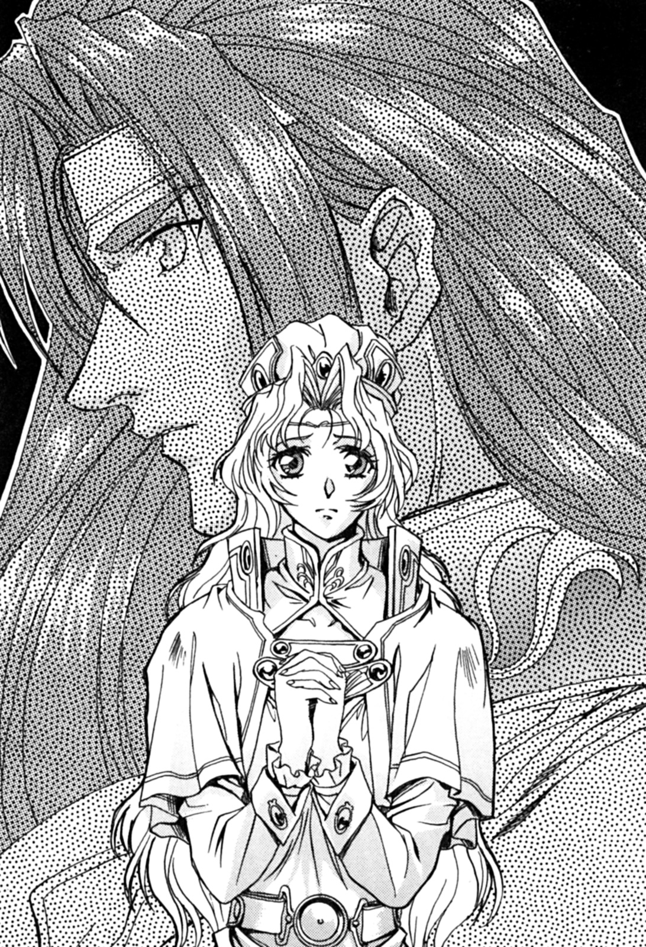
Jenny said, she was giving her advice, but she was also interested in this magician.
Then, she asked the magicians name.
“……His name is Louie, son of Headmaster Carwes.”
Melissa said in a low voice.
“Louie?”
As soon as Jenny heard that name, a shock went through her entire body, she hadn’t felt that kind of feeling in years.
“Do you know him?”
“Ah, of course I know him. I was good friends with Carwes for thirty years……”
Jenny answered.
However, this wasn’t the only reason she was surprised.
(Is this fate?)
Jenny said inside herself.
(No, this must be a coincidence……)
However, it doesn’t seem destiny had any part in this, for it was the decision that she made thirty years ago that was to blame.
Jenny looked into Melissa’s eyes, with a hint of envy.
“Thank you Jenny, I’m already feeling better.”
Melissa certainly didn’t know Jenny’s true feelings, she slowly stood up and smiled.
“You cannot escape him, you must face your hero.”
Jenny said these words, intending to encourage Melissa.
Then, she thought about this moment, she knew that Melissa shouldn’t run away from this opportunity to gain life experiences.
Looking at Melissa walk away from the chapel, Jenny had a feeling, a feeling that a passionate era was coming.

4 – Thieves Guild

“Five thousand silver coins, that’s my lowest price.”
The information broker said, with an obvious grin on his face.
“No one has found the remains yet. Can you imagine, that place is probably filled with countless treasures.”
“Yes, I can imagine——there being no treasure!”
Merrill said bluntly to the information broker.
The Thieves Guild operated in an underground bar, they were currently in a small room.
Merrill was trying to negotiate the price of the information.
“We will only give you money once we have found the treasure, deal?”
Merrill tried a different approach, though they risked losing the deal entirely.
“You know what? I don’t like gambling.”
The broker said bluntly.
(Damn it! He won’t take a risk!)
Merrill said inside herself.
“Just pay the price that I’ve given you. I’ve already discounted it from the price of seven thousand silver coins. Or——”
An insidious grin appeared on the brokers face.
“If you have no money, you can spend the night with me……”
Upon hearing this, Merrill pulled a dagger and immediately put it towards the broker’s neck.
“I want you to see the sun come up tomorrow, you’ll shut up.”
Although the broker was still smiling, Merrill had nothing but murderous intent on her mind.
Since she received combat training in the thieves’ guild, Merrill knows how to handle all types of opponents, her skill and speed with a knife is unheard of. However, in terms of overall experience, she is still not mature enough, if she was to fight anyone who wasn’t in the thieves guild, she’d probably lose.
“That’s a great sense of humour you’ve got……”
The broker said, his face now tense.
“I’m not joking.”
Merrill’s face now became calm, as she put the blade back into her sheath. She was wearing loose clothing, so her chest was a little exposed.
“You seem more like a Cat, than a rabbit, if I say so myself.”
The broker said in a teasing tone.
“Well, now I’m a bear.”
The broker sighed.
Rabbits and cats are jargon used in the thieves guild. Cat refers to thief, and bear refers to a an adventurer.
There are also more terms used in the thieves guild, for example dog refers to someone being a spy for the royal family, fox is someone who is a fraudulent liar, and brokers are generally called “rat”. Rabbit refers to someone who works in a brothel.
“This is nonsense. Cat’s like you are really rare.”
When Merrill was a baby, she was thrown away by her parents, a homeless couple found her lying on the street and took her in, but they sold her to the thieves guild when she reached five years old.
From the moment she arrived she was forced to pay for her own freedom. If she had chosen to become a rabbit, there would be no way out of the endless cycle of prostitution. Therefore, after a careful assessment, she decided to become a cat and take the thieves guild training. They were really impressed with her skills, and in just one year she earned her freedom.
To everyone in the thieves guild, she will always be a cat.
“I’m not doing it for money……”
Merrill murmured.
One year ago, Merrill found herself needing money, she was almost penniless. So she joined the ranks of adventures, seeking money and treasure.
“Alright, I’ll cut you a sweeter deal, how does four thousand sound?”
“Broker……”
Merrill looked up, her big round eyes staring right at him.
“Are you thick in the head!?”
He seemed very angry, he stretched out his hand.
Merrill took out a few gems and carefully put them in his hand.
“Although they aren’t top quality, these stones should be enough.”
Since she was running low on money, she used precious stones for payment instead of money.
“Wait until the end of the bidding, then I’ll give you the information.”
“I know.”
Merrill then turned to leave.
She went to the door, and was about to open the small handle of the door, but she suddenly thought of something, she then turned and faced the broker.
“What’s wrong?”
“I forgot something.”
Merrill smiled at the broker, then winked.
“Oh, thank you.”
“Little Merrill……”
All of a sudden, he started laughing, he then raised his right hand in response to Merrill’s thanks.
“If you were like that more often, then maybe the price would be lower.”
“I don’t want to bargain that way!”
Merrill shouted, then she kicked the door open and left the room.

***

“So, did the negotiations go smoothly?”
The following morning, the three female adventures including Louie came to the cottage. They asked this question because they were preparing to leave.
“I you already know, why ask?”
Jenny said coldly.
The red-haired warrior woman was holding her right eye, the bruising was fairly obvious, and there was also signs of swelling. That was from yesterday, the result from Louie’s punch.
She looked at Louie, seeing the scar she left him yesterday, it looked very painful.
Even so, he was still excited.
“We’re finally going on an adventure……”
Louie had mixed feelings about this whole ordeal.
He really wanted to cry out in pain, he thought about doing it, but he didn’t want the girls to think he was a bigger fool than he already was.
“Yeah, don’t bust my leg this time.”
The thief girl looked at Louie with contempt in her eyes.
“We are looking forward to see if you are truly a hero.”
Melissa said, sounding very superficial.
(Well, just you wait and see.)
Louie said inside himself, he then looked down at his waist.
A sword was hanging by his waist, he brought it with him this morning.
He spent a lot of time choosing the right sword, Louie didn’t want just any old sword. Finally, he choose a long-handled straight double-edged sword, it was like this sword was made for him.
It could be said that the sword became his travelling companion, a trustworthy friend that he can always rely on.
After waiting a while, the entire group had all their equipment ready.
“Off we go!”
Genie loudly announced.
The adventure had finally begun.

5 – The First Adventure

“……This is a dangerous area, only adventures dare roam these parts.”
The little thief Merrill said.
Louie was born in the capital of Ohfun, this was the first time he had been outside the city limits. Therefore, it was necessary for the girls to brief him about the area.
At the beginning, the girls were only talking to each other, but after a while, they started to talk to Louie.
Though this proved to be too much for Louie, as Merrill’s high tone and fast talking made his head spin.
To cope with Merrill’s height, Louie had to bend over a little, he carefully listened to every word she said.
“For an adventurer there’s two things that they do, fighting or exploring.”
For those who were good at fighting, they generally guarded caravans or worked for important figures. As for the people who have expertise in exploring, their goal was to explore the ruins of the ancient kingdom, or they find missing persons or missing items.
“What areas are our group proficient in?”
Louie asked, after listening to Merrill.
“Our group is all rounded! As you can see, Genie does the exploring and fighting while I handle matters in town. ”
The thief girl proudly said, sticking out her chest.
“No matter what the task, will you accept it?”
“Only if we are paid well. However, we don’t just don’t accept any job. For example, if the job is life threatening, we won’t take it.”
Merrill said in a serious voice.
“We also want to test our abilities, whether it be wisdom, strength, skills, etc……”
“You’ve said enough.”
Merrill wasn’t finished, Genie interrupted her.
Perhaps she thought that Merrill was telling Louie too much.
“Genie, since you weren’t willing to teaching him the basics of adventuring that task fell onto me. What would happen if we wandered into wilderness and he wasn’t prepared, it would be a disaster!”
“We shouldn’t have let a rookie join in the first place, it’s too much trouble. We should have just picked a female magician instead.”
“That wouldn’t work. He was a hero chosen by God and I must follow him, even if it’s against my will.”
When Genie complained, Melissa refuted her argument.
(Is that so?)
Louie said inside himself.
Louie was listening to all three of them, he found out that all three of them were criticizing him directly. One thought that he was stupid for not knowing the outside world was dangerous, one thought that he was a rookie, and the other one only tolerated his existence because God told her so. These three female adventurers really didn’t want anything to do with Louie.
(I just have to be patient.)
Louie said inside himself.
It seemed they were now approaching their chosen destination.
In the ruins of the ancient kingdom, there are a lot of dangerous traps and monsters. To overcome these dangers, one must have determination and strength.
Louie suddenly felt excited.
However, at that time, something caught his foot.
Louie fell on his back, his hips and back violently hitting the ground.
“You are so clumsy, I doubt you’ll even be able to protect yourself.”
The thief girl said.
Louie couldn’t hold back his anger, he slowly stood up.

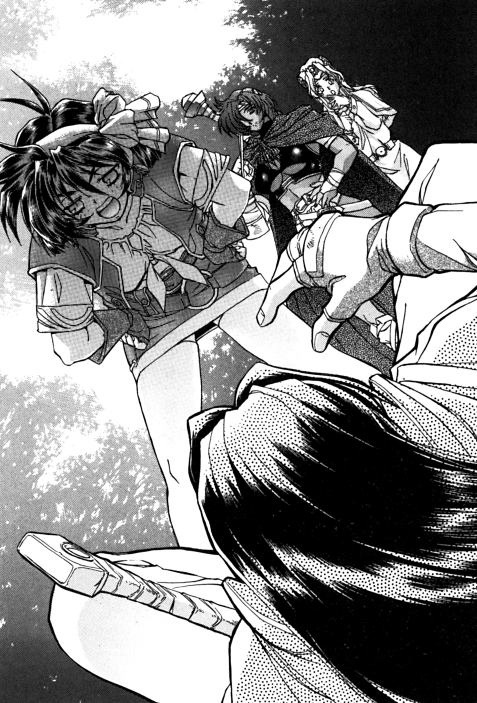

His luggage was still fastened around his waist, it looked fine. He was mostly carrying bags to put all the treasure in, he also carried some herbs for magic.
Although Louie said they wouldn’t need them, the female magician Ila insisted that they would come in handy, she more or less forced him to take it with him.
She also didn’t forget to remind him about their deal.
Ila wanted Louie to bring back any valuable artefacts from the ruins for her research.
Louie patted the dust off him, and then moved forward.
The three women had left Louie behind, he could see them in the distance. They weren’t’ arguing anymore, they appeared to be laughing.
(Looks like they’re happy without me.)
Louie decided to keep his distance between him and the three women.
Even if there was no one for him to talk to, he was still interested in getting to the ruin, because that’s when he could have some fun.
(The ruin is right around the corner.)
Louie said inside himself, he now couldn’t’ see the three women in front of him.

6 – Coolie

Finally they came to the ruins of the ancient kingdom, it’s been five days since they left Ohfun.
The Yasugarun mountain range could be seen in the distance, a town could also been seen half way between them and the mountains.
Although most of the ruins of the ancient kingdom are covered in weeds, this wasn’t the case for this ruin, Louie could tell people had been here before.
“I wonder what treasure is inside.”
Louie said out loud.
“Don’t get your hopes up.”
Merrill said rudely.
Out of the three women, the thief girl was the worst, mostly because her personality and mannerism was fairly straightforward, though Louie didn’t care about the tone of her voice.
Even so, Louie knew they still thought of him as an outsider.
“This ruin is very close to that town, so there’s a high possibility that we won’t find anything.”
“I know.”
This was common sense, Louie already knew that.
There ruin wasn’t very big, that status of the owner must have been very low. The ruins which Carwes and the King found were much bigger than this, when compared to the ruins they found, this was nothing.
“There must have been some part which hasn’t been explored.”
“Here we go.”
The thief girl proudly smiled, as she looked through the ruins.
“Even though this ruin is nearby a town, there should be something that people have overlooked and not explored.”
Because this ruin was nearby a town, other adventures have most likely explored and taken what treasure they found. However, sometimes ruins outside of big cities and town remain largely ignored because of the dangers within.
“In ancient ruins, there is generally a door that leads underground.”
After Merrill said that, she jumped onto a pile of rubble. She then knelt down on one foot, and started examining the rubble.
“It’s below!”
Looking through the rubble, Merrill could see some type of mark.
“If we can get this rubble out of the way, we can gain access to the underground area. It was covered by all of these stones, that’s why no one has found it yet.”
After Merrill said that, she started to come down from the pile of rubble. Because of her very short skirt, she had to move carefully so nobody saw her underpants!
“Is a door really hidden beneath this rubble?”
They didn’t know how many adventurers had come across this ruin, but the fact that no one had found this door was cause for concern.
“I found part of the door that wasn’t under much rubble.”
After inspecting the door, she heard an echo after she knocked on the door, she speculated that there could be a staircase underneath the door.
“So this is……”
After listening to the words of Merrill, Louie felt enlightened.
Previously he has heard from other people mention that thieves have the ability to look at something in a way that normal people can’t, he didn’t expect to see it first-hand.
“I’m amazed you found that door and knew what was underneath.”
“A survey of this ruin is necessary. However, that’s not the reason we came here.”
“We came here for another reason?”
Louie curiously asked the thief girl.
“Yeah, we’re also here to fight some monsters. We’ve heard of a group of monsters that feed on the local villagers livestock, this ruin might be their hideout.”
It was most likely evil goblins, usually they didn’t go near humans and hid deep in the forests or mountains. However, they reproduce really fast, and because of this they need to find new place to live, this unfortunately leads them to live close to humans, much to the anger of the local population.
This village is also located on the border, so this type of trouble isn’t unusual to them. However, that doesn’t mean they won’t try and do something about it, recently they’ve been hiring adventurers to help them with their problems.
Adventurers are the best choice when it comes to these matters.
“It seems other adventurers came here before, one of them was a thief and marked this door, but he or she didn’t tell their employer.”
That also means that the intelligence broker could know.
“Does that mean this is a scam?”
“Yes, most likely.”
Merrill said, Louie accepted this.
Although Merrill looked cute, but she was also a thief, she could be fooling Louie and he probably wouldn’t notice.
“Let’s get on with this!”
Genie shouted out aloud, she was getting bored.
“In short, someone’s marked a door and hasn’t come back. Moving on……”
Melissa also felt the same way as Genie.
(No one has opened this door……)
Louie constantly repeated those words that the female warrior said in his head.
Those words proved attractive for him. If no one has opened the door, then that meant something valuable could be inside, and he thought it was worth the risk.
“It would be great if we could get this door open.”
“We just need to understand something……”
Melissa revealed a noble smile.
“We need to remove all this rubble, would you be willing to remove all this rubble?”
While the three women looked fairly able to move rocks, Louie was fairly confident that he could move them all himself.
“Sure, I’ll move it all.”
Louie threw down all his luggage, including his magical wand.
Then he started moving all the rubble, one small pile at a time.
“Come on, let’s have some food!”
Melissa was in a particularly good mood.
Louie didn’t say anything, he just continued moving the rubble.
“Well, let’s eat!”
The red haired female warrior said to the other two women, as they sat on some nearby rocks. She took off the bag around her back, and started removing all kinds of things, such as bread, fruit, and some easy to store meat.
Merrill cheered loudly, as she seized a piece of meat. She then started to cut the meat into small pieces with her small dagger, then she put it into her mouth.
“Be careful not to choke.”
Genie said dismissively.
“Stop acting like I’m a child.”
Merrill’s mouth was stuffed with food, while chewing she shouted angrily to Genie.
“I only eat meat, it’s good for the body!”
Melissa took some fruit, she took a dagger and carefully peeled the skin off, she then cut it into several pieces and put it onto a small wooden plate.
Genie held out her hand, and all three of them put a piece in their mouths.
Then Melissa started to peel the skin off another piece of fruit.
“That magical companion we have is pretty good.”
Merrill said in a mocking tone, as she looked over at Louie moving the rubble.
Then Louie suddenly remember the incantation for the lightweight spell, if he used that then the heavy stones could be moved easily.
“Do you think he’ll be able to move all those rocks?”
Halfway through eating her meal, Genie stopped.
“He just wanted to show how much of a man he is! When he gets tired, he’ll stop.”
Melissa had nothing to say, she continued to peel.
“I just hope he’s not as stupid as he looks.”
Merrill said, as she continued to eat.
From time to time she would take a drink from a leather pouch, just like an animal who drinks from a lake, her face was covered in water. If there was a nearby river or lake, they could easily get more drinkable water, however, they don’t have time to dilly dally.
Since the information broker told them the ruins were small, so the underground section must be very small. So it wouldn’t take too much time to explore the place, this is why they didn’t take too much food with them,
(So this is what I get for four thousand silver coins? They’re better be some treasure.)
Merrill said inside herself, as she continued to chew meat.
Then she smiled, for all she knew this ruin had lots of treasure hidden away somewhere. However, she still didn’t know if they would actually find anything worthwhile.
Secretly, Merrill was watching the magicians every move.
Even though the summer heat was relentless, Louie kept moving the rubble off the door. With his armour and most of his clothes removed, the physique of his upper body was very attractive. His muscles were covered in sweat, he looked like a natural born fighter.
“I wonder if he’ll move them all.”
“He’s already helped out a lot, but if he continues like that he’ll become tired. Then we’ll have no on to move those rocks.”
Melissa didn’t eat that much because her appetite isn’t that big.
However, she was still making food. She buttered some bread and sprinkled vanilla powder on it, then she called for Louie to join them. But he wasn’t willing to stop lifting the rubble. Melissa wasn’t going to accept this fact.
Even though she didn’t like him, she still thought he needed something to eat. She had seen bare chested men before, but the sight of Louie’s physique made her nervous. She knew that she mustn’t be fooled by a man’s body, however, she thought that he was simply showing how superior men are to women.
Men are naturally better than women, so a woman can only play the role of being protected……
The spirit of chivalry, Melissa hated this.
Because she couldn’t stand that sort of thing, she gave up her aristocratic name.
“Women are only beautiful decorations.”
Suddenly she heard the words of her fiancé.
When Melissa came to Ohfun to join the Temple of Mylee, she met High Priest Jenny, although she was a woman, she had a very high position in the church. From that point onward, she was told that one day she would serve a hero chosen by her God Mylee.
(Even so……)
Melissa sighed deeply.
When the God of War gave her a revelation, she was told that the magician Louie was her chosen hero.
However, this man didn’t have the qualities a hero should have.
(This trial, may be too much for me……)
Melissa put her head down and repented.
At that moment, Genie couldn’t take it anymore, she stood up.
“I’ll help you move that big rock……”
Genie said to Louie, while she pointed at a big rock on top of the door.
Louie had already removed more than half of the rubble, but there was some pretty big rocks.
“Let me finish, I’m almost done!”
Louie replied, he didn’t intend on stopping.
His body sweat had long dried into his skin due to the intense heat of the sun, and although he was out of breath, his face didn’t look tired at all.
“Without the use of the lightweight spell, it’ll be impossible for a normal person to move it……”
“Then let me help you with it.
Genie said bluntly, then she began to move towards the rock.
“You should leave this kind of heavy handed work to a man who knows what he’s doing.”
Louie said.
However, Genie didn’t answer him, she just fiercely started at him. Louie thought that he hurt her pride with that comment.
(This is it!)
Louie smiled.
“Alright then, we’ll both move it together. You grab that side and I’ll grab this side.”
Louie said. However, Genie never said a word while they moved the rock, she just stared at him.
Merrill and Melissa came over to watch them move the rock, though they didn’t help.
Genie watched Louie struggle to move the rock, she knew that he needed help all along.
“Those two people, they seem so alike!”
Merrill said to Melissa, with her hands on her cheeks.
“Do you mean their physique?”
Melissa asked.
“I guess so, but more like they’re personality.”
“Really?”
Melissa said with a puzzled look on her face.
Because she didn’t know what type of man Louie was, she really didn’t know how to answer. However, Merrill made this very clear, her observations were rarely wrong.
Suddenly Melissa hugged Merrill from behind.
“Melissa, what’s wrong?”
She knew that Merrill didn’t grow up with a lavish lifestyle like she did, and that she saw everyone in a different light because of this.
(He’s not a bad person……)
While Melissa kept hugging her, Merrill gazed towards Louie.
With her big round eyes, she saw a big sword.
She knew Louie was in trouble, and this time she didn’t want to hesitate.

7 – Goblins

All the stones on top of the door had been removed.
Merrill then came onto the scene, she was looking for the correct position of the door.
She knocked on the door, then she started to pour water over the dust covered door, the flow of the water would determine the cracks of the door.
“I got it! I got it!”
Merrill shouted repeatedly, with her dagger in hand she drew a big square.
“Good girl!”
Genie said, as she touched Merrill’s head.
“Don’t treat me as a child!”
Merrill said angrily, as she pushed Genie’s hand away.
“Do you know how to open it?”
Melissa asked.
“I’ll need to examine it a little more. However, we could get our magician to use an incantation to open the door!”
Little Merrill watched proudly.
(They need a man to do everything.)
Louie said inside himself. He then prepared to chant the incantation, he was going to use the “unlock” spell.
“Alright, it’s magic time!”
Louie said.
As he began to chant the incantation, he could feel himself get slightly weaker, though this is only natural as using magic does take some of your strength away.
“Since this ruin is small, there shouldn’t be many hidden dangers.”
Merrill said.
(I still hope there’s some fun to be had.)
Louie said inside himself, just as he finished the “unlock” spell.
At that moment, a large grinding sound could be heard, the door was opening.
After the huge door fully opened, everybody could see a staircase leading underground.
“Alright, let’s go in!”
Genie said as she lit a torch, she was the first to descend the stairs. Merrill and Mellissa followed after her, Louie was guarding the rear.
(Oh yeah, I forgot I borrowed this from Ila……)
Louie reached into his pocket, and pulled out a magical treasure.
It was the “four” magical glasses. Before leaving to go on the adventure, he borrowed several magical treasures from Ila.
——“This is a very important item to me, you better bring it back!”
Louie remembered what Ila said to him before he left.
Because this was very important to her, she told him more than once. She really didn’t want it getting lost or broke, she even asked if he wanted her to accompany him.
This magical treasure is very dangerous, logically speaking, it should be sealed away with all the other forbidden treasures. Mainly because it has the ability to kill someone with the evil eye, a function within the glasses.
However, this wasn’t the reason why Louie wanted it. He needed it to see in the dark, it would come in useful when searching dungeons or seeing in the night.
When Louie put on the glasses, he began to chant the incantation for night vision. Then, his vision became all red.
He could clearly see everything as clear as day, with this he could move freely in the dark.
While feeling the effect of the magical glasses, the three girls and Louie continued down the stairs.
“Yuck, there’s a bad smell……”
Genie said, desperately trying to find its origin.
“It could be the smell of dust, sometimes books have this smell.”
Louie said aloud.
“Or this foul odour could be coming from a foul beast……”
“Maybe it’s a zombie. The ancient kingdom manipulated undead monsters.”
After listening to their words, Merrill said something.
“Could a necromancer really be in here?”
A necromancer is a magician who manipulates and creates undead monsters. Among the undead monsters, there are zombies, vampires, headless horsemen, and so on.
This made Louie become excited.
“Melissa, you change positions with Merrill. Merrill, keep an eye on our rear, and remember to protect the stupid magician.”
“Ma'am” Yes, Ma'am!”
Whenever Genie gives instructions, Merrill always loudly agrees.
“If our opponent is an undead monster, the magician is going to be more useful than any of us.”
Merrill said.
They finally came to the bottom of the stairs, in front of them was a big room and two doors.
“Two doors? Which one do we take?”
Genie said, then she put her hands on one of the doors. She tried pushing it open, but it wouldn’t open.
“Maybe they’re locked.”
Merrill said, then she ran to Genie’s side.
“Aren’t you supposed to be guarding the rear?”
Louie said.
“I know. Just give me a minute over here.”
“No matter. Monster or not, I’ll defeat whatever comes my way.”
Louie pulled out a sword, he bought it the day before he departed from Ohfun.
He turned around, and took a good look at the staircase.
Then, he suddenly discovered something.
(Is that……)
There was a space at both sides of the stairs, it looked like it was doors.
Genie didn’t notice this, since her touch didn’t light up that area. However, Louie was using the magic night vision glasses, with this he sees in the dark.
Louie walked towards the door. Then, he gently put his hand on it, it easily opened.
He heard strange sounds coming from within.
It was a big open room, there was dozens of small creatures wriggling towards him.
Just then, he smelled that terrible stench again.
(This was the odour Genie was talking about!)
At that moment, Louie could only think of calling out the monsters name.
“Goblins!”
Louie cried, Genie and Merrill turned around to see the oncoming danger.
“You idiot! What did you do?”
Genie’s voice thundered behind him.
“Retreat!”
Melissa shouted.
“What the hell were these things doing here!?”
Louie grabbed his magical wand, and took a defensive posture.
He then walked slowly back to the bottom of the stairs, and planned to take on the goblins one at a time.
The goblins were holding small daggers, they were more agile than they expected, one of them swung it’s dagger at Louie.
It hit him in the thigh, although it was painful, fortunately the stab wound wasn’t deep.
“You bastard!”
Louie shouted at the goblins, as he charged them with his sword and magical wand.

8 – A strong magician

“You are so stupid!”
Genie looked very unhappy.
Goblins were lying unconscious across the entire room, most of them were knocked out by Louie.
He used his magical wand as a weapon, he beat the monsters with it until it broke. He then charged them with his bare hands, only three goblins were killed in total.
“Man, that was quite the fight.”
Louie immersed himself in the excitement of victory.
His body has a couple of scratches, but his injuries were only minor.
“What an unacceptable way of fighting……”
Melissa loudly protested.
(What is she talking about?)
She was obviously upset about the way he fought, it was totally unbecoming of a hero.
“Anyway, why don’t we explore the rest of the ruins?”
“I doesn’t matter anymore.”
Merrill said faintly.
“The goblins probably got into the ruin through a hole, which means they made this place their nest. I don’t think we’ll find any treasure here.”
“Let’s get out of here. We shouldn’t linger in a goblins nest.”
Melissa proposed, everyone was in agreement.
The entire room was stained with the blood and smell of goblins, the air in the room was intolerable.
The four of them headed towards the stairs.
Walking back up the stairs, the trio never said anything, they just kept sighing.
Louie looked at the three depressed women. Even though they didn’t find any treasure, he didn’t know why they didn’t find the fight stimulating.
“Didn’t you guys find this place interesting?”
Louie asked when they exited the underground ruin.
Of course, the wind didn’t give him any answer, it just blew on by. It seemed summer was coming to an end.
(This summer was pretty hot.)
Louie said inside himself.

Chapter 3 – Broken Wand

1 – Ancient Wood

“You broke your wand?”
Louie’s door was suddenly opened, and the female magician called Ila rushed in.
Louie was doing abdominal exercises, his entire upper body was naked.
(This woman, she just walks in casually.)
Though, Louie never does lock his door.
Seeing the glasses lying on his bed, Ila relaxed herself. Meanwhile, Louie got up and put on a shirt.
“You have such a great physique, why do you still exercise?”
“Oh, I’m not exercising.”
It seemed she didn’t understand that he was simply keeping in shape.
“Anyway, I’m not interested in muscular men……”
Ila said to herself. She then closed the door behind her, and walked straight over to Louie.
“What’s this I hear about your wand?”
“Oh, I broke it.”
Louie had a helpless look on his face.
He used the wand when he fought the goblins, he bashed the goblins in the head with it, thus breaking it two.
“It broke into two halves!”
After listening to Louie giving his explanation, Ila didn’t want to believe it.
“Your wand is broken, just like how I broke my hand.”
Ila was dressed in the usual magician garb, except she had her sleeves rolled up, she was pointing to her wrist.
Her skin was white, it was really quite fine.
“A wand is very important!”
A magical wand is proof that you belong to the Magician's Guild, it could also be said that it’s the spirit of a magician. Without a wand, you might as well resign from being a magician.
“What will you do?”
“I’ll get a new wand made.”
“Do you want me to get Mr. Carwes?”
“No way, my grandfather is also my mentor.”
“You need a 500 year old ancient wood to make a new wand, and three days or more for the magic ritual!”
“Since my grandfather is Headmaster Carwes, he can help me get that old wood.”
“500 year old wood just doesn’t grow anywhere!”
As precious as ancient wood may be, you wouldn’t find it by just looking in the outskirts of the Kings forest.
“The only place where you can find some is Tartious Forest, and that place is filled with all kind of dangerous monsters.”
“However, the forest is so big that I probably won’t encounter any.”
“Tell that to all the people who lose their lives there every year.”
Ila’s tone was dire.
“I’m not afraid. Monsters or demons, I’ll defeat them all, just like how I defeated those goblins.”
“Yes, but you broke your wand in the process, didn’t you?”
Louie was left speechless.
“T-This time I won’t be so careless. I’ll be using a sword to fight.”
“And you can’t use magic since you don’t have a wand. Anyway, will those adventure companions you met go with you?”
“No!”
Louie said defiantly.
The three women didn’t want anything to do with him anymore. Since Louie broke his wand, they took him for a walking joke. On the way back from the ruins, the trio constantly called him a pig.
“Well, are you going alone then?”
Ila’s eye’s blinked wildly.
“Yes.”
“Ah, I see……”
Ila seemed to be thinking, then she went silent for a moment.
Then——
“You……can accompany me tonight……”
She said to Louie.
“What’s got into you all of a sudden?”
“I might never see you again, so I’d like to create some fond memories.”
Silence filled the room for a moment.
“That’s just like you.”
Louie said, while laughing.
“I’m just kidding! I just want to accompany you, so I can hear about your adventures.”
After that, Ila left Louie’s room, regardless whether they reached a decision or not.
Louie stared blankly at the wall, he really enjoyed having fun with women, but now he was really tired.
“If someone is envious of my life, then I’d happily switch with him.” Louie said inside himself.

2 - Companions

“……He even broke his wand.”
Said Melissa the acolyte, her eyes were filled with tears, High Priestess Jenny looked at her with remorse.
“He used an important symbol of a magician to beat goblins in the head, and when his wand broke…he used his fists……”
Then, Melissa repeated “This is against my will” five times.
(She can’t be serious……)
Once known as the “sword princess”, the High Priestess listened to Jenny, although her face was calm, she was actually very angry.
Melissa didn’t say it, but she wanted a different hero from the God of War. From Jenny’s point of view, Louie was her friend’s son, she known him ever since he was little.
“He is always shirtless in front of women, that kind of behaviour is barbarous. He doesn’t discuss anything with us, clearly he is a man that thinks for himself, he could have caused serious harm to his companions. If God doesn’t give me some inspiration soon, I’m afraid my faith in God may waver.”
Jenny could understand how Melissa was feeling, but she didn’t want her quitting the faith over this.
(Louie shirtless in front of women…)
When the King founded the country of Ohfun, one thing was always certain, men would exercise topless to try and attract members of the opposite sex.
A strong burly figure, of course women admire this, but most women still prefer a gentler man. However, most men don’t understand this.
(When it comes to a beautiful physique, Louie clearly excels in that area.)
Jenny thought.
When Jenny was young, she always held the firm belief that a strong body was needed for fighting.
As a woman, she always maintained a well-proportioned body, using a dancing sword technique with an elegant posture, she gained the name “sword princess” through defeating opponents.
“How can you say that……?”
Jenny said to Melissa.
To qualify as a member of the clergy, you must get an evaluation from Jenny. Whether you are strong or weak, you will learn fighting skills so you can defend yourself.
In Melissa’s case, she always helped out in less physical demanding tasks. For example, she would always help out with sermons for the younger believers.
In the future, she would most likely be teaching large groups of people, but now she was too young, and she needed to learn to control her temper.
Melissa always fantasied about getting a hero, one that was perfect in every way, someone that would be worshipped like an idol. Unfortunately, such people do not exist in this world, hero’s come in all shapes and forms.
“What should I do?”
Melissa asked Jenny, with a puzzled look on her face.
“I am willing to listen to the High Priest’s instructions.”
“Rather than listen to my opinion, you should follow the mission God has given you.”
Jenny then spoke in a commanding voice.
“God has given you a mission, you were told to follow your magician hero Louie. Even though he doesn’t have the qualities of a hero yet, you should embrace your duty, not run away from it.”
After listening to Jenny, Melissa couldn’t help but feel disgusted.
Jenny knew that Melissa could endure, even if Louie didn’t have the qualities of a hero.
(Louie was always such a gentle child.)
Jenny thought, thinking about the times she spent with Louie when he was a child.
Seeing that Melissa was trembling in front of her, she thought of some encouraging words.
“You should reach out to him, try to understand more about him from his daily life, maybe then you’ll find out if he is the hero you are meant to serve.”
“……I will.”
Even though she promised her, she couldn’t help but show that she was unhappy.
Then, she unsteadily stood up, and left the chapel.

***

“He broke his wand."
Merrill was recounting their adventure to the information broker.
“I can’t believe a magician even did that.”
“Why not? He’s an idiot.”
Merrill laughed. She then took two steps towards Shamsul.
“What do you want?”
He continued to watch her, a smile appeared on her face.
“Thanks to your lousy information, we almost ended up dead!”
The smile on her face disappeared in an instant, she was furious, but so was the broker.
“Hey! You know full well how dangerous it can be going on an adventure!”
The broker found Merrill’s expression offensive, he could only think of defending himself.
“Everyone knows it dangerous, but don’t you feel uneasy knowing this?”
Merrill’s face relaxed, she was calm once again.
“I would certainly feel uneasy.”
“Well, now that you feel that way, don’t you think you should return our money?”
He couldn’t afford to lose money, or even give it back for that matter. Unfortunately for Merrill, she was flat broke and needed the money.
“No refunds.”
After Shamsul finished, he felt a pair of small hands touching his.
"But......"
"But what?"
Little Merrill’s eye’s sparkled, she moved her face closer to Shamsul’s.
“That may apply to other people, but I am an only child. Don’t you want to help me?”
“Of course, you’re my friend after all.”
Merrill waited for an answer from the broker.
“Then……”
He started to smile.
“What’s that look supposed to mean?”
Merrill leaned back from the brokers face.
Shamsul smiled like a wild dog.
“Hey, smile for me again……”
“You’ve got to be kidding.”
Merrill cried, she then followed that with a roundhouse kick to Shamsul’s face, his body flew through the air, impacting the floor of the bar.
“Don’t be so impulsive, I was only joking.”
Shamsul staggered as he got up, as he looked at Merrill.
“You try something like that when I was being sincere, that was a bad joke.”
Merrill confidently said.
“But thanks to your joke, I’m feeling a little better.”
“That was rude……”
Shamsul patted the dust off his clothes, Merrill then sat down on a seat at the counter.
“This time you’ve really done it.”
“Well, you can’t please everyone.”
Shamsul put his elbows on the counter.
“What was your friends name again, Louie, wasn’t it?”
“What are you talking about, did you forget or something? You were the one I bought the information about him from.”
“Ah, yes, he’s the adopted son of Headmaster Carwes at the Magician’s Guild. That guy really doesn’t behave himself, he’s got into fights with our people several times.”
“Don’t tell me you want to introduce him to the thieves’ guild?”
“Maybe, though he does have a great physique, he could become a great man…maybe even a hero one day.”
“The guy is still useless.”
Looking at his performance in their last adventure, little Merrill didn’t think Louie had what it takes to join the thieves guild.
“Anyway, I’ve got some other information about him. In fact, I forgot to tell you last time. ”
“I’m not paying.”
Merrill made this very clear, even if she wanted to buy the information, she wouldn’t be able to since she doesn’t have any money.
“Alright, I’ll give you this one for free, as well as a little gift.”
“Good, what’s the information?”
“Well……it’s related to his background. No one knows who his biological parents are.”
“Okay.”
The broker peaked the interested of Merrill.
The thieves’ guild has extensive information on everybody, they know everybody’s biological parents, except for Louie’s.
“And……”
Merrill smiled, and reached her hand out to Shamsul.
“I want to know more about that guy, Headmaster Carwes. He may be a great man, but I’m sure you’d be able to learn more about him if you got closer to him.”
“Come on.”
Shamsul said, as he put a jewel into Merrill’s hands.
(Oh, this must be worth at least 200(0) silver coins……)
As soon as Merrill had the stone in her hand, she started thinking about how much it was worth.
(Anyhow, since Louie is our travelling companion, it should be easy to glean some information from him.)
Merrill had got a task that was too simple, she liked it that way. She then put the jewel into her bag, said goodbye to Shamsul and left the underground bar.

***

“He actually broke his wand.”
After Genie finished speaking, a mocking smile was on her face.
Genie was talking to one of her former colleges from the mercenary guild. His name is Barb, he’s about thirty years old, but you wouldn’t know that by just looking at him.
“That magician is unbelievable.”
Barb said, as he drank from a glass.
“By the way, I didn’t expect you’d become a knight of the Kingdom of Ohfun?”
Barb was previously a mercenary, strictly speaking, his type of character isn’t’ generally allowed to become a knight.
Genie didn’t think he’d become a knight either.
“The Kingdom hasn’t been around that long, they had a shortage for talent. When I was in my third year as a mercenary, I did some fencing and found success.”
“Yeah, I understand.”
If Ohfun was a normal country, knights would be from the royals of the country.
However, since Ohfun was created recently, they had to choose their talent from people who might not have been eligible in another country.
“With your abilities, you’d make……”
“Women can’t become knights.”
Genie said coldly.
In the past, someone had said something similar to her. The faces of a group of men emerged in her mind, men who were of nobility, they tried everything in their power to stop her.
“Let me be very clear. I don’t have any interest in serving the royals.”
“Then what do you want to do?”
“If you’ve been listening, I’m currently and adventurer. I think I’ll continue doing that.”
“That is a possibility, but you’ve got to think about your future.”
“I was young once, but it’s too early to be worrying about what I’ll be doing when I’m old.”
“You mean you won’t become a mercenary again, not even for the Kingdom of Ohfun……?”
Currently there is no war, so any tasks a mercenary gets would be easy.
“I don’t have the motivation to fight for the kingdom, I’d rather fight monsters, mostly because it’s more interesting.”
Genie shrugged.
“Is that so?”
Barb looked disappointed, he then stood up.
“I have to go back to the city, what about you?”
“I think I’ll wait here for my companions.”
“My house is on Mayor Street, if there’s anything you’d like to discuss, you know where to find me. Hopefully I’ll be seeing more of you…anyway, I wish you the best of luck.”
Genie saw through his words, she though they had a hidden meaning.
“Why? Is there something you want to tell me?”
Genie was being frank.
“Yes, you’re always welcome.”
“However, you’re a knight now, and you don’t even have a wife, I feel sorry for you.”
In an instant, Barb’s face became very stiff, then he smiled.
“Well, you could always take that spot.”
Barb laughed, then he said his goodbyes and left the bar.

3 – Awkward encounter

“Why are you here……”
Louie and Ila appeared in the bar wearing their casual clothes, however, when he stood in front of the three women, Louie couldn’t believe his eyes.
All of them had the same look on their face, they didn’t welcome this chance encounter.
“You! You shouldn’t be here!”
Genie said with displeasure.
Indeed, Louie visits this place regularly, the alley of Joy Street. But today he took Ila with him, it wasn’t very convenient for her to be in this place.
“Are these your companions?”
Ila said to Louie.
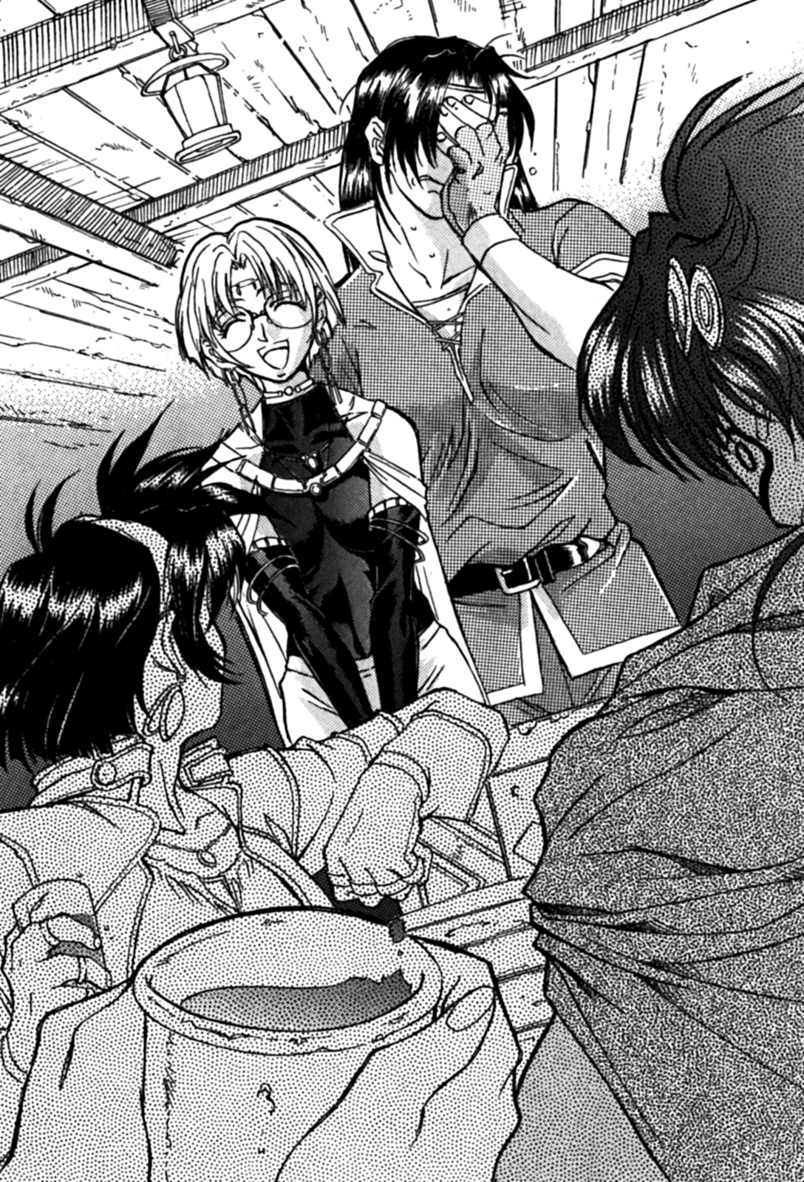

Louie nodded his head, he looked very troubled.
“Yeah, but they don’t seem to want me as their partner anymore.”
Ila listened to Louie’s words, she sighed, then looked at the three girls.
“Each of them is a great beauty. They are like a harem from the Kingdom of Sand and Dust.”
A harem from the Kingdom of Sand and Dust refers an elite selection of women from around the continent, they are generally used as the Kings personal concubines.
Louie wanted to supress the screaming he held within himself, they may seem like a harem, but he thought that they were torturous demons.
If Louie said what he really wanted to say, the bar would most likely be turned into a bloodbath.
“We have somewhere to go.”
Louie whispered in Ila’s ear.
“Why? This is nothing more than a chance encounter, we shouldn’t have to go somewhere else.”
Ila quickly replied, then Genie immediately pulled a chair to their table.
“Good evening.”
Ila greeted them politely, then everyone looked at Genie.
(This is hell……)
Louie felt himself fall into a deep sleep.
But since he was in a bar, he realized he could eat and drink.
(This is going to be boring.)
Louie walked unsteadily, he sat down on the seat between Ila and Merrill.
Everyone then began to introduce themselves, meanwhile Louie ordered some food and drink.
The atmosphere of the next forty minutes was very strange.
Louie did his best to avert the gaze of the three women, but Ila on the other hand was looking at all three of the women.
Genie had a look of displeasure on her face, they all continued to silently eat and drink, Melissa looked like she could endure the silence.
The only exception was Merrill, she had been looking for opportunities to speak, but the atmosphere was too glum. Thus, she didn’t utter a word.
“These girls seem very quiet.”
Ila observed them for a long time, with a look of satisfaction on her face, she turned to Louie and said:
Louie didn’t answer, he didn’t’ want to be cursed by Genie for breaking the silence.

Ila started to ask about their adventures.
Genie sat in front of her, she found this a very good topic. However, when she mentioned the battle with the goblins, Louie could feel the blood surging in his body.
“A large group of goblins came at us, and in the midst of the fighting…Louie was using his wand to bash the heads of the goblins, then…”
All the women then spoke in unison.
“He broke his wand——”
“Yes.”
Louie said.
“And now he’s got to get some wood to make another one.”
Ila explained this to the three women, she had a very happy look on her face.
“His destination is the Tartious Forest, the demon forest.”
“The Tartious Forest!”
The three women repeated.
“There’s an old tree that grows somewhere deep in the forest.”
“I doubt he’ll come back alive.”
Genie mercilessly said.
“It’s suicide.”
Merrill said.
“I’m going to have a bigger headache is he does come back alive…...”
Melissa said.
Louie wanted to shout at them.
"So, ah ......"
Ila said, she put her hand into her purse, and started looking for something.
She pulled out a couple of items and put them on the table.
“A flute, wooden sticks, and some cloth?”
Louie said, as he looked at the items on the table.
Everything Ila had were magical treasures, since that was her special field of study.
“This cloth is a “forest fairy cape”. If you wear it and chant the magical incantation, the cape will turn you invisible. However, there’s no way for it to stop smells and sounds from getting out from the cape, so it’s useless against animals.”
Merrill looked the most interested out of the three women, she leaned from her chair and reached for the cape.
Although Merrill and Louie were sitting right beside each other, such a move put her breasts in front of Louie’s face. Upon closer inspection, her body wasn’t fully developed yet, so her body was petite, such an image reminded Louie of the body of a fairy.
“Next is the two sticks, when you are lost in the forest, just insert one end into the ground, and throw the other in the air, then it will show you what direction your companions are in.”
Merrill looked at the sticks, and examined them closely.
“I’m not seeing any marks on these sticks, what if I accidently walked in the opposite direction?”
“Ah, you have a keen sense of observation.”
Ila then explained what would happen.
“That’s where the problem lies, if you get lost there’s a fifty percent chance that you’d head in the right direction……”
“We can’t use that thing.”
Genie said with distain.
“Cant’ you just paint some kind of marker on the sticks?”
“No. I’ve tried, it emits some faint kind of magic if someone tries to tamper with it……”
“That’s enough!”
Louie said. If Ila went on to explain all the magical treasures, then they would probably be here for a while.
Moreover, Louie wanted to prevent any needless quarrels with the three women.
“What is this flute?”
Merrill said, as she picked up the little flute.
“That’s called a Magical Flute.”
“And it does what……?”
“It summons demons.”
Ila smiled.
“It will be more effective in the Tartious forest.”
“Once you summon the demons, will they do whatever you say?”
Melissa asked.
“Nope, if it was that powerful, it would have been locked away with all the other magical treasures.”
“So, when should we use it?”
“I think you could use it when you want to practice martial arts……”
Ila said, as she nodded.
“I love to practice martial arts, like me at them!”
Louie’s mood improved, he was ecstatic now.
“Just make sure you use it when the moment is right.”
After Ila had finished speaking, she moved her hair out of the way so she could drink.
“Regardless of the matter, it could come in useful.”
“I don’t think so.”
Genie said, her face was full of disdain.
When Ila heard that, she turned to Louie and said:
“Is that right? Looks like you’re still needing a stronger partner.”
She deliberately didn’t look at Genie’s eyes, she was trying to provoke her.
Of course, it worked.
(Forgive me.)
Louie wanted to shout from the bottom of his heart.
“My special magic glasses and its last ability could come in useful.”
Although Ila wasn’t wearing those glasses now, nor would she ever use the fourth ability due to it being lethal.
“Hey, Ila, can we change the pace and continue to drink?”
Louie knew that if this continued, a bloodbath would ensue.
“What? Don’t tell me you wanted to go somewhere else alone with me?”
Louie wanted to say something that would derail this provocative conversation, he didn’t want to tangle with Genie on a day like this.
So Louie just smiled, he then forced Ila off her chair.
Ila was very fit, but she started enthusiastically holding Louie’s arm.
Louie pretended that nothing happened, he said his goodbyes then left, taking Ila away from the bar with him.

4 – A change of heart

“Well, that wasn’t fun.”
After Louie had gone, it took a while before Merrill said anything.
“Obviously.”
“It was boring.”
Melissa agreed with them.
“The nerve of that women, how dare she insinuate that we need a stronger companion! If I ever meet her on the road I’ll…”
Merrill moved her fingers across her throat.
“It’s his fault that his wand broke, it’s not our responsibility to fix it.”
“That women is also an idiot, is she trying to cause more problems between us and Louie? I don’t know, but I get a weird feeling from her.”
Then, the three women cursed Ila’s name. And then they cursed Louie’s name, and sighed deeply.
Now the three women’s throats were dry, due to the excessive cursing.
“……Those two, they must think the Tartious forest poses no threat.”
Merrill said to herself, as she finished her drink.
“Even the hunters only go to the edge of the forest, they are afraid of going any deeper. Anyway, I heard a rumour that there’s some ruins of the ancient kingdom deep in the forest, but adventures don’t dare to go there.”
“But then again, he’s just not anymore ordinary person.”
Genie said, then they all began to think about Louie.
“Do you think he’s actually going?”
Merrill murmured.
(No wonder the broker Shamsul payed special attention to him.)
“What if he actually becomes a hero……”
Melissa staggered as she remembered the revelation from her God.
The three women then looked at each other and sighed.
“This is boring.”
They all said at the same time.
“Hey, ladies, looks like your all in a bad mood. Why don’t you drink with us?”
Two drunken men said, as they approached them.
At that moment, Genie decided to vent out her anger on them.
“You’ve got to be kidding!”
Tables were overturned and glasses were sent into the air.
The bar was turned into a battlefield.

***

The next day——
Ila and Louie are walking down South Street.
He stressed to Ila that he didn’t want to walk with her, but she insisted.
Of course, Ila brought her magical treasures with her.
After walking for a while, they discover the three women in front of them.
“Hey!”
Merrill greeted them.
“What brings you here?”
Louie stood still for a moment, it was like he had seen a ghost.
“After you left, we got into a fight at the bar.”
“A fight?”
“Yeah, it was just some riff-raff so we’re okay.”
Although Merrill was a lovely little girl, Louie sensed something was off about her.
“Actually, we were looking for you.”
“For me?”
“Yeah, we want to go with you.”
Louie never thought he’d hear those words.
“If you two go alone, there’s no way you’d make it back alive.”
“If something happened, I wouldn’t be able to fulfil my obligations to my faith.”
Melissa said, looking to distant hills.
“We were also looking for a certain troublesome magician.”
Genie said.
(I never expected such kindness from them.)
Then Louie thought that they would be asking for favours as compensation.
However, he knew this was a good thing. Because he has heard all kinds of stories about the Tartious forest, and none of them good, so more people in his party is better.
But, there was a problem……
Louie looked to Ila, who was wearing the magic glasses.
“Isn’t this great?”
Ila smiled, and began to talk.
“Since they are willing to go with you, you won’t be needing my help. Anyway, I’ll head back to the Magicians Guild and prepare for you guys coming back.”
Ila put a bag on Louie’s back, then waved goodbye.
“The material needed for the creation of a new wand doesn’t necessarily have to be a big stick, twigs and branches can be used. But still, ancient oak is the best thing to make a wand with.”
Ila then turned and left, Louie stared blankly as she walked away.
“Don’t go!”
Genie then spoke with an impatient voice.
“Let’s get there and back again, before we change our minds.”
Merrill started laughing.
Melissa didn’t speak, she didn’t even look Louie in the eyes.
“Alright.”
Louie replied, and then all of them followed Genie out of the city.
With the warm sun on their back, they headed towards the Tartious forest.

Chapter 4 – Tartious Forest

1 – The Sacred Tree

“This is unbelievable.”
The beautiful blonde priestess said as she shook her head, she shook it quite violently.
“I can’t believe it.”
Little Merrill said.
“This really is unbelievable.”
The burly warrior woman said, as she squinted at the man.
(I don’t want to believe this is true.)
The man was none other than a magician of the Kingdom of Ohfun, Louie. He heard the three women talking, but he knew he couldn’t answer them back.
Mostly because he knew he wouldn’t be forgiven.
Because of Louie, all four of them were now prisoners of the Tartious forest. Known commonly as the “Forest of Strife”, a forest full of goblins and all kinds of other creatures, but mostly notably Elves.
Despite the forest being a dangerous place, they didn’t run into any kind of monsters despite moving deep into the forest.
Their goal was to find a five hundred year old oak tree, and bring the tree branches back to the Magician’s Guild, then Louie would be able to create another wand.
Otherwise, Louie cannot use magic. Besides, you need a wand and a long cape to be a magician, it will also let others know who you are. A magician doesn’t generally carry a sword either, but Louie does.
The search so far has progressed smoothly. Unfortunately, the only place where they can find an old tree is somewhere in the Elf territory, everyone except Louie couldn’t believe that they’d have to do there……

***

Louie cut off an oak branch, a moment later he heard a strange sound.
He knew it was Elf tongue, but didn’t know what it meant.
Learning the Elf language is one of the compulsory language courses in the Magician’s Guild, although learning such a thing isn’t that important.
The most important language is the language of the ancients, especially the high and low languages. If you can’t understand the meaning of these two languages, you are not qualified to become a magician.
Louie grew up learning the ancient language under his adoptive father, Carwes.
But Louie had been unable to speak the Elf language.
Though if he knew the Elf language, maybe Genie would praise him for his efforts.
“I’m sorry, I’m don’t know the Elf language.”
Louie said, as started climbing down the tree.
Genie looked around, but she couldn’t tell where the voice came from.
“It’s probably just a stray elf. Unless they have a hiding place nearby.”
At that moment, the priestess of the Goddess of Mylee stepped forward, she had an uneasy look on her face.
“Could it be a dark elf?”
“Maybe……”
The female warrior said, as she pulled a large sword from her back.
She had much experience fighting dark elves and goblins, in addition to her fighting skills, they would stand a good chance at winning in combat.
“A dark elf? This place really is dangerous.”
The little thief girl Merrill murmured, as she pulled out her dagger.
Louie just happened to be in a unique position, he was right above her and he could clearly see her breasts. However, even from his point of view, Merrill’s chest was nothing special.
“Are you jumping from there?”
Genie asked Louie, as she raised her head.
“You must be joking!”
Louie angrily replied.
In order to obtain more branches, Louie climbed over the tree a couple of times. If he jumped from such a high place, he’d certainly injure himself, or even lose his life.
“Why don’t you use an incantation?”
Genie said, mocking him.
(If I use magic, then demons are sure to come. But I don’t have a wand.)
Louie thought. Even if he could use magic, the group would surely become food for the monsters.
So far they hadn’t encountered any monsters, maybe it was good luck on their part, but they are in a dangerous forest, luck can only get them so far.
(This is no time to mess around.)
Louie said inside himself.
Whether it was magic or a projectile, Louie was an excellent target right now. If an enemy attacked, he’d be done for.
“Do you think they’ll attack the guy in the tree first? Though it’s not like they know our position……”
Little Merrill said, Louie could hear her clearly.
“The hero should shoulder any responsibilities……”
Merrill finished speaking, Melissa couldn’t stand her comment.
“You think he’s a hero?”
Melissa said in protest.
Louie couldn’t stand it either, he didn’t want to be the first one to be targeted by the enemies magic and arrows.
However, nothing happened.
“If we get attacked, you better move!”
Louie couldn’t bear it any longer, he loudly shouted.
“……I know!”
Louie cried. Then he left the tree, he floated gently to the ground, he was like a feather.
(That actually wasn’t too hard, the height was only a little more than mine.)
Louie thought. His heart now calmer than it had once been.
Genie showed Louie her obvious disdain.
Melissa wondered, if he was able to jump from that height, does that make him a hero?
“Well, why don’t you ask a dark elf?”
A figure dropped to the ground, and slowly walked towards Louie.
“Never mind, it’s just a regular elf.”
Merrill put her hand on her chest, and sighed.

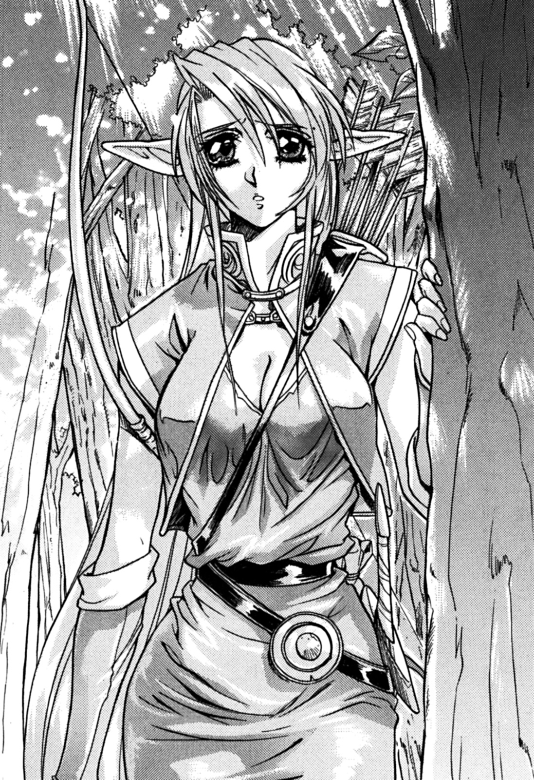

She had long, thin leaf-like ears, her silver hair went down to her waist, she had a tall yet plump figure, she was also wearing dark green clothes. Also, tied to her waist was a dagger, on her shoulders was a bow and a quiver. Currently, she was examining Louie.
Louie looked back at her, she was a pretty young woman. He had heard that elves live long lives when compared to humans, he couldn’t imagine how old this elf in front of him was.
However, he had only heard rumours about their beauty, now he knew it was true.
She was like a fine paining or a magnificent statue, through the gap in the trees leaves and sunlight smiled upon her, this gave the young elf girl a more fantastic impression.
Louie had long become accustomed to women, but to see a beautiful elf, he couldn’t help but stare.
The elf stopped about ten steps in front of Louie.
“She is wary of us.”
Melissa said to herself.
“Obviously, she’s just met us.”
Louie said, in response to her words. Melissa looked at him coldly.
(I’ve got to make a good impression.)
Louie thought. If he wanted to prove he was a hero to someone, it was be this elf, and not the woman who follows him because of a revelation from her God. Louie sometimes thinks that her revelation was nothing more than a simple dream, though he would never say this to her, mainly because he feared the repercussions.
However, thanks to Melissa, Louie was able to become an adventurer. He intends to learn as much as he can from the three women in his party, this will enable him to become a great adventurer.
Especially when it comes to comparing himself to the warrior woman, he didn’t want to lose to her again. One day, he hopes that he could be called a magical warrior.
“……This is nerve-racking.”
The elf girl was standing ten paces away from Louie, he didn’t know what to say to her, he hesitated for a long time. Finally, he said something.
“You said this is nerve-racking.”
Merrill went behind Louie and pushed him.
“If there is something wrong, I am willing to help.”
Little Merrill is a thief, she was accustomed to negotiating with all kinds of people. She knew it would be hard for Louie to talk to her, but she wanted him to at least make an effort.
“Talk to her.”
Merrill said coldly.
“She must have appeared because we were cutting branches off that tree, hopefully we haven’t troubled her.”
“……Is that so?”
That is most likely one of the reasons. Because this is a forest where elves live, they serve as the de-facto guardians.
“Have we troubled you, since we cut the branches?”
Louie asked the elf girl.
“We don’t mean to destroy this tree. You see, it’s still in good condition. Anyway, what has been cut off will only grow back.”
Louie said, not knowing if that was true or not.
The ancient tree they took the branches from was over five hundred years old, the tree trunk was also very strong. Even if they took ten branches, it would not have that much impact on the tree.
“Although it will not wither……”
The elf girl said thoughtfully.
“Oh, so you can speak? We entered this ancient forest to gather branches for a special reason, we have got what we came for. We will leave the forest immediately.”
“……I know.”
The elf girl sighed, now she started to speak rather slowly.
“This tree……no, all of these trees are called Trees of the Dead. Our tribe has a custom, if someone dies, their body is buried in the ground, and a tree is planted on top.”
“In other words, these are graves?”
The words of the elf girl caused Louie great shock, after listing to her explanation, he realized that their actions were no different from grave robbers.
“Yes, this place is very important to my tribe, it’s a scared place.”
Then, the elf girl looked at some branches lying on the ground. From the looks of it, a tree had been cut down recently.
“Cut down……”
The elf said in a remorseful tone.
“Ah——we had nothing to do with that!“
Merrill said, trying to convince the elf.
Genie and Melissa looked at each other, and sighed.
“We really didn’t know, we’re sorry.”
Right now, this was the only thing Louie could say.
“No, I should have said something before you cut the branches……”
Then, the elf repeated the words “cut down” again.
“We apologise for our actions.”
In this vast forest they looked for a long time, but they didn’t expect to stumble upon a scared place that belonged to the elves. They would have to find ancient trees someplace else.
“You can have these back. These are the branches that we cut.”
Louie picked up the branches, and walked towards the elf girl.
Then, Louie apologized to the elf girl again. After they said their goodbyes, Louie and the three girls turned to leave.
“Wait a minute!”
The elf girl shouted.
“What is it?”
“This is our forest, normal humans or hunters aren’t allowed in these parts. If you walk around in the forest, it will only cause me further problems.”
“Your forest, but we……”
Then, the elf’s tone of voice changed.
“You cannot casually cut down trees and kill animals. If you want to bring back some branches from the ancient trees……”
The elf girl lowered her head, it looked like she suddenly thought of something, then she lifted her head, she had a bright smile on her face. It was almost as bright as a flower in full bloom.
“If you don’t mind, come and meet my tribe. If you return to my village, you can have as many branches as you want.”
“That’s great……”
A smile appeared on Louie’s face.
At the same time, someone mercilessly kicked Louie in the back of his foot. Out of the three women, Merrill was the only one who would attack using her feet. Also, she was a thief, nothing she does is considered “clean”.
“What was that for?”
Louie said, staring at the little thief girl.
“Don’t you think it’s strange?”
Merrill bent over and whispered into Louie’s ear.
“What do you mean by strange?”
Louie spoke as quietly as he could.
“I’m referring to that elf’s suggestions, are you stupid or something?”
“That’s a terrible thing to say.”
Louie couldn’t stand the thought of the elf having ill intent.
“Don’t worry about it.”
As a result, Merrill denied Louie a smile.
“Elves are a noble race, they wouldn’t do anything mischievous.”
“Are you sure about that, this is their territory?”
Merrill couldn’t believe that Louie ignored her warning.
“She’s not an evil dark elf, she probably wouldn’t hurt a fly.”
Louie said with confidence.
Although this was the first time Louie had met a real elf, he had read numerous books about them, he was convinced that he was right.
“In addition to dark elves, I’ve heard rumours about other elves.”
“A rumour is just a rumour. I believe that this elf is a woman of her word.”
Louie said decisively.
Merrill was very confused, she slumped her shoulders.
“If you say so.”
Merrill said with disdain.
“I cannot allow you to casually walk around the forest either, I’ll lead you out afterwards.”
The elf girl was listening to all of Louie’s and Merrill’s conversation, she could see through their anxiety.
(I believe in this elf, she is trustworthy.)
Louie was determined——
“It’s dangerous to walk around the forest unguided, we would also be causing problems to the elf. We’ll do as she says.”
Then, Genie said something.
“……If you say so, brave hero.”
While Melissa was reluctant to follow Louie, this was the first time she had not complained about him.
Perhaps out of Loue’s confidence, Melissa wanted to reassure everyone.
“In any case, it’s not like we’re going to die.”
Naturally, Genie was upset, Merrill too. However, they didn’t show they’re dissatisfaction.
“Alright, it’s decided.”
Louie said, while smiling. He then told the elf girl that they were “willing to go with her”.
Though, that’s not to say that Louie didn’t find her a little suspicious.
Then, they all introduced themselves to the elf.
“My name is Celecia.”
The elf girl introduced herself, and thus they began a relaxing stroll in the forest, heading towards the Elf village.
After a while, they finally reached the elf village.
Immediately, four armed elf soldiers descended upon them, they disarmed the group and put Louie and the three women in a small hut, they were effectively under house arrest.
They were charged with the crime of hurting a Tree of the Dead.
However, Louie didn’t know how serious this charge really was.

2 – Magical Treasures

“I can’t believe this.”
The three women said simultaneously.
“You can say that again.”
Louie’s conscience was shouting at him, it was telling him that it was all his fault, he wanted to block out all such thoughts.
Though, there was one thing that he wanted to know. Why did they stick him in the same room as the women? If he was in a separate room, he wouldn’t have to listen to the three women berate him.
Right now, Louie felt like he was in purgatory.
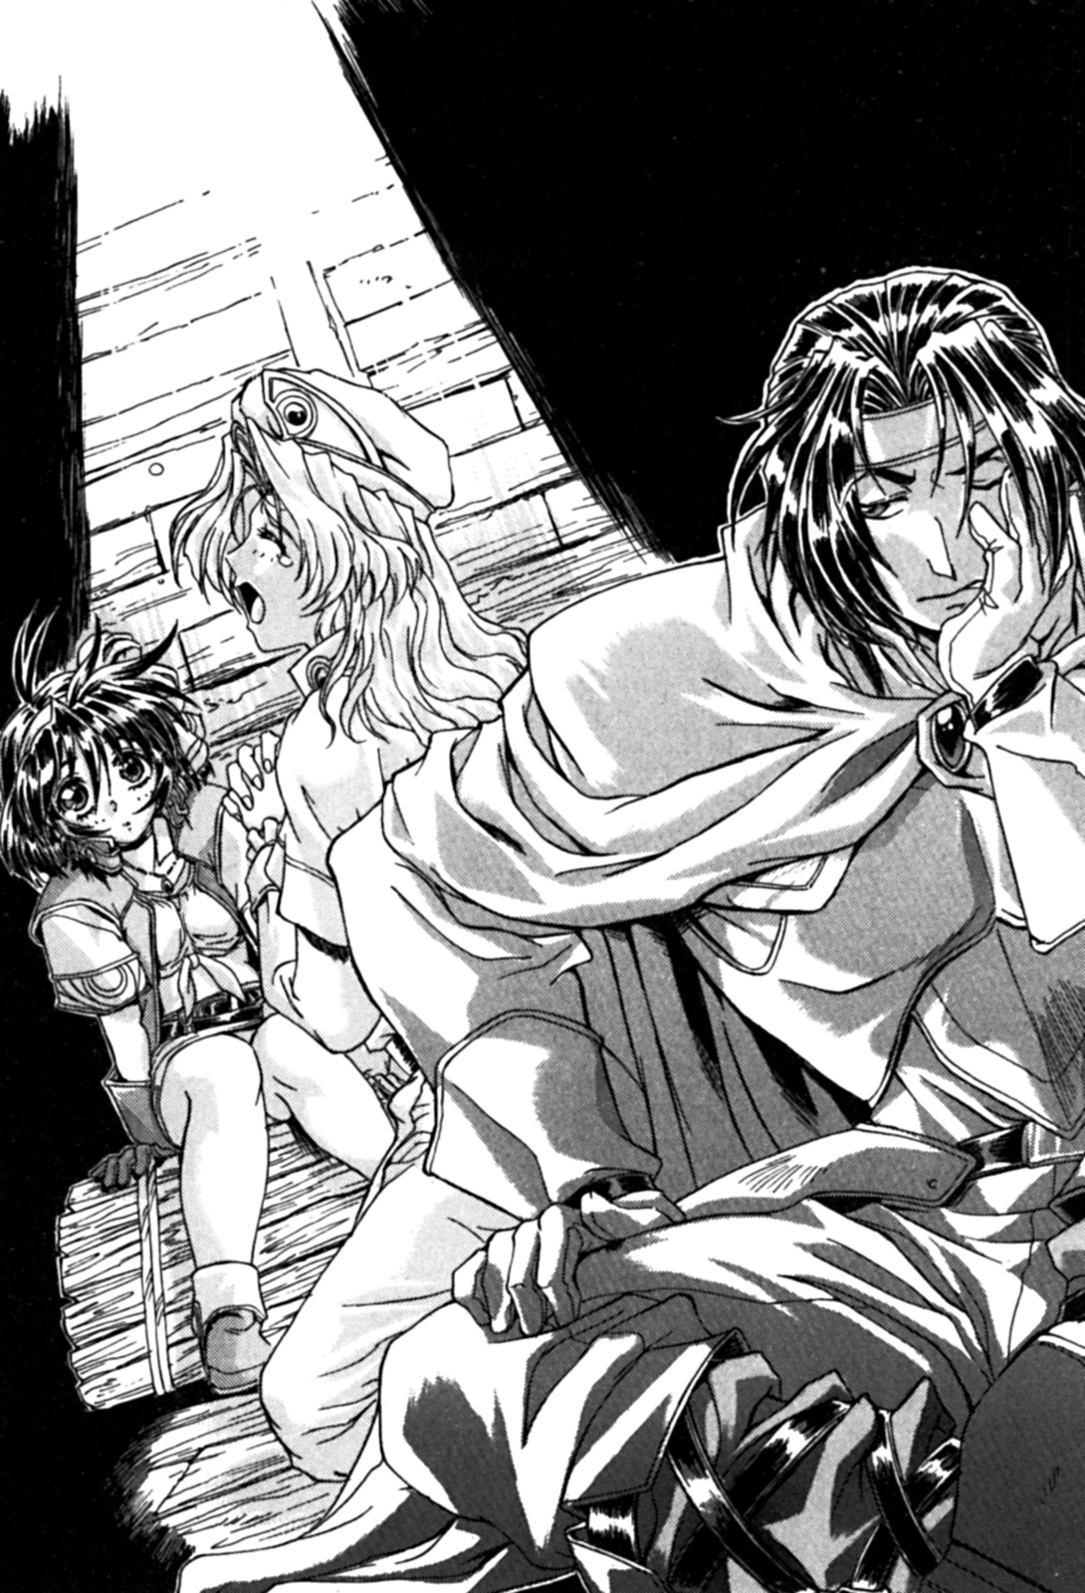

“What will happen next?”
Merrill thought out aloud.
“I don’t think they’ll kill us……”
Genie wasn’t confident in her answer.
“In the end, all we can do is hope that the elves are honourable.”
Melissa wanted to believe Louie.
“I’m sure it will work out just like in the books.”
No matter how Louie tried to justify it, it just came across as useless.
“You can’t be serious. Do you believe everything you read in a book?”
“Well, yeah.”
Louie admitted, much to the dismay of the three women.
“Oh, Great God of War, Mylee. Your foolish servant hasn’t finished her trials yet, her life is in danger.”
Melissa continued praying, she hoped that if they died, it would be a mercifully one.
(Do that someplace else.)
Louie didn’t intend to die here. However, he didn’t think he could lose his life for cutting a branch from a tree!
“Perhaps if we confess our sins to God, we will be forgiven.”
Louie jokingly said, he wanted to liven the mood.
“Well, you are the hero so you should go first.”
Genie sneered at him, Louie felt like he was a fool being ridiculed.
It was clear to Louie. He was responsible for this whole incident today, since he was the one who wanted to ancient branches in the first place.
“Although the elves took our weapons, we still have our luggage. There must be something that we can use to escape.”
However, Merrill immediately said: “I don’t want to get chased around in a forest by elves unarmed”.
Indeed, they’re weapons were confiscated before they were put in this hut.
Though, since Merrill was a thief, she did have some tools tucked away in her luggage.
(I forgot, I borrowed some magical treasures from Ila……)
Louie almost forgot, before he left for the Tartious Forest, Ila literally handed him a pile of magical treasures.
They were the “forest fairy cape”, two sticks that point in a direction, and a magical flute. These three magical treasures each have a magical effect, the cape renders the wearer invisible, the sticks show the way, and flute can summon demons.
These three treasures hadn’t been used yet, but in this situation, they were totally useless.
(There’s no way these would come in handy.)
“Anyway, we should at least try and communicate with them.”
Louie said to the three women.
“Do you have a plan?”
Genie said, then their attention shifted to the entrance to the hut.
The door was opened, the elf girl called Celecia appeared before them.
“What are you going to do with us?”
Louie asked.
“The elders are discussing what to do with you. You humans are different from demons, but this is the first time we’ve caught humans harvesting the sacred wood.”
“You lied to us!”
Merrill shouted at the elf girl, she was furious.
“Say what you will, but it was for the best. Even though I lied to you, I truly am sorry.”
Celecia’s face was full of emotion, Louie looked at her quietly.
“Don’t you have a conscience?”
Melissa calmly said.
Listening to Melissa, Louie knew that the elf was afraid of something.
“If I let you walked around the forest and take the sacred wood, the tribe would have blamed me. I was forced to lie to you, I’m sorry……but there was no other way.”
“Our actions may be unforgivable, but will you kill us?”
Genie said in a low voice.
“That’s not my decision. It’s up to the elders. Though, I’m happy that the man wanted to believe in the elves. Normally humans hold prejudice against us.”
“What prejudice?!”
Merrill shouted.
“I’m sorry, most people have trouble understanding elves.”
Louie felt betrayed too, but he didn’t hold a grudge.
“Really? What a pity……”
Celecia revealed a lonely smile.
(I really have poor luck with women.)
Louie thought, as if he had been cursed.
“I’ll send someone to give you water and food. As for your fate, it’s out of my hands.”
Celecia said.
“I was almost moved to tears.”
Genie’s laughter rang out in the hut, but she was actually quite upset.
“You say this is the first time you have caught humans, but if these demons cut wood, what do you do to them?”
Melissa asked the elf girl.
“What do you think we do to them?”
Celecia said with a grin.
“Oh, I understand.”
“I believe that you humans are more sensible than demons. Though, the elders don’t think like I do, they think humans are just as bad as the demons. But if you can prove to them that you are different from the demons……”
Celecia said, hoping that Louie would understand her. Then she left the hut.
“Thanks for the advice.”
Melissa said, then she watched Celecia walk away through a slit in the door.
“I have a bad feeling.”
Melissa then turned and faced Genie.
“I think this is a trial.”
“Maybe it is.”
“Then so be it.”
Genie and Merrill agreed with Melissa.
“It was just a branch, why must they throw a fuss?”
This was an unexpected development, naturally Louie was stunned. He couldn’t wait any longer, he just wanted to kill someone.
“That damn woman, these elves can’t just kill us.”
“These elves aren’t noble at all, and apparently normal people can’t understand them.”
“They are more stringent than the thieves’ guild.”
The three women said.
“I don’t want to die here.”
The three women said in unison.
Louie had something else in mind, instead of complaining, he wanted to create some kind of distraction.
“Alright, but how do we bust out of here?”
Even though they could be killed, Louie found himself rather calm, he wasn’t afraid at all. However, when he heard those words, he couldn’t help but feel uncomfortable, mostly because Genie could put all their lives at danger.
“Elves don’t just use magic, they use bows and arrows too.”
Genie smiled as she talked.
“And their archery skills are outstanding.”
Merrill said outright.
“Great God of War Mylee says that life is a battle.”
Melissa said.
“They can’t decide when we die!”
“If we are really going to start a fight, I’m happy to join in. However, if I do, will you accept me as your partner again?”
“We aren’t going to wait here for the elves merciful judgement, that isn’t our style.”
Genie angrily looked at Louie.
“That’s not what I said. Anyway, shouldn’t we discuss the plan?”
“There’s no need for that.”
Merrill said in a low voice, something was troubling her.
“I will not give up!”
Louie wanted to convince them.
“However, if we can prove to them that we aren’t the same as demons……”
“Yes! I am a monster!”
Louie happily shouted, as he put his hand on Melissa’s shoulders.
“Wait, what……”
Melissa was stunned by Louie’s sudden outburst, all of the women were.
“It’s true! It’s true!”
Louie shouted wildly.
Genie and Merrill looked at each other.
“I’ll let them know, that humans and demons are different!”
Louie vowed. He had thought of a concentrate plan, one which would secure their freedom.

***

"I can’t believe it."
Celecia said in disbelief.
“Our tribe hasn’t been attacked by monsters in decades, ever since I was born, I haven’t even see that many monsters.”
Louie heard the elf girl say, he wondered if she was hundreds of years old.
While the elders were discussing what to do with the humans, the village came under attack from monsters.
Louie and the three women were freed from captivity, but they were to help defend the village against the monster attack.
Although they had gotten their weapons back, Louie was still un-armed. Now he had to rely on his strength, though he still could have used a sword.
They don’t know how many monsters Louie knocked out.
Also, Genie showed her impressive combat skills, she defeated a lot of monsters.
The elves found that they fought bravely against the monsters, this removed any doubts that they were harmful to the elves.
Also, they didn’t take the chance to escape during the confusion. This helped convince the elves that they weren’t bad guys.
“These humans think the elves are noble, also, as you can see, they helped fight against those monsters. Do you think you can change you point of view of the humans?”
Celecia tried to convince the village elders, she hope that they forgive them for the crimes they have committed. As a result, Louie and the three women were freed.
They also got the branches Louie wanted (and some small branches that Ila wanted). They had got what they came for.
Then, they were led to the edge of the Tartious forest by Celecia.
“You may go back to the human world.”
“Great, thanks to your help, we were able to return safely.”
Louie said to the elf girl, he gripped her slender hands, and shook her hands.
“It was my pleasure.”
Celecia said, her cheeks glowing red.
“Well then, goodbye.”
“Goodbye. I hope we meet again.”
After they finished speaking, Celecia slowly disappeared into the woods.
“Meet again, what does she mean?”
Merrill murmured after the elf girl left, she then forcefully breathed ten sighs of relief.
On their way back through the forest, the three women were silent. As far as Louie knew, he was all alone.
Although he can up with a plan, it created unexpected results.
Louie didn’t just free them, they got what they came for.
However, the monsters attack wasn’t random, in fact it was because Louie used the magical flute to call a bunch of monsters to his position. If the flute was used to its fullest, an entire army of monsters totalling a couple hundred would have descended upon the village. Luckily for Louie, he didn’t know how to do that.
Since the battle was really intense, the elves did suffer some causalities, Louie felt saddened by this.
People died, and Louie knew it was all his fault.
This was how the forest became known as the “Forest of Strife”, because elves and monsters always fought each other.
The elves always knew that battle with monsters were inevitable, this helped prevent more people from losing their lives, the helped Louie’s conscience.
“Let’s go home, we don’t need to be in this forest anymore.”
Louie said to the three women, they all breathed a heavy sigh of relief.
“I couldn’t believe that……”
The three women said in unison.
Now, they leisurely walked back to town.

Chapter 5 – All for Love

1 – Contrived Knight

It was a knight on a white horse, he gracefully swaggered down the street. On his silver armour was a unicorn crest of the kingdom of Ramliearth, it was the early summer and the sun was shining brightly.
He had blonder hair, blue eyes, skin was white as snow, and lips as red as red lipstick.
People were walking down the street, all of them were attracted by the knight’s appearance, he seemed like something straight out of a painting, flawless, they even wondered what gender he was.
However, the knight simply ignored the people’s presence, he just held the horse’s reins, his eyes looked straight ahead.
At last, the knight stopped in front of a bar. He carefully jumped from his horse, he then lovingly put his horse in the bar’s stables, giving it some animal feed and water. Then, he went into the bar.
The time was exactly noon, there was a lot of people in the bar, most of them having some food, or something special to drink.
The knight observed his surroundings, he finally found a vacancy in the corner, he moved through the crowd until he reached the table.
“Can I sit down here?”
This table had two people sitting at it, the knight wanted to politely seek permission before sitting down.
The two people was a man and woman, both of them were dressed in robes, next to the table stood a wand. From just looking at the wand, you could smell the scent of wood in the air.
These two people were magicians. The knight noticed this, in the Kingdom of Ohfun, there was a sizeable Magician’s Guild.
“Of course you can, knight of Ramliearth!”
The female magician wearing glasses said, sitting next to her was a burly male magician.
The two of them were Louie and Ila, both of them went to the bar to get food and drink after a long night of non-stop studying, orders from Master Foltess.
“I’m sorry, but I’m a free knight.”
When Ila mentioned that he was from Ramliearth, it reminded him of something.
“If I cannot complete my oath, I can’t go back to my country.”
(What’s that got to do with us?)
Ila said inside herself.
(He's also a bit too self-conscious, or he’s simply a megalomaniac.)
Right now, Ila didn’t want to know any more about this knight. However, something that he was wearing peaked her interest.
“……Your sword and armour are impressive.”
“You think so?”
The knight said with a proud look on his face.
“In fact, my armour was crafted by elves, and my sword is from the ancient kingdom, it has special magical properties……”
Ila stared at the knights armour and sword, the fact that his sword was tied to the ancient kingdom intrigued her even more.
“……That’s admirable.”
The knight was surprised by this, it usually took a little longer for a woman to become obsessed with him.
However, he saw that Louie was grinning at him. If he started laughing at him, it might provoke a duel.
(There is no reason for us to fight.)
Although Louie and Ila stayed up all night, their senses weren’t dulled one bit.
Right now, Louie was observing the knight physique and appearance, he didn’t think he was that strong of an opponent.
Regardless of how luxurious someone’s sword or armour, your ability to a sword is what counts.
(Anyway……)
Then an employee of the bar came over and asked the knight if he wanted anything.
“Give me something to eat, and some wine, please.”
The knight said.
The employee brought his food and drink over a moment later, the knight ate quietly, finishing his meal before Louie. After he called an employee, he paid with coin.
Then he slowly stood up, and bowed to Louie and Ila.
“Excuse me, sorry for bothering you.”
“No, that’s alright, it was nice seeing your cool outfit.”
Ila said, staring at the knights armour and sword.
“I’m sorry, but do you know where the temple of Mylee is?”
“The temple of Mylee?”
“Why are you so surprised?”
Seeing such a reaction from Ila, the knight was overwhelmed.
“……Oh, I’m sorry.”
Although the knight didn’t care, Ila still apologized. In fact, there was a reason she was so surprised.
Louie and Ila were heading to the temple of Mylee anyway, naturally Louie asked if the knight would like to accompany them. The knight was pleased to accept his kindness, and express his gratitude to the two.

2 – A Failure of a missionary

“……Life is a battle.”
The followers of the church had gathered, all the faithful were now listening to Melissa.
She spoke in an intellectual tone, they repeated her, Melissa’s popularity among the believers was very high.
Most of them were young men. Though Melissa didn’t notice this, she just liked that lots of people had come to listen to her sermons.
In order to make sure that the temple runs smoothly, the believers are required to help out around the temple. Activities range from preaching, martial arts training, and healing injured or sick people with magic.
All of the followers of Mylee do this type of work once per month.
“……When I say battle, I don’t mean a battle on the battlefield. Ever since someone is born, they go through all sorts of trials, they can only move forward with their fight. And so, we request God Mylee give us power, to help those who are feeble and give them courage to face their fate……”
Melissa preached the teachings of Mylee, the God of war.
But today, she had a helpless expression, even her voice was low.
Since she came back from the “Forest of Strife”, she’s been slightly depressed.
(My shoulder is sore……)
Ten days ago she was forced to catch Louie, she gained a slight bruise on her shoulder doing this. Although the traces of the bruising had faded, she could still feel pain once in a while.
Also, whenever she would feel pain, Louie would appear in front of her, his excited face, and happy expression.
But this time, she seemed to be able to forget the pain. However, there was a lingering feeling, she wasn’t happy. Was it that Louie was the only one that could make her happy?
(Why, why do I feel this way?)
Melissa had no idea, she had been fine walking down the street, but now she couldn’t calm down.
Now it was time for martial arts training, Melissa had been unable to concentrate, she tried not to harm her opponent with her Warhammer.
(Life is a battle……)
Melissa thought that if she could follow the teachings, maybe she could free herself of this feeling.
Right now, she was facing a problem.
A trail was right in front of her, she must confront it. It was a trial given to her by God.
(Oh, God. I don’t think the magician is a hero.)
Louie had a burly stature, he was had big muscles and was strong, he was a lowly and savage person, truly a brute.
(How can such a man be a hero?)
Melissa can’t remember how many times she’s asked god this question. However, she failed to get an answer, she can only accept that this is her mission.
There is still some time before he becomes a true hero, but can Melissa really discover the essence of what it means to be a hero?
Honestly, Melissa is lacking some self-confidence right now.
If she can’t stand him, then the only thing she can do is remodel him into something else.
Melissa hoped so. If Louie doesn’t change, then she might not continue to follow him.
So, she just didn’t want to look at him, or have contact with his body. If left unchanged, Louie will continue to prove nerve-racking to Melissa, but she was prepared to endure it for the time being.
Is she fated to both love and hate him? Melissa was confused, so very confused.
“A real hero is……”
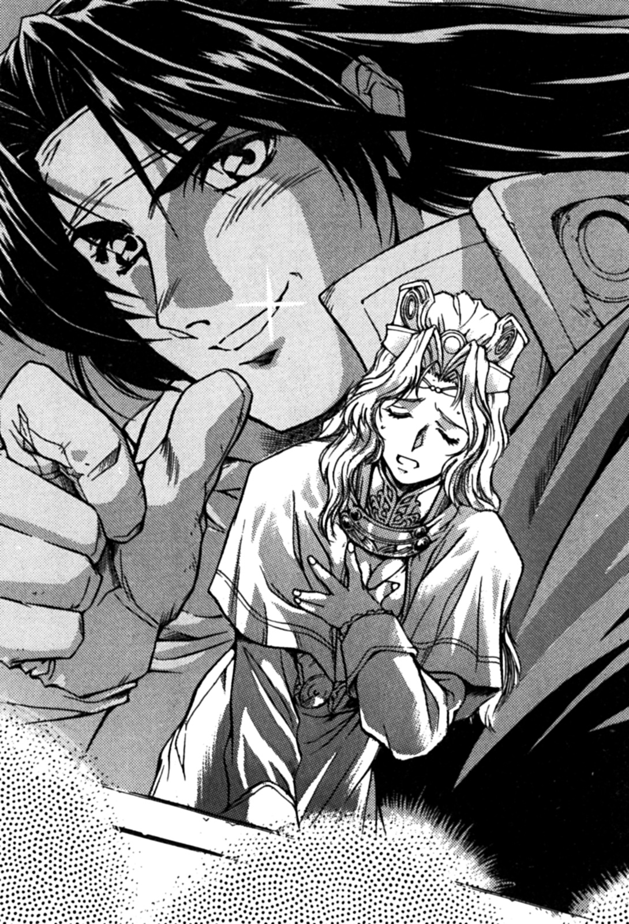

Melissa was still preaching, turning now to talk about the sacred story of heroes.
When she was about to say the next part, however, she couldn’t find it within herself to continue.
“A real hero is……”
Melissa repeated the sentence.
All those gathered in the church stared at her, eagerly waiting for her to continue.
“A real hero is……”
She repeated the sentence for a third time.
Melissa was unable to continue, she put her head down, her forehead was constantly sweating.
The believers sensed that something was wrong with her, and thus they started making some noise.
“A real hero is……what?”
Then, Melissa finally responded to the believers after a moment of silence.
“What?”
Melissa said, her voice trembling.
Then she realized what she had said, she wanted to leave.
“……We’ll stop here for today.”
Melissa then left before the crowd, leaving most of them dumbfounded.

3 – Duel

The thief girl Merrill and the warrior woman Genie went to the temple of Mylee, they happened to run into a group of believers outside the temple.
“Today Melissa was a bit of strange.”
Merrill’s ears were very sensitive, so naturally she heard the passing believers say this.
“……So, Melissa’s mood hasn’t changed?”
Little Merrill said to the burly woman beside her, with a sigh.
After coming back from the forest of strife, Melissa always looked like she was preoccupied with something else, or that her mind is someplace else.
“That guy is harmful.”
Genie said coldly.
She was referring to the magician Louie.
“He’s unbelievable too.”
Merrill nodded and said.
“Although that elf girl betrayed us, we did end up getting freed……”
“In the end, I don’t know if he is an idiot or smart.”
“Does Melissa intend to endure this forever?”
Merrill said, with a worried look on her face.
“She has no choice, this is a task given to her by God.”
“I hope things haven’t’ been too hard on her……”
Merrill was really worried.
She thought that if Melissa endured this any longer, she would probably have a nervous breakdown.
Though if they could get rid of Louie, perhaps Melissa wouldn’t be so sad.
Merrill did received some assassination training at the thieves’ guild, although she had never used it before, however, she can’t forget how to kill a man.
But, taking things into account, she didn’t want things to escalate to that.
If Melissa’s chosen hero were to die, she would not be able to complete the trails given to her by god, and maybe she would commit suicide knowing this.
Since it was a mission given by god, Merrill and Genie would have to accept it.
“Melissa can’t say what’s in her heart, she doesn’t know what to do with that guy……”
Even though Louie wasn’t a bad person, he is still a man, and once something is set in stone, it can affect a woman dearly.
Speaking of men, many just want a woman for pleasure, if this weren’t the case, the thieves guild wouldn’t run a brothel.
The natural relationship with men is what made the three women seek out another female companion, they didn’t want anything to be awkward between members of the opposite sex.
However, fate can sometimes be cruel. Not only has Louie joined their adventuring group, but he has caused a number of events that have upset the group. Luck seems to have abandoned them at this point.
“That guy is Melissa’s problem, all we got to do is keep him in line.”
Listening to Genie’s words, Merrill could only nod in agreement.
They had made an appointment with Louie to meet here, he said that the female magician would also be coming.
Louie tried to explain it to them, apparently the branches from the ancient trees could also be used to create artificial organisms or magical dolls.
Merrill found this a little hard to understand, however, she summarized that they could be valuable.
She seemed to want to use these items are some sort of commission fee, but the girls were happy as long as they could make some money.
That appointed time for the meeting was drawing near.
“That guy?”
Merrill said, as she spotted Louie in the distance. Melissa then came forward and greeted them.
“Let’s go into the atrium……”
Melissa said, trying to show some enthusiasm, but truly, she was exhausted.
(Today’s sermon was so bad……)
Melissa said inside herself, knowing that others were probably criticizing her somewhere.
They then came to the atrium, the three of them chatted, while awaiting for Louie to arrive.
A while later, Louie arrived. Along with two other people, one was Ila, and the other was……
“Conrad!”
She was very surprised by the appearance of the knight, she didn’t know how he found out she was here.
“Hey, Melissa!”
The knight said, after he saw Melissa.
“You know him?”
Louie asked Melissa.
“I met this guy at the bar, he was heading here anyway so we let him tag along.”
Louie said, hoping that Melissa would thank him for bringing him.
However, she didn’t say anything, but he could tell that she wasn’t happy.
“Who is that guy?”
Genie said, as she stood closer to Melissa.
She looked at the girly knight, his physique wasn’t impressive. If he turned out to be a real knight, Genie would find that hard to believe.
“He is my fiancé!”
Melissa’s voice wavered as she spoke.
“Fiancé!?”
Merrill said in surprise, she stared at Melissa, then looked at the knight.
“Yes.”
Conrad was now visibly moved as he spoke:
“Me and Melissa have already agreed to be married.”
“Really?”
Merrill asked, Melissa nodded as she blushed.
“Really? I never would have thought.”
Louie understood the relationship between them, now he started laughing.
“So, you’re fiancé is quite handsome.”
Louie joked, but this only made Melissa’s face redder.
“Come with me, let’s go back together! Back to the kingdom of Ramliearth!”
Conrad slowly moved towards Melissa, his voice like an opera singer.
(This isn’t good.)
If she was to leave with this strange guy, then Louie’s life as an adventurer would end. Louie started thinking, if might be a good thing for her to get away for a while, but he couldn’t stand by idly and let a companion leave the adventuring group.
Louie could almost hear a devil whispering into his ear: “Let her go, then maybe our days will be better.”
“That is already a thing of the past.”
Melissa said to Conrad, her expression was very serious.
“I abandoned my house, so I’m not obligated to comply with the marriage agreement set by my father.”
“This isn’t about the arranged marriage. I really love you!”
Conrad looked at Melissa as he spoke.
“This is like watching a drama……”
Merrill said as she sat on the floor, her hands propped on her cheeks, she had the idea of guarding Melissa from the knight.
Genie had a ferocious look, as she stroked her face.
However, Ila was the only one who had a pleasant look on her face.
“But I don’t love you!”
Melissa made that very clear.
“No, you will fall in love with me. I’ve become a knight, I believe now that I am absolutely qualified to be your hero.”
“That’s not what I want.”
Melissa looked at her fiancé from head to toe, she sighed. She couldn’t see what exactly changed since she last met Conrad, the only thing different was that he was holding a sword and wearing armour.
“And……”
Melissa said, as she looked over towards Louie.
“And what?”
“I’ve found my hero.”
Melissa said as she bit her lips, she wanted to forget that even happened.
“But I am willing to die for you.”
“I have to help me, guide him, my mind and body are his.”
She never actually did any of those things for Louie, let alone give him the time of day.
“What!?”
Conrad acted as if a tragedy had befallen him, he staggered back a few steps.
“A hero, who exactly is this man?”
“It’s him.”
Melissa’s face was angry, as he pointed at Louie.
“You are Melissa’s hero……”
Conrad stared blankly at Louie.
“I guess so.”
“But he’s a magician? You never wanted me to use magic……”
“That’s the way things are.”
She could only think of annoying memories, Melissa looked depressed.
In the Kingdom of Ramliearth, magicians were the thing that annoyed her the most. Because Ramliearth was a “magical kingdom”, all the knights learned to use magic.
However, due to these knights excessively relying on magic, martial arts became to be despised.
“I got a revelation from God. This man is my hero……”
“Unbelievable, just unbelievable——”
Conrad moaned.
(I don’t believe this either.)
Louie sent the knight a compassionate look.
Melissa herself was unwilling to accept this, however, she can take advantage of this to make her fiancé back off.
(She usually isn’t this nasty.)
Although Louie wanted to comfort Conrad, he didn’t know what to say.
“……Now you know, so please go back.”
Melissa said coldly.
Conrad looked like a large hammer hit him, he just stood there motionless.
“Don’t you have anything to say?”
Melissa said to Louie, he could only stand still.
She then ran over and tugged on his right arm, he could feel her large breasts pushing against him, little Merrill couldn’t bear to see her do this.
Louie didn’t hate her for doing this, but that’s not to say he didn’t enjoy it. Melissa’s intention was clear, though she wasn’t doing it to make Louie happy.
“Then we’ll fight! We’ll fight……”
Conrad shouted, looking directly at Louie.
“A duel?”
This happened all of a sudden, Louie didn’t fully understand what he meant.
Conrad pulled a glove off and threw it at Louie, it hit his chest and then fell to the ground.
“I want to fight you! We’ll find out who the real hero is, we don’t give a revelation from God!”
Louie looked at the glove at his feet, he felt a tingling feeling in his head.
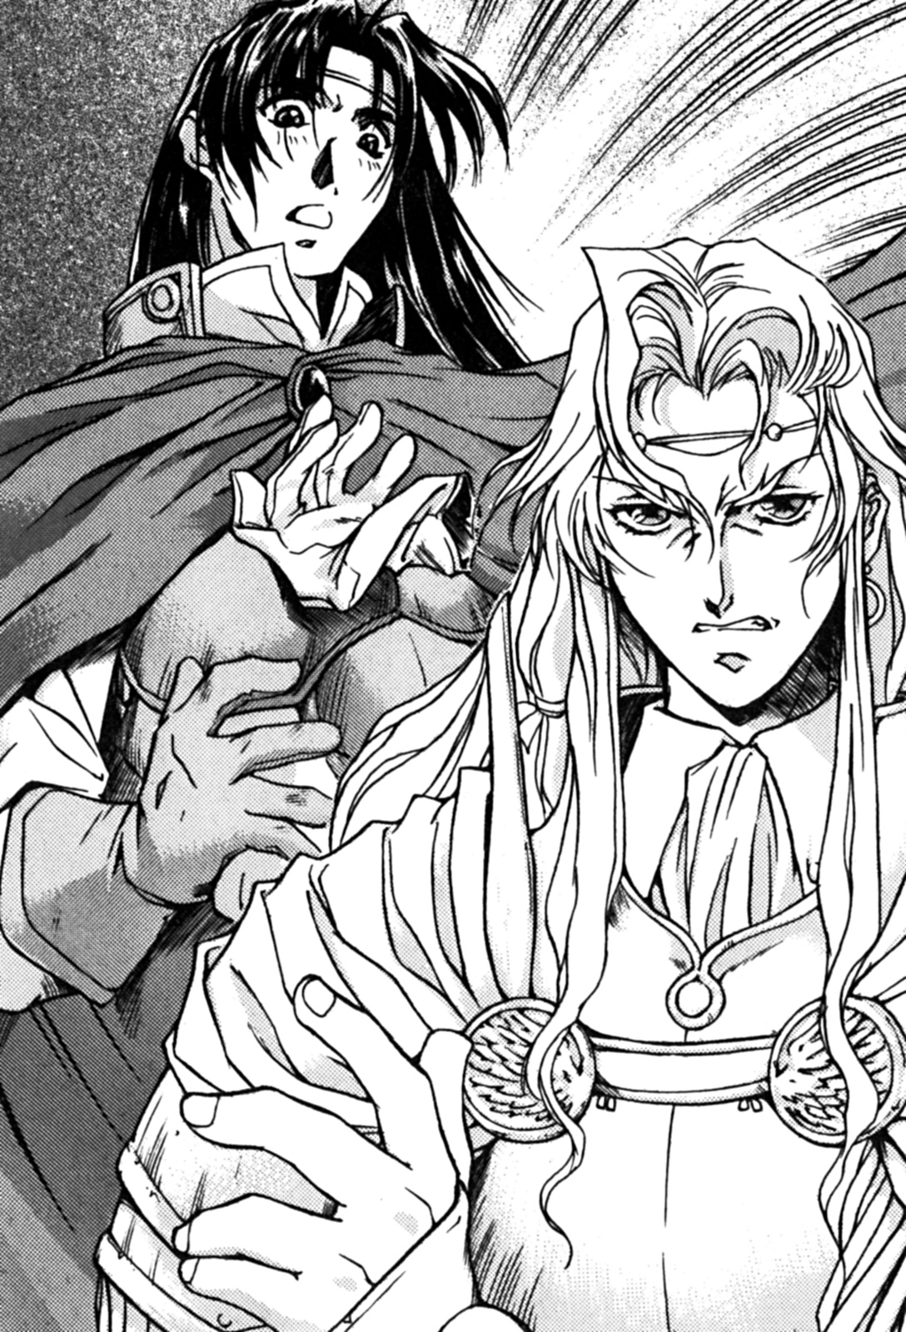

“Who do I have to fight you?”
“Why do you have to ask? It’s for love!”
“Love……”
Conrad may have felt that way about Melissa, but Louie didn’t feel like he did.
“You will accept this challenge!”
Melissa said, clinging to Louie’s arm.
“W-What?”
Louie shouted, not even getting to decide for himself. However, when he looked at Melissa, she gave him a cold look, he didn’t want to imagine what would happen if he said no.
“Conrad, if you win, I’ll go back to Ramliearth with you. But if this guy beats you, you’ll never come near me again.”
Melissa said to her fiancé, then she looked at Louie.
“Isn’t that right, my hero?”
How is this right at all! Melissa is strong-arming Louie into this, and he is so shocked he can’t speak for himself.
“Alright, the duel will take place seven days from now at noon, here will be the venue.”
Conrad decided, he then turned and left the temple’s atrium.
(Wait a minute! Wait!)
Louie screamed internally, of course, the knight couldn’t hear his cries.
“You’re going to fight, Louie.”
Genie said wickedly.
“It’s a duel.”
Merrill said, tapping Louie on the shoulder.
“Yes, a duel.”
Melissa stated. From the look on her face one thing was certain, she was determined. Then, she suddenly let go of Louie’s arm.
“You’re going to fight a knight.”
Ila said, then she moved besides Louie and whispered in his ear.
“I’m sorry……”
Louie lifted his head, he looked distressed. No matter what they thought, he didn’t think he could win against the knight.
Although he might not look very strong, the knight from Ramliearth has received considerable training in fencing, and much more. While Louie hasn’t been using a sword for long, he didn’t stand much of a chance.
(Maybe I will be killed.)
A dark wave came over Louie.

4 – A slow man

The room wasn’t that big, numerous magical treasures were scattered about the place, you could literally smell the ancient magic coming from them.
They were in the sorceress Ila’s room, only Louie and her were in it.
Both of them had just come back from the Temple of Mylee, they had something to eat, then went to Ila’s room.
“How are you going to do it?”
Ila said, while she has cleaning and moving stuff around the room. Meanwhile, Louie was just sitting down on a nearby chair.
“I’ll do what I can.”
Louie had to accept this challenge, he was obviously frustrated.
He had to duel a knight called Conrad from Ramliearth, a neighbouring kingdom.
Louie didn’t really want to fight Melissa’s fiancé, but he couldn’t back out at this point, he had to prevent Melissa from going back and marrying someone she doesn’t love.
“All for love, I have to fight him for the woman he loves. There’s no way getting around this.”
“Well, you could always kill Melissa.”
“Ila……”
A chill went down Louie’s spine, he didn’t know if Ila was joking or being serious.
“I could always run away from the fight.”
“That priestess was the one who decided for you, she only wants to take advantage of you.”
“Yes, she forced me into this.”
Both of them looked at each other, the feeling was mutual.
“But running’s not your style, surely you don’t want to give her to that knight?”
Ila coughed, to arouse the attention of Louie.
“Of course not.”
Louie immediately said.
“Well, you are a man, so you should defend your woman.”
Ila smiled gently.
“Whatever the reason, I’ve got to fight that guy.”
“How will you win?”
“Sometimes you’ve got to rely on luck. Also, that knight looks kind of weak, I really don’t know what he was thinking……”
“That knight……”
Ila murmured, something was troubling her.
She wanted to tell Louie what it was, but she reckoned he had enough things to deal with.
“If you’ve got luck on your side, then you might win.”
She then stared at Louie.
“Though, if the opposite happens, do you have any last words?”
Ila joked. But she wasn’t joking, she knew this was the likely outcome.
“There’s no need for that sort of thing.”
“You’re so boring, want to help me gather these magical treasures?”
Louie thought about this, was he boring? However, he didn’t want to ask that question to Ila.
“Well, I think I should practice some fencing first.”
“Fine, you do that while I do this.”
“What?”
“Do you have to ask, collecting magical treasures obviously.”
Ila had a serious look on her face.
Louie suddenly felt a moment of regret, he felt that he shouldn’t have asked that question.
Then, Louie left Ila’s room. He didn’t want to talk anymore.
Because he stayed up studying with Ila last night, he was tired, and went to sleep early. He wanted to deal with all his troubles tomorrow, not today.
He went fast asleep. Regardless of whatever studies he had the next day, he only concentrating on training.
After five days, Louie heard some rumours.
Five robbers broke into a hotel in Ohfun, and apparently a knight beat the whole lot of them.
The entire town was talking about this guy.
Louie and Conrad’s duel was tomorrow.

5 – A Powerful Sword

“Have you heard?”
It was the warrior woman Genie’s voice, she appeared in front of Louie.
Behind her was the thief Merrill and the priestess Melissa.
“Yes, I heard……”
Louie sighed.
He was resting in the Magicians’ Guild main hall, if others saw him doing this, he wouldn’t know what they’d say.
His bare upper body, his impressive physique, his entire body was covered in sweat.
Summer is coming.
“I heard that the knight struck down five robbers.”
When Louie heard about it, it was almost noon. He had heard it from Daryl, a magician from the Magician’s guild.
Louie was obviously very concerned about this rumour.
“Yeah, it’s true.”
Merrill stepped forward.
“I went to the thieves guild, they confirmed it. Conrad really did defeat those robbers, I also heard that he was summoned by the King himself.”
Louie was not amused.
He felt like a prisoner on death row, and tomorrow was his execution day.
“Some thieves tried to kill him.”
Merrill obtained this information at the thieves’ guild.
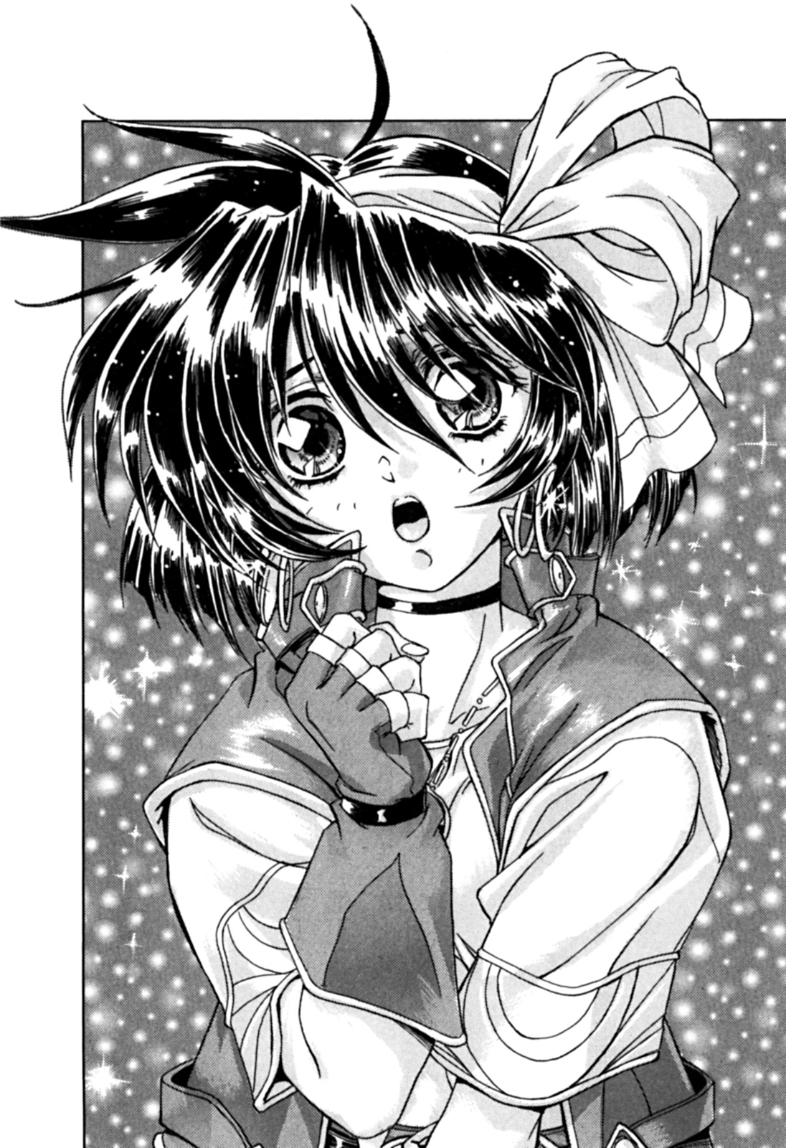

“He killed them all.”
“……That guy seems pretty cold-blooded.”
It seemed strength alone wouldn’t win Louie this fight.
While Louie accepted the knight’s challenge, he doesn’t intend to kill his opponent, but he didn’t know if that applied to the knight.
However, after listening to Merrill, Louie gave up on that idea.
“I can’t believe it.”
Melissa said.
“I wonder how he became so powerful……”
Louie said, obviously bewildered.
(This guy is pathetic.)
Melissa thought, she was disgusted with him.
“It may be a bit late, but do you want me to train you?”
Genie said to Louie.
This proposal was the best thing Louie had heard in a while.
“Well, do you want my help or not?”
“Hey……”
Merrill said to Louie.
Louie had a sad look on his face.
“There’s a chance I could die in this fight, isn’t there?”
“Obviously.”
Merrill had a serious look on her face.
“Don’t worry. If you die, I will accompany you……as part of the wild rejoice.”
Melissa had thought about this a lot.
“Wild Rejoice” refers to visiting deceased heroes in the underworld, it’s part of the teachings of Mylee.
(That’s reassuring!)
Louie screamed internally. He decided that if he died, he would like to become a star in the sky.
“Anyway, have you seen that college you travel around with today?”
Genie suddenly changed the subject.
“Ila doesn’t always come with me.”
Louie said impatiently.
He thought she wanted to see her because she’s a magician too, and a female. The three female adventures originally wanted a female magician to join their group, but they had to settle for Louie since Melissa received a revelation from God.
(I guess it won’t be too bad if I lose my life in this silly duel.)
Louie thought.
“She’s away for a few days, I think she was going to buy some magical treasures. She’s not at the guild.”
Ila’s home was the largest merchant building in Ohfun, her father had collected numerous magical treasures as a hobby. This definitely influenced Ila, you could say she was just like her father.
Perhaps after tomorrow, he’ll never see her again. This is what Louie thought.
He recalled numerous past memories, she was always kindly helping Louie.
Unfortunately, there is no way he can say goodbye to her now.
“Even if my opponent is more powerful, I won’t run away. I will make every effort to fight him. But if I lose, I might be killed. So, you better forget about me.”
Louie didn’t have any hatred towards the three women, he just didn’t want them worshipping him after he died with food and drink.
(If that sword sends me to heaven, it wouldn’t be that bad.)
He didn’t want to die in pain. But then again, maybe this “knight” wasn’t merciful, for all Louie knows he could have some special torture technique.

5 – Battle of the magical treasures

Then, the day of the duel had come.
Louie arrived early at the Mylee temple.
People didn’t know if he was afraid of being late, they could only speculate.
Although Louie had come to fight, he was unarmed, his last chance to buy a sword was outside, he wasn’t even wearing armour, he just wore the clothes he usually wears around Joy Street.
However, Louie didn’t intend to give up, he was going to try his best to win. If you measured his physical strength and ability, Louie wouldn’t lose this upcoming duel with the knight. Though, he would need to see how his opponent fights first, that would give him an advantage.
The day before the event, the followers of Mylee spread the news of the duel to the townspeople. They didn’t know what kind of arena would be setup, but they were sure it would be better than any street brawl.
Lots of people came to watch the duel, but they only knew that Conrad from Ramliearth was fighting. They didn’t know who his opponent was, now why they were fighting.
Louie really didn’t want to say “it was for love”. When he became an adventurer, it was to have fun and find treasure, not to battle for love.
“……Looks like I finally caught up with you.”
Louie was sitting on the floor thinking about things, when suddenly he heard a female voice behind him.
“Ila?”
Louie didn’t think she would appear, thus he had an astonished expression.
“I thought you weren’t coming.”
“Of course I was coming, I’ve got to see you fight.”
Louie was surprised by her appearance, naturally Ila was angry, she then handed him an elongated object.
“This is a gift for you.”
“Is this a……sword?”
“Yes, but this sword is from the ancient kingdom.”
Ila smiled, Louie then started to unwrap the wrapping paper, and stared at the sword in amazement.
Under the early summer sunshine, the sword shined, contained within the sword was over five hundred years of protective magic, this is why it was so bright.
What Ila gave him, was certainly a magic sword.
Louie looked at the sword, the language of the ancients was carved into it.
(I can’t believe it.)
“If you say the phrase dancing in the darkness, it should prove more effective……”
After Ila finished talking, she sat down beside Louie.
“This is amazing, Ila, but is it really magical?”
Louie was sceptical, he didn’t expect to get something like this before the fight.
“Of course it is. I checked it myself, you can be rest assured.”
“But, that knight also has a magical sword……”
“I know, but you can do it. Believe in yourself, Louie.”
Ila said, then Louie was ready for the fight.
His opponent had a luxurious armour and a magnificent sword, if it wasn’t for Ila and that magical sword, Louie probably wouldn’t stand a chance.
Finally, the time of the duel was near.
Ila actually fell asleep on the shoulders of Louie, she looked very tired.
At the same time, Louie saw Merrill and Genie pass through the crowd of onlookers, and come towards him.
Merrill happily waved at Louie. He didn’t know whether it was to cheer for him or to say goodbye, Louie was confused. Although Merrill seemed like a child, naïve and innocent, she was actually more complex than that.
Genie didn’t greet Louie, she just took a bunch of snacks and ate them.
Then, Melissa and an old woman appeared before Louie. He knew that old woman, he lifted his head to look at her.
It was the highest ranking person in the Mylee temple, known as the “Sword Princess”, it was Jenny, one of the founding heroes of Ohfun.
Louie’s adoptive father——Carwes, it was him and Jenny who accompanied Rijarl when he founded Ohfun.
Of course, Louie had met Jenny several times, he even grew up learning some things from her.
When Melissa saw Ila slumped against Louie’s shoulders, she just looked at them coldly, then she turned to face the High Priestess.
On the surface, the duel was a fight for Melissa’s love, and if Louie was seeing another woman, this wouldn’t sit well with her.
Jenny then smiled at Louie.
(This is troublesome……)
Louie felt embarrassed, he pretend to close his eyes, to escape the invisible pressure from Jenny’s smile.
Finally, Conrad the Knight from Ramliearth made his appearance. The entire crowd clapped to welcome him.
(Why are the clapping for him? I’m the local here.)
This made Louie a little sad.
To the crowd, it was just a battle between a knight and an evil villain.
“……What’s happening?”
The clapping of the crowd had awoken Ila.
“The time of the duel is near.”
Louie said, he then took the sword, stood up, and made his way towards the arena.
“Huh?”
High priestess Jenny uttered, she was surprised by something.
“He’s your hero, right?”
Jenny said sternly.
“Yes.”
Melissa replied.
“He looks good. Do your best, hero……”
(I wonder if he’ll lose.)
Melissa said insider herself, she wouldn’t dare to say it out aloud.
“Let’s get started!”
The High priestess said, she was responsible for starting the duel.
Louie had his sword in hand, Conrad too.
“Come on, attack!”
Louie shouted.
“Alright! Dance, my sword!”
Conrad shouted, it was the ancient language……
Then, he resorted to an unstoppable strike.
Louie didn’t expect this move, Conrad’s strike cut his shoulder a little. At this point, the crowd was cheering even more than usual.
Louie then tried to keep his distance, he didn’t want to get hit again.
(This is it!)
Louie charged at Conrad, swinging his sword with all his might, but his attack was easily blocked.
It seemed that his defence was impenetrable.
Then, Louie remembered something.
(At the start of the duel he shouted “Dance, my sword.”)
Louie understood that his sword was somehow similar to his. At the start of the match he shouted a magical incantation, thus instantly giving Conrad the advantage.
“Dancing in the darkness suits you very well.”
Louie then shouted “Dancing in the darkness”, the ancient language phrase given to him by Ila.
A weird tingling sensation went through Louie’s entire arm, it was like the sword was shaking in his hands.
Then, the sword suddenly flew out of his hands. It flew towards Conrad, and violently attacked him.
“Damn you!”
The crowd then began shouting louder.
(Victory will be mine!)
Louie showed a confident smile, and quickly moved to the back of his opponent.
Conrad was clearly at a disadvantage.
“Well, looks like this duel was only the beginning.”
Louie said standing behind Conrad, in a mocking tone.
“W-What?”
Now Conrad’s sword flew from his hands, and the two swords battled each other in mid-air.
Conrad then tried to pull a knife out, Louie saw this, and swung his right fist right at Conrad.
Smack!
Louie was quite accustomed to using his fists.
Conrad was beaten to the ground, he painfully rolled away, unable to get up.
Louie raised his arms in victory, the crowd cheered. However, those who wanted to see him lose, sighed and left the arena.
However, there was still people clapping. It was Ila and the “Sword Princess” Jenny.
Merrill and Genie were still eating, they looked bored, but Melissa was blushing.
“……This is the way of fighting.”
Melissa couldn’t help but state her true feelings, her body was trembling.
“This is simply against my will!”
She said her usual phrase, and turned away.
However, something was different this time.
Previously she had been unable to recognize him as a hero, or that he could even become one.
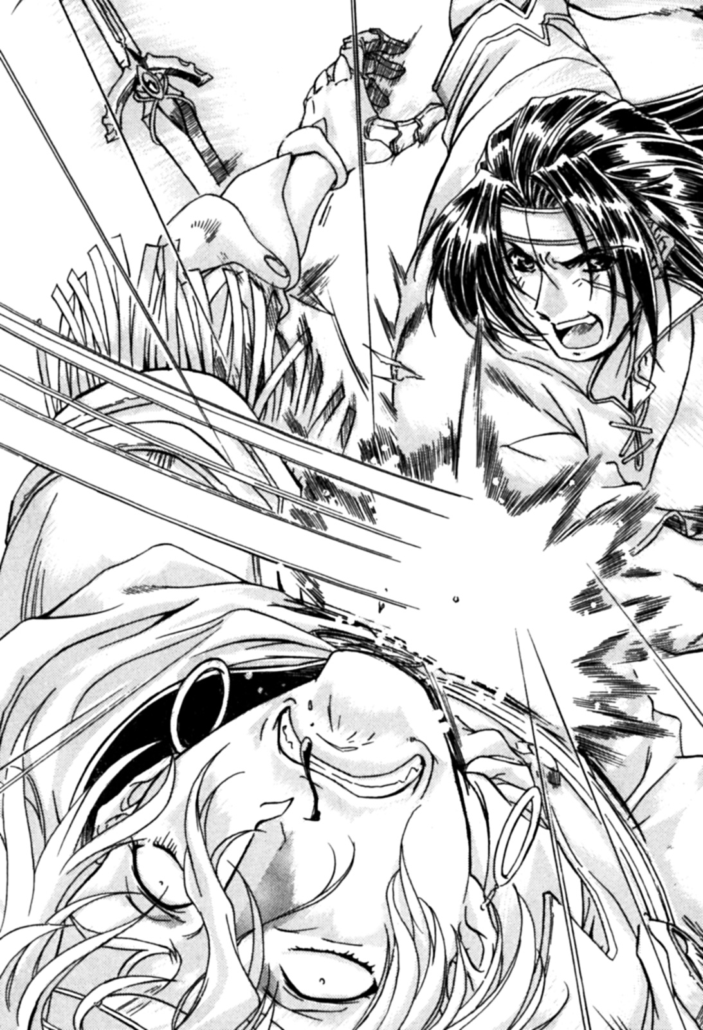

However, she might be wrong.
Louie didn’t have to accept this duel, Louie and Conrad both fought for different reasons, and not for their personal gain.
He wasn’t fighting for love, there was no motivation he used for the duel, Melissa didn’t even really encourage him, and yet he still came out on top.
“Maybe it’s not against my will……”
Melissa looked back at Louie.
(If he continues like this, he could one day become a hero.)
Louie was now staring directly at Melissa, his smile shining brightly, their eyes locked, Melissa smiled back at him.
(In the end, maybe he will become a hero.)
Behind Louie, the two swords continued to dance.

End of Rune Soldier Louie Book 1
Translated by Ciaran Hillock aka Dirk Diggler
https://chillock-amt.blogspot.co.uk
Email: chillock@hotmail.co.uk
Do not replicate or copy this work without permission.

