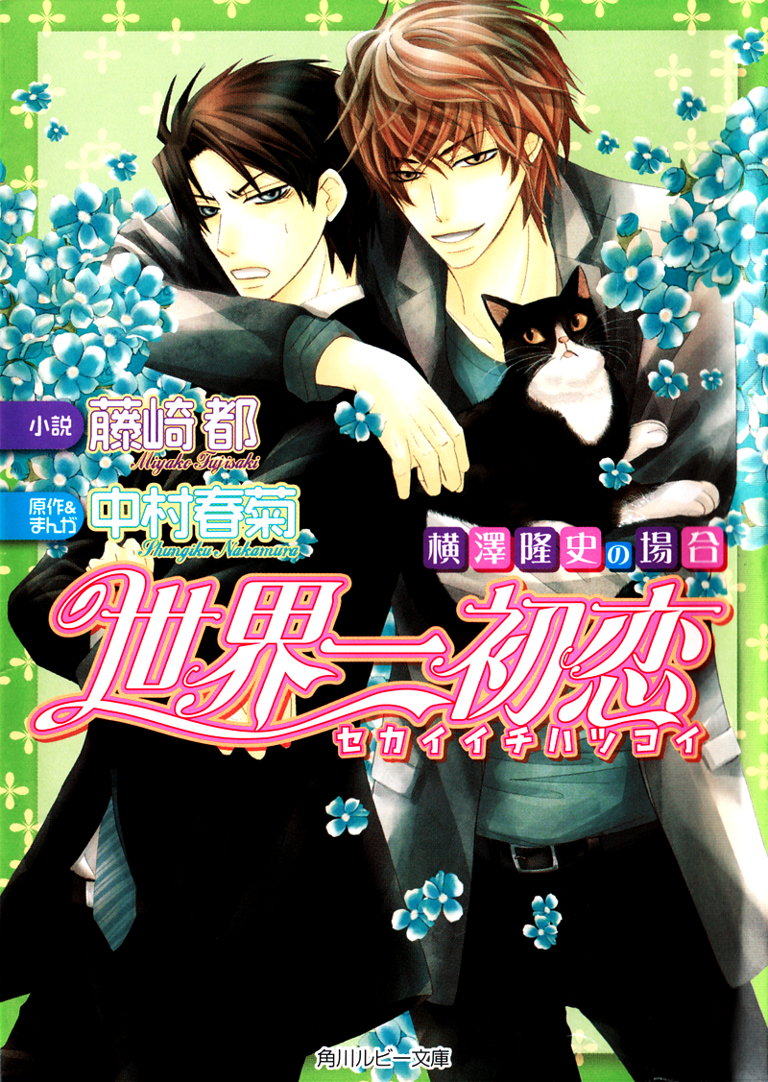
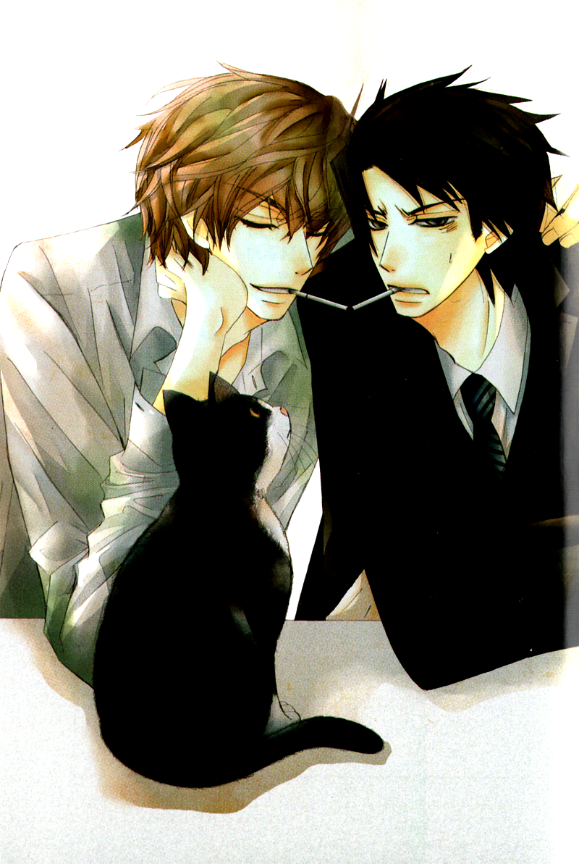
Title: Sekai-ichi Hatsukoi ~ The Case of Yokozawa Takafumi
Author: Fujisaki Miyako (original work: Nakamura Shungiku)
Translator: fencer_x of September Scanlations

Chapter 1
First loves never last–I knew that from the very beginning.
He had at least understood that there was no ‘romantic love’ in the feelings held for him. Showing him his weaknesses, taking advantage of him…that was all simply depending on him as a close friend.
And yet, the reason he couldn’t cut away his lingering affections…was because he still held out some small hope. He didn’t have to be his lover–it was enough if he could just be the most important person in his life. It would have been more than enough…if he could just stay close by his side.

He could hear the sound of rain falling outside.
The rain slapped loudly against the asphalt, the sound seeming to resonate sympathetically with his own irritation. The rain had been falling for quite some time tonight, and yet even the mud-darkened water swirling outside couldn’t wash away the blackness soaking through his heart.
He glanced up at the television in the izakaya he’d ducked into for shelter from the weather and noticed a warning for strong thunderstorms. He’d initially planned on heading home once the rain let up, but the rain which had started falling in the early evening was certainly showing no signs of stopping, and he realized he’d long since lost the moment to leave the bar safely.
…Or well, perhaps that was just an excuse he told himself. In truth, he likely only wanted to put off returning to that room filled with memories of him for as long as possible.
And it wasn’t so bad while he was emptying glasses of sake in the midst of his despair, but right now he could feel a roiling sickness in the pit of his stomach–hardly surprising; there was no way he wouldn’t be feeling the effects of drinking that much. On the bright side, he didn’t have a headache. He furrowed his brows at the discomfort and tried to roll over, subsequently noting a strange sensation against his cheek.
“Where…am I?”
Slowly pushing himself up off the gently springy mattress, Yokozawa Takafumi knit his brows in confusion as he took in his surroundings, a room he’d never seen before. It was neither his own house nor that of any of his friends. The simple aesthetic spoke of a business hotel–and yet he had no recollection of checking into a hotel. The last thing he remembered was settling in at the izakaya because the rain hadn’t stopped yet…
“I can’t remember…”
Sifting through his fuzzy memories, the one thing he was able to recall were the words of the bartender, worried that he was drinking too much. At any rate, he had to get rid of this hangover and fast, or he wasn’t going to be able to use his head at all.
He’d never gotten this drunk before in his life; after all, it had always been his job to look after a certain someone who liked to get shit-faced himself. He’d never so much as imagined that he would wake up one morning and not be able to remember anything.
Shaking his head wildly, he regained a bit of sense and blinked several times in rapid succession while massaging his sleep-heavy eyelids with his fingers. It was in that moment that he sensed something strange about the bits of himself that he could see.
“..........”
While he didn’t recall stripping, for some reason he was completely naked. He hardly ever slept in the nude to begin with, and curiosity led him to lift up the comforter.
“?!”
Realizing he wasn’t even wearing any underwear, he grew flustered and quickly covered up his lower half.
Perhaps he’d just gotten drunk and stripped of his own volition, throwing his clothes about. Telling himself this, he glanced around the room, but was unable to locate even a single sock, let alone his suit itself.
Finding his boxers had just slipped under the bed, he stretched out an arm to grab them and slipped them on under the covers, breathing a sigh of relief. There was a world of difference in ease of mind between having at least one piece of clothing on and wearing nothing at all.
He had also noticed one other thing when he’d surveyed the room: the sound of the shower running. Apparently he’d interpreted the sound of the shower from the bathroom as the sound of falling rain in his dreams.
But that was hardly the problem: that he could hear the shower running…meant that someone was using it.
He’d never in his life brought a casual acquaintance to a hotel like this. Quite the contrary, he was firmly against having relationships with strangers. And yet, when he paused to consider the state he’d been in the night before, he had to admit it wouldn’t have been all that strange if he’d been that careless…
As he sat there worrying on endlessly, the sound of the water running suddenly stopped.
“..........!”
He held his breath and prepared himself to confront whatever woman was about to come out of that bathroom. While he didn’t know why they’d come there with him, he knew he had a responsibility as a man to accept the consequences of his actions.
Yokozawa ran through a dozen patterns and simulations in his mind–but his thoughts ground to a halt when the person who stepped out of the bathroom, dressed in a robe, was in fact a man.
“Oh, you’re awake. How’s that hangover?” The man mopping at his wild hair that dripped with water from the shower and speaking with an air of nonchalance was none other than the editor-in-chief of Marukawa Shoten’s featured magazine Japun, Kirishima Zen.

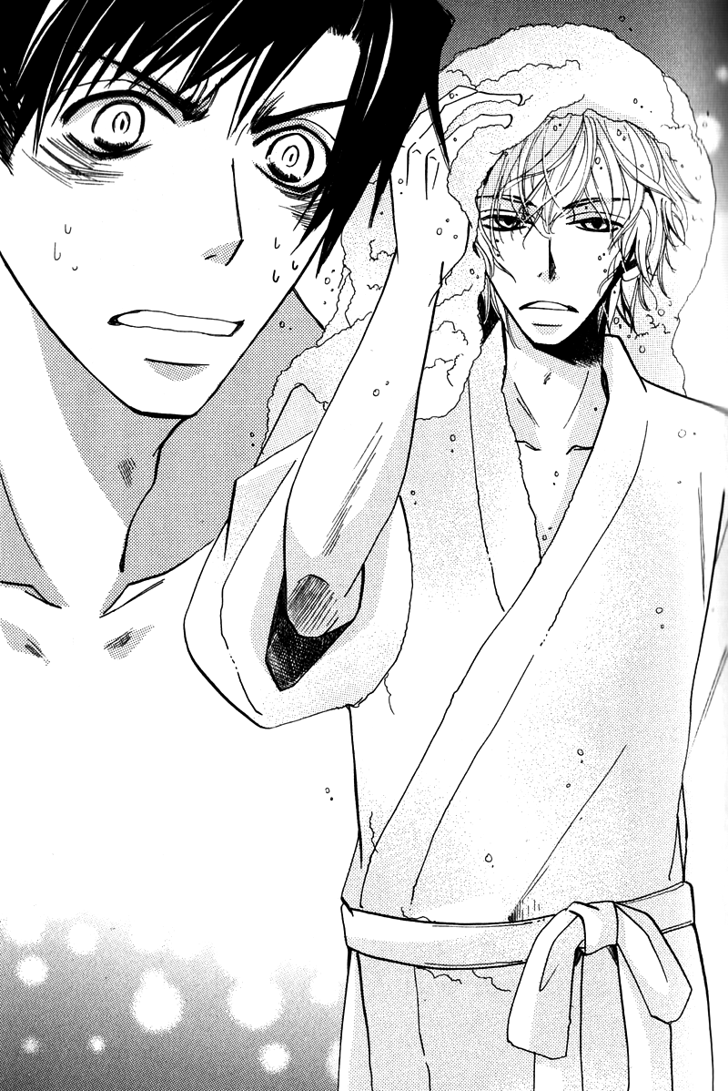
With perfectly balanced and arranged long, almond-shaped eyes and thin lips, his composed expression made it quite evident he hadn’t just woken up.
Yokozawa did his best to try and force his blanked-out mind to restart, releasing a trembling voice. “…Wh–why are you here…?!” He couldn’t wrap his mind around why on earth he would be here, in this hotel room, stark naked with someone he normally hardly ever spoke to outside of work.
Kirishima maintained his cool in the face of the dumbfounded Yokozawa. “What’s with that? You trying to say you don’t remember anything about last night? Take a hint from your surroundings and I’m sure you’ll figure it out.”
“My–surroundings?”
Under any other circumstances, his ire would’ve risen at the arrogant way Kirishima addressed him with those thin lips, but right now he had no such leeway. Were this a manga or a TV drama, this would’ve easily been concluded as a plot device where two people get drunk and wind up sleeping together–but that typically involved a man and a woman, and they were both men here.
…But while he wanted to reject that idea outright on those grounds, his powers of persuasion were lacking just now on account of the fact that he didn’t remember anything.
In Yokozawa’s mind, he’d always known that he wasn’t gay–and yet the person he’d held an unrequited love for all these years had been a man. It stood to reason, then, that the hurdle towards homosexuality for him was substantially lower than for complete heterosexuals.
For now, the top priority was remembering what he’d done the previous evening, anything at all! He frantically scoured his hazy memories and drifted back to just when he’d left the office…

Yesterday had been the absolute worst day of his life.
After having a stop firmly put to the love he’d held onto for so long, unable to give it up, he’d sulked his way into an izakaya on the way home from work. Downing drink after drink with little thought to the taste, simply wanting to get drunk, he now recalled how Kirishima had happened to wander into that same bar.
“Kirishima-san…what are you doing here?”
“Was looking for a place to get out of the rain and figure I’d grab a bite while I was at it…but, hey–aren’t you hitting the bottle a little hard there?”
“‘Course not. What–you alone? Then here, grab a seat. Hey–can I get another one of these? Or, wait–no, make that two more.”
They’d rarely shared a drink together like that, even if they met outside of work, so perhaps he’d just been a bit lonely and looking for some company. Regardless of what he’d been thinking when he’d done it, Yokozawa had forced Kirishima into taking the seat next to him. Perhaps realizing that it was futile to reason with a drunk, Kirishima sat down and joined Yokozawa in his pity party.
He recalled how they discussed how well the sales of one of the newer authors were going, griped about how reprints weren’t coming fast enough, complained about a rather popular author coming down with something and having to put off their manuscript, all of these bits of discord that they normally kept bottled up inside he now spilled forth freely.
But after that…he couldn’t remember anything.
“So you really don’t remember at all?”
Lifting his head at the rather shocked comment, Yokozawa found that Kirishima had finished getting dressed while he’d been deep in thought. As the final touch, he was slipping his watch onto his arm. Gazing upon such a well-composed figure as his, Yokozawa grew suddenly self-conscious, considering his own sleep-ruffled hair, stubble-lined jaw, and the fact that he was still very much naked.
“Yeah–it’s no wonder, if I really did drink that much.”
When he spoke the excuse, Kirishima threw him a suggestive glance and teased him with a reprisal of his own words from the night before. “Really, now? After you told me ‘course not’ when I asked you if you’d been drinking a bit too much?”
“That was…” While he did faintly recall saying something to that effect, it was rather underhanded to bring up the idle musings of a drunk man here. Still, Yokozawa had no place to object here.
“…Well, I suppose salarymen do occasionally have days where they just want to get pissed. But pulling others into it as well is something of an inconvenience, so try to be a bit more careful in the future.”
“I know that well enough without having you tell me, thank you very much.”
“Take advice your elders give you without the back talk.”
“What–what are you doing?!” Kirishima had reached forward and was ruffling Yokozawa’s hair roughly–and the moment he moved to brush the hand away, a memory floated through his mind at the feeling of those fingers threading through his hair.
This wasn’t the first time he’d been touched by those fingers–he could sense it. Memories of the skin were proof that you had interacted with another person.
He didn’t want to accept it…but they’d probably done that. Yokozawa could feel his body heating up bit by bit as he drew his own conclusion. It was too frightening to go so far as to imagine in any detail what had happened; no matter how you looked at it, it was clear this was not a pretty picture.
“…What’s with you getting so quiet all of a sudden? Started remembering last night a bit, have we?”
It was no use crying over spilled milk. What mattered most to Yokozawa just at this moment was simply the matter of had he been on top…or bottom.
He didn’t feel any particular discomfort or strangeness, so they couldn’t have gone all the way. And while he couldn’t picture himself getting involved with Kirishima of his own accord, he was even less inclined to picture himself being pushed down.
But more than that, it was quite a shock to realize that Kirishima even swang that way. They weren’t close, so of course they knew nothing of each other’s private lives–but noticing that he wore a ring on his left ring finger, Yokozawa assumed he was married. Had they really done something together?
“…Can I ask you something?”
“Depends on the question.”
Realizing that unless he asked directly he’d never get a proper answer, Yokozawa got right to the point: “Are you gay?”
“Aren’t you?”
“Of course not!” The reflexive negative response was due to the fact that he really had never thought of himself as gay before. After all, he’d only ever fallen in love with one person of the same sex. So in all truth, he’d never really figured out if he did like men in general, or if it was just Takano.
When they’d first met, Yokozawa had had a girlfriend. But he’d always felt more comfortable spending his time with Takano than with his girlfriend, and shortly after devolving into only meeting up now and then, the whole thing had dissolved naturally. Since then, he’d never had a steady relationship. Others had fallen for him often enough, but he’d never made any moves of his own volition.
“What’s with that response? You were griping last night all about how you’d just gotten your heart broken by another guy. Do you have any idea how many times I had to hear you go on and on about the same thing?”
“I said that?!” At Kirishima’s words, his blood ran cold. Shit, how much had he said? This could be big trouble if he’d spoken Takano’s or Onodera’s names aloud…
“You seriously don’t remember anything, do you? You were downright annoying, going on about how I could’ve made him so much happier than that guy and Don’t you think so, too?? But–anyways, don’t get too worked up. You never said his name.”
“I didn’t?!” It was pathetic, the way he had latched onto Kirishima’s comforting words.
Perhaps he’d had a look of desperation on his face, for Kirishima huffed while watching Yokozaw closely, “You don’t have to ask me while looking so damn tragic; it’s the truth. You never said who the guy was… But, given how worked up you are, I can probably guess that he works at the office, huh?”
“Th…that’s…of course not.” A chill ran through him at the sharp deduction, and he pasted on a poker face and lied through his teeth. He had to applaud himself for being able to get that shit-faced and still not breathe a word.
“But–it was a guy, right? The person you’ve had feelings for all this time.”
“That’s…” He couldn’t remember how far he’d spoken the previous evening, but given the confidence with which Kirishima was saying these things to him, it was unlikely that he was asking leading questions.
“This isn’t one of those books Sapphire spits out, you know, so don’t try to tell me Oh the person I fell in love with just ~happened~ to be a man. There’s no way you’d have romantic feelings for another guy without something there to begin with. If you weren’t gay–you wouldn’t be worrying this much anyways.”
Seeing the way Kirishima’s shoulders shook with repressed laughter as he teased, Yokozawa unthinkingly raised his voice. “Wor–who said I was trying to–and, why the hell are we talking about me?! I asked you a question!” While he’d hardly meant to be worrying over it, not being able to remember anything put him in an awkward position. If this whole affair turned out to be true, he was going to die of embarrassment.
He fully understood that he was being goaded on by cheap teasing, but he somehow couldn’t control himself when dealing with Kirishima, leaving his emotions to rise to the forefront.
“Why, I never realized you wanted to get to know me that much. And actually–I’m fine either way. I’m attracted to strong-willed types, regardless of gender.”
Meaning for him, this entire thing was no big deal at all, therefore leaving Yokozawa with no way of determining what was truth and what was fiction.
“You sure you don’t go for guys? You were probably a total jock at an all-boys’ school.”
“What the…” Yokozawa felt humiliation well up within him, sensing that he was essentially being told any guy will do for you. But while he understood that if he raised his voice and let his emotions get the better of him, he’d just be brushed aside, he still wanted to get in just one good retort, and sarcastically responded, “And what about you? So anyone’ll do for you? You’re pretty damn low for making a move on a drunk guy.”
“What’re you going on about? You’re the one who was clinging to me begging me not to leave you alone.”
“There’s no way in hell I’d ever do something like that!”
At Yokozawa’s snapped objection, Kirishima smoothly returned, “You really wanna say something like that when you can’t even remember? If you’re so sure that’s not what happened, dig around in your head a bit more and then talk.”
“..........”
Cutting Yokozawa’s words off with a finger under his chin to force him to look up, Kirishima spoke with a coldness to his voice. “I love taking prideful guys like you down a peg or two.”
“Stop fucking around! Don’t get so full of yourself!” Yokozawa let himself ride the wave of anger and tried to shove Kirishima down, grabbing at him. But before his fingers could find purchase on the man’s collar, he found his arm wrenched to the side and instead he was pushed down onto the bed on his stomach.

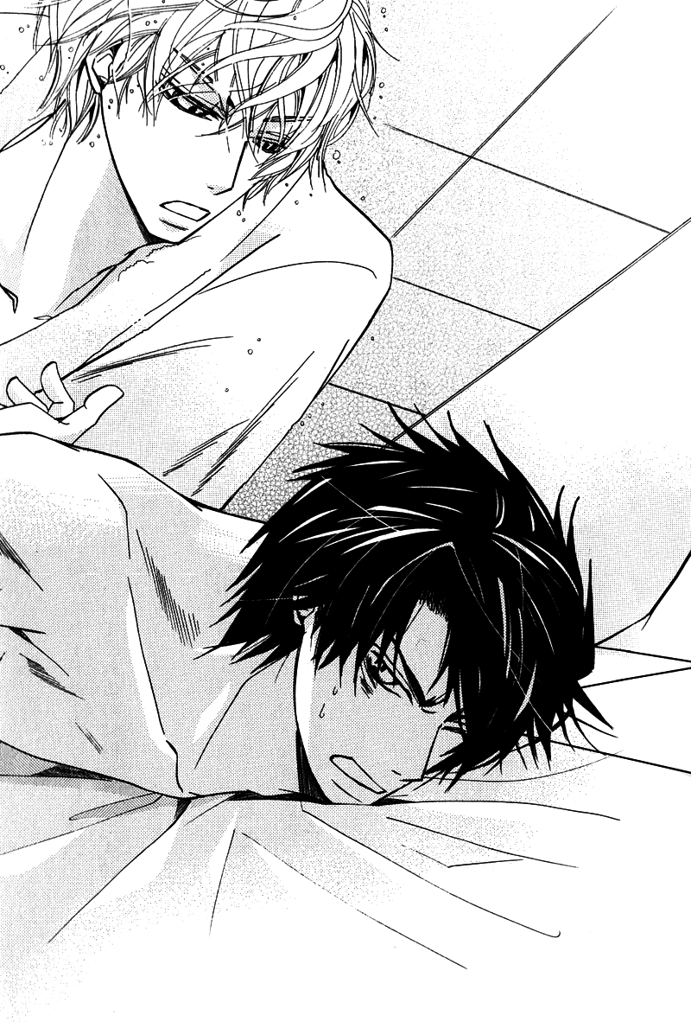
“I’m afraid I can’t condone such violence.”
“Ow–ow ow ow, dammit! L–let me up!” He groaned in pain at the move Kirishima had pulled, never having imagined he could have been so easily pinned down as this, and the more he struggled, the sharper the pain felt.
“You really shouldn’t underestimate people, you know; you never know what kind of tricks those who appear weaker than you might have up their sleeves.”
“I don’t need your lecture–let me up already!” Given the skill with which he’d accomplished the act, the guy probably had some sort of martial arts background–but Yokozawa really didn’t care one whit about that at the moment.
As he struggled impatiently despite the pain, Kirishima at last released his hold.
“Guess the wild bear of the sales department was all bark and no bite, huh? You’re quite a ways away from being able to take me down.”
“Dammit…” Sitting back up, Yokozawa began to rub at his painful joints and glared up in retribution at Kirishima, who looked down upon him with his hands on his hips. While he may have seemed slender clothed as he was, going at it as they just had it was obvious that he had quite a body on him.
The chest beneath his jacket was tough and solid, with no slack to be seen, and his clothes had been well tailored to smartly show off his sturdy figure. To go after this guy when he was outmatched in words and body…was digging his own grave. He could do little more than sit there quietly, shaking in humiliation.
“I’ll also add that looks have nothing to do with anything, so don’t try to play dirty. That goes for both men and women.”
“Huh?”
“I’m saying what’s on the inside is what counts. Oh–and by the way, your suit’s hanging in here.” Kirishima knocked on the closet door. ”You should take the opportunity to just sleep in til check-out. Your head’s probably still fuzzy from the alcohol, right?” He’d taken the trouble to hang up Yokozawa’s suit…it was a small nicety.
“And what’re you doing?”
“I’m headed back to my place for a bit. I’ve paid for the room already–so all you have to do when you leave is return the card key.”
Leaving together would’ve been awkward, to say the least, so Yokozawa counted himself lucky that Kirishima was leaving first; he got tired just thinking about the sight of them lining up at the checkout counter together.
But at that moment–a single question invaded his sense of relief: “…Oi, wait a minute. What happened with yesterday’s tab?” Yokozawa didn’t recall leaving the bar or even pulling out his wallet–but given that he was sitting here as he was right now, it must mean that he had either paid and not realized it…or skipped out on paying altogether.
“Isn’t it obvious? I paid it. You were so far gone you couldn’t even walk straight; it was hard shoving your big ass into a taxi.”
“Then maybe you should’ve just left me alone.” If he’d done so, then Yokozawa wouldn’t be here listening to him complain and none of this would’ve happened in the first place. While he realized none of this could be helped now, he still couldn’t help regretting it. ”
“Not like I had any choice, you know? I happen to like that bar–I’d have been pissed if I got kicked out cause you went and made an ass of yourself there.”
“Oh, well then I do apologize.”
Hearing this monotone apology, Kirishima whipped out his wallet and pulled out a long receipt. “Hand over your part of the bill.”
“I was going to! You think I want to have to owe you anyth–…wh-what the hell is this amount?!” A set of numbers greater than he could have imagined were lined up at the bottom of the bill he snatched from Kirishima; it was a whole order of magnitude greater than he typically spent out drinking. He’d spent more out drinking in one night than he typically did in a whole month.
Noticing the way Yokozawa’s face had gone white, Kirishima took the opportunity to explain the extraordinary amount. “You were ordering nothing but the really pricey stuff, you know. That’s why I told you to take it easy.”
“..........”
While Yokozawa desperately wanted to ask why he hadn’t tried harder to stop him, he understood that it hadn’t been Kirishima’s place to do so in the least. And even if he had tried, Yokozawa likely wouldn’t have listened.
“I’ll let you save face: let’s split the bill evenly. I make more money than you anyways.”
“I don’t need your pity! I’ll pay for whatever I ordered!” It was Yokozawa’s policy to take care of himself with his own two hands, even if that required a bit of work. But unfortunately, Kirishima saw right through him and chuckled lightly.
“Stop being so stubborn. You went white when you saw that receipt! Now be a good little boy and do as I suggest.”
“You…” It was humiliating being seen through like this, but truthfully, his wallet was really going to take some damage from this until payday. Still, he wanted to settle this debt properly. If they’d been closer, they could’ve just settled this the next time they met, but his relationship with Kirishima extended no further than the fact that they worked in the same company.
Unfortunately, he didn’t have enough cash on him to pay in one lump–he had no choice but to owe Kirishima for this.
“Just–wait until payday, would you? Once I’ve got the money, I’ll be sure to pay you back in full.”
“I told you half was fine, didn’t I? Do you seriously not want to owe me anything that much?”
“I just don’t want you going out of your way for me is all!”
“I see… Well, it’s nice that you’ve got such a strong sense of responsibility. I suppose I’ll take you up on your offer then. Oh–and I forgot one more thing. You’ll be working as my servant for a while.”
“…Excuse me?” Yokozawa found himself unable to keep up with the sudden shift in topic and blinked several times in quick succession.
Seeing his puzzled expression, Kirishima explained slowly, as if giving directions at work, “I’m saying that, for the time being, you’re not to go against anything I say.”
“And–why exactly do I have to do that?” He couldn’t understand a word this guy was saying. Even taking into account the context of their conversation thus far, he could find nothing foreshadowing this.
“Because you’ve chalked up one hell of a debt. Dragging me into your drinking party, making me listen to you bitch, then making me pay the tab and look after your drunk ass…that alone is a lot.” With no room to object, Yokozawa could do little more than sit quietly. “Plus–I’m sure you don’t want these embarrassing pictures to get out, right?”
“…’Embarrassing pictures’…?” From his words, it was impossible to understand whose pictures they were and just how they were embarrassing–but it still sent a chill up Yokozawa’s spine.
“You sure are slow–the ones I took of you last night, of course.”
“Wha–when did you take those?!”
“I’m sure you can figure it out yourself. You work for a publishing company; try using a bit of imagination.”
“Stop fucking around–delete them! Right now!” He leapt up from the bed and reached for the cell phone in Kirishima’s hand, trying to snatch it away, but Kirishima smoothly stepped to the side out of his way and left him making a fool of himself.
“Why on earth would I do such a wasteful thing as that? If you want me to delete them, then just do as I say without protest. I’ll delete them when I’m done playing master-and-servant with you.”
“What the hell are you thinking…?!” He never would have suspected that someone holding such a position as Editor-in-Chief would stoop so low as to threaten someone like this.
“Who knows? You really think I’d reveal my ulterior motives just by you asking? Well–I’m off. Have fun dreaming about how embarrassing you looked~”
“Wa–wait! OI!!”
But Kirishima was gone, leaving him with only those teasing words. Yokozawa couldn’t even chase after him, as he was still naked.
“…This is absolutely horrible,” Yokozawa whispered in a soft groan, left alone in the quiet room sitting in bed with nothing but his underwear on.

The storm from the previous evening appeared to have let up now that it was morning. The sky after the storm was a light blue, and in ironic contrast with the sunny skies above, Yokozawa’s midsection squirmed with nausea from the hangover.
Kirishima had urged him to sleep in until just before check-out time, but he wasn’t so insensitive that he would’ve been able to just laze about in that condition. He’d hopped in the shower to shake off some of the fatigue, and barely an hour after Kirishima had left, Yokozawa also checked out.
The suit he found hanging in the closet had been nicely dry-cleaned for some reason–but there was no telling what people in the office would think if he showed up wearing the same suit he’d left in the day before. Given that he also needed to feed his cat, he decided to drop by his apartment first before heading into the office.
On the way, he stopped by a drug store and picked up a turmeric energy drink, downing the contents while understanding that it would be some time before it kicked in.
“Achoo!”
The man walking in front of him had been sneezing for quite some time now. Was the cold going around again? Perhaps the reason he was feeling like utter crap wasn’t due to the alcohol but was in fact the start of a cold. Resolving to drink some of the antifebrile he kept in his desk for just this reason, just in case, he reached a hand out to forcibly hold the elevator doors open as they started to close.
“Wait, I’m getting on!”
“Ah… G–good morning…”
“!!” The person who’d boarded before him was none other than the newbie from the Emerald editing department, Onodera Ritsu. He was also the person Yokozawa least wanted to see right now. Yokozawa grimaced and faced forward. “Oh. It’s you. Don’t make me look at people I don’t want to see first thing in the morning.”
“…I’m sorry…”
Granted, Onodera probably didn’t want to see him either; it was rarely a pleasure to confront one’s love rival. Unable to stand the silence which stretched between them, Yokozawa broke it of his own volition. “You’re here early for an editor. Are you just that slow at work?”
But Onodera didn’t respond to Yokozawa’s sarcasm with his usual fervor. “That’s not it. I just have to turn in the project proposal for the next volume. I figured sooner was better…”
“You know, it’s not like you have to be so gung-ho about a job you don’t even like. Shouldn’t you be writing up your request to transfer to literature first?” This was neither sarcasm nor teasing; he truly did feel that if it was a job he hated, then there was no need to continue it.
Not everyone could do what they loved for a living, sure; but it was still possible to find worth and meaning in such a career. They weren’t sheltered little children, so if it was impossible to change his feelings for the line of work he found himself in, then to continue it was disrespectful to both the job and his coworkers.
“Ah–umm–! I really…do feel that I’d like to try my hand as a manga editor!” Onodera jumped in, cutting off Yokozawa, and his breathing grew somewhat labored. “I know I still have a lot to learn, so I’d appreciate it if you could help teach me as well. E–even though, to be honest, I don’t really get along well with you. Takano-san says you really know your way around the business.”
To think that the day would come when Onodera would say something like this to him of his own accord…perhaps pigs would fly today. When the guy had entered the company, it had seemed like he’d looked down on the manga division, but since being assigned to Emerald, perhaps his way of thinking had changed.
…And it was probably all thanks to Takano’s influence.
The pain he’d put off as being just part of the hangover came back lancing through his chest. The half-healed scar in his chest ached with a throbbing pain. In an effort to cut away that scar by his own hand, he sniped back arrogantly, “Of course I do! But it’s way too early for someone like you to be begging tips off of me!”
Onodera took a small breath, and Yokozawa suddenly felt ill, realizing he’d spoken the same words as Kirishima had earlier. Perhaps just because he wasn’t feeling well, having to face Onodera like this made his scolding words even harsher. Realizing that it wasn’t wise to crush his spirit when he finally seemed to actually have some fire to him, he softened his next words to Onodera, who had recoiled next to him. “Well, though I don’t want to, I will admit: You do your job well.”
“!!”
Onodera was clearly shocked at Yokozawa’s words. The elevator stopped at the 3rd floor, and the doors gently opened. Throwing a glance back at Onodera, Yokozawa stepped off onto his floor. Even though the Emerald editing offices for the shoujo manga division were on the 4th floor, Onodera stepped off with him. “That proposal–it was well done. You can move ahead with it.”
“Eh?”
“But if you can’t pull it off, then it’s worthless. I’m doubtful as to whether or not you’ll actually be able to do so, but I’ll cooperate. Because it’s my job.”
His eyes went round, and he bowed, flustered. “Ah, right! I look forward to working together!!”
“And one more thing.” He had to know–this one thing, he had to confirm. If he let this chance slip by, they would never have the chance to talk alone like this again, and he didn’t want to anyways. He took a deep breath and tried to keep his voice as even as possible as he spoke. “Are you in love with Masamune?”
“!!”
Takano had told Yokozawa his feelings on the matter himself the previous day, letting him know full well that he had absolutely no chance of cutting in. But he still didn’t know how Onodera felt.
The guy seemed as if he had at least some fleeting interest, but he had to confirm whether or not they resonated with Takano’s own.
After a long, almost painfully heavy silence, Onodera nodded shortly, his face bright red. “…Yes.”
Yokozawa let his eyes slide shut, then opened them again slowly. “However you feel… If you hurt him, I won’t hesitate to take him back. Just keep that in mind.”
He left Onodera dumbfounded where he stood and headed into the sales offices. He sensed the elevator doors behind him open and close again. He stalked across the completely empty floor and slumped into his chair. Lifting his palm to his forehead, he whispered weakly, “…What the hell am I doing…?”
That hadn’t been a declaration of war at all; he’d simply wanted to give Onodera a little push. If he’d really intended to actually take Takano back, then those words were just going to backfire on him.
Perhaps he’d given the guy a hand because he’d sensed that Onodera was really, truly serious. The hesitation and faltering had disappeared from his expression.
Something…had happened between them the previous night, it was almost certain.
“…Maybe someone like that suits him more.” For a guy who tended to overthink things and get depressed beyond belief, dating someone seemingly weak but with pure, uncomplicated feelings like Onodera might…actually work out in the end.
He just wanted Takano to be happy. Precisely because he knew how bad things had been before, Yokozawa wanted this more than anyone else in the world. While he had wanted to be the one to make the guy happy, it couldn’t be helped so long as Takano himself didn’t feel the same way.
“…Time to get to work.”
It wasn’t like him to sit here wallowing heartbroken forever. If he could just immerse himself in his work, then surely the pain in his chest would eventually fade.
Lifting himself up and making the back of his chair squeak in protest, he opened up his laptop and turned on the power.

None of his coworkers wanted to get closer to Yokozawa than was absolutely necessary, given how he’d been working like a demon since that morning. However, as he had no inclination to make small talk just now anyways, he considered this all for the best, and after finishing his out-of-office work, he’d immersed himself in paperwork for the remainder of the day.
“….Dammit.”
Every time he moved his arms, his starched undershirt tugged at him tightly, reminding him of that morning that he just wanted to forget. Given that he could hardly complain to someone else about having to see a workplace superior in his bathrobe, he was left to anguish alone.
In an attempt to forcibly remove the images from his head, he threw himself into his work, taking care of each piece of business one by one. He’d already finished preparing the paperwork for the print-run decision meeting at the end of the week, and given that it’d been decided to add in another run of the back issues for a series about to release a new volume, the stock shortages should have been taken care of.
“All that’s left…is that project proposal, huh…”
Yokozawa’s department dealt, by and large, with promoting comics sales–and their most important project of the moment was Za Kan. Not only were plans under way for a movie version, but they also had to ensure that sales of both the new volume as well as back issues went well. Selling books was the very duty of the sales department.
Quite a bit of money went into putting out a movie, and with the increase in staff came an increase in labor and overall costs. If they couldn’t rake in a net revenue exceeding those costs, then there was no point in all the promotion going into it. In order to keep a series popular with the fans, you had to constantly bring in new ones.
Regardless of whether a series was selling well or not, the sales department were always the ones getting told to Sell more!! To carry out that mission, they were kept working like dogs day and night. And while he admittedly barely had room to even breathe this way, it was a job Yokozawa felt quite suited for.
He’d chosen to work in the publishing industry for the simple reason that he loved books. Given that he’d never wanted to be involved in the making of books, as with authors or editors, he’d initially intended to work for a regular trading firm. However, one day, he’d happened to catch a television spot describing work in the sales department for a publishing house and changed his ambitions completely. After all, it was no difficult task to go out and meet with people, and if he was going to have to sell things to people, he may as well sell them something he himself liked–that was how he viewed it.
It had only been instinct at the time, but even now he felt that he’d made the right decision. He felt that he was doing worthwhile work, and working at a place like Marukawa Shoten, which was full of workers with strong personalities of their own, was easy even for a strong-willed person such as himself.
“…Hm?”
In putting together all of the paperwork from the individual departments, Yokozawa realized that he still lacked the data regarding the promotional materials to be used in the campaign starting the next month. The sales department was responsible for ordering and putting together all of the point-of-purchase items and posters and the like, but without the raw images from the editing department, making such orders was impossible.
Yokozawa called out to a man seated diagonally across from him, a subordinate who’d just gotten off the phone. “Oi, Henmi! Have we gotten the promotional materials data from the people at Japun yet?”
“No, not yet. They were supposed to get it to us this week, but…”
“‘This week’? Do they realize it’s Friday now? Don’t tell me they’re planning on bringing it in Sunday night or something, right? Get over there and see if you can’t light a fire under their asses. Nothing’ll get done by a simple phone conversation.”
“Y-yes sir!” Henmi quickly stood from his chair at Yokozawa’s scolding; perhaps because he was worked up, Yokozawa had been harsher than usual.
Reflecting that he’d better support the guy with this project from here on out, Yokozawa let his gaze wander around the floor–and was startled to find Kirishima standing at the entrance to their offices.
“Geh!”
Henmi, who’d just been on his way to the Japun editing offices, panicked and rushed over to greet Kirishima. “Kirishima-san! This is quite a surprise! You rarely come down to the sales department. I was just on my way up to see you!” Others around them appeared equally curious as to just why Editor-in-Chief Kirishima had come all the way down to the sales floor.
“Just brought by the data for the promotional materials. Sorry it took so long. Some of our people had meant to bring it over a while back, but it wound up getting buried under some other documents and we just unearthed it now.” He handed a data CD to Henmi.
“Thank you, and I’m sorry to have had the editor-in-chief himself bring it all the way here…”
“Nah, I was on my way anyways.”
“‘On your way’?” Henmi sounded audibly confused at Kirishima’s words. No surprise, as there was little likelihood he could guess what Kirishima’s true reason for coming could be.
Yokozawa had a very bad feeling and turned his back to avoid meeting Kirishima’s gaze, instead pretending to focus on his computer screen. But naturally there was no way something like that was going to keep him from being noticed, and Kirishima easily found him. “Oh there he is. Yokozawa, come on–we’re going drinking.”
“?!”
The entire floor broke into murmurs at Kirishima’s invitation, unable to believe that Kirishima had come all the way here just to invite Yokozawa, with whom he’d clearly never had any relationship outside of work, to go out for a drink. Indeed, given that they’d gone at it rather heatedly a few times during meetings, several had in fact thought them to dislike one another.
Strolling over to Yokozawa’s desk, he repeated his invitation again for good measure. “Did you not hear me? I said let’s go get a drink.”
“…I’ve still got work to do.” He made a small attempt at resisting, but Kirishima just snorted derisively.
“Huh? There’s no way you of all people haven’t met your quota on time. What the hell have you been doing all day?”
“Shut up! This is next week’s work!” As soon as he’d let the words fall from his lips after getting riled up, he realized he’d been goaded on. The expression on Kirishima’s face as he grinned down at him was irritating beyond anything.
“Then do it next week. These guys’ll be able to work better without a loudmouth like you here anyways. Right?”
Henmi, who’d been watching the both of them with unguarded interest, responded in a flustered manner as Kirishima suddenly turned the conversation to him. “Eh? Ah well, that’s…” That he didn’t outright deny the implication…meant that the agreed with it, at least in part.
When Yokozawa directed a harsh glare at Henmi, Kirishima reached forward and ruffled his hair roughly. “What the–hell are you doing?!”
“Stop giving your underlings a hard time. It’s just cause you’re making such a scary face is all! Cut them some slack. Now hurry up and get your shit together and let’s get out of here.”
“And why on earth would I go out with you?” Tired of playing this game in front of such a large audience, he unthinkingly let out his true thoughts. But Kirishima remained cool even in the face of Yokozawa’s unpleasant expression.
“Aren’t you a little young to be going senile? Don’t tell me you’ve already forgotten about this morn–”
“…!” Yokozawa loudly pushed his chair back in an effort to cut off Kirishima’s words. He’d never suspected that Kirishima might threaten him like that in the office of all places. Cutting in before he could say any more stupid things, Yokozawa raised his voice and spoke. “Ah! Oh that’s right! We were supposed to have that chat about the campaign!”
“Exactly. So glad you remembered!”
Yokozawa seethed at the shameless smile the guy pasted on; but if he let himself blow up here, there was no telling what sorts of rumors might sprout up. “Well, shall we go, then?”
He’d never used expressions like this even while making the rounds on business. If he’d known this sort of thing might come up, perhaps he would have worked more on his forced smiles. Yokozawa brushed past Kirishima out the door and left the office, fleeing the curious gazes of his coworkers.
“Well? Delicious, right?”
“…Yeah, it is.”
Taking a sip of the Hokuriku sake Kirishima offered him, he had to admit it was delicious enough to make his eyes pop out. The bouquet like flowers that wafted through the nose and the sweetness that spread across his tongue were both top-notch, and the aftertaste left him feeling refreshed. It was frustrating to agree so easily, but delicious things were delicious, regardless.
After enjoying a light meal, Kirishima had taken him here to this bar specializing in Japanese sake. The place had a completely different atmosphere from the usual haunts he frequented with the other sales department folks and customers. Even the little bowl they received their snacks in was of fine quality, and the employees all conducted themselves with the utmost politeness, lacking the usual pushiness noted in chain restaurants; it was a comfortable place to spend time.
“You’ll be turning 30 soon; try learning how to drink properly while you still can.”
“I hardly ever drink like that, I’ll have you know.”
“Heeeh…is that so?”
“Yes, that’s so! And anyways, I’ve still got a good two years before I hit 30.” Feeling as if Kirishima wasn’t going to believe him, his tone rose in strength, and realizing that he’d raised his voice, he quickly glanced around the room. Thankfully, they’d been seated fairly far inside, and it didn’t seem that any of the other customers had noticed.
“Those two years’ll fly right by.”
“Shut up.”
Kirishima simply sipped his sake happily, enjoying watching Yokozawa get riled up. Realizing that it was useless reasoning with Kirishima, Yokozawa faced front again and raised his Edo-faceted glass to his lips. He savored the mellow flavor on his tongue and took in the rest of the bar.
The clientèle seemed to be comprised mostly of men older than Yokozawa, though there were a few women there alone. With warm, indirect lighting, the dim bar had a rather chic feel to it and was quite cozy. In the past, he’d avoided these kinds of bars that dealt with high-priced sake because they didn’t suit him, but a place with this sort of atmosphere he probably wouldn’t mind coming back to alone. He wondered who Kirishima usually came here with.
“…So are you having fun, dragging me to this kind of place?”
“I really wanted to see your grumpy face.”
“You’ve got a really twisted personality, you know.”
“I actually get complimented on my personality rather often.” Yokozawa felt himself start at the way the corners of Kirishima’s lips lifted whenever he smiled.
He spoke viciously, doing his best to avoid getting sucked into the atmosphere surrounding Kirishima, who seemed to be purposefully trying to get him to frown. “I’m sure your subordinates have a hard time getting work done under a boss like you.”
“There’s no way I’d ever do anything cruel to my cute little underlings. I’m sure they’re a hell of a lot happier at least than those poor sods under you.”
“That’s not–!” True…he tried to say, but then recalled Henmi’s earlier reaction. If his attitude was actually sucking the life out of those around him, then that was hardly a good road to be walking down.
Not everyone was super competitive. For every hard-worker who could soundly speak his mind, there was another who suffered under the stress.
“Your guys are doing good work over there; let them know it now and then. It’s a world of difference just saying little things like ‘good work today’ and ‘thank you.’”
“…n’t think I understand that already?”
“You understand it but you still don’t do it, right? Not much longer and the only one who’ll be willing to put up with your tsundere shit will be your lover.”
“Who’re you calling a tsundere?!”
“Though you’ve got hardly any dere to you, I’ll admit.”
“What the hell’s that supposed to mean?” Quickly losing the drive to keep up with him, Yokozawa shifted and turned the other way, feigning distraction by downing his drink. The taste was great, and it slipped down his throat smoother than water. If he wasn’t careful, it’d be all too easy to drink too much of this.
Kirishima noticed him staring bitterly at his empty glass. “Want some water?”
“I’ll be fine; I’m not downing them at the same speed I was yesterday anyways.” He should be fine if he quit right about now. He wasn’t a lightweight to begin with; it was only that he’d drunk far more than usual the previous evening. “Anyways, why are you being so damned persistent with me?” Until just now, he’d been distracted with being irritated with the way Kirishima flaunted himself, but when he stopped to think about it, it was rather strange.
He had to have companions his own age in the company; there was no reason to invite Yokozawa out like this. And drunk though he may have been, he hadn’t needed to make a move on a guy most of the company knew as a ‘wild bear;’ if he felt like it, Kirishima could surely snag most anyone he wanted.
He couldn’t understand the reasoning behind going out of his way to make someone who had absolutely none of the charm Kirishima did come along with him just because they’d happened to meet at a bar and he’d seen Yokozawa at his weakest.
“Didn’t I tell you? I like messing with prideful guys.”
“You just keep babbling stupid shit, don’t you? And if you’ve got a thing for prideful guys–our company’s full of them, if you haven’t noticed. Why’s it gotta be me? Why not, I dunno…like, Takano…” He unthinkingly had torn open his own wound with his words. There was no way he wouldn’t suspect something now that he’d brought up that name here of all places. Praying that Kirishima wouldn’t notice the way he was shaking inside, he hesitantly glanced over.
“Takano? Nah, he’s no good. He may be prideful, but he’s more sensitive than he looks; feels like he’d go down with one hit. He probably wouldn’t be able to give much of a challenge if I really went after him.”
“..........”
He had to admit, he was impressed with how good a judge of character Kirishima was. Just as he said, Takano definitely had a sensitive side to himself. He could put up a good bluff, but once he got down it was for the long haul, and he wasn’t good at picking himself back up. But in that same vein, if he let you get close to him, he’d open his heart to you and trust you no matter what. Granted it had been far more obvious back when they were in college, and on entering the workforce and growing up, he seemed to have mellowed out some. But his basic elements still hadn’t changed in the least.
“I don’t go for greenhorns like that who’re still full of themselves.”
“Hey–you do know he and I are the same age, right?” He understood that he tended to look older than he actually was, but if Takano was a greenhorn, then surely he was as well. He couldn’t agree with Kirishima’s point.
“I’m talking about on the inside. Though well–I guess he was able to get Emerald back on track because he has that young sensitivity to him. But you’ve got your own good points to you; you don’t have to be so sensitive to the fact that you’re the same age.”
“I–I’m not sensitive to it–!” He seemed to have gotten the idea that Yokozawa saw Takano as a rival. While it was leagues better than having him realize that Takano was the guy who’d rejected him, it still irritated.
“Really? Well, I will admit you’re something of a greenhorn yourself, the way I see it. I wouldn’t mind teaching you everything from head to tail, though, if you want.”
“…Yeah, it’s not just your personality that’s twisted, your hobbies are too.”
“I happen to think I’m a rather good judge of character, personally.”
“Look who’s talking.” While he didn’t want to put himself down, per se, he couldn’t fathom what about his hard-assed self was interesting to this guy. If he was really intent on dragging someone around with him, wouldn’t it have been better to find a meek little subordinate of his own?
“You know, for a guy who’s got such a big attitude usually, you sure have a low opinion of yourself. You’re good at your job and you’re not bad on the eyes. Have a little more self-confidence, would you?”
“Wh-what the hell is that? You’re grossing me out here.” He grew flustered at being flattered so suddenly. He couldn’t help feeling like praise falling from Kirishima’s lips was actually a trap somehow.
“I can see you’re not used to being complimented. You don’t have to blush.”
“I’m not blushing–!”
“Hmm? You’re not really convincing anyone with a face that red.”
“Stop saying whatever comes to mind! Anyways, how the hell can you tell if someone’s sexy or not in a dim bar like this?”
“You got me there.” Kirishima shrugged his shoulders at Yokozawa’s point. Yokozawa sighed, fed up with the way he still looked like he was enjoying himself somehow. They’d never interacted much outside of work together before anyways, but he still would never have imagined Kirishima to have such an easy-going personality.
Inside Marukawa Shoten, he was known as a major hit maker, having helped release more hits than anyone else in the company, and Yokozawa had always imagined him to be much more of a workaholic–but the real thing was quite different.
“…I’m going to the toilet.”
“Didn’t you just go? Maybe you’re older than you think~”
“Shut up!” Kirishima saw him off with an easy smile, and with a feeling of unease, Yokozawa slipped into the bathroom situated further inside the bar.
He stood in front of the clear mirror, not a smudge on it, and sighed deeply. He tended to lose his temper quickly when it came to Kirishima. He knew he hadn’t been drinking that much tonight, but for some reason, he couldn’t keep calm next to that guy. Whether it was because he was someone who’d seen Yokozawa at his weakest or perhaps because he was just an uncomfortable presence to be around in general, he couldn’t tell. He’d always felt a sense of unease about Kirishima before, but as they’d never had to share space for very long outside of meetings, he’d never been able to figure out what exactly it was that threw him off.
But even without knowing why he felt this way, there was still a way to deal with it. All he had to do was distance himself from the man in question. If he could do that, he could escape from this constant irritation as well. “…Easier said than done, though.”
It wasn’t as if he was doing this of his own volition; he was being jerked around by Kirishima himself. Which meant he could only wait for Kirishima to grow tired of teasing him. No matter how he looked at it, it always came back to that. Against an opponent who ranked above him in years and company standing, someone he couldn’t win against with words or physical strength, it was futile to rebel any more than he already had.
“Dammit…”
At his wits’ end, he couldn’t help but be irritated. Cursing softly, he turned the faucet on full blast and splashed his flushed face. He could feel some composure return in the wake of the chilly water, and he mopped his face with a handkerchief he pulled from his pocket. Taking a final breath, he exited the toilet.
“Your sleeves are wet, you know. Dry yourself off properly before you come back.”
“Don’t touch me.” He slapped away the hand Kirishima had reached out to him with and proceeded to wipe off his sleeves with the handkerchief he’d just returned to his pocket.
“You don’t have to be so worked up; I’m not gonna bite. Aren’t you being a bit oversensitive?”
“No, I’m not.”
“Really, now?” The suggestive way he smiled at this grated, and the fact that for some reason he couldn’t tear his eyes away from that look, that face, gave Yokozawa pause.
“Well, shall we get going? I can’t spend two nights away from home, after all.” Kirishima took his bag in hand and slowly slipped out of his chair. Seeing the action, an employee arrived shortly with the coats they’d checked.
“Ah–wait! I’ll get the bill this time.”
“I already paid.”
“Huh?! Oi–wait a minute! There’s no reason for you to treat me!”
“You young things are way cuter when you let us treat you, you know.” Kirishima breezed out the door and started up the steps to ground level without glancing back.
Yokozawa called out to him, arguing loudly as he chased him down. “Like I care about being cute or not! At least split it down the middle! You paid for the hotel too, didn’t you? I don’t want to rack up any more debts to you!”
“But you’re broke right now, aren’t you? Don’t push yourself.”
“That’s not the point!” True, he wasn’t entirely confident in how much he had in his wallet right now, but he sure as hell wasn’t shameless enough to let Kirishima treat him without a fight.
“Well, if you’re so intent on paying–I suppose I’ll let you.”
He felt relief flood him at finally wrangling a concession from Kirishima. “Fine–how much is–” As he pulled out his wallet to check how much he had on him, his necktie was grabbed and he was jerked forward. “—–?!”
His eyes bugged out in shock, and a tongue thrust its way between his lips, tracing along his teeth. Feeling the inside of his mouth thoroughly explored as he trembled beneath it, he sharply stilled his own tongue. His mouth was ravaged, leaving him unable to even breathe properly, and there seemed to be no end to this passionate kiss that felt as if it were driving him insane.

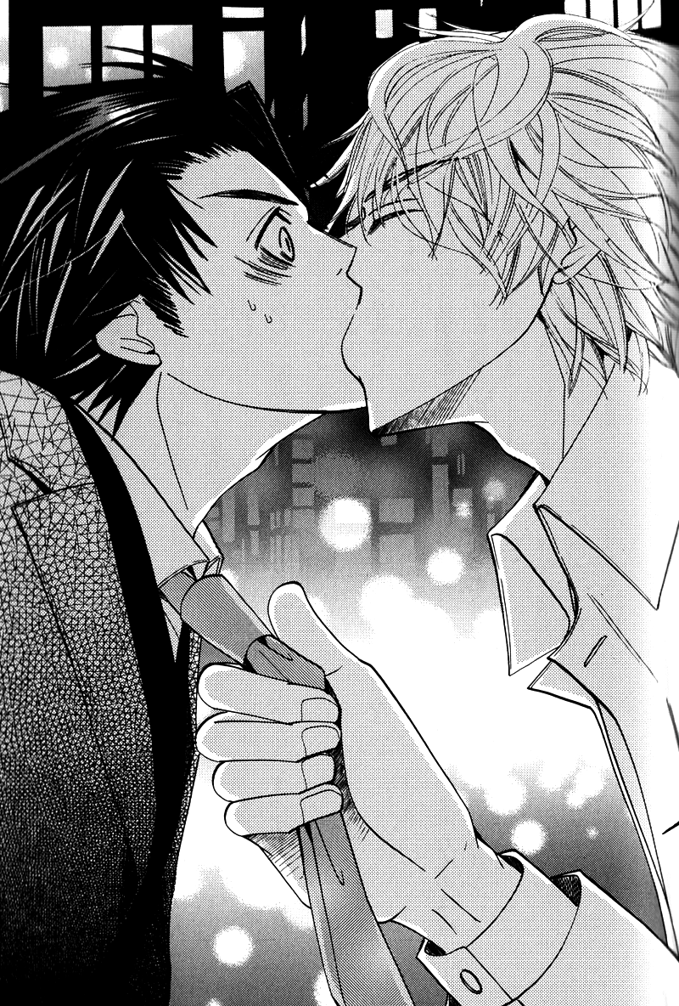
“Nn…nnn…!”
Kirishima’s kiss was amazingly good–so much so that he felt he was about to faint. Even if he’d wanted to push the guy away, his will was completely paralyzed and his body refused to move, as if he were bound up tight.
A band of drunken partygoers passed by, cheering loudly, and still their lips remained joined.
“…ha!”
When at long last the kiss was broken, his body was flooded with a dull paralysis, and he found himself unable to remain standing on his own. He leaned his body against the wall on which hung the bar’s signboard and complained with his still-numb lips, “What the hell are you thinking? In a place like this…!” He forcibly wiped his wet lips with the heel of his hand but was unable to erase the faint sensation left behind on his lips and tongue.
Kirishima snickered at the red-faced Yokozawa. “So you’re saying it would’ve been fine somewhere else?”
“Like hell. I can’t believe you’d pull a dirty trick like that–!”
“Dirty? You’re not being very convincing, considering the fact that you can’t even stand on your own two feet right now. You’re a grown man–so stop whining like a little girl. You’re not gonna try and tell me that was your first kiss or something, right?”
“Who said…!” Yokozawa’s face grew a shade redder at this teasing. With anger and humiliation blended together, the blood was rushing to his head, leaving him unable to piece together a proper sentence.
“Well you just looked so innocent, I thought maybe… But if it wasn’t, then all the better. It’d be a shame if I’d stolen your first kiss from you, after all.”
“..........!!”
“Ah, well I’m this way–you’re taking the subway, right? Don’t take any shortcuts this time and head straight home, young man~”
“I don’t need you telling me what to do!”
“With you getting all riled up like that, it just makes me wanna tease you more–and you don’t want that, do you?”
“Why you–!!”
He knew he was being toyed with; he probably seemed like a perfect plaything to someone like Kirishima. It hurt to admit it, but every time he opened his mouth, it just sounded like the howling whine of a dog that’d lost a fight.
“Well, be careful heading home. Oh–and one more thing.”
“What now?”
“Thanks for the meal.”
“…I’m so getting you back for this.” Like a minor villain in a movie, he spit the jeer at Kirishima, who turned his back and walked away leaving behind his irritating words with a roguish smile. It had been all he could come up with at that moment, a fact that was rather shameful. Shaking with anger, when he realized that he’d yet again let the guy see him in a weak state, he had no choice but to embrace the humiliation.
“Fucking around like that…” His palm felt warm where he’d made a fist, and his racing heart was probably due to his seething rage. Bottling up his indignation, he turned his back and jogged away.

Chapter 2
“Tsk…”
A mere few meters’ walk after leaving the comic shop, Yokozawa felt a small pain in his foot and tsked in irritation. Somehow, while walking, a small pebble had worked its way into his shoe apparently.
He paused and slipped off the shoe to remove the pebble. Balancing on his left leg, he turned it upside down to remove the foreign object and realized that the soles had been worn quite low.
Even though he performed maintenance on them at least once a week and had several pairs he wore on a rotating schedule, making the rounds like this almost daily as he was had done a number on the soles. Recalling that he kept a spare pair in his work locker, he decided to take the pair he was wearing by a shoe repair shop on the way home that day.
“Yet another expense…”
He set the shoe down gently on the asphalt and slipped his foot in, sighing as he considered the sorry state of his wallet. If he didn’t dip into his savings, he probably wasn’t going to be able to make it until payday. He’d had quite a good number of expenses to take care of this month, after all.
What with all the congratulatory gifts he had to pay out for his subordinate’s wedding and a friend’s baby shower and the like, and then having to replace his broken cell phone on top of making the rounds at the bars with acquaintances, he was barely scraping by with more than a week left to go until payday.
He’d been far too careless to go out and drink alone in this financial condition, even if he had just been dumped; there were limits to the appropriateness of getting drunk.
If he hadn’t gone into that bar…if he’d just gone straight home, he would’ve been able to avoid the annoying situation he now found himself caught up in. Even though he knew there was nothing to be done about it now, he still couldn’t help but regret his actions.
“..........”
Takano had been his very first love.
Sure, there’d been a few people he’d dated upon entering university, but whenever they’d asked if he loved them, he’d found it difficult to respond to the affirmative with confidence. They’d been good friends, and he’d felt calm when he was with them, but he’d never felt any really overpowering emotions when he was with them. He’d often assumed that perhaps he just wasn’t the type to really fall in love at all–but right around when he’d convinced himself of that, he started to grow close with Takano.
It had been difficult, initially, to approach Takano, with his cynical attitude and self-abandonment complex. But on realizing that this was all simply a front to hide how lonely he truly was, he found he couldn’t leave the guy alone. On finally speaking to one another, they found that they actually shared fields of expertise and hobbies, and conversation sprang up naturally between them.
When they conversed, Takano’s pessimistic mask seemed to fall away, and he showed a smile more suited for someone his age. Yokozawa, so fascinated and charmed by this, gradually began to spend more and more time with Takano, growing apart from his girlfriend–perhaps at that point, he was already in love with the guy.
Then, one night, Takano had been in a particularly bad state, and on the heels of the drinks they’d been downing, they crossed a certain line. Even as he realized that Takano regretted it…Yokozawa confirmed his own feelings. He didn’t love this man as a ‘friend’, he was in love with him.
He had never remotely imagined that that very same love would be put to a stop in such a horrific fashion.
“Oh gosh, excuse me!”
“Ah, no, it was my fault.”
Caught up in his thoughts as he’d been, he’d run right into a high school girl carrying a paper bag from a bookstore clutched to her chest. She’d been engrossed in conversation with a friend and apparently hadn’t even noticed Yokozawa walking right towards her. She’d flushed, ashamed she’d let her mind wander like that, and then had run to catch up to her friends.
It seemed the girl and her friends had just come from the very same large-scale bookstore Yokozawa himself was heading towards, Books Marimo. He started walking forward again, thinking blithely to himself that it’d be nice if that bag was full of our books.
Today he was on a mission to test the waters regarding a campaign for an upcoming new release. While the best case scenario involved getting the store to agree to put out all of the previous volumes from the same author along with the new release, he understood that there were limitations on space to take into consideration. Convincing the store to permit them more space than other companies fell squarely on the shoulders of the sales department workers.
“Hm?”
The moment he stepped into the comics area of Books Marimo, he caught sight of a rather gaudy-looking employee putting together a display in a prominent position on the floor. He had a shiny, shimmering air about him that made him seem as if he’d just stepped off the pages of a shoujo manga title–and he was in charge of this section.
Yokozawa had been informed by the manager on a previous occasion that he only worked at the store part-time, primarily attending art school, and looking like some elegant prince, he not only had a gaggle of female fans following him about but was also rather well-versed in shoujo manga, which he was in charge of.
Apparently he’d always enjoyed shoujo manga himself, and the posters decorating the shelves were all garnished with his own passionate thoughts and recommendations, such that any series he promoted–no matter how small-time the magazine it came from–always sold like hotcakes.
Yokozawa had often caught sight of other salesmen from rival companies trying to push their wares onto him, but he always reminded them modestly that he was only promoting titles that he himself enjoyed, and the fact that they sold well was due not so much to his efforts but to the content of the books themselves.
And of course, while it was true that boring books would never be picked up by the public anyways, it was equally true that there was no guarantee even interesting books would obtain any measurable readership. If you couldn’t get readers to stop and take a look in the bookstore, there was no chance of getting them to learn just how interesting a book really was.
This was why salesmen such as Yokozawa wore down the soles of their shoes traveling from store to store hoping to show off just how interesting their companies’ titles were. In doing so, they could make the first step in winning favor among those employees who worked with those titles on a daily basis.
“Welcome to–ah, it’s a pleasure to see you!”
Sensing Yokozawa’s presence, the worker in charge of the area, Yukina Kou, turned to him with a smile. While there was no obvious reason for him to treat Yokozawa with such courtesy, he seemed particularly dazzling today. Faced with someone like this, his faintly-colored eyes fringed in long lashes, there was no doubt that the high school girls Yokozawa had run into earlier had been made to buy as many books as their allowances would grant.
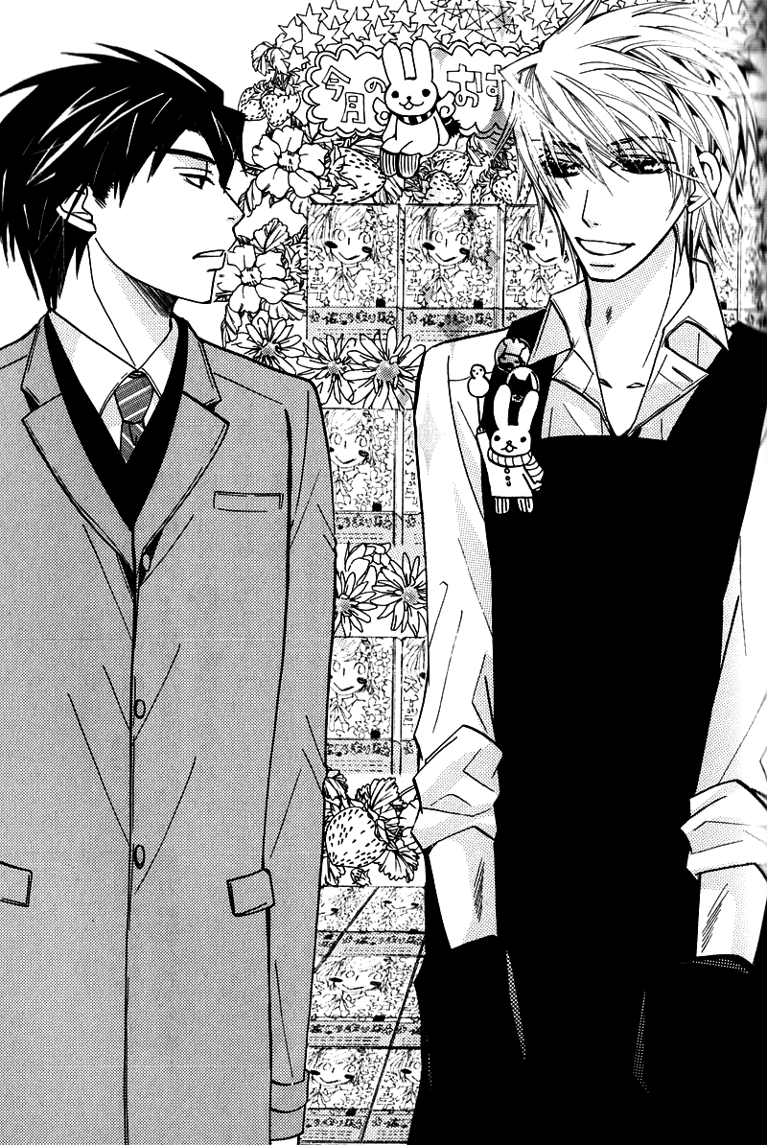
“Good work today. I need to speak with the manager; is he around today?”
“He went into the back a little earlier. Shall I call for him.”
“Please.”
Leaving him with a soft smile, he ducked around behind one of the registers and picked up an internal line. While he waited, Yokozawa took a moment to look over the display he’d been working on once more.
Apparently today’s theme was ‘First Loves’, and various titles under that theme, both new and old, were lined up together. Of course, Marukawa had several series displayed as well.
“…This sure takes me back…”
The book he’d picked up without thinking happened to be the very first title Takano had been in charge of, back when he’d first joined Marukawa. It had turned out to be the title that pulled a struggling author out of a long slump and had even been made into a movie. Since then, that same author had maintained a steady wave of popularity in Emerald.
Back then, Yokozawa had run himself ragged, desperately trying to promote the title, and in his off time he’d gone around to stores that the sales department people typically never set foot in, finding every spare moment he could to make sales calls. His hard work eventually paid off, though, and when the book took first place in the monthly sales rankings for the company, they’d shared a congratulatory drink together.
“He’ll be here in just a moment; would you mind waiting?”
“Sorry for the trouble. Oh–how are classes going? You always seem to be here when I drop in–you’re not slacking off, are you?” he casually questioned. Putting together displays like this and selling their books was all well and good, but the guy had to be busy with his art school lectures and projects and whatnot.
“Oh stop it, Yokozawa-san! It’s spring break right now. And I’ve got great grades, I’ll have you know, so there’s no need to worry.”
“Well, I’m sure you’re being careful about it at least. So how are this month’s sales going?”
“Honjou-sensei’s new work is doing rather well out of all this month’s releases. All the customers who buy the new volume wind up coming back the next day to buy the back issues, too.”
“That’s always a plus.” That the customers were going through the trouble to purchase previous volumes was a testament to the attraction in the newest volume. While the author herself was rather a dull sort, her manga was good. Yokozawa had been confident that if people would just read the story then the number of fans would increase, but it made him all the happier to have results actually proving it.
“And then there was Mutou-sensei’s work from last mo–ah, the manager’s here! You can hear the rest from him–I’ve got to get back to the display.”
“Got it–thanks for everything.” He waved to Yukina as he returned to the display setup before stepping towards the manager, who approached at a jog.
“Yokozawa-san! My apologies for the wait.”
“Not at all; I’m sorry to have called you away while you were busy.”
“Oh no, I was about to head back out anyways.”
The manager of Books Marimo was quite a manga fan himself and was in charge of the shounen manga section. Thanks to him and Yukina, the manga floor here held the best lineup in the whole city–and it was for that very reason that all of the publishing houses had their sights set firmly on this store.
But having a large selection also meant it was difficult for many titles to stand out, and the salesmen from each company worked tirelessly trying to get their titles positioned in prominent locations.
“Thanks so much for setting up that Za Kan corner last month. Thanks to your efforts, the sales went better than predicted, and we’ve had to commission an emergency reprinting.”
Hearing the results his work had helped bring about, the manager rejoiced as if he himself were responsible for the whole thing. “Really? That’s amazing! What with the movie coming out soon and all, I’m really looking forward to the upcoming events. Oh–that reminds me, when is the next volume of Za Kan going to be released?”
Yokozawa lowered his voice so as not to be heard by any customers nearby. “It actually hasn’t been announced yet, but just between you and me, the release date will be announced in one of the magazines being released next week, so feel free to make another dedicated display if you like.”
“Oh absolutely! Definitely!! Uwaa~ I can’t wait!! I just love Za Kan, you know! Of course I read it serialized in the magazine as well, but I always look forward to the cover and under-printing.”
It was truly a blessing having the employees be actual fans of the work in question. Compared with books stacked in a simple, orderly fashion, shelves stocked in shops that really were passionate about the titles always appealed in some way to customers. More than a few books that had never stood out despite being decent works were put on display with a simple promotional poster drafted by the employees and subsequently became hits.
“We’re always thrilled to hear you say that. I’ll be sure to let the parties concerned know that Books Marimo is doing their best to help promote the work.” With these words, Yokozawa suddenly recalled just who Za Kan‘s managing editor was and felt an uncomfortable chill run through him.
Ijuuin-sensei’s editor…was the editor-in-chief, Kirishima.
He started to regret for a moment what he’d just promised, but then realized that even if he avoided the guy, there was no escaping being dragged around by him.
“Please let them know that I’m always looking forward to each issue.”
“I certainly will. I’m sure the author will be more than pleased.” He pasted on a salesman’s smile, praying that the man couldn’t tell just how he really felt inside.

From that day on, the days when Yokozawa could get by without having to see Kirishima dwindled to nothing.
He hadn’t a clue what kind of enjoyment the guy was getting out of it, but practically every day Yokozawa found himself being dragged out for dinner. While rather shocked at first, those around him had slowly but steadily grown accustomed to the situation, such that nowadays he even found people coming to him wanting to know where Kirishima was.
However, while Yokozawa himself was also getting used to the setup, he remained perplexed, still not understanding what exactly Kirishima’s true intentions actually were. No matter what he asked, the guy was always evasive in his responses, giving nothing but vague, baseless answers.
And yet, so long as the guy kept a firm grip on whatever embarrassing photos he claimed to have, no matter how it irritated him, Yokozawa couldn’t afford to make any false moves.
He’d given thought to trying to steal the opportunity to grab Kirishima’s cell phone and delete the images himself, but the guy never gave him the chance, as if he could see right through Yokozawa and figure out exactly what he was planning.
Before heading back to the sales floor, Yokozawa took a detour to the 4th floor where the Emerald offices were to let them know how well the latest volumes were selling. As soon as he stepped off the elevator, though, he noticed the place was bustling with much more tumult than usual.
It was hardly a quiet place to begin with, but today it was downright noisy.
“What’s wrong?”
“Apparently Takano and Onodera shared a double bed on their business trip!!”
“What?!”
When he consulted the female editor standing nearest to him, she responded cheerfully, but Yokozawa couldn’t grasp her meaning in the slightest. Seeing the way his brows furrowed at her incoherent response, she proceeded to explain. “Due to a mistake by one of the girls in general affairs, they apparently couldn’t get a room with two twin beds. A rather cliched situation, sure, but that doesn’t make it any less exciting~!”
It was hard to understand her through her excitement, but he managed to grasp the basics. Apparently Takano and Onodera had gone out of town on an overnight business trip together the day before. There, through some mistake when the general affairs personnel had reserved the hotel room, they’d been forced to share a double bed than the preferred twins, which were unavailable.
“Onodera-kun looks absolutely exhausted, and Takano-san refuses to say what happened that night! Doesn’t that seem fishy to you?”
“..........”
He had no words with which to respond to the boldly confident statement. When he turned to glance in the direction of the Emerald desks, Onodera was making a fuss, like always, and those around him were teasing him mercilessly.
“Ricchan, did something happen?!”
“What exactly are you implying by something?!”
“Sorry, Onodera, but Yoshikawa Chiharu has writer’s block, so I’ll be using that as a setup if it’s all right…”
“PLEASE DON’T. And why are you holding a telephone receiver?!”
Putting aside Kisa, who was rarely serious to begin with, even the typically indifferent Hatori was digging into him. While Onodera had been rather prickly when he’d first joined the company, he seemed to fit in quite nicely now, a full-fledged member of the editing division.
Takano put a stop to the others’ teasing of Onodera as he flailed about. “Do what you want.”
“Takano-san!!”
“Ah…I think I’d like to hear the details of this one.” Mino joined in, going after Onodera.
“Me too!!”
“Sure! Onodera, let them hear all about it!”
“So? So? What’s the real deal, Ricchan?”
Casting a sidelong glance at Kisa, who still wasn’t letting up, Yokozawa moved to leave. There was no way he could be expected to get riled up with that lot. Just before departing the editing division, though, he caught the conversation of a group of women standing nearby.
“Well, it’s not impossible for a relationship to start from a coincidence like that!”
“Ooh, so–who do you think topped?”
“Takano-san, of course! Onodera-kun doesn’t look like the proactive type, after all.”
The female editors were watching the goings-on in the Emerald department with glee, tittering away in their own little fantasy world. Yokozawa recalled distantly that the editing division for Sapphire, Marukawa’s BL label, was also located on this floor.
These women had likely long ago disposed of frivolous ideas like reality. They were able to rejoice over situations like this happening to other people precisely because it was fantasy. He found himself pondering dark thoughts about how, if he told them that Takano and Onodera really were in a relationship together, they wouldn’t be able to bring themselves to get excited over it like this.
“…Idiots, all of them,” he spit out in a whisper, and returned to the elevator he’d just left. Alone at last in the little box of a car, he sighed irritatedly. The wound in his chest that had at long last started to heal, little by little, began to throb painfully again.
Of course there was no way he’d get over being rejected like that in the little over a week that had passed since then. Returning in a dour mood the the 3rd floor, he found it steeped in a similarly unusual atmosphere. However, gone was the light-hearted mood from earlier, and instead everyone was frantically running about making phone calls.
“Henmi–what’s going on?”
The moment he noticed Yokozawa, Henmi let out a voice sounding as if he were about to start crying. “Yokozawa-san! Why didn’t you answer your phone?! I’ve been trying to reach you!”
“Ah–sorry, I didn’t notice… So?”
“It’s terrible! We’ve been fielding non-stop calls with questions about Za Kan–all wanting to know if the movie premier date and the cast information are true!”
“What?! How did that information get out already?! They weren’t supposed to release any information until the magazine goes on sale! Where’s the leak?!”
Yokozawa rolled his eyes as Henmi explained, “Apparently it was written on a fax we sent to one of the book stores…
“A fax for the book store?”
“It was passed around at the branch, and a reader happened to snap a picture of it and uploaded it online. Then it just exploded from there apparently.”
In other words, they themselves had ignored the information prohibition and given the information to one of the book stores ahead of time. And even worse–they hadn’t even realized it had happened until readers themselves had called to confirm. It was inconceivable for no one to catch this.
While many might think there was no reason to get so bent out of shape over information as insignificant as this being leaked, this was a promotional strategy that had been in the works since over a year before. One wrong move, and everyone’s hard work would be for nothing.
Yokozawa was in charge of checking all paperwork sent outside the company. There was no way he would’ve let something like that slip by. He quickly fired up his computer and opened the e-mail from Henmi, checking the document in question.
He let out a small gasp when he noticed the creation date listed in the file properties.
“…Ah…!”
That stormy day–the day he’d been rejected…even thinking about it now, he knew he’d been completely out of it that day. He’d been irritated at how pathetic he was, and even the smallest words from his coworkers had thrown him into a rage–everyone had been walking on eggshells around him. That in itself had irritated him even further, and he’d probably lost all ability to focus.
But no matter the reasoning, a mistake was a mistake. Making a simple error like this…he was setting a horrible example for his subordinates, given how he liked to walk around all high and mighty.
“What should we do…?”
“There’s nothing to do. Sorry–this is all on me. It’s not your fault. I’ll go make my apologies to the editing department.”
He’d have plenty of time to regret his actions later. Right now, he needed to go bow his head to everyone he’d inconvenienced, think of a way to resolve the situation, and plan how to proceed from here.
Biting back his self-loathing and turning around, the very person he needed to go and see most was standing right in front of him.
“Ki–Kirishima-san.”
“We need to talk. Come with me.”
“…Right.”
Kirishima brought him to an empty room reserved for small-scale business meetings. When the door shut behind them, locking them in the windowless room, he couldn’t help but feel a bit suffocated–probably because of his guilt.
“You probably know what I came to talk to you about, huh?”
“…I do. This was all my fault–I’m really, truly sorry for this.”
“To think that the great Yokozawa Takafumi would make a stupid mistake like this. You may talk a big game, but in the end you’re still human.”
“…….” It hurt, but he couldn’t refute it. Indeed, if he’d been in Kirishima’s shoes, he probably would’ve used even sharper language. There was no recovering from this even if he made an excuse. He could only sit here quietly and let Kirishima unload on him.
“…Does this have anything to do with why you went and got pissed out of your skull?”
“!!” His expression went stiff as Kirishima hit the nail on the head, but it was too late to try and hide his agitation now. Kirishima probably knew his suspicions were founded now.
“I’ll bet not a single one of your people would ever imagine that you’d let your personal affairs affect your work.”
“…Say whatever you want. I won’t fight back.” He seemed indifferent on the surface, but Yokozawa knew the guy had to be seething inside. Anyone would throw a fit if a year’s worth of hard work and preparation were all for nothing because of someone’s careless error. If he’d been in Kirishima’s place, he’d be a raging fire of fury.
That Kirishima wasn’t the type to act on his emotions could probably be chalked up to his age as much as his demeanor, but Yokozawa wished he’d just go ahead and let him have it, certain he’d feel better that way.
“…Geez, stop looking like a little kid who just got caught playing a prank. I just wanted to have a little fun with you.”
“…A little fun…?”
“I’m telling you I’m really not mad. Though you have kind of made things difficult for me. As long as you feel bad for it, I suppose that’s enough. But you’d better not make the same mistake twice. Your standing would never recover–remember that.”
“But–what do you mean ‘that’s enough’? We can’t exactly take it back, you know!” It was impossible to recover information that had already been leaked. Yokozawa felt himself growing even more flustered than the ever-composed Kirishima.
“Then–why not just play it up as an advance marketing ploy?”
“Advanced marketing?”
“Say you leaked a little info to get people excited. Everything works out nicely then, don’t you think? We’ve gotta get sales up on the magazines and comics too, after all, so I’ll just have the people in my office tell whoever calls up the editing department that the full details will be available there. Thankfully, none of the really big points got out, so for now, I’ll have the author and the anime development people accept it.”
Yokozawa was absolutely dumbfounded at Kirishima’s suggestion. He’d never imagined that the editing people would be the ones to come up with a plan to fix this mess.
“…Wait, are you…covering for me?”
“What else does it look like? Be grateful–oh, and that’s another one you owe me.”
Truthfully, he’d really wanted to avoid racking up any more debts with Kirishima, but now was not the time to fall prey to his own pride and obstinance. He had to take care of the mess he’d created first, and he nodded to Kirishima.
“It was my fault. I really…do feel terrible about this.”
“If you really feel bad, then try being a bit cuter about it.”
“Huh?” Despite his earnest apology, Kirishima was now suggesting something he didn’t understand at all, with a completely serious face.
“It’s ‘I do apologize.’ Go on–try it out.”
He got goosebumps at the revolting tone the guy used, and more than Kirishima’s tone being disgusting, there was no way that Yokozawa could be expected to say it cutely given his voice and looks. Unable to stand it anymore, Yokozawa snapped, “Who the hell is saying that?” Kirishima released a laugh at the shout, and Yokozawa felt his irritation returning at this attitude. “Stop laughing!”
“There you go–that’s more like it! Everyone around you falls apart when the wild bear acts all depressed.”
“…Huh?” Had he been…trying to cheer Yokozawa up? The moment he realized this, his face went red. He was humiliated that the guy had not only noticed, but gone out of his way to make him feel better.
Realizing, though, that he was the one at fault, he couldn’t exactly gripe at the guy to mind his own business. Growing all the more uncomfortable with the situation, he had no choice but to keep his mouth shut.
“Anyways–for now, tell the other guys down in sales that I really bitched you out. You can pay me back by selling twice as many new and back issues of my series as usual.”
“Twice as many? Who the hell do you think I am? Even if you didn’t ask, I’d still sell more than that!” With this harsh retort, the uncomfortable feelings from before blew away.
“That’s the spirit! Ah–right right, come grab a bite to eat with me after work today. And make sure you’re ready to go by 6, no matter what.”
“…Fine.” The fact that he’d gone out of his way to emphasize a time seemed to imply he had some sort of plan in the works. But given Yokozawa’s weakened position, he didn’t have any choice but to go ahead and accept the invitation anyways.

“So? Just where are we off to today?”
“You’ll find out when we get there. Today I’m gonna let you eat the best food in the entire world, so look forward to it~”
“Huh?” was Yokozawa’s indifferent response to Kirishima’s better than usual mood. If they were going to just have dinner, anywhere was fine, really–and yet Kirishima continued to lead them away from the station. After work, they’d boarded the train and ridden for a good 20 minutes before disembarking, only to continue walking even further with no goal in sight.
Yokozawa had dug into his work with the intent to clear his reputation and wound up finishing everything he’d planned for the day by 5:30. Just as he was reflecting in annoyance that this made it seem like he was actually looking forward to his plans with Kirishima, he received a text from the man himself.
/Looks like I’ll be a little longer, so wait for me at the station. If you manage to get done early, buy three green tea-flavored Bavarian cream puffs./
Despite being quite puzzled by the message, Yokozawa did as asked, but he still didn’t know what he was supposed to do with this thing he held in his hands now. Was Kirishima going to eat them, perhaps? But–thinking back on their meals together so far, he hadn’t seemed particularly fond of sweet things in the least. There was the possibility that he just thought liking sweet things didn’t suit him, and so he’d hidden it, but it was impossible to be sure.
“We’re eating in this residential area?”
“Just keep your mouth shut and follow me.” Kirishima ducked inside a rather normal-looking apartment building. He opened the autolock with a passcode and headed for the elevator. Maybe there was a restaurant operating out of one of the rooms here? He couldn’t even begin to imagine where they were going, but seeing as Kirishima had instructed him to just shut up and follow along, he couldn’t ask any more.
“Well, here we are!”
“This is…?”
The building seemed to be set up as a family-type housing complex, with each section cordoned off by a small gate that came up to about waist-height. In the entryway of the room they’d stopped in front of, there was a light-blue child’s bike leaning against the wall. The questions started piling even higher in Yokozawa’s mind at the sight of this item that seemed absolutely steeped in personal lifestyle-ness.
Yokozawa shifted his gaze around, trying to see if perhaps the restaurant’s name was written anywhere. He finally noticed a nameplate underneath a carelessly hung up jump rope–Kirishima.
“This is–your place?”
“Yup. It’s not very tidy–but there’s at least enough space to have dinner, so don’t worry.”
He never would have imagined that he’d be taken to the guy’s home. Kirishima opened up the gate into the front entryway with a key he pulled from his pocket and called out towards a room where a light was on, “Hiyo, I’m home!”
“Welcome back! Oh, do we have a guest, Papa?”
“Papa?!” His voice rang out shrilly at the unfamiliar word. He glanced back and forth at the man and little girl before him, comparing them. They didn’t look alike in the least, but the gaze which Kirishima wore now was gentler than Yokozawa had ever seen him look at anyone else before.
It seemed the bicycle out front was his daughter’s. If one thought about it, this whole situation wasn’t all that strange, but perhaps because he already had an initial impression of Kirishima, Yokozawa had never fathomed the possibility that Kirishima was a father.
“What, is there a problem with my being a papa?”
“I–no, that’s…not what I meant…”
Standing before them, prim and proper, was a little girl of about ten, her hair up in a ponytail. Her big brown eyes were fringed with long lashes and looked like they were going to overflow with every blink, and her rosy cheeks were round and full.

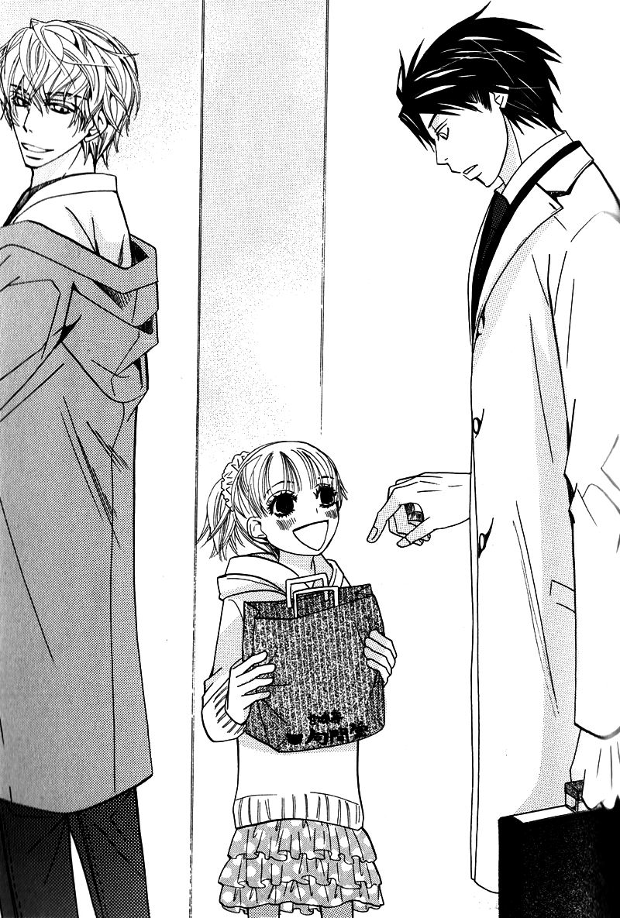
Yokozawa had been, suffice it to say, shocked when he found he’d been taken to Kirishima’s house, but even more surprising was the fact that he had a daughter this old. Seeing Yokozawa’s hesitation, Kirishima introduced the girl.
“This is my daughter Hiyori; she’s ten years old. And this man here is Yokozawa; we work in the same company. He may look like this–but he’s still in his 20s, so don’t go around calling him ojisan or anything, ‘kay?”
“Got it! Can I call you ‘Yokozawa-oniichan’?”
“Uh…sure…”
Hiyori then proceeded to give a proper greeting to the still befuddled Yokozawa, bowing her head shortly. “It’s a pleasure to meet you. I’m Kirishima Hiyori! Thank you for always taking care of Papa!”
“Ah–yes, I’ll be taking advantage of your kindness tonight. I’m Yokozawa Takafumi.” Caught up in the moment, Yokozawa gave his own proper introductions.
Seeing how impressed Yokozawa was with how well she handled herself for her age, Kirishima jumped in with, “Hiyori–he doesn’t take care of me. I’m the one who has to take care of him.”
“Papa! Don’t say such childish things!”
“Geez, it’s just a joke! Oh–right, Yokozawa? Don’t you have a present for Hiyori?”
“Huh? Ah–oh, this?” Apparently the green tea-flavored Bavarian cream puffs he’d been made to buy earlier were for Hiyori. When he held the bag out for her at Kirishima’s prompting, her expression instantly brightened.
“Uwaah!! Green tea-flavored Bavarian cream puffs! I love these! Thank you, Yokozawa-oniichan!!”
“Oh–I’m glad you like them.”
“I’ll put them in the fridge for now, then we can each have one for dessert!”
She cradled the paper bag to her chest as if it were a precious item. Seeing the way Yokozawa watched her with a smile on his face, Kirishima sought his agreement on the situation with an unusually gentle voice. “My Hiyori’s pretty cute, huh?”
“Geez, Papa! Stop sounding like a stupidly doting dad! I’m going to finish up dinner preparations–so have a beer or something while you wait!”
“Yes ma’am~”
Hiyori flushed at Kirishima’s words and fled into the kitchen. Even Yokozawa couldn’t help grinning at the sight.
“I’ll admit–she’s so cute I never would’ve pegged her as your kid.”
At his words, laced with thinly veiled sarcasm, Kirishima shifted his features into a pleased expression one wouldn’t have imagined him capable of given his usually cool demeanor. “She takes after her mother. I’m never letting her get married.”
Even Kirishima became a typical doting parent once safely behind the walls of his own home, apparently.
Yokozawa found himself grasping for a response, faced for the first time with Kirishima’s fatherly side. ”So…what about your wife? Is she out shopping or something?” He had only just now considered the fact that there was a wife involved. Wearing a wedding ring, and with a daughter to boot–that meant there had to be a mother around somewhere.
At this, he realized–Kirishima being a married man…meant that he’d been cheating with Yokozawa the other night, hadn’t he? Despite the fact that Yokozawa hadn’t really had any choice in the matter, he most definitely did not want to face the guy’s wife right now.
Then, just as his chest started to throb with the pain of guilt, Kirishima responded, surprise evident in his voice, “…Wait, you didn’t know? I don’t have a wife.”
“Huh?”
“And–just so you know, we didn’t get divorced. She died of illness, before Hiyori was old enough to even remember her.”
“…I’m sorry. That was really insensitive of me to ask.”
Kirishima probably spoke so casually of the matter because he didn’t want to make Yokozawa feel uncomfortable. He’d probably been asked that same question a dozen times over before, after all.
“It’s not a big deal. It all happened around when you’d just entered the company anyways; it’s not strange that you didn’t know.”
And suddenly…things made a lot more sense. The reason he always left work early–except for just before the end of a cycle–despite being the editor-in-chief, and always came in to the office early…must have been because he was coordinating his work schedule with raising his daughter.
“Geez, use your head; do you really think I’d have cheated on my wife with you?”
“Well I couldn’t tell–you’ve still got your ring on after all!” It was humiliating the way the guy saw right through him like that–but it was Kirishima’s fault for not explaining properly and making Yokozawa read too much into the situation in the first place.
At this implication-laden complaint, Kirishima came back with an unexpected response. “…What, are you jealous? If you want me to take it off–all you have to do is ask. I just wear it to keep authors from asking stupid questions.”
“I never suggested that!” Yokozawa wished the guy would stop assuming he was jealous. He felt like an idiot for feeling sorry for Kirishima in the first place now.
“Come on, you don’t have to blush.”
“I’m not blushing.” As he found himself getting worked up dealing with Kirishima teasing him, Hiyori stuck her head out into the genkan, having now finished preparing dinner and grown tired of waiting for them.
“Papa! Yokozawa-oniichan! Dinner’s ready! How long are you two going to hang around in the genkan?”
“We’re coming–just wait a minute. Come on, don’t keep Hiyo waiting.”
“You’re the one who started a conversation here!” he snapped at Kirishima’s comment dripping with feigned innocence. Following behind Kirishima, who laughed him off easily, they proceeded into the living-dining area.
All around the room, the walls were decorated here and there with Hiyori’s drawings and paintings. Combined with the soft pastel walls, it was an atmosphere worlds away from what Yokozawa had imagined of Kirishima.
“What does she do when she’s here alone?”
“My parents live nearby, so if I have to work late, she stays with them. My mother comes over from time to time and makes dinner, too.”
“Why not live with them?”
“If I did that, I’d wind up just sponging off of them for sure. Living this far away is just right, as I see it. Ah–you can sit over there.”
When they reached the table, they found a pot full of delicious-smelling curry. Provoked by the scent, Yokozawa recalled that he was absolutely famished. He hadn’t had anything since that afternoon, when he’d wolfed down a riceball he’d bought at a conbini while making his rounds.
“Yokozawa-oniichan, do you want a beer? Or oolong tea?”
“Have a beer. You’ve got the day off tomorrow, after all. If you drink too much, you can just spend the night.”
“I’ll pass, thanks. Could I get some oolong tea?”
“Eeh?? You should spend the night~!”
Yokozawa’s chest hurt at the pitiful face Hiyori directed at him, but he was rather reluctant to stay the night at Kirishima’s place. To keep things from worsening, he quickly used his pet cat as an excuse. “I’ve got a cat waiting for me at home. Maybe next time?”
Hiyori’s eyes brightened, and she latched onto the word cat. “You’ve got a kitty?! What’s its name??”
“Sorata. He wasn’t really my cat at first, but well, some things happened. He’s over ten years old now, though, so he’s an old cat. You like cats?”
“Yup!! I love them! You’re so lucky… I want a pet cat, but Papa always says I’d never be able to take care of it…”
“Hey, I never said you couldn’t have one. I said I didn’t mind so long as you think you could take care of it properly on your own. I’ve got a hard enough time taking care of myself, after all.”
Taking pity on Hiyori’s unhappy expression, Yokozawa couldn’t help issuing an invitation: “Then–would you like to come over and see him sometime?”
“Can I??” An excited expression blossomed on Hiyori’s face. It was a smile that felt like the sun in Spring, just as her name suggested, and Yokozawa felt his heart warm just from looking at it.
Getting closer to Hiyori…meant his relationship with Kirishima would deepen as well. He knew it wasn’t wise to get any more deeply involved with the guy, but he found himself willing to do most anything when faced with someone as cute as this.
“I don’t mind, but…I’m not sure if your papa will agree or not.”
“Papa?? Can I go see the kitty at Yokozawa-oniichan’s house??”
“Hmm, I dunno… I suppose that’ll depend on your grades from third semester.” Kirishima issued his conditions to Hiyori, who’d begged him in the sweetest voice she could muster.
“Geh…ah, okay…I’ll do my best…”
“It’s simple enough, isn’t it? All you have to do is raise your math grades.”
“Maybe you find it simple, Papa, but it’s hard for me!” Apparently Hiyori wasn’t all that good at math, and she made a face of disgust, as if being forced to eat something she disliked.
Taking pity on her, Yokozawa offered, “Then, would you like me to teach you?”
“Really?! Could you help me with my homework later?? There’s one I can’t understand no matter how hard I try!”
“Okay then–it’ll be my thanks for dinner.”
Watching Yokozawa and Hiyori making their arrangements, Kirishima couldn’t help popping in with, “Can you even teach?”
“Of course I can; I was a home tutor part-time during college.” Of course, all of his students had feared his grueling, demonic way of teaching, but given that their grades went up nevertheless, he’d been well recommended by all of their parents. And he’d only been particularly hard on the ones who weren’t putting forth any effort anyways; there was no sense in buckling down on someone already doing their best.
“Okay! It’s a date then, Oniichan!”
“Right right.” He executed a pinky-promise with her little, twig-like finger, honestly fearful that if he put even the slightest force into it he’d break it.
“Oops! I forgot to put out the salad! Wait just a minute!”
“All right–don’t drop the plate running, though!” While she was in the kitchen, Kirishima commented amusedly, “Geez, you wouldn’t expect it, but you’re really good with kids. Don’t tell me–animals like you too, huh?”
“That’s cause animals and kids both see people for who they are on the inside.” He hadn’t ever been around any other animals, so he couldn’t be sure, but he at least had never met a dog or cat that didn’t like him. The ones who were always too afraid to even approach him were always adult humans.
“You do realize that by saying that you’re admitting that you’re scary at first glance, right?”
“Shut up.” He knew perfectly well that he had an intimidating mien and equally intimidating voice–but it wasn’t as if there were anything he could do about it. If he smiled too much, it would probably just make others uncomfortable, and using an ingratiating tone was just unthinkable.
“Well–it’s nice that you and Hiyo seem like you’ll get along. Made it worth it bringing you here. Feel free to get closer with her.”
“You sure you want that? What if I come up to you later and tell you Hiyo and I are getting married?”
“Hmm, yeah…you’re gay, after all. It’d wind up being an unrequited love for Hiyo then, huh… Ah well, such is life.”
“I told you: I’m not gay–”
“Geez, I’m starving! Hiyo~ we’re gonna start on the curry, okay?”
“Okay! There’s lots left over, so eat as much as you want!”
“Here, you too. Itadakimasu!”
Having his rant cut off by Kirishima left him feeling a bit of indigestion, but he was too hungry for that to be a problem, so he quietly picked up his spoon without comment. “…Itadakimasu.”
He dug into the roux and rice together, lifting a bite to his mouth. The roux contained chicken, carrots, potatoes, and a bit of quail egg. Perhaps it had been made to suit Hiyori’s taste, but it was a sweet flavor that was steeped in a cozy gentleness.
He could cook for himself perfectly well, but since joining Marukawa, he’d found less and less time to cook at home. Snacks were easy enough to make, but he tended to eat his meals almost wholly outside. Even though he knew it was bad for his body, it was more troublesome than anything to worry about it, so he couldn’t bring himself to spend the time in the kitchen.
Back during college, although he hadn’t had much money, there’d been a certain someone at his side whom he had to make sure ate properly. So every day he’d made meals which were perfectly balanced nutrient-wise. Thanks to that, he’d grown quite skilled in the kitchen, but nowadays he was rather rusty.
“Papa, Yokozawa-oniichan, how’s my curry?” Hiyori sounded a bit worried, toddling in from the kitchen carrying the salad.
“Delicious. Yokozawa–Hiyo’s special curry’s pretty tasty, huh?”
Yokozawa couldn’t help the small chuckle that escaped him at Kirishima’s expression. Their coworkers and authors they worked for would probably never imagine that Japun‘s editor-in-chief could look like this. Keeping his shoulders from shaking, he nodded. “Definitely the best in the entire world.”
At Yokozawa’s words, Kirishima smiled broadly. “See? Just like I told you.”
“Thank goodness! Oniichan, eat as much as you like, okay??” Hiyori was even happier than Kirishima, and her smile lit up her whole face.

Chapter 3
“Yokozawa-san, are you not going home yet?”
“Hm? Ah, yeah… There are still a few things I want to take care of.”
“I see. Well, then I’m off.”
“Good work today.”
Waving Henmi off as he took his leave for the day, Yokozawa leaned back in his chair and exhaled softly. There was hardly anyone left in the sales department, and most of those that were still around were making plans to leave. Given that, as a rule, overtime wasn’t approved, more than half of the lights on the sales floor had already been turned off.
It had been a while since Yokozawa had stayed this late at work. Kirishima usually had him finishing up and being ready to leave early, but today he had yet to receive any such instructions.
“…Oh, right. It’s the end of the cycle, isn’t it?”
The reason Kirishima hadn’t yet arrived to meet him must have been because the magazine hadn’t yet been sent off to the printers. If he was busy, it would probably be better to go to his place on a different day.
Since that first night he’d been taken to Kirishima’s house, he’d started dropping by quite regularly. Some nights Hiyori made them dinner, and others they enjoyed leftovers cooked by Kirishima’s mother. And given how frequently he’d been coming over, he’d grown quite close with Hiyori now.
He’d already bought a treat for her today, having picked it up while out on his sales calls: a basket of colorful macarons he’d bought at an underground department store’s bakery floor. There was no way a little girl wouldn’t love getting a cute treat like this.
Readying himself to head home, he made his way to Kirishima’s floor, planning to just leave Hiyori’s present with him and then leave for the day. He boarded the elevator and pressed the button to head two floors up.
Given the late hour and that many of them had different release dates or had already finished their submissions, a good half of the editing division had already left for the day. Stepping into the Japun editing area towards the back of the floor, he found Kirishima hunched over the editor-in-chief’s desk, perusing a proof and looking exhausted.
“Geez, aren’t you finished yet?”
At Yokozawa’s voice, Kirishima rubbed at the corners of his eyes and responded, “You think I want to still be here? One of the authors broke her deadline really seriously and the proof still isn’t done.”
“What the hell’s with that? Why didn’t you just drop her and fill the space with some submat?” Whenever an author wasn’t able to meet their deadline, the ripple effect tended to hit hard down the production line. They ran the risk of being late with deliveries to editors, the printers, and–if they were particularly unlucky–distributers too, so it would eventually become a problem for the sales department as well.
“Don’t talk like that. It wasn’t like she wanted to be late. I wouldn’t cut her any slack if she’d just pissed around and broke her deadline.”
“Then what’s wrong? Was she sick?”
“It’s her dog. Apparently he came down with something suddenly, and between taking him to the vet and all, she had to push back working on her manuscript.”
“That’s just–”
“I know, I know. You wanna say something like you’re too soft on your authors, right? But when I thought about what I’d have done if it had been Hiyori that got sick…I couldn’t do it. It was my decision to wait, so I let all the editors who’d already finished their work go home. I couldn’t make them hang around just for me.”
“..........”
Yokozawa had always heard that Kirishima was very businesslike at work, and that he was a stickler for punctuality. The reason so many authors liked him must be because of times like this, when he showed intense compassion. Every author, no matter how stubborn, would listen to Kirishima, if no others–not because they trusted his skills as an editor, but because they believed in him as a person, undoubtedly.
Kirishima set the proof he’d been reading down on his desk and dug around in his pocket, eventually pulling out his house key and handing it to Yokozawa. “So, that’s how it is–would you mind heading home without me, then?”
“Ah, I’ll pass today. You can take Hiyo her treat when you leave.”
“Do you have other plans or something?”
“Plans…? Well, no, but I can’t exactly go over to your place when you’re not there, can I?” Granted, he was already well-acquainted with Kirishima’s mother, but he felt uncomfortable just going over unannounced. And more than that, there really was no reason he should be going over almost every day in the first place.
“If you don’t have anything else to do, it’d actually really help if you could go. My parents are off on a trip with the neighborhood association right now, so Hiyo’s home alone tonight.”
“What the–then why didn’t you say so sooner?! What the hell are you thinking leaving a little girl home alone?!” Leaving aside the fact that Hiyori was rather level-headed for her age, it didn’t change the fact that she was still just ten years old. There was little worry of any strangers getting into the apartment, given the building’s security, but it was still worrisome to leave her all alone.
An outsider might have thought this an overreaction on Yokozawa’s part, but he understood well that children felt lonelier than adults imagined when left by themselves to watch the house. Yokozawa’s own parents were in fine health, but they both worked, and Yokozawa had been a latchkey child when he was younger; for this reason, he understood how lonely it could get for a child left by themselves until late at night.
“It’s not like I could help it–I thought I’d be done already. I already told her I’d be late, and I’m sure she’d be fine even if I left her on her own tonight, but–”
“Yeah yeah just hand over the key already!” Snatching the key from Kirishima, he quickly made his exit.
“I’m counting on you, thanks!”
“Phone Hiyo and let her know I’m coming!” Tossing back this final groused command, he hurried on to Kirishima’s house.

“Welcome, Oniichan!”
Hiyori met Yokozawa in the genkan wearing an apron with a rabbit character printed on it and her hair in twin braids. Seeing that he was out of breath from running all the way from the station, she made a funny face.
“Oniichan–did you run all the way here? Ah! Did you need to use the bathroom maybe?”
“…I hurried because I heard you were here all alone.” Seeing her confused expression, now Yokozawa felt a bit embarrassed. Maybe he’d been a bit over-worried.
“Papa said you were headed home first–so you came because you were worried about me? I’m fine on my own you know! I can watch the house and lock up all by myself~ But I’m still really happy you came!”
Yokozawa’s expression softened at her carefree smile. “So nothing happened while you were here alone?”
“Nope, nothing at all! I was over at Yuki-chan’s place until evening, after all.”
“Is Yuki-chan a friend from school?”
“My best friend in my class! She lives one floor above here. I had some pudding her mama made for a snack earlier. And then–” Apparently she couldn’t help wanting to babble on about her whole day. Everything that she held back telling Kirishima because he was her father, she spoke to Yokozawa about with abandon. She probably saw him as a friend now.
Listening to her carry on with no signs of stopping, they headed into the house properly, and Yokozawa slipped on the slippers that by now had pretty much been labeled his own. Without his even realizing it, the number of items in this apartment that were ‘for Yokozawa’ had started to grow. Hiyori had prepared Yokozawa his own chopsticks and rice bowl, and he even had a designated seat at the dinner table now.
“Oh–right right. I brought something for you. Sorry if any of them are broken from running here.” He’d completely forgotten about the bag he held while running here. But even if some of them were broken, these were macarons, so they weren’t inedible by any means.
“What kind of candy is this?”
“They’re called macarons. Apparently they make them a lot in France. I bought them because they had a lot of pretty colors.”
“They’re really cute! It’s almost a waste to eat them!” Hiyori pulled out a clear jar wrapped with a ribbon. Thankfully, despite the way he’d handled it, it didn’t appear that any of the contents were broken.
“If you like them, I can always bring more again. So feel free to dig in.”
“Then we can have some together later! Thanks so much, Oniichan!”
“You’re very welcome.”
Maybe the reason she was able to say she was fine and behave this excitedly was because she hadn’t even realized she was lonely. Children tended to put up a brave front so as not to worry their parents. Hiding their feelings like that, they eventually convince themselves that they really feel that way.
“You sure are cute, Hiyo.” He couldn’t help the comment that slipped from his mouth when he felt his heart assaulted by Hiyori’s lovable expression.
She flushed brightly at his compliment. “Eeh? What’re you saying, Oniichan? Ah!! Papa’s way of speaking has rubbed off on you!” Her suspicion perhaps sprang from the fact that the compliment was even more embarrassing than if Kirishima had said it.
“I said you were cute because I think you’re cute, that’s all.”
“You don’t have to say those kinds of things, geez!” She was all the more cute with her cheeks puffed out in anger, and Yokozawa let out a loud bark of laughter. It had been ages since he’d been able to laugh like this.
“I can’t believe you’d laugh at me!”
“Sorry, sorry. I’m really sorry… Ah, you’re wearing an apron–does that mean you’re cooking something?” While it was a fairly obvious change in topic, Hiyori just gasped in surprise.
“Oh, right! I’m making dinner! I’m still peeling the vegetables, but you’re going to eat, right?”
“What are you making?” Despite her ten years, Hiyori was quite the cook. Apparently she helped with dinner preparations whenever her grandmother cooked for them, too.
“Today I’m doing a recipe we learned in home ec–nikujaga! I did pretty well in class, so I thought I’d be able to cook it fine on my own. I even bought meat from the grocery store myself!”
“Sounds delicious. Would you like me to help?” She could probably make it fine on her own, but dinner would be ready sooner if they worked together.
“Really? Can you cook, Oniichan?”
“What’re you saying? I’ve been living on my own for a long time, I’ll have you know. I can make the basics at least. How about I make some stewed pork and bring it over next time?”
“Awesome! I want to try some! You’re so lucky… Papa can’t cook at all! He can’t even peel an apple properly!”
It was probably the first time he’d heard her complain about her father, and Yokozawa recalled now that he’d never seen Kirishima in the kitchen once except for traveling to and from the refrigerator for a beer.
“That’s pretty bad, I’ll admit. But you made curry for us the other night–who taught you?”
“Grandma! I help her out all the time. Ooh! Can you make pudding, Oniichan?” She really must have liked that pudding her friend’s mother made for her today.
“Pudding’s simple. It’s just a bunch of mixing and steaming.”
“Wow! Teach me next time??”
While he’d never made pudding from scratch before, he had made egg custard and figured the basic technique had to be the same. Making a mental note to look up a recipe later, he recalled the reason they’d started this conversation in the first place. “All in due time. If we don’t focus on this nikujaga of yours first, we’ll never have dinner.” They likely had the ingredients in the fridge right now, but pudding was far from a proper evening meal.
“Oh yeah–I’m getting hungry, too… Ah! Wait a minute, Oniichan!”
“Hm?”
Hiyori dashed into her room without explaining, returning after a moment holding something red to her chest. “You should wear an apron, right? Here, I’ll lend you this!”
“Ah, thank y…”
The apron she held out for him was a red frilly piece with white polkadots. It was a cuteness reminiscent of the Emerald offices, and while he could reasonably picture Hiyori in it, Yokozawa himself was another story. The furrow between his brows deepened just thinking about what he’d look like in the thing.
“Papa bought it for me for my birthday, but it’s too big for me to use just yet. It might be a little small for you, but it’s all I have right now…”
“It would be a waste to get your present dirty, though, right?”
“You wear an apron so you won’t get your clothes dirty. It’s a waste not to use it!” She seemed set on lending it to him, so to refuse would be rude. But it wasn’t as if Kirishima was going to see him in it, so after much hesitation, he decided to borrow it without fuss.
He finally took the apron from her, reminding, “Then I’ll use it gratefully. But–don’t laugh if it doesn’t look good on me, got it?”

“She’s sound asleep,” Kirishima announced, leaving Hiyori’s room to find Yokozawa enjoying a beer on the sofa and settling down beside him.
“She was pretty worked up today, after all.” After they’d made dinner together, Yokozawa had made her take a bath, looked over her homework, and then sent her off to bed in place of her father who still hadn’t arrived home yet. Kirishima finally made it in around midnight.
Despite the fact that it was the end of the cycle, the guy didn’t really look all that tired, and in fact seemed in almost decent spirits–but it could have simply been that the fatigue had him worked up, so Yokozawa purposefully avoided pressing the issue.
“You really saved me today, thanks. Nothing happened, then?”
“We made dinner without issue, and she finished all her homework–so no, nothing happened. I even managed to finish a few work items of my own I had left to do.” He’d seen to some paperwork he’d brought home with him while waiting for Kirishima to arrive after putting Hiyori to bed–though the sofa had been so comfortable, he’d nearly nodded off a few times while working.
“Careful–you’re sounding like a better father than me right about now.”
“You just suck at running a household.” He never would have realized Kirishima had been married with a kid if the guy hadn’t told him. He’d mentioned a while back that he only wore his wedding ring to ward off questions from authors–which meant he’d probably been approached romantically more than a few times in the past.
“And yet you seem rather comfortable with it.”
“Sorry I look old for my age.”
“I was complimenting you, geez. I think it’s better than looking all worked up, at least. Hiyo trusts you anyways, right?”
“Well…yeah.” Whenever he brought up Hiyori, Yokozawa found he couldn’t reply as sharply as usual. Seeing Yokozawa grow quiet, Kirishima fell silent as well.
Just as he was wondering how long this uncomfortable silence was going to last, Kirishima spoke up in a soft voice, “…Did Hiyori…say anything?”
“What do you mean, ‘anything’?”
“Like…that she was scared being left alone, or lonely–I just thought maybe she’d have told you if she felt that way. She’d never say it to me because she doesn’t want me to worry.” It seemed as if Kirishima actually dealt with the same fatherly worries as the rest of the world.
“Well, she never said she was lonely, if it makes you feel better. Just kept going on and on about how she was just fine on her own. And oh yeah–that her friend Yuki-chan’s mother let her eat some pudding she’d made.” He pondered now that perhaps she’d been unconsciously jealous of that friend.
As if he were considering exactly the same thing Yokozawa was, Kirishima’s expression shifted into a slightly dispirited mien. “…I see.”
“And that bothers you.”
“Of course it does! It would be fine if I just had a job where I could get home earlier, but even if I changed jobs, there’s nothing else I can do but be an editor!”
“You’re working hard enough as is! There are days with any job where you’ll have to work late hours–and kids will understand that even if you don’t tell them. Just give her attention on the days that you can, and let her know if something’s bothering you.”
Kirishima gaped at Yokozawa as if he’d just seen a ghost. “…There’s a first. I never expected you’d be the one to comfort me.”
“I didn’t say it for you. All I was doing was saying what was best for Hiyo…”
“…So you had a pretty lonely childhood yourself, then?”
“…I just stayed at home by myself a lot, since both my parents worked.”
It had admittedly been lonely when he was by himself, but he’d been able to forget those feelings so long as he had a book in his hands. Once they’d realized that he was fine if they gave him books to read, his parents had started giving him enough allowance to cover not only his meals, but the occasional book purchase as well.
He knew that they loved him, and he understood that they were busy with their jobs–so he’d always thought it was just his role to sit quietly and not get in their way.
Still…it wasn’t like he’d never wished that they’d listen to him talk some. While from an adult’s perspective it may have seemed like they were just humoring him, he still would have liked for them to listen to what he found that day, or what new thing he learned, or what he thought about a book he’d just finished–even just for a little bit would’ve been fine.
Kirishima was quite good at doing that, he felt. Despite the fact that he was an editor–a line of work known for breeding night owls–he had his schedule planned out perfectly and was usually able to finish his work and make it home by 6 PM. And on top of that, he had more work than most others, ensuring that even the most no-name of his authors outsold their peers–he was amazing for being able to accomplish all of that. While his personality may have been slightly twisted in places, it seemed mainly limited to being directed at Yokozawa himself for now, and his authors and subordinates all appeared to have great faith in him.
“I guess that’s why you’re good at taking care of people.”
“Maybe.” Even Yokozawa himself wasn’t entirely sure if his habit of being overprotective was genetic or just a product of the environment he’d been raised in. He was at least sure that the reason he was so good at cooking was because of how he’d grown up. “Oh–so what did you do for dinner?”
“Haven’t had any yet. I’m starving, though.”
“If you were just waiting on a proof, you could’ve just grabbed something at the office and eaten there.” Even if delivery wasn’t an option, he still could have at least quenched the hunger pangs a bit if he’d had one of the others still hanging around go and buy something.
At Yokozawa’s annoyed expression, Kirishima returned with an excuse that sounded downright childish: “I made myself wait–because I wanted to enjoy that delicious nikujaga that you and Hiyo were making.”
“I didn’t say you had to stuff yourself or anyth…wait a minute–how did you know we were making nikujaga?!”
“Hiyo texted me: ‘Oniichan and I are making nikujaga‘. Apparently she was pretty thrilled to cook with you–I didn’t even know you knew how. Quite a shocker, there.”
Yokozawa hadn’t even noticed that Hiyori had been texting anyone. He wasn’t exactly thrilled with Kirishima knowing that–but when he thought about how Hiyori had felt, he couldn’t stay mad. “It’d be stranger if I couldn’t. Which reminds me–Hiyo told me all about how her papa can’t even peel an apple properly.”
“Who needs to peel apples? Just eat ‘em how they are! And as long as she knows I can’t do anything myself, she learns faster–so it works out for the best.” He seemed quite proud of himself for this–but that just made him a bad example. It wasn’t really a good habit for a parent to take on, but Yokozawa supposed that this carefree attitude generally worked out for Kirishima.
“You don’t seem very worried; what’re you gonna do when Hiyo gets married and moves out?”
Yokozawa wondered idly what Kirishima would look like when he found out Hiyori was getting married–he was probably the type to be all smiles on the surface but silently weeping underneath it all. Or maybe he wouldn’t care at all what others thought and just blubber on like a little girl.
“Then I guess I’d just have to have you cook for me. I’m looking forward to your pudding and stewed pork, by the way.”
“Huh? I told Hiyo I’d make that for her! Why the hell do I have to let you have any?!” Just how much had Hiyori written about Yokozawa in that message? Maybe he’d let his guard down too much just because Kirishima wasn’t around.
“What do you mean why? Because I want to try it, of course.”
“It was a rhetorical question! And–what the hell are you laughing at? It’s creeping me out.”
“Oh nothing~”
“If you’ve got something to say, then spit it out!” No matter how the guy tried to play it off, his expression said he was hiding something. But despite Yokozawa’s best glares, he didn’t seem moved in the least.
“It’s a secret. If I told you, you’d definitely get pissed. But–if you promise not to get mad, then I don’t mind telling.”
“…Whatever, idiot.” Yokozawa had quickly grown tired of putting up with Kirishima when he was purposefully teasing him. If he was going to play hard to get, then there was no sense in giving him the pleasure of the chase.
“What, you’re not curious?”
Kirishima seemed quite put out as Yokozawa turned the tables on him. “Not really. Anyways–I’m leaving. Fix yourself dinner. Even if you can’t peel an apple, I have full faith that you can heat up some miso soup at least.” Kirishima was home, and Hiyori was asleep–Yokozawa had no reasons left to stay in this apartment.
“Why don’t you just spend the night? It looks like my mother aired out the futon in the guest room, after all.”
“Don’t be stupid–I’ve got a cat, remember? I’m sure he wouldn’t get into any trouble, but I can’t just leave him on his own.” Sorata may have been the same age as Hiyori, but he was a senior in cat years. He was a pretty laid back cat and didn’t cause any problems, but even cats got lonely when left on their own.
“Ah, right… Sorry for keeping you here for so long. You really did help me out tonight.”
Hearing these words of genuine gratitude that were worlds away from his quips before, Yokozawa couldn’t help feeling a bit embarrassed. To hide this, he fired back with a comment that wasn’t entirely truthful, “It wasn’t for you–it was for Hiyo. Don’t get the wrong idea.”
“Yeah, I know. But still–thank you.”
“..........” He couldn’t bring himself to look Kirishima in his smiling face–all he wanted to do was get out of this room, flooded with a slightly different atmosphere from usual, as quickly as possible. “Well, I’m off then.”
Kirishima stood as well while Yokozawa hurriedly pulled on his coat and prepared himself to leave. “The last train’s long gone; you want me to drive you home?”
“It’s fine; I’ll take a taxi. And–what, you were planning on leaving Hiyo here alone?”
“Oh…right. Then, here–take this. Your fee for babysitting.”
“I never asked for th–” When he tried to refuse the bills that Kirishima had pulled from his wallet, instead he had it forcibly pressed into his hand.
“Just take it. You’ve got your cat waiting for you at home, right? Hurry up and get going. If it bothers you that much, then sell the shit out of my books and get me a raise.”
“…Fine.” Realizing it would be even ruder to continue refusing, he grudgingly accepted the money.
“All right then–be careful going home. Good night.”
“G-good night…” He quickly left the apartment, as if fleeing Kirishima’s gaze. Jogging towards the elevator hall, he pushed the call button several times in succession, unable to calm down.
“…What the hell is my problem?”
His pulse had started to rise, and for some reason his entire body felt flushed. His palms were sweaty from balling his hands into fists, and his vision swam before him.
But more than all of this, he couldn’t understand the irregular pounding of his heart–and the furrow between his brows deepened in confusion.

Chapter 4
Being shoved onto the platform from the completely packed train car that had just arrived really pressed home the fact that a new week was starting in Yokozawa’s mind. Gazing at the wave of humanity rushing off to their respective offices, all wearing the same suits, Yokozawa flushed himself into the crowd.
Monday mornings were always depressing. It wasn’t that he hated his job or anything, but taking a two-day break really made it difficult to force yourself to get back to work. And on top of it all, the beginning of the workweek tended to be packed with meetings, which made him feel even more lethargic.
Everyone had to share their information and trade opinions back and forth, together, but for the impatient Yokozawa, all of that was just a pain in the ass.
It wasn’t as if they were all working with the same motivation, after all, so it made sense that they all worked at different paces. For every instance that they were able to time their pace and work towards a common goal, there were also times when they all managed to undermine each other. It pissed Yokozawa off to no end when he thought about how it would’ve been more profitable in the long run for him to just visit another bookshop or two in the time he wasted in meetings.
He did feel, however, that Marukawa Shoten was a company with a relatively high ration of independent thinkers; if it weren’t, a brash persona like himself would’ve been kicked out long ago.
With age, he’d started to be able to look at himself from an objective point of view. While his elders would probably still call him green, he felt he’d rounded out considerably. His teenage self probably never would’ve imagined he’d be able to paste on a sales smile the way he could now.
He picked up breakfast from a convenience store and started up the now familiar hill he traversed every day. He passed a group of women strolling at a gentle pace and stepped into the main building through the automatic doors.
Two women with perfectly made up faces and not a hair out of place sat smiling at the reception desk greeting those who entered, be they employee or guest. But–today, their smiles seemed to be hiding something.
“Ah, Yokozawa-san! Good morning!”
“Good morning!”
The women continued to stare at him with a gaze that looked as if they wanted to say something, and Yokozawa just glared back suspiciously. He had the strange feeling he’d encountered this sort of snickering somewhere before, rather recently, but he couldn’t recall where.
“Morning… Do I have something on my face?” He couldn’t help wondering where that Ah! from earlier had come from. When curiosity moved him to ask the reason, the women attempted to placate him and pasted on their usual smiles.
“N-no! It’s nothing!”
“?”
Feeling a strange unease reminiscent of having the small bones of a fish stuck in his throat, he reminded himself it wasn’t worth pressing the matter and left the reception area behind with no further questions.
Taking a place standing behind a few editors waiting to board the elevator, he grew bored in the idle time and pulled out his cell phone, checking the texts he’d just received. And that was when the editors’ conversation happened to float into his ears.
“Man, I just cannot get over that picture Kirishima-san showed us.”
“It totally threw me for a loop! I was wiped out from working overtime, but that snapped me right out of it!”
“It was kinda like getting to see Yokozawa-san’s unexpected true self, you know?”
Yokozawa had initially tuned out their conversation, thinking it nothing more than idle gossip, but his brows furrowed when his own name entered the mix. They had definitely just mentioned a photo.
On wracking his mind to remember the photos Yokozawa was aware that Kirishima had of himself, all he could come up with were those photos–the ones that Kirishima had taken of him that night and subsequently used as blackmail material. While it was hard to imagine that Kirishima would show those to just anyone without reason, he couldn’t very well let this pass.
“Oi, what’s this about me?”
“Uwah! Yokozawa-san?!”
When he called out to them from behind, they glanced back with shocked expressions. One turned pale, and the other looked as if he were about to bolt at any moment.
“So what pictures did you see, exactly?”
“No-nothing!”
“If it’s nothing, then why do you look like that?”
“That’s…that’s just–”
“Spit it out!” he growled in a low voice, and the pair flinched in fright. When he fixed them both under a harsh glare, they began to speak in an attempt to explain themselves.
“W-we didn’t ask to see, understand? Just–Kirishima-san was showing it off last week! Saying that you were waiting at home with dinner for him…”
“Huh?!”
“And–then he showed us a picture of you that his daughter had sent him in a text message… Where you were cooking in a red apron…”
He trailed off, but Yokozawa didn’t need to hear another word to know exactly where that picture had come from–mostly because the only other person who’d been in that kitchen with him had been Hiyori. He couldn’t fathom what had been going through her mind when she’d sent it, but given that he knew she hadn’t meant anything by it, he couldn’t bring himself to be mad at her. What was harder to forgive was the one who’d passed around the photo in the first place.
This must’ve been why Kirishima had been in such remarkably high spirits on returning home Friday night. With that sickly simpering smile and putting on airs…it all made sense now.
He’d been a colossal idiot to think of Kirishima as a good father so easily; knowing now that he’d been making fun of Yokozawa behind his back, he felt his anger boiling over.
“I–it wasn’t our fault! You…understand that, right?”
“Forget it. Right now.” He turned a harsh glare on the pair who’d been hesitantly trying to test the waters around him and ordered them to clear their minds of the image in a gravelly voice.
“But–even if you tell us to, we can’t…”
“Stop your bitching–if you can’t do it on your own, then I’ll help you!”
When he made a fist and raised it to face-level, they grew much more obliging. “N-no, we can do it just fine!”
“And spread the word, too! If anyone breathes a word about this, I’ll make it so they never sell another book again!”
“R-right!!” Just as they straightened up, the elevator reached the first floor, and the doors slowly opened. Despite the fact that they’d been waiting first, the pair obediently stepped to either side to let Yokozawa pass. “Please, go ahead!”
“Aren’t you going to get on?”
“Oh uh–I forgot to drop by the conbini, so–I’m stepping out for a bit!”
“Oh me too! I didn’t buy lunch yet, so I guess I’ll go, too!” They then fled the building, leaving Yokozawa to board the elevator alone.
He tsked softly. “Geez…” The women at reception had probably been snickering because they’d seen that picture of Yokozawa in an apron, too.
Given the time, Kirishima should already be here in the office. Planning to give the guy a piece of his mind, Yokozawa pushed not the button for the sales department on the 3rd floor, but the 5th instead.
Most of the editors with flexible enough schedules weren’t here at this time of morning. Some of them might not even arrive until well into the afternoon. Yokozawa exited the elevator and stepped onto the completely empty shounen manga floor, headed towards the Editor-in-Chief’s desk located near the back.
At the beginning of the week just after finishing a cycle, the only person on the whole floor right now was Kirishima. “Morning. You’re here early.”
Rather than returning the greeting, Yokozawa let his emotions get the better of him. “What the hell were you thinking?!” His loud shouting echoed around the floor–and while most everyone else would’ve cowered in fear at that voice, Kirishima was cool as a cucumber.
“You sure are energetic this morning. But careful–raising your voice like that will send all the blood straight to your head.”
“And just whose fault do you think that is?! I can’t believe you’d just go flashing around other people’s pictures without their permission, you bastard!”
“Oh, that. Well it was just so cute I couldn’t help myself. I thought I’d show you off, and when I let Katou see it, everyone else just gathered around, see.”
“Don’t give me that just couldn’t help myself shit! You even went and showed it to the receptionists!”
“Oh yeah–I was bragging about you earlier, too. Hiyo went out of her way to send me a text message, after all. Going on about how I should work hard because she and Yokozawa-oniichan were making nikujaga for dinner~”
“But that doesn’t mean–”
“Look, I even made it my wallpaper.” Kirishima flipped open his phone and turned the screen to face Yokozawa. There, for all to see, was Yokozawa cutting up vegetables while wearing a red apron with white polkadots.

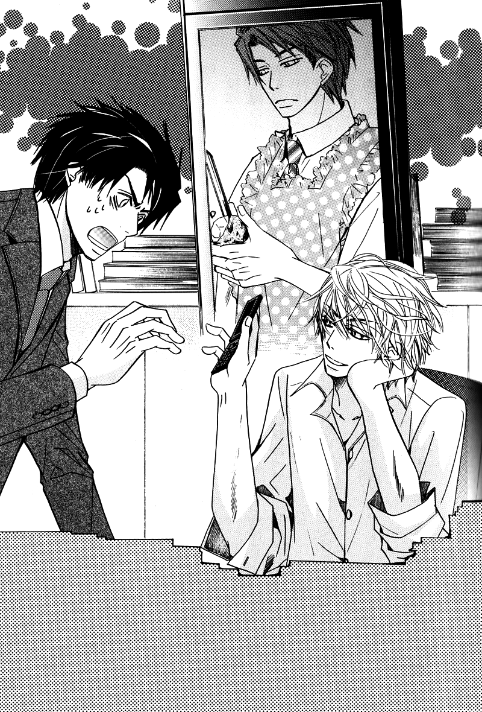
“Cut it out! What the hell is your problem?!” In the picture, he had a knife in his hands and was peeling a potato, looking as if he’d been doing it for years. Yokozawa’s head throbbed in pain when he thought about all his coworkers who’d seen this picture.
“It’s just an innocent hobby of mine is all. Come on, it’s fine–you look adorable. This got me through the end of the cycle, you know.”
“Like I care about that! That’s not the issue here–” Sensing the presence of others, he cut himself off. Who knew what rumors would pop up next if people caught him arguing with Kirishima like this.
“Good morning, Kirishima-san!” Two female editors assigned to the anime news magazine entered, carrying their breakfast in their hands. On catching sight of Yokozawa, they started chattering away.
“Yokozawa-san, we saw it!”
“We thought it was strange when Kirishima-san was smiling like that while staring at his cell phone on Friday night, but to have it be over a picture of Yokozawa-san–! That really was quite a shock! That red apron really suited you–it was so cute!”
“Cu…” At their innocently spoken words, he felt a sense of vertigo wash over him. By now, he was used to hearing it from Kirishima, but this had to be the first time a woman had ever called him cute.
He tossed a glance to the man standing at his side, staring off into space and feigning innocence.
“…Oi. Just how many people did you show that picture to?”
“Hm? Oh, I don’t really remember… Before I knew it there was a huge crowd standing behind me, soooo…I guess most everyone who was still around?”
“You…!” When he unthinkingly raised his voice, he heard snickering voices.
“You sure are close with Kirishima-san, huh!”
“How’d you get to be such friends? I never noticed you two hanging out together before.”
“We’re not close!” His brows drew together at the untruth. They probably couldn’t imagine how he’d been taken advantage of in a weakened state and was being blackmailed now. They didn’t seem to mind this response, though, and instead started their own private conversation.
“But–we saw him cooking dinner with Kirishima-san’s daughter at his home! You don’t suppose he’s after her, do you?”
“Of course not! Do you even realize how old she is? I don’t have a Lolita complex!” He caught Kirishima grinning wildly at his unfortunate state. He could practically hear the guy thinking in his mind Yeah, cause you’re gay.
“But I never even realized you could cook~ Quite unexpected, I must say! And you even know how to wield a knife–are you good at housework like that?”
“That reminds me! A bunch of us were thinking of taking a cooking class soon–would you care to join us? Supposedly it includes tips on how to work a bit of simple French cooking into–”
“Like hell.” His angered voice, which could usually make anyone quake in their boots, was now laced with a streak of humiliation, and he knew that it lacked impact. Rather than quailing before the irritated Yokozawa, the women instead continued speaking as they pleased.
“…I feel like I can relate to him more now! Knowing that even Yokozawa-san has a domestic side to him…”
“Oh yes! He’s definitely more approachable now!”
“..........”
Yokozawa’s head started throbbing painfully, and he couldn’t even bring himself to grouse at the gossiping women. He’d never been good at talking with women in the first place; they always burst into tears at the slightest harsh word–and if they didn’t, then instead they were always griping at him.
If he said any more than this, he was just going to be digging his own grave. Deciding he’d be better off changing targets, he turned back to Kirishima. “Anyways–get rid of that picture. Right now.”
“What’s it matter if I keep it for myself so long as I don’t show it to anyone else? Hiyori went out of her way to send it to me, after all.”
Yokozawa rolled his eyes at Kirishima’s pouting face. He felt bad for Hiyori, but if he let this guy keep hold of the data, there was no telling where or when he’d show it to someone. It was bad enough for him to keep the data on his phone, but to let him keep it as his wallpaper was out of the question.
“Just hurry up and get rid of it already! I can’t trust you!”
“I don’t like suspicious people, you know. I suppose it can’t be helped, though–I’ll delete this one for you.......... There you go.” After pressing a few buttons on his cell phone, he turned it so Yokozawa could see and pressed the ‘delete’ button.
Stroking his chest in relief at this one grain of worry finally disappearing, he couldn’t shake the sense of unease at Kirishima’s words. I’ll delete this one for you… Maybe he was overthinking the emphasis on those words…but he couldn’t help but read into it that this meant he still had in his possession the photos from that incident that he was holding over Yokozawa.
If he had his way, he’d much rather those pictures be deleted than this one, but there was no way he could confront him about that while others were around. For the moment, it seemed he hadn’t shown them to anyone else, but he couldn’t discount the possibility that Kirishima might slip up somewhere along the line. They really needed to talk about this; they couldn’t keep up this farce for forever, after all.
“Aww, what a waste~”
Yokozawa turned back to the female editors on hearing their dejected comments. “And–you, too! Erase it from your memories! Right now! Or I’ll make it so you never sell another magazine in this business again!” It was the same trump card he’d played on hearing the gossiping pair earlier, and the women dissolved into complaints.
“Eeh?! You must be joking, surely!”
“That’s abusing your position! You’re so stingy, Yokozawa-san!”
“What you’re doing is a violation of the right to protect my image, as I see it!”
“Geh…”
But it was Kirishima who stepped in to mediate when Yokozawa raised his voice at the quailing pair. “He does have a point, you know.”
“Stop talking like you’ve got nothing to do with this! Who do you think’s the most at fault here?!”
“Well that would be you, for dressing up in such a cute outfit.” At his cocky response, the women joined in with their support, concurring with him.
Recalling his headache from earlier, Yokozawa massaged his forehead and took a deep breath. “Don’t get too full of yourselves.” Seeing that he was well and truly getting pissed off, they finally quieted down. Truthfully, he didn’t mind so much the teasing so long as it was kept at an appropriate level, but they really needed to know their limits.
In place of the cowering pair of editors, Kirishima once again apologized. “I’m sorry. I really didn’t think you’d get this pissed off. I was tired and just–got a little full of myself. I’ll tell everyone I showed the picture to to let it go, so–forgive me?”
“You’d better.”
“I said I would; a man never goes back on his word.”
Having pressed home his point with Kirishima, Yokozawa left. It was only Monday, and already he was exhausted. He boarded the elevator, which had luckily enough been stopped at the 5th floor, and returned to the sales department on the 3rd floor. He’d come into work early intending to get some work done in the morning while he could, but now he’d completely wasted his free time.
A good half of the sales department personnel had already arrived, and as he hung his coat on the coat rack, Henmi noticed him and lifted his head from where he’d been focusing on his computer.
“Ah–good morning, Yokozawa-san!”
“Morning.” He tossed back the greeting as he made his way to his desk. He unconsciously judged Henmi’s state, curious as to whether or not he’d seen the picture. Despite his misgivings, though, Henmi seemed the same as always.
Most of the sales personnel had already left by Friday evening–Yokozawa himself had been the one to douse the lights on their floor, even. Considering that, the likelihood of Henmi having seen the picture was next to zero, but he still decided to make sure, just in case. “…So, did you see it?”
“Hm? See what? Ah–the materials for today’s meeting? I was just about to!”
“Oh–no, it’s fine if you haven’t seen it.” It seemed word hadn’t gotten around to Henmi just yet. When he thought about it, given that Kirishima had shown the picture off on Friday evening, really the only ones who would’ve had a chance to catch it were those stationed on the shounen manga floor. There was no way it would’ve gotten all the way down to the sales floor.
“I–I’m sorry! I’ll read through them right away!” Misunderstanding Yokozawa’s words, Henmi grew flustered and quickly turned back to his computer. Feeling it too much of a hassle to clear it up, Yokozawa decided to just let him get back to work.
Really–it wasn’t as if it was anything he needed to be all that ashamed of anyways. He’d just worn something that hadn’t suited him was all, and he reconsidered that perhaps there hadn’t been any need to overreact as he had.
He turned on his computer and started to go through the emails that had piled up over the weekend. He put off reading through the digests and skimmed over messages containing bookstore information and comments from readers, first taking care of those messages he could reply to immediately.
“The new issues seem to be selling rather well!”
“Yeah. They’re flying off the shelves faster than we’d anticipated. Looks like we’ll need to put in a reprint order soon.”
“And it seems the timing was perfect for the Za Kan release announcement, too. The back issues are selling nicely, and the magazine is selling off quickly as well, thankfully. Kirishima-san’s tactic really saved us!”
“Yeah…though I’m not sure if it was just a happy accident or if he was actually that clever.” He could probably learn a thing or two from Kirishima, who always tried to turn any situation into an opportunity. Before he’d started being dragged around like this, he really hadn’t known much about the guy. Kirishima had always been so aloof and standoffish, Yokozawa had assumed he was a crafty fox of a man that no one knew what he was thinking.
Granted, that was exactly what he was, but Yokozawa now understood that that was only one side of him. He was also the type of horrible person who’d trip you up if you gave him the chance…just as he was also a father who couldn’t help fawning over his daughter and who gave in to his emotions all too easily from time to time.
“That reminds me, Yokozawa-san–you’ve been in a rather good mood lately!” Henmi commented idly, keeping his gaze on his computer screen.
Yokozawa quickly tightened up his slackened expression and objected, “Huh? Just how have I been in a good mood?” How could he possibly be having fun after having been so thoroughly rejected and then subsequently jerked around by Kirishima?
“Just–the furrow between your brows has gotten shallower, and you’ve been leaving work earlier, too. We were all a little worried for a while there, since you seemed really depressed.”
Yokozawa hadn’t realized in the slightest that everyone had noticed how depressed he’d been–but thinking back now, he did get the sense that they’d all been treading carefully around him.
With his personality, though, he could hardly bring himself to thank them for caring. “I’ve been leaving earlier because I’ve been less busy with work, that’s all.” Given that he was lying through his teeth, he was less articulate than usual.
“Really? It looks to me like you’ve been taking on more work than usual… Have you not noticed that because of that, I’ve had more work than usual as well?”
Yokozawa turned on Henmi at his jokingly reproachful words. “That hardly counts as more work!”
“Unlike you, Yokozawa-san, I’m just a rank-and-file worker! Please don’t be so unreasonable!”
“What’re you going on about? I’m just a rank-and-file worker, too. I’ve just got more years and experience on you, so I know the gist of how things go is all.”
Henmi gaped at Yokozawa in wide-eyed shock. “Eh? Are you…trying to make me feel better?” His gaze was unbearable, and Yokozawa immediately regretted saying something so unlike him. He really should have avoided doing things he wasn’t used to.
“If you want to take it that way, I suppose.”
“…You’ve definitely changed a little! When was it…I suppose from around when you started going out for drinks with Kirishima-san?”
“..........” He swallowed thickly when Kirishima’s name came up so casually in conversation. He clenched his teeth to keep his agitation from being noticed and pasted on a poker face.
“Man, at first, I was shocked whenever Kirishima-san came all the way down to the sales floor! When did you two get to be so close?”
“We’re not close.”
The female editors from earlier had made the same comment, but given that he had reasons he couldn’t turn down any of Kirishima’s invitations, he supposed as others saw it, they seemed to be getting close. But he hardly considered the time he spent with Kirishima to be fun.
When he refuted the insinuation with a sour expression, Henmi misinterpreted it as his just being humble and replied cheerfully, “Oh come on now, it’s plain to see how the tension in your shoulders relaxes when you’re talking to Kirishima-san! Ah–is the reason you’ve been in such a good mood lately because you’ve been spending time with Kirishima-san, maybe?”
“Like hell!”
“!!” Henmi immediately shut up when Yokozawa suddenly snapped at him. He probably hadn’t expected to be shouted at, given how the conversation had been progressing thus far. Yokozawa immediately regretted his actions, seeing Henmi sitting there wide-eyed and at a loss for words.
It was better to be misunderstood than to have everyone know the truth; he should’ve just let the chips fall where they would. But somehow, whenever it came to Kirishima, he always wound up overreacting like this.
“…Sorry. I didn’t mean to raise my voice like that.”
“Oh…n-no…”
Unable to repair the now-awkward atmosphere between them, Yokozawa stood up from the seat he’d just taken. He needed to get some fresh air and cool his head.
“I’m going to make my rounds.”
As he stuffed a file in his briefcase, Henmi hesitantly reminded him, “Eh, but–we have a meeting from 11 o’clock…?”
“I’ll be back by then. I’ve sent you the documents by email, so print out enough for everyone.”
“Wait–Yokozawa-san?!”
He ignored the call and continued on in the opposite direction from all his coworkers just getting into the office.

“…I’m absolutely exhausted…” His first time out drinking with clients in a while had been rougher than usual. Even though there was drinking, it was unforgivable to go so far as to actually get drunk, so he hadn’t been able to shake off the nerves and tension.
Burying himself in work today and thereby avoiding Kirishima had helped to cool his head. He knew that having drink with a manager from a bookstore who’d invited him out earlier would be a just cause to turn the guy down–but it still left him feeling guilty, somehow.
When he’d texted Kirishima with /I can’t come over tonight/, though, he’d been surprisingly understanding. While the response had been a bit anticlimactic, he had to take into account the fact that Kirishima was an office worker just like himself. When he thought about it, there was no way he could have expected Kirishima to put Yokozawa over his work.
Yokozawa was more than a little concerned at how disappointed he actually was, when he himself had been the one to say he wouldn’t go.
“What the hell is wrong with me…?”
He looked forward to being able to see Hiyori, that much was true, but he’d only been dragged around against his will by Kirishima–it wasn’t like he’d let his guard down around the guy. Sure, he might’ve been a bit touched by some of the things Kirishima did, but that was it.
As for the picture Hiyori had sent…to tell the truth, he wasn’t really all that pissed about it anymore. When he’d first learned of it, his blood had gone straight to his head, but it wasn’t as if he’d been doing anything all that embarrassing, and reflecting on it now, it was probably more pathetic that he’d let himself blow up that much over it.
More than that, though, he was concerned at how large a role Kirishima had now come to play in his life.
He set his briefcase down on his table along with chain-store gyuudon he’d bought for dinner and pulled off his suit jacket. As he slipped casually into his chair, Sorata came pawing at his feet. “Meow~”
“Ah, Sorata–I’ll get your dinner for you, wait a minute. You can eat the canned stuff tonight.”
Sorata was rarely this clingy, but perhaps because Yokozawa had been pulling so many long hours lately, tonight he’d been on Yokozawa’s heels from the moment he’d gotten home. Maybe he was lonely from being left on his own so long.
“It’s been a while since we got to eat together, huh? …Sorry I’ve left you here alone so much lately. Work’ll let up soon, so bear with it a bit longer.”
His apartment stocked with only the bare minimum of items required to get by felt lonelier than usual for some reason. Having gotten used to being surrounded by the liveliness of a child, it was now impossible to deny that it was lonely here. If it weren’t for Sorata being here, he probably wouldn’t have been able to stand being by himself now.
“That’s ’cause Hiyo’s such a chatterbox…” Always going on about and then, and then from one topic to the next–popular fads at school, or what subjects she had lessons in that day, what she had for lunch, she loved talking about everything that happened to her that day. Sometimes she’d get tired in the middle of a conversation and just drift off like that.
She was probably asleep right then. Apparently thinking he was planning on coming later, she’d sent him a text earlier urging /Come over tomorrow!/–but while he longed to see her, he didn’t plan on going to Kirishima’s house again for the time being.
He needed to set some boundaries and put his thoughts in order. He couldn’t understand why he lost his composure like this whenever it came to Kirishima. Like this, he hadn’t even had time to think about his broken heart.
“Dammit–why does his face keep coming to mind?” Even though Kirishima was the last person he wanted to see right now, whenever he let his guard down, he found himself thinking of the guy. Never in his whole life had there been such a person as Kirishima to throw Yokozawa off his game like this.
Spacing out while still holding the canned food, he heard Sorata meow at him for attention. When he glanced down, Sorata was rubbing against his feet in irritation.
“Ah–sorry, sorry. Here, I’ll open it now.”
He ran a bit of warm water into the can after opening it to loosen the food and dumped the contents in Sorata’s food bowl, at which point Sorata dug in with vigor. Since he’d been spending a lot of time out of the house, Yokozawa had taken to leaving out dry cat food. While Sorata didn’t seem to really have any likes or dislikes, he obviously preferred canned food.
“Tasty, huh?”
Of course, Sorata was so engrossed in his meal that he offered no response. He wasn’t a young cat anymore, so Yokozawa understood that he needed to put him on a diet, but the guilt of not being able to be there for Sorata much ate at him, and he found himself picking up new brands of food whenever they showed up on the grocery store shelves.
Watching the way Sorata ate, obviously enjoying his meal, he couldn’t help but think that he needed to buy some more for him. Takano would often berate him with You’re too soft on Sorata, and Yokozawa did understand it–but he still couldn’t help himself.
“…Guess I’ll eat, too.”
But his gyuudon had gone cold by now and somehow tasted even worse than usual.

Chapter 5
“Good work today…and sent.”
The doors to the elevator opened on his apartment’s floor just as Yokozawa finished sending off a reply to the email he’d just received from a co-worker.
It was Sunday, and he’d just finished up helping out at a handshake event for an idol group who’d recently released a photobook. There’d of course been the reasoning that there weren’t enough staff for the event, but Yokozawa had also been tapped to help out because of his imposing presence, which would help stifle any unreasonable attempts by overzealous fans to get close to the idols.
Standing work wasn’t exactly difficult, but given that he had to constantly be on alert, it was exhausting on the nerves. His associates were thrilled to be able to see the idols up close, but Yokozawa couldn’t bring himself to to stir up any feelings for these girls who were a good decade his juniors.
“…Maybe I really am gay.” Engaged in his mumbled self-deprecation, he felt around inside his bag, finally pulling out his key.
Given that his apartment faced north, the hallway was rather chilly from always being buffeted by the wind. March was already more than halfway over, but Spring still seemed far away this year. On days like this, he liked to sleep curled up with Sorata. The cat was usually rather moody himself, but even he wanted to curl up for warmth on occasion, too.
“I’m home.”
Locking the door behind himself, he slipped out of his leather shoes. It was rather quiet in his apartment this evening–Sorata usually came to greet him at the door, but tonight, he was nowhere to be seen. He flipped on the lights and headed into the living room, and there he found Sorata curled up in a corner of the couch.
“…Sorata?”
When he called out, Sorata raised his head and glanced Yokozawa’s way, but then immediately curled back up again. He would usually come and rub himself between Yokozawa’s legs, waiting to be picked up, but today he seemed content with just a glance, not even moving to get up.
Maybe he was just sleepy from eating too much. Thinking he’d take the opportunity to refill Sorata’s water bowl, he turning on the kitchen light.
“…What the hell, you haven’t eaten a bite.” Hardly any of the dry food he’d set out before leaving that morning was gone. Given that Sorata was usually quite the glutton, Yokozawa had been worried recently that he would need to put him on a diet. For the cat to leave food in his bowl like this…it was really rare. Going back into the living room to check on him again, he noted that Sorata seemed rather listless.
“…Sorata? Oi, what’s wrong? Do you feel bad?” Despite knowing full well that of course Sorata could hardly respond, even when approached with questions as now, Yokozawa couldn’t help himself. This was the first time he’d ever known Sorata to have no energy or appetite.
He suddenly recalled a conversation with another owner in the waiting room when he’d taken Sorata to the vet clinic for a checkup before. They’d spoken of how a cat they’d owned before had seemed listless one evening, but they decided to wait it out and see if there was any improvement… By the next morning, the cat had died. Since then, the owner had made sure to immediately bring his cat to the vet any time there seemed to be something wrong with it.
Yokozawa had read about a number of similar cases on the Internet as well. What if something really was wrong? Maybe he was overreacting, but he couldn’t discount the possibility.
“I’ve…I’ve got to get him to the vet clinic immediately…”
Grabbing Sorata’s carry-case, he fished around inside the drawer where he kept Sorata’s vet ID card. It was a weekend today, so of course there were no examination slots scheduled–but if he waited until morning, it might be too late. Clinging to hope, he finally managed to locate the ID card and quickly dialed the number on it.
Regardless of the fact that it was a Sunday evening, when he called up the local veterinarian, they gladly agreed to see him. Hailing a taxi that allowed pets to ride with their owners, Yokozawa couldn’t help still feeling uneasy all the way to the clinic.
What if this was something serious, something that might threaten Sorata’s life…? He couldn’t shake that feeling of unease. Even when he tried to keep a positive outlook, only the worst-case-scenarios came to mind.
Others might look at him and scoff that it was just a pet–but to Yokozawa, Sorata was like family. Unlike humans, pets couldn’t speak, so they could only communicate their feelings through movement and expression. While there were certainly times when that was frustrating, they still managed to communicate clearly.
Frantically brushing aside any unpleasant thoughts, he settled in to wait for the check-up to finish–at which point Hiyori burst into the waiting room.
“Oniichan!”
“Hiyo…!”
Right on her heels was Kirishima. “Are you all right, Yokozawa?”
On the way to the clinic, he’d thought about calling Takano right away, but in the end, he decided not to. He couldn’t bear the thought, now of all times, of being pitied by him. But all the same–he couldn’t deny that he was lonely and wound up phoning Kirishima on impulse.
The moment he saw Kirishima’s face, he felt a wave of relief wash over him–but at the same time, a sense of regret settled as well.
Even if he was worried, it had been a mistake to call up Kirishima. No matter how precious Sorata was to Yokozawa, to any onlooker, this likely seemed like the most trivial of matters.
“I’m sorry… You came all this way just for a pet…”
“Don’t say just for a pet! That cat’s like your family, isn’t he?”
At Kirishima’s harsh words, Yokozawa felt a pressing heat behind his eyes. “Ah…yeah…” He dropped his head, determined not to cry in front of them, and grit his teeth.
Hiyori reached forward and squeezed his hand in her own. “It’s okay! I’m here now! Sora-chan’ll be just fine!”
“…Yeah, you’re right. Thanks, Hiyo.” He was one pathetic adult, having to be cheered up by a child. But the warmth of Hiyori’s hand was reassuring, and just as he returned a smile her way, the door to the examination room opened.
“Yokozawa-san, please come this way.”
“Right.” When the elderly veterinarian called out to him, Yokozawa stood up as if he’d been jerked from his place. Patting Hiyori’s head in thanks for her staying by his side, he stepped into the examination room.
Sorata was sitting quietly on a small, waist-high table and seemed to have had no issues with the check-up. He looked utterly nonchalant, as if his earlier lethargy had been a complete ruse.
“So, how is he, sir?”
Seeing Yokozawa’s worried mien, the doctor dove into his explanation of the check-up results with a gentle smile. “You can stop worrying. I gave him a general examination, but I couldn’t find a single thing wrong with him.”
“Really?!”
“Indeed. At the very least, it doesn’t seem that he was feeling bad from eating something that didn’t agree with him. He probably was just not feeling very energetic is all.”
“Then–there’s nothing wrong with him?”
“Yes–as you can see, he’s absolutely fine now, and there’s no worry of him being sick. But Sorata-kun isn’t getting any younger, so he should be fine–but just in case, you’ll want to keep an eye on him for the time being.”
Sorata appeared to be delighted being held by a veterinarian he was fond of. Maybe it was just as the doctor had said and he’d simply been feeling listless.
…Which meant Yokozawa had gotten worked up over nothing. He felt relief and shame well up inside of him at the doctor’s diagnosis. It hadn’t been anything major at all–and yet he’d gone and gotten worked up and roused the vet from his bed at this late hour, even going so far as calling up Kirishima. There were limits to losing your head over things.
Fighting against the humiliation that had started to bubble inside, he bowed his head low. “Thank you so much!”
“Think nothing of it. I’m only glad it wasn’t anything serious. Perhaps he was just feeling a bit lonely. Sorata-kun is very lucky to have an owner who cares so deeply for him.”
Taking Sorata back from the veterinarian, Yokozawa held him close to his chest, feeling a stab of guilt when Sorata brought his face close, looking for attention.
Yokozawa hadn’t been getting home until late recently, and he hadn’t been able to play with Sorata much or even bring him over to see his former owner, Takano. Of course Sorata would feel lonely.
“I’m sorry to have troubled you so late in the evening.”
“It’s nothing–this is my job, after all. Please take care.”
“I certainly will.” He bowed once more and then stepped out of the examination room, at which point Hiyori rushed over.
“Ah–Oniichan! How is Sora-chan??”
“Seems he was just a bit lethargic is all. He’s not sick, so there’s nothing to be worried about.”
“Really?? That’s great, Sora-chan! Oh–hello! I’m Hiyori! It’s a pleasure to meet you~!”
Hiyori straightened up and patted Sorata’s head. Sorata’s eyes flattened into slits, obviously enjoying the feel of her little hand.
“So–it wasn’t anything serious, then?”
“Looks like it was just me overreacting. …Sorry for causing you trouble this late at night.” He apologized for inconveniencing them due to a simple misunderstanding.
“What the hell are you acting all dejected about? Aren’t you happy it wasn’t a serious sickness or anything?” Kirishima slapped him on the back forcefully. Despite being called out on a Sunday night without warning, neither Kirishima nor Hiyori seemed put out in the least, simply rejoining in Sorata’s good health. At this, Yokozawa finally felt the tension in his shoulders fade away.
“You sure you don’t need to get any medicine for him?”
“Yeah, I can go home now. Just–he’s not a kitten anymore, so the doctor said to keep an eye on him.” Reciting what he was told by the vet, Yokozawa slipped Sorata into his cage. They couldn’t hang around in the waiting room forever.
As the three of them stepped outside, the night sky above was dotted with stars and a crescent moon. They seemed brighter than usual, as the quiet neighborhood in which Yokozawa lived had relatively few street lamps.
“When he said to keep an eye on him…did that mean during the day, too?”
“Nah–seems like the usual amount of time should be fine. I’d love to be with him always, but that’s hardly feasible…” He had a job, after all, so he could hardly stay at home full time just for Sorata. It would have been enough if he could at least get home earlier, but this week he already had a lot on his plate.
Perhaps if he had a friend he could ask to watch Sorata, that would be fine, but the only person he was close to who lived alone and could have a pet was Takano–and there was no way he could ask someone who had an even more hectic schedule than Yokozawa in sales to care for a pet.
Just as he was wracking his brain for any possible options, though, Hiyori’s hand shot into the air, waving around for attention after hearing their conversation. “I’ll watch him!!”
“Huh?”
“Sora-chan can just stay with us until he feels better! I’m on spring break right now, so I can be with him full time!”
“That’s a great idea!”
“Right??” Hiyori’s chest puffed out in pride as Kirishima praised her. But while Yokozawa appreciated the thought, he knew he couldn’t ask for that much. Sorata was the cat he’d taken in from Takano, professing that he would take care of him; Yokozawa had a duty to watch over him.
“I’m grateful for the offer, but if you did that, you wouldn’t be able to go anywhere, right? Don’t you want to play with your friends?” He couldn’t stand the thought of Hiyori’s freedom being taken away just for Yokozawa or Sorata.
But Hiyori remained resolute. “I can play with my friends anytime! It’s more important to make sure Sora-chan gets better soon, though, right? You’ve got work, Oniichan, so leave it to me!”
“Listen to Hiyo and accept the offer, would you? Or are you saying you can’t trust her?”
“Of course I’m not saying that!”
“After all, this is you we’re talking about: you’re probably thinking you don’t want to cause us any more trouble, right?”
“..........” Being seen through so easily, Yokozawa had no room to refute the accusation. Kirishima probably saw him as nothing more than a child.
“I’ll tell you this straight out, then: It’s no trouble at all. In fact, it’s more of a pain to have to see you sitting on the fence like this. And–while we’re at it, you come and stay with us, too.”
“What? Why the hell do I have to–”
“I’m worried for the cat, sure–but I’m worried about you, too. It’s not wise to leave you by yourself. Have you looked in a mirror lately? You look like shit.”
“Cut it out–stop poking me!” Yokozawa slapped away the hand that had come up to poke his cheek. He looked horrible because he’d been worrying incessantly over Sorata–it wasn’t like he himself was sick. It was nice of them to worry for him, but it was decidedly unnecessary.

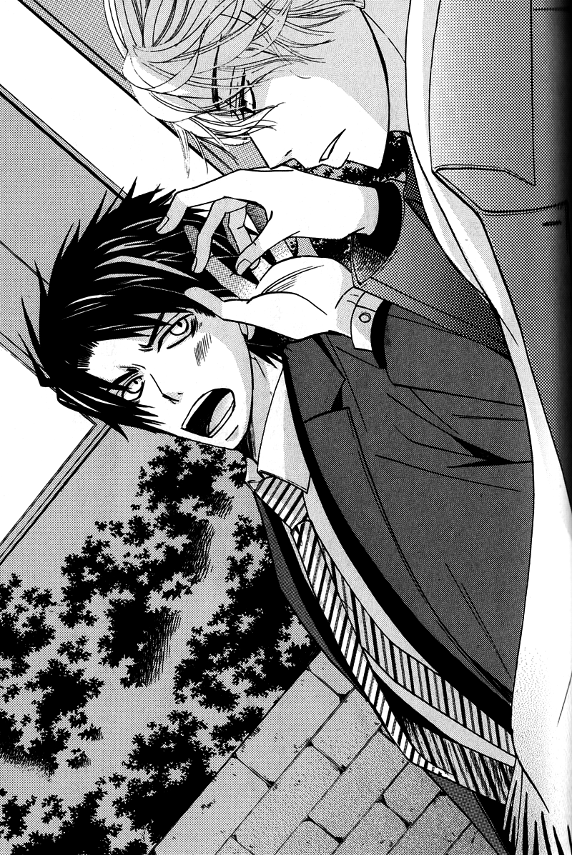
“We’ve got a spare room, and if all you do when you get home is sleep, what’s it matter where you do it? You think it’s better that way too, right Hiyo?”
“Yup! Come stay at our place, Oniichan! It’s more fun if we’re all together!”
With Hiyori staring up at him with her eyes sparkling, Yokozawa found himself enveloped in an atmosphere where he couldn’t argue any further. Even though he knew full well this was all Kirishima’s doing, he couldn’t fight against the innocence of a child.
He snapped softly at Kirishima in a voice Hiyori couldn’t catch, “That’s low, using Hiyo like that…”
“It’s my policy to use whatever’s at hand to get the job done. Now quit your bitching and get in the car. We’ll stop by your place so you can pick up a change of clothes and the cat’s things.”
“But–”
When Yokozawa continued to hesitate, Kirishima pulled his trump card: “This is an order. You know what that means, right?”
“……..!” At the emphasis, Yokozawa instantly recalled how he’d been taken advantage of. Having that incident held over his head, Yokozawa had no choice but to comply.
Seeing Yokozawa grow quiet, unable to object, Kirishima took the opportunity to draw things to a conclusion. “Well then, it’s settled! You’re fine with it, right Hiyo?”
“Yup!”
“Hop in the back with Sorata, Hiyo. And make sure you buckle up!”
“Yes sir~”
“Wait–oi!”
Hiyori picked up Sorata’s cage as instructed by Kirishima and climbed into the car, and before he could try to take it back, he found himself pushed into the passenger seat. He had to bend down to try and fit into the unexpectedly small space that seemed to have been sized just for Hiyori.
“Yokozawa–you buckle up, too!” Kirishima slid into the driver’s seat in high spirits, and the car sped off with its one feline and three human occupants.
Chapter 6
Under the care of the Kirishima household, Sorata bounced back such that he was unrecognizable as the same cat from before. Yokozawa had feared at first that he might be nervous in a new house, but he quickly warmed up to both Kirishima and Hiyori. And while it was nice that Sorata was able to get all the attention he wanted whenever he desired, he seemed now to be even more needy than he had as a kitten.
While Yokozawa honestly regretted involving Kirishima in all of the ruckus just because of his hasty conclusion, he couldn’t help but be relieved that there really had been nothing wrong with Sorata in the end. If it had been too late to do anything…Yokozawa probably wouldn’t have been able to recover.
Maybe Sorata really had just been lonely. Animals disliked being left all alone any more than humans, after all. Seeing Sorata playing with Hiyori without a care in the world, Yokozawa deeply regretted all the days he’d been late in coming home.
Still–it wasn’t as if he could purposefully reduce his workload, and he was doing his best now to arrive as early and leave as early as possible, even if it was a mere ten minutes either way.
“…Mornings start pretty early around here anyways.”
Wake-up calls were early in a home with a child in it. Hiyori liked to come bursting in and leap onto Yokozawa’s chest before his alarm clock went off, and despite taking heavy damage to his midsection, this was Hiyori, so he could hardly get mad at her, leaving him no choice but to get up without complaining.
While his staying here with Sorata had been an unwilling concession initially, now that a week had passed, he found himself growing accustomed to his life here. In the bathroom, set up alongside a child’s-sized toothbrush was a blue toothbrush that Hiyori had picked out for Yokozawa.
After washing his face, Yokozawa wandered into the living room, where Hiyori pounced upon him holding a hairbrush in one hand. “Oniichan! Do my hair!”
“What’ll it be today?”
“Hmm–we’ve got P.E. today, so put it in a ponytail! Oh–and I wanna wear this, too!” In the palm of her hand, Hiyori held a scrunchie that Yokozawa had bought for her. She appeared to be quite fond of it and had been asking him to put it in her hair every day.
“All right then, sit down.” Yokozawa had started helping her do her hair after seeing Hiyori reading a magazine and fretting over wanting a cute hairstyle like her friends. She’d apparently been trying to do it herself when she couldn’t have her grandmother help, but she’d unfortunately not been very successful.
Yokozawa had always been skilled at delicate operations, and so was able to quite easily give Hiyori the hairstyle she wanted. Since then, he’d been in charge of fixing her hair almost every day. She’d been particularly thrilled the time he’d given her an elaborate braid that had been the envy of all her friends at school.
“You sure are a lot more skilled than you come off.” Kirishima watched in admiration as Yokozawa attended to Hiyori’s hair, the other freeloader Sorata curled up on his lap.
“You’re just really unskilled is all. Learn to at least do your own daughter’s hair, geez.”
“Hey–I can’t help it. Whenever I try, it always winds up looking like crap.”
“Don’t make excuses. If you can typeset a manga, you should have no trouble learning to fix hair with a little practice. Hiyo–it’s not too tight, is it?”
“Nope, just fine!”
He finished the ponytail off with the scrunchie. “All right, then–you’re done. Go check in the mirror.” Yokozawa felt he’d actually gotten quite good at this by now. He was rather fastidious by nature and found he had a knack for accomplishing these tasks that required dexterity and focus.
“Thanks, Oniichan!” Hiyori turned a bright smile on him and then darted into the bathroom. Watching her flit away with a pleased expression, he poured himself a cup of coffee and took a seat at the table.
“Here–you take milk in yours, right?”
“Yeah.”
Kirishima passed him the milk set out on the table. While Yokozawa preferred his coffee black, he’d taken to enjoying his morning coffee with milk since hurting his stomach once. While it may have been a futile effort, he tried to be as careful as possible, considering that he led a rather alcoholic lifestyle.
Watching Yokozawa sip his cooled cafe au lait, Kirishima commented idly, “Like this…we’re kinda like a couple of newlyweds, huh?”
Certain he’d misheard, Yokozawa furrowed his brows and returned, “Huh? Did you say something?”
“I said, this reminds me of life as newlyweds. I’m the papa, and you’re the mama.” He pointed back and forth between himself and Yokozawa, face serious.
It was a rather dull joke, and Yokozawa couldn’t bring himself to laugh, instead deepening the furrow between his brows. “Stop saying weird things like that.”
“There you go again, blushing.”
“I’m not blushing!” He understood perfectly well that Kirishima only teased him because he got riled up like this, but he couldn’t let it go. When he failed to keep his emotions in check and moved to turn the tables on Kirishima, he caught Hiyori’s voice.
“What’s going on?? What’re you talking about?” Apparently she’d gotten curious hearing Kirishima raise his voice in laughter and poked her head into the living room, her backpack in one hand.
“I was just telling Yokozawa how nice it’d be if he’d be our mama.”
Yokozawa stiffened at Kirishima’s words. “Oi, don’t say weird things to a kid!” He hadn’t expected the guy to bring that kind of thing up in front of Hiyori of all people.
Hiyori tilted her head, following up with a logical argument: “Eeh?? But–Yokozawa-oniichan’s a boy! If he was going to be anything, he’d be a papa!”
To keep Kirishima from butting in with any more useless commentary, Yokozawa quickly changed the subject. “Hiyo–forget your dad for now and finish getting ready for school. It’s almost time for you to meet up with the others, right?” At Hiyori’s school, children living in the same area all gathered in the mornings and traveled to school together. If a student was late, they ran the risk of being left behind.
“Really? I’d better hurry! Ah! I haven’t packed my gym clothes yet!!”
“They’re in a bag in the genkan. And–make sure you wear your sneakers today, not the red shoes!” Yokozawa had taken the liberty of preparing her gym clothes the night before after checking her schedule.
“Right~!”
Watching Yokozawa skillfully directing Hiyori, Kirishima stifled a laugh and muttered, “…Yeah, you’re definitely suited to be a mama. You’re more maternal than most of the mothers around here, even.”
“Zip it!” He could feel himself growing weary from his habit of blurting things out unnecessarily, and he made a sour expression at Kirishima’s observation.

“Excuse me, Yokozawa-san? I’ve put together the stockpile information for the manga print-run decision meeting at the beginning of next week, so could you please check it?”
Suddenly called out to while he was focusing on his computer screen, Yokozawa snapped back to the present. When he glanced up, he found Henmi standing beside him holding a sheaf of papers. “Sure–I’ll take a look later. Oh, that reminds me: things were pretty rough last month. Does it look like there’ll be any trouble for next month?”
Print-run decision meetings were meetings at which decisions were made regarding how large a print-run to have for a particular title. There, the sales and editing departments and the distribution center gathered together to decide how many books to have printed based on an author’s previous works and survey data.
The distribution centers were in charge of stockpiles, and always tended to lowball the figure, whereas the editors, who worked hand in hand with the authors themselves and had helped make the books themselves, threw out jokingly high figures.
“No, I think it should be fine this time! The back issues being ordered are all works that have been shown to sell well, so I don’t foresee any titles that should cause trouble.”
“That’s good, then. We’ve never had one of these things go smoothly, though. Who the hell do they think is out there actually selling the books?”
He personally believed that figures the sales department drew up were the most realistic. They were the ones who had a feel for the stores that distributed their titles, and all of their suggestions were made upon comparing the figures with past data as well as other parameters. It wasn’t as if he couldn’t understand the feelings of the distribution center–who didn’t want to stockpile too many titles–or the editing department–who had high hopes for the titles they’d worked so hard to bring to life–but there was such thing as an ‘appropriate volume’.
Granted that sure, for every title that was an explosive hit and wound up selling far better than expected, there was always one that turned in disappointing sales figures, rarely did such a difference come into play.
“That’s true… The distribution center rarely agrees with our suggestions, after all.”
“Well, that’s tough shit for them.”
Henmi gave a bitter smile and rubbed between his brows. “I really wish we could have a nice, quiet meeting for once, though.”
“No such thing with those guys in the meeting.”
“Aah…”
With his concentration broken, Yokozawa decided to take a break, and after saving the file he’d been working on, he put his computer to sleep. Clasping his hands together and stretching, he felt his joints creaking. He’d been sitting at his desk in the same position for so long, he’d gone stiff all over. While this was usually about the time he’d head home for the day, it didn’t look like that would be possible any time soon today.
“Sorry, I’m gonna step out for a bit.”
“Bathroom break?”
“Smoke break.”
Since he’d started living with the Kirishimas, he’d held back on having even a single cigarette after leaving work every day. But for that reason–the number he’d indulged in during the day had spiked.
He stood from his seat, tapping his vest pocket to ensure his cigarettes were there. On their floor, there was a smoking room bounded on all sides by clear walls–in the ever-expanding environment of non-smokers, it was a bit shameful to still be indulging.
“Maybe I should kick the habit myself…” Even as he muttered the words to himself, he knew it was just lip service. He understood full well that this was doing nothing but damage to his body, but he just couldn’t help it. During work, he’d always find himself reaching out for one, and he kept his smoking at home to a minimum out of consideration for Sorata. Cigarettes weren’t just a luxury item for Yokozawa–they were the quickest way to relieve stress.
For now, though, he’d need at least one smoke to help him finish up his quota for the day, so quitting would have to come at another time. Telling himself he’d just keep it to the one cigarette, he stepped into the break area.
“…!”
Yokozawa stopped short when he realized who was already standing in the smoking room. He didn’t even need to see the guy’s face; just by his posture he knew immediately who it was.
“…Masamune…”
It was indeed Takano smoking alone. He probably had some black coffee in the mug on the counter he was leaning against, too. Despite being told time and again that black coffee was bad for his digestion and would leave a sour taste in his mouth, Takano always took it black when Yokozawa wasn’t around, refusing to even sweeten it with milk.
Perhaps he was pulling some overtime as well tonight. Takano may have been a terror to his subordinates, but he was even harder on himself. He’d at first been worried about having subordinates who were older than him, but he’d quickly realized that he had no choice but to do his job as befit someone standing at the top of the ladder, and so he loaded himself down with at least twice as much work as anyone else.
“…He looks exhausted.” Takano would never show his weak side before others, reserving any complaints and worries for Yokozawa’s ears only. The comfort of knowing he was trusted so deeply…may have been one of the reasons he’d never been able to give up on his feelings.
Simply seeing that back facing him, Yokozawa felt the feelings he’d meant to toss aside come welling back up again. He’d loved him–loved him so much, loved him more than he could help. And he’d known that it was a one-sided love, so he’d kept quiet and simply enjoyed being able to be by his side.
Yokozawa had been the one to ask for time to let everything settle–but he knew that time alone couldn’t resolve this. He’d thought that the wound from being rejected had started to heal…but even now he could feel it throbbing painfully and realized that he still had not been able to give up his lingering affections for Takano.
What had changed from before, though, was that now…there was no hope left. That was the only difference.
Fighting back the urge to just leave, he took a step forward and pushed on the clear door, calling out in a calm voice, “Hey, Masamune. You taking a break, too?”
“Yokozawa…” Takano turned around, eyes wide and gaping like a fish.
Yokozawa had worked hard to keep from having to speak with Takano outside of meetings or work-related projects, so it had truly been a while since they’d been alone like this. He’d been afraid that he’d be a lot less eloquent when it came to this, and he felt relieved that he’d been able to pull it off rather naturally. “Doing okay?”
“More or less, yeah.”
“Eating properly?”
“Of course.”
“..........”
“..........”

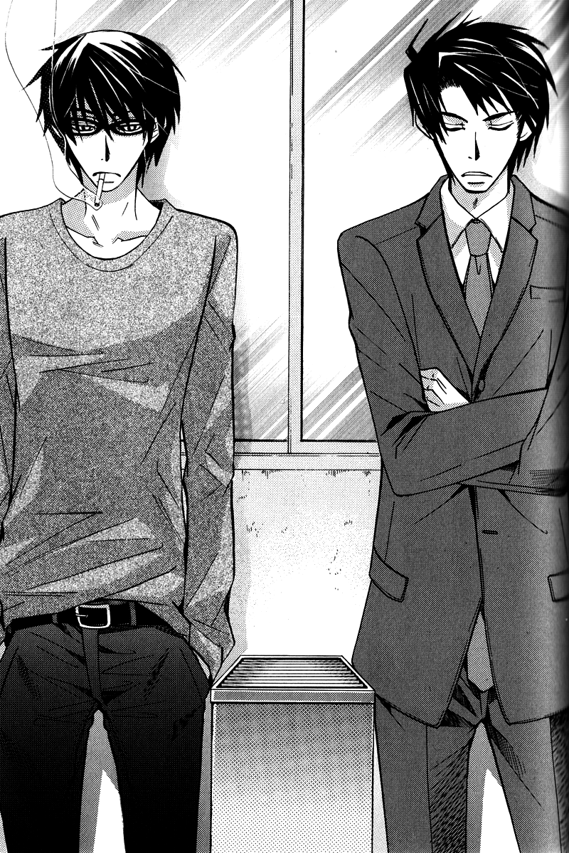
He’d tried to start a conversation, but just like that, it had fallen by the wayside. The reason they couldn’t keep up a conversation like before was likely because they hadn’t really come to any understanding between themselves yet.
“How’s Sorata doing?”
“Energetic as ever. He’s such a fatass, I can’t keep up with him.” It was bad enough that Kirishima spoiled him, but Sorata was always begging for more treats. Hiyori, on the other hand, was unexpectedly strict in that respect, and kept an eye on them in place of Yokozawa.
“…So you sure seem to be close with Kirishima-san lately.”
Yokozawa’s heart skipped a beat at the eerie timing that made it seem as if he’d read his mind. “We’re not close; he’s just dragging me around is all.”
Takano’s expression grew suspicious as Yokozawa’s ambiguous response. “Really? Why don’t you just turn him down if you don’t like it, then?”
“It’s not–it’s not like that, it’s just…”
If he spilled the details of how he’d gotten close with Kirishima, Takano would eventually realize the pitiful state Yokozawa had been in when he’d been rejected that night–and above all else, he definitely did not want that known.
But it was almost as annoying having Takano think he was just merrily flitting about with the guy as well.
Still, when he clamped his mouth shut, unable to come up with an effective excuse, Takano seemed to not care much at all and easily changed the topic. “That reminds me–I tried calling your apartment last night, but I guess you got home really late that evening.”
“Oh–no, I wasn’t home last night. Sorry if it was an emergency.” Given that he’d just professed that he wasn’t close with Kirishima, there was no way he could reveal that he was staying at the guy’s place. He knew that he wasn’t doing a very good job of hiding his discomfort, but Takano seemed even more oblivious to his feelings than usual today, and so he didn’t call Yokozawa on it.
“It wasn’t urgent or anything, so don’t worry. Were you at your parents’ place or something?”
“Ah, yeah… Something like that.”
When Yokozawa’s business trips coincided with particularly hectic times in the editing department, leaving Yokozawa unable to ask Takano to look after Sorata, he would often ask his parents to look after the cat.
Right now, all of the sales department personnel–Yokozawa included–were quite busy, and he usually would’ve asked Takano to watch Sorata right about now. Maybe he was worried that because of what had happened between them, Yokozawa was avoiding asking him for any favors. Takano fell silent, a pained expression on his face. “…………”
He hadn’t intended to get the guy worked up, but it seemed his attempts at supporting the conversation had only served to make things worse. At a loss for words, he could only patiently endure the heavy silence between them.
It was Takano who broke the tension first. “…I’m sorry.”
“Masamune?” At the sudden apology, Yokozawa let his mask fall for an instant, but quickly stiffened his expression again, straightening up.
“I…thought a lot about it on my own, and realized I was in the wrong. I was always going to you for advice and taking advantage of you. I realize that was…pretty insensitive of me.”
How long had he been thinking about this, to bring up these words now? Going out of his way to make the first move himself, he was worlds away from Yokozawa, who always ran away from the important topics like this.
He loved this straightforward aspect to Takano. He’d always been self-defeating and cynical in his way of thinking, but that was all just a front to protect his fragile, easily hurt heart. Perhaps that was why Yokozawa had been so strongly drawn to him.
But what of Yokozawa himself? He’d consulted Takano as a close, personal friend time and again, but he’d never been able to truly tell him how much he’d loved him until the very end.
Steeling himself, he took a deep breath. “Seriously. You’re the editor-in-chief of a shoujo manga magazine! Learn to read between the lines a little, will you?” He pasted on an easy smile, pretentious. It was the most honest thing he could say for Takano right now.
Even if their love could never be, he wanted to stay Takano’s companion. He would probably never find someone he felt so comfortable around again.
“I’m not bothered by it anymore–so, sorry. For saying weird things. Let’s get a drink together again some time.”
At Yokozawa’s words, the tension visibly eased from Takano’s shoulders. “…Yeah, sure.”
“Though I’ll probably be busy for some time yet. There’s an anime production in the works, so I’ve got a lot on my plate. Oh–I just remembered there was an urgent project I need to do. I’m heading back to the sales floor. It’s Friday, so I’ve gotta get it all wrapped up today.” He knew it was a pathetic excuse to say he just remembered, but he needed something to wrap up the conversation.
“Sure–gimme a call when things settle down.”
Takano probably saw right through him. Still–taking this excuse at face value was for the best for both of them. “I will. See you later.” Tossing back a final smile as a bluff, he turned and left. If he spent any longer around Takano, his carefully crafted mask was going to slip off and shatter on the ground.
“Oh, that reminds me.”
“Hm?”
“…Give my regards to Onodera.”
“…I will.”
Waving one hand at Takano’s reply, he left the smoking room. What sort of face was Takano making right now? He was curious, to be sure, but he didn’t dare turn around, instead continuing straight forward.
Without realizing it, his tightly gripped fists had left nail marks in his palms.

While he’d left Takano professing a need to finish some work, he couldn’t bring himself to return to the sales floor just yet and instead slipped out onto the outside emergency stairwell looking for a place to be alone.
The sun was already setting, leaving the sky dyed in the colors of early dusk. This was also a designated smoking area, but in a season such as this, few were those who would come out here only to be battered about by the north wind. It was an ideal place if you wanted to be left alone, though.
“..........”
He released the tension that had been building up in his shoulders from nervousness and exhaled softly. He’d been able to talk with Takano more calmly than he’d expected–and yet, at the same time, it had made him remember all of the lingering affections he still held for the man.
He knew full well that there was absolutely nothing to hope for, but the fact that he loved Takano had not changed one iota.
“If I could forget it that easily, I wouldn’t be in this situation, would I…” he reminded himself, taking his cigarettes out of his vest pocket. Biting one between his teeth after tapping it out with a finger, he lit up using a lighter decorated with an anime character from one of Marukawa’s own titles.
Behind him, there was the sound of an iron door opening, and for a moment he stiffened in apprehension, but when a familiar voice called out to him, he was relieved.
“You’re like a high school brat trying to sneak a smoke under the teachers’ noses.”
“Shut up.”
He knew the voice belonged to Kirishima without even turning around. He didn’t even need to ask how he’d known Yokozawa was up here; he’d probably seen Yokozawa head out onto the emergency stairwell and had followed him up. Perhaps he’d thought it suspicious that Yokozawa would go out of his way to find some place to be alone, or perhaps he’d seen him and Takano interacting. He wouldn’t have come up here to bother him during business hours without a reason.
“If you’ve got something to say, spit it out.” He leaned back against the landing’s railing, cigarette held in his teeth.
Kirishima drew up beside him and leaned against the railing himself. “I’m trying to think of something right now. Gimme a cigarette.”
“I thought you quit.”
“Sometimes even I wanna do something bad for my body.”
Yokozawa pulled out the cigarette case he’d just returned to his pocket and passed it to Kirishima.
“These are some pretty light smokes you’ve got. Gimme a light, too.”
“Do it yourself.” Yokozawa moved to pass him the lighter as well–but Kirishima just reached forward and grabbed onto his necktie, jerking him close to bring their faces together.
“Nah, this’ll do fine.”
“..........”
Yokozawa dropped his gaze so their eyes didn’t meet at this close distance–and in doing so, he found himself staring at Kirishima’s lips. They were thin, well-suited to the wry smiles he liked to give out. He wondered idly how many others knew how Kirishima opened it wide when he laughed loudly. Surely no one else in the editing department would believe that despite the way his fingers delicately held a cigarette, he was actually quite clumsy.
“…Finally got it lit.”
“Ah…yeah.”
The few seconds it took for the cigarette to catch had seemed immeasurably long. Kirishima took a long drag and then easily released it, opening his mouth quietly. “…Are you all right?”
“What’re you talking about?”
“Don’t play dumb. Something happened with Takano, didn’t it?”
“It’s not polite to spy on people.”
“If you didn’t want people seeing you, you shouldn’t have made that face in a public place.”
So he had seen them together… He’d turned his back to Takano, but Kirishima must have noticed his expression from outside the smoking room. “…And what kind of face was that, exactly?”
“You know full well–that’s why you’re out here in the first place, right?”
“If that’s the case, then what the hell are you doing here?” He could feel his anger rising at Kirishima who continued to poke at all his sore spots, no matter how hard Yokozawa tried to keep them hidden. To keep him from noticing this, he took a drag on his cigarette–but for some reason, no matter how much nicotine he took in, today it just wasn’t giving him the relief he sought. “Sorry, but I really don’t feel like being your plaything right now. Please leave me alone.”
He was without a doubt completely exposed right now. If this kept up, he wouldn’t be able to keep Kirishima from seeing a side of Yokozawa he didn’t want to expose.
“If I did that, though, you’d just get depressed and go and deepen that furrow between your eyebrows. And just when I’d finally managed to get it to disappear, too. Well–I suppose it wasn’t that easy a job, though.”
“What are you…”
And that was when he realized it: he’d been so drunk, he’d lost all memory. It wouldn’t have been strange at all for him to have let slip that Takano had been the one who’d rejected him. This guy had just been pretending not to know.
Perhaps that had been why he’d dragged Yokozawa all over then: to keep him from dropping any deeper into depression. Indeed, he hadn’t been alone with Takano just the two of them until today–and that was all because he’d spent every free moment he had…with Kirishima. His vision swam with shock and confusion at the realization that…he’d been being protected all this time.
“I never would’ve pegged you for such a meddling type.” Even his sarcastic quips were softened by the quaver in his voice. He couldn’t bring himself to put up the brave front he’d managed with Takano earlier.
“I surprised even myself. I couldn’t just leave you alone though; maybe because you reminded me a bit of myself from a long time ago.”
“Hmph, and just what part of me is like you?”
“The way you spin your wheels on fruitless efforts and always wind up getting the short end of the stick.”
Yokozawa grimaced at Kirishima’s perfectly on-point comment. Indeed, it was exactly as he said: particularly with regards to his actions since Onodera had turned up. Each and every thing he’d said and done had done nothing more than force the pair to reconfirm their feelings for one another. All of his efforts to tear them apart had only served to bond them even closer, bolstering his position as a spoiler.
No matter how skilled his dexterity, it had no effect on his actual life. He knew better than anyone else that he utterly failed at all the essential parts. But–he never would have pegged Kirishima as the same type.
“…Like you’re anything like me.”
“I’m getting on up there in years; it’s just a mask. It’s only that I’m good enough at it that you greenhorns don’t notice. But on the inside–we’re really not all that different at all.”
Yokozawa couldn’t tell if he was being truthful or just trying to cheer him up, and Kirishima continued to speak when he didn’t respond. “You’re really pure-hearted; one wouldn’t know it from looking at you. You’re always taking that first love of yours so seriously, even though nothing ever came of it, and putting on airs to keep from hurting him.”
“And what makes you so sure it was my first love?”
“Because you blurted it out while you were drunk–but then, anyone can tell just by looking at you. If it wasn’t your first, you wouldn’t suck this much at being in love with someone.”
“..........” He couldn’t help wondering just how much he’d spoken to Kirishima that night. That he had hardly any memories of it continued to worry him.
Unable to keep calm, he quickly pulled out his pocket ashtray and put out his cigarette. If he didn’t do something different right now, he ran the risk of saying something he would regret.
But Kirishima continued to bombard him with conversation, heedless of his attempts to calm himself. “I’m going to say something–and you’re not going to like it–but what you’re feeling? That’s dependency.”
“Wha–?” His mind went blank, and he couldn’t grasp what he was being told. Or rather–it wasn’t that he couldn’t understand, but that his mind was flatly refusing to comprehend it.
“‘I’ve got to be by his side, I’ve got to support him, I know him better than anyone else’. Thinking that way is just the underside of wanting someone else to do that for you.”
He wanted to be needed, wanted to be supported, wanted desperately for someone to know him better than anyone else did.
Having his ugliest secrets exposed, he felt all the blood rush to his head. “What the hell do you know?!”
Kirishima maintained a cool mien in the face of Yokozawa’s raised voice, and the difference in their composure only served to underscore how pathetic Yokozawa was.
“Reactions like that are proof that I hit the nail on the head. If you’d never realized it before–think it over now. Why did you love him in the first place?” That calm, remonstrating voice of his was so damn irritating.
“You sure talk big for someone who doesn’t know anything about me! I’m fucking tired of your meddling–so stop trying to manipulate people just because you think you know better than them!”
Yokozawa realized that he’d just said something horrible in a fit of anger–but he had no clue how to stop these feelings from bursting forth.
“…Yeah, you’re right. I…realize that I don’t know everything about you.” Yokozawa felt a stab of pain in his chest at Kirishima’s sad smile. It was different from the pain that he’d felt when he’d been rejected–because this time, the pain sprang from a deep sense of guilt.
If he didn’t apologize right now–their relationship would never recover. But despite this sense of urgency, the words he next spoke were completely the opposite of an apology: “Just–get the hell away from me! Don’t come around me anymore! I don’t want to see your face ever again!”
At this, there was a silent pause–after which Kirishima spoke shortly, “Fine, then.”
“..........”
“I don’t have an ash tray–would you mind getting rid of this for me?” He passed the shortened cigarette back to Yokozawa and turned on his heel, leaving behind Yokozawa and disappearing back through the iron door into the building.
He’d done exactly what Yokozawa had asked–so why did his chest hurt so much?
He opened his mouth for a moment to call for him to wait–but hesitated. Yokozawa was the one who’d run him off; he had no right to try and stop him. He didn’t even know how he would’ve tried.
While he warred with himself, the large iron door slowly slid shut again, closing with a loud slam.
To Yokozawa, it sounded like Kirishima’s rejection incarnate.

Chapter 7
In his right hand, he held an apple pie that he’d bought at a patisserie, and in his left he toted a plastic grocery bag laden with cooking ingredients.
Yokozawa’s steps were slower than usual along this path he was now well familiar with, weighted down as he was with hesitation and apprehension. He hadn’t trudged this slowly towards a destination since the morning after he’d run away from home following a fight with his parents.
“…I guess this was kind of like running away from home, too, huh…”
Yokozawa had returned that evening to his completely empty apartment. While he’d been a bit concerned about Sorata, he hardly had the nerve to just swan in like nothing had happened after blowing up at Kirishima like that. And anyways, Sorata was better off being looked after by Hiyori than by Yokozawa in his rough state. The cat was rather attuned to humans’ emotions and wouldn’t come near Yokozawa when he was in a mood. He supposed cats didn’t like a tense atmosphere any more than humans.
He’d holed himself up for a full day in his apartment without trying to make any contact–and of course no contact came from Kirishima’s end either. Yokozawa was disgusted with himself for futilely hoping in some corner of his heart that he’d get a phone call–when he’d been the one to lose his temper and go on about never wanting to see Kirishima again.
Since having Kirishima turn his back on him, Yokozawa had been plagued with feelings of regret. It had been nothing more than a simple outburst of unwarranted anger.
If he’d been in Kirishima’s place, he never would have gone out of his way to give someone that sort of advice. It was hardly his place to get involved in other people’s love lives, and at best was nothing more than a waste of time. He knew quite well, also, that Kirishima typically avoided such bothersome efforts.
But for him to chase after Yokozawa and purposefully point out everything Yokozawa had wanted to cover up…he had clearly done it all just for Yokozawa’s sake.
He still couldn’t fathom just why this guy was going to such lengths to concern himself with Yokozawa–but he did understand…that Kirishima had never put anything less than his full effort into it.
He’d been forcefully jerked into Kirishima’s territory and had his rhythm completely shattered, but in truth…he had never once disliked it. The reason Yokozawa had been able to get through these past few weeks without sinking into black despair and hiding himself away when left alone…was all thanks to Kirishima.
“..........”
Standing at the front gates, he took a deep breath.
Maybe he’d run out of patience with Yokozawa now; maybe he’d never be able to earn forgiveness for how utterly ungrateful he’d been for what Kirishima had done for him. Regardless, apologizing properly was the very least he could do. More so, he could hardly leave Sorata with them forever, and he wanted to at least thank Hiyori for her part.
“…I just don’t know when to give up, do I?”
But of course, the foremost reason he’d come here…was because he wanted to see Kirishima.
The entire previous day, his head had been swimming with thoughts of Kirishima. Why did I say that to him…? Not for the first time, he found himself regretting his words and actions and hating his inability to be honest with others.
Strangely enough…he hadn’t thought of Takano once. Maybe he’d finally been able to restore his feelings to some semblance of order after talking two days before. While his feelings of loving the man had hardly disappeared, he could firmly admit that they lived on in him as a part of his past.
“…Okay.”
Just as he finally steeled himself to push the intercom button, though–the door opened from the inside, and out dashed Hiyori. “….!”
“Ah! Oniichan! Welcome home!” Her grin stretched across her whole face, and Yokozawa felt a pain in his chest. Her innocence reminded him of how very small he was. He’d been just as open and honest as she was when he was younger–when had his personality become so difficult to deal with?
“…I’m back.”
“Did you not have work today?” He’d tried to think up an excuse for his recent absence, but it seemed Kirishima had passed it off as his just having work to do.
“Oh–no. Are you headed out somewhere?”
“Yup! Going off to play with Yuki-chan!” If he recalled correctly, that was a friend of hers in the same apartment complex.
“Then–here, take this with you.”
“What is it?”
“An apple pie. That’s the whole thing–so you can cut it up and share it with your friends.” He’d brought it as part of his apology. Kirishima hardly ever ate sweet things, so he figured it was better to just give it to Hiyori to eat with her friends.
“Yaaay! Thank you, Oniichan! I love apple pie!!”
“Hold off until snacktime, though, all right? Oh–what are you doing for lunch?” He’d brought enough ingredients for all three of them, but if things turned sour, he intended to just prepare something for Hiyori and head back home.
“Yuki-chan’s mama is cooking something! Is that for us…?”
“Oh–no, this is for dinner.” Hiyori was a sharp one, but he didn’t want her worrying over him, so he glossed over it easily.
At this, Hiyori’s expression brightened. “So that means we can all have dinner together tonight! I’ll hurry back soon and help you get ready!”
Unfortunately, whether or not they’d be eating together tonight weighed heavily on how his talk with Kirishima went. It was a tall order to hope for forgiveness–but there was no need to let Hiyori know that.
“Don’t worry about it–I’ll call you when it’s ready, so go have fun. You’re cooped up in here all the time watching Sorata, so go and spread your little wings for a change. Friends are important, you know!”
“Gotcha! Then I’ll wait for your call!”
“Be careful.”
Hiyori stepped past the gate and looked about to dash off–but before doing so, she stopped and let out a small ah!, turning back to Yokozawa. “That reminds me! Oniichan, I have a favor to ask…”
“What is it?”
“Papa hasn’t been feeling well since Friday night, it seems. Could you maybe try and talk to him?”
“Eh…?” His heart thudded heavy in his chest at the words Friday night–the day when Yokozawa had said all those horrible things to Kirishima.
” He won’t tell me what happened… He spills his coffee and breaks plates, but keeps telling me it’s nothing. Grandma says that maybe it’s something he can’t really talk about because I’m a girl–so I thought, maybe Papa would be able to talk to you more easily.”
“…Yeah, maybe. I dunno if I’ll be much help, but I’ll see what I can do.” With the way Hiyori was staring up at him with hope plain in her eyes, there was no way he could let her know that the reason her father was in shambles was likely all his fault.
She seemed relieved knowing that Yokozawa was on the job, though. “I know you’ll do fine! Please take care of him!”
“Got it.”
“Bye~”
After seeing her down the hallway, Yokozawa stepped back into the apartment. As he secured the lock on the front door, Sorata padded out to greet him. He slinked along lazily like he’d been living here for ages before jumping up onto the small sofa and curling up for a nap.
“Guess that’s your spot now, huh?” Sorata let Yokozawa’s words float by, pretending to sleep soundly–but his ears still twitched in response.
After a bit of searching, he found Kirishima out on his bedroom’s veranda, a beer in one hand despite the sun still shining high in the sky.
“…Drunk before noon? Hardly appropriate.”
Kirishima didn’t even turn around before replying. “…What the hell are you doing here? I thought you never wanted to see me again.” He’d probably sensed it was Yokozawa from the moment he entered.
It was the first time he’d been forced to stare at Kirishima’s back like this. Not being able to see someone’s face was the same as being unable to read their emotions.
Facing that stiffened back, Yokozawa drew himself up despite his hesitation and bit out his apology: “…Sorry about the other day.”
“For what?”
“For what–?” He felt his ire rising at the way Kirishima asked a question he very well knew the answer to already–but reminded himself he was in no position to begrudge Kirishima given that he was the one seeking forgiveness. If he truly intended to apologize, he needed to face the things he didn’t want to head on, without flinching. “…I completely blew up at you. That time…it was just like you said; I overreacted because everything you said was true.”
“I see.”
Yokozawa’s shoulders slumped at the brusque response. It seemed a single, simple apology wasn’t going to be enough to repair their shattered relationship. “…I guess that means you won’t forgive me, then.”
At his pouted muttering, a strange voice came back, probably sounding less upbeat than usual because he was drunk: “Forgive you? Why? It’s not like I’m mad or anything. You were the one who got angry–just like you said, I was being too nosy. I’ve always been like that, not knowing my boundaries. I’m the type who’ll water a plant til it drowns.”
His self-deprecated ramblings came off as his true feelings–and in them, Yokozawa couldn’t detect a hint of anger or irritation.
“…I’m grateful to you, you know.”
“What, for the cat?”
“For Sorata as well–but, the reason I was able to face him then without running away…was all thanks to you. Before meeting you, if I’d run into him, I would’ve avoided facing him and probably turned tail and run.” If he’d been allowed to wallow in his own despair, he would’ve fallen into a horrible state of mind. The only reason he was able to get through it as well as he had was because Kirishima had been by his side the whole time. While it had sometimes been irritating being teased as he had been, it had undoubtedly served its purpose as a distraction.
“…You would’ve been fine without me.” Kirishima turned to face him now, and he didn’t look drunk at all. Of course, given what a heavy drinker he was by nature, there was no way he would’ve gotten drunk with a single can.
“…Maybe. But–if you hadn’t been there for me, I probably would be thinking about him even now.” He would have been left living gloomy days clinging to feelings that could never go anywhere.
“…So what are you saying you’re thinking of instead right now?”
“..........”
Yokozawa’s words stuck in his throat; he hadn’t expected such a response. He dropped his gaze to the floor to keep Kirishima from noticing his face burning up with shame.
“…You don’t have to say if you don’t want to.” It seemed he wasn’t teasing Yokozawa just now; he really was curious.
“…out you…”
“What?”
“I was thinking about you dammit! I’ve been doing nothing but thinking about you for the past two days! It’s annoying as hell not being able to think about anything but YOU!”
“About…me?” Kirishima’s expression was honestly shocked, and he gaped openly at Yokozawa, who in turn felt so embarrassed his face could have lit up in flames.
“I kept…thinking how you had to be so pissed at me for saying those things to you. Th-that…you hated me now…” He trailed off, knowing his face had to be red now. He’d gone all out in expressing himself just now–but Kirishima continued to stare at him, dumbfounded. Irritated at the lack of any sort of response, Yokozawa snapped peevishly, “Are you even listening to me?”
“I am, I am! Just–you surprised me, and I thought maybe it was a dream…”
“Quit messing around!”
“Yeah, I don’t think I quite caught that–could you say it once more?”
“Like hell! Geez, I’m done with this–I’m leaving.” He was well and through with such embarrassing displays. He couldn’t bring himself to spend another minute enveloped in this awkward atmosphere. He’d promised Hiyori he’d make dinner for her, so he’d have to just call her up and apologize on his way home.
But as he turned to leave, he found his wrist gripped in a strong grasp, holding him in place. “Where do you think you’re going?”
“Let me go–I said I was leaving.”
“You think I’m gonna just let you leave, after you say something cute like that?”
At Kirishima’s challenging words, Yokozawa’s brows knit together. “…You know, I’ve thought this for a long while, but–you’re probably the only person alive who’d think anything about my bear-like self was cute.”
“Maybe so,” he laughingly agreed–and that in itself was annoying. But when he opened his mouth to gripe at Kirishima, who was grating his nerves even now, the man suddenly grew serious before him. “First loves never last.”
“…!”
“Do you still believe that?”
It seemed Yokozawa had gone so far as to blurt out something like that while he’d been drunk. Those were the words Yokozawa had told himself time and time again.
“You should just…try falling in love again, the right way. If you’re in love properly from the very beginning then isn’t that in a way your first true love?”
“…You know, maybe you’re more fit for working in Emerald than Japun with lines like that,” he jeered in response, trying to cover up how utterly mortifying it was to be told something as cliche as that–but Kirishima refused to budge.
“Say whatever you want–it’s not like you hate this sort of mood, after all. And you’ve been falling for me for a while now.”
“Who says that about themselves? You’re shameless.”
“So choose me. If a stubborn asshole like you is gonna be in love with someone, I’m way better suited for you than anyone else. I’ve got a kid–but I think that’s a plus, personally. And she happens to like you, so it all works out, right?”
“How the hell is that a plus?”
“And I’ll accept everything about you. You don’t have to forget how you loved him before–those are precious feelings, so hold onto them.”
“What…?”
“I said I’d accept you unconditionally–you don’t have to change one bit.”
Kirishima’s words soaked straight through into his chest–and at this reassurance, Yokozawa felt as if a great weight had been lifted from his shoulders.
“…Just so you know, I come with a lot of baggage.”
“I know.”
“I’m moody, and it aggravates people.”
“I said it’s fine! And I kinda like that about you.”
“And you’re fine with the fact that I’m petty and get jealous easily?”
Kirishima chuckled softly at the threat, reaching forward and smugly tucking a finger under Yokozawa’s chin, forcing his gaze up. The wedding ring that should have been on his left ring finger was nowhere to be seen. ”If you’re confident that you’re loved–then there’s no reason for you to feel that way. And I’m perfectly fine with you being jealous. It’s proof of how much you care.”
Kirishima was blowing away his concerns one by one, eventually leaving him with no room to object.
“…I won’t forgive you if you toss me aside, you know.”
It was the best response Yokozawa could come up with just now.

Just as he felt the wind whip up, the sun disappeared behind the clouds rolling by in the sky above, and a chill suddenly snapped through the air. At Yokozawa’s stifled sneeze, they decided to head back inside. Recalling only now that it wouldn’t have been impossible for a neighbor to have overheard their conversation, a cold sweat broke out across Yokozawa’s brow.
He couldn’t shake the feeling that he’d just said something completely unlike himself, carried along by the heat of the moment. Eager to shake off the strange mood that had draped itself over them both, he cut the tension with a purposefully normal comment: “…Well, I guess I’ll go do the prep-work for dinner. I promised Hiyo earlier that I’d cook tonight.”
The reason it now felt even more awkward than it had out on the veranda…was probably because this was Kirishima’s bedroom; it made him hyper-aware of Kirishima’s presence. He’d never been particularly good with strategizing to begin with–leaving his only options being to push or pull.
When he endeavored to quickly remove himself from the bedroom–before he could even grip the doorknob, the door was pressed shut before him.
“What–?”
Kirishima then locked the door soundly and wandered back to the veranda window, drawing the curtains. ”Let’s start over.”
“Start over?” As he stood there stock still in the dimly lit room, he felt something press against his body, and a moment later he found himself toppling backward as he was shoved onto his back on the bed. “What the hell are you–”
When he tried to lift back up, Kirishima mounted him like a horse, pressing down with all his body weight. As Yokozawa faltered for just how best to respond to this, blinking several times in succession, Kirishima stared down at him, confessing abruptly, “…I lied to you, before.”
“You–lied?”
“…We didn’t sleep together that night. You just misunderstood–and I decided to let it go. Though, we did technically sleep together in the same bed, at least.”
“……..What?”
“Wasn’t that nice of me? Not laying a finger on that lovely meal conveniently spread out before me?”
“What the–fuck! Why the hell didn’t you say so in the first place?!” The truth of Kirishima’s words finally hitting Yokozawa, he felt like an utter idiot for having worried so much about what had happened in those blank parts of his memory.
“Shouldn’t you be relieved? Or–would you rather we’d actually done it?”
“I–never said that!” He hadn’t said that, no–but Kirishima had a point; most people would’ve felt relief at learning the truth…
“So–that’s why I suggested we start over. We both have feelings for each other now, after all–so there’s no need to hold back anymore.” He set to work peeling off Yokozawa’s shirt–and had managed to reveal his chest when, realizing what Kirishima was trying to do, Yokozawa jumped in.
“Wait wait wait!” he snapped frantically, but Kirishima paid him no heed. Yokozawa reached down to grab the hands that were roaming over his chest and abdomen now, but Kirishima lithely twisted out of his way.
“We’ve waited long enough, haven’t we?”
“Weren’t you depressed not five minutes ago?!” He tried to shove away Kirishima, who now had his face buried in the crook of Yokozawa’s neck, but it was no use.
“You cheered me up.”
“Then–for now, let’s just talk this out–”
“If you’re so intent on talking, let’s do it right here.”
Managing at last to loosen Kirishima’s hold over him, Yokozawa started to crawl over the bed to escape–but Kirishima quickly grabbed him by the hips from behind and effectively paralyzed him. With his free hand, he reached around to loosen Yokozawa’s belt, dragging down the zipper.
“W–we don’t have to do this right now!”
“Don’t you agree it’s important to go through the proper procedures with this, though? Besides–if I let you go now, you look like you’ll run off with your tail between your legs.”
“Like hell I would!”
He knew Kirishima was just trying to rile him up, but he couldn’t help the words that just fell off his lips. Just then, he hated the side of himself that couldn’t back down from a challenge.
“…You sure you wanna say something like that?”
“…A man never goes back on his word.” His words were nothing more than pure show–truthfully, on the inside, he was already regretting saying it. The reason Kirishima looked like he was trying not to laugh was probably because he could see right through this facade.
“You’ve got some balls on you.”
“Just–get on with it then,” he ground out, backed into a corner as he was. The more time that ticked by, the more his resolve wavered. Blessedly, as he was being held from behind, at least they didn’t have to look each other in the face. He didn’t much care for staring into a lover’s eyes while he fucked.
“…That is so not sexy at all. Pay a little more attention to the mood, would you?”
“Shut up! I’m not cut out for that kind of stuff…!” His breath stuck in his throat at the heat he could feel from Kirishima’s hands even through his clothing. He felt heat rush to his groin as Kirishima traced the outline of his cock through his underwear.
“If you’re scared, you can just close your eyes.”
“Like hell I’m scared.” He tried to keep his mood prickly and shifted his gaze off to the side, focusing on the sunlight bleeding through the curtains to keep from having to see Kirishima stroking his crotch. He was trying to best to avoid thinking about it, but his thoughts kept being dragged back to the task at hand, feeling each and every stroke of those fingers along him.
At length, he felt the fingers slip beneath the hem and move to press his underwear down further as Kirishima wrapped his fingers around Yokozawa’s cock directly.
“….?!”
He’d expected a dry sensation–but the fingers that held him now were slick with a liquid. In surprise, he glanced down at himself, noticing a small bottle with a pink cap tossed to the side.
“This should get the job done faster, don’t you think?”
“Where did you get…?” Kirishima’s fingers seemed to be slicked with baby oil, obviously intended to be used as a lubricant now.
“When Hiyo was little, she had really bad dry skin–so I’ve always got some on hand.”
“Don’t remind me of Hiyo at a time like this…!” Hiyori probably even slept here from time to time; it was too much to handle thinking about the dirty things they were doing in that same place.
“Oh, well I’m so very sorry about that. I’ll help you forget I even mentioned it.” With that, Kirishima tightened his grip. With only a few strokes, Yokozawa’s cock now stood taut and erect.
“Haa…ah…” Kirishima’s skillful fingers, slicked along by the oil, drove Yokozawa to new heights. “…ngh, oi. Why am…I the only one being touched…?” At this rate, he was going to climax alone–and he had no intentions of showing such a pathetic side to himself at a time like this.
“What, you want to touch me, too?”
“If I let you have your way, we’ll never get through this.” He forcibly twisted around, changing their positions so that they now faced each other. Intent on relieving himself of the frustration of being toyed with unilaterally, he loosened Kirishima’s pants and stuffed a hand down his underwear.
Kirishima gasped softly at being grasped without the slightest hesitation, and Yokozawa at last allowed a small smile to grace his features, pleased with drawing out the reaction he’d hoped for. “Well aren’t we the sensitive one?”
“Just a little taken with how bold you are.”
“If you’d rather have a blushing virgin, you’ll have to look elsewhere.”
“I doubt I could find anyone else as pure-hearted as you, though.”
“How about I make it so you can’t spout any more mushy shit like that?” Intent on accomplishing just this, he started moving his hand along Kirishima’s cock and swiped a finger over the crown, finding it already dripping.
“God you’re slow…” Kirishima pressed his hips forward and brushed their cocks together, and Yokozawa could feel their rising body heat and racing heartbeats pulsing through them both everywhere they touched.
“Oi–what the hell are you–”
Kirishima had grabbed him tightly, forcing their strokes into concert. “It’s faster this way, right?”
He could hardly shove the guy away after coming this far, so he’d have to grit his teeth and go through with it. Telling himself this, he poured his focus into bringing Kirishima off. He’d come this far already–so he fully intended to make the guy climax first. “Ha…ah…!”
“You’re hard as a rock…”
“You too…”
They were close enough that Yokozawa could feel his breath on his face, and he found himself unable to tear his eyes away from Kirishima’s half-parted lips. He was struck by the sudden intense urge to kiss Kirishima–and likely wouldn’t have hesitated if he were at all the type of person to give in to such urges easily.
He licked his lips to distract himself–at which point Kirishima grunted out softly, “Is that an invitation?”
“Huh? Ah–oh, I didn’t mean…” At Kirishima’s question, he realized how suggestive the action had been and flushed in shame.
“Then stop being so fucking adorable without intending to.”
“Stop calling me adora–nngh…!” His lips were quickly covered, forcing his objection back down his throat and drawing out a soft sigh at the gently forceful sensation.
A warm, wet tongue pressed into his mouth and held Yokozawa’s own, sucking hard enough to paralyze, practically ravishing Yokozawa’s mouth. It was official: Kirishima was a damn good kisser.
He could feel his very core melting just by Kirishima sucking on his tongue, and when he brushed against the inside of his mouth, his entire body felt on fire. Being toyed with relentlessly like this, he couldn’t help giving in to the sensations driving him crazy, and released a shuddering breath. “Ah…un…”
Yokozawa somehow managed to keep his swiftly dwindling sensibilities in check through sheer force of will, distantly noting that if he dropped his guard for even a second, he was going to peak.
Kirishima eventually broke the kiss, staring down at Yokozawa with a worried expression. “…Did you not like it?”
Realizing he must have been grimacing rather sourly, Yokozawa somehow managed to reply with surprising honesty: “…I hate to say it–but I didn’t dislike it.” It pissed him off not being uncomfortable with the whole situation.
“…Good, then.” Stealing his chance when Yokozawa loosened his mouth, Kirishima pressed in again for another kiss. He didn’t dislike it, just as he’d said–but it was dangerous the way Kirishima’s kisses could sap his strength like this. It wasn’t rough or forced–and yet he couldn’t resist.

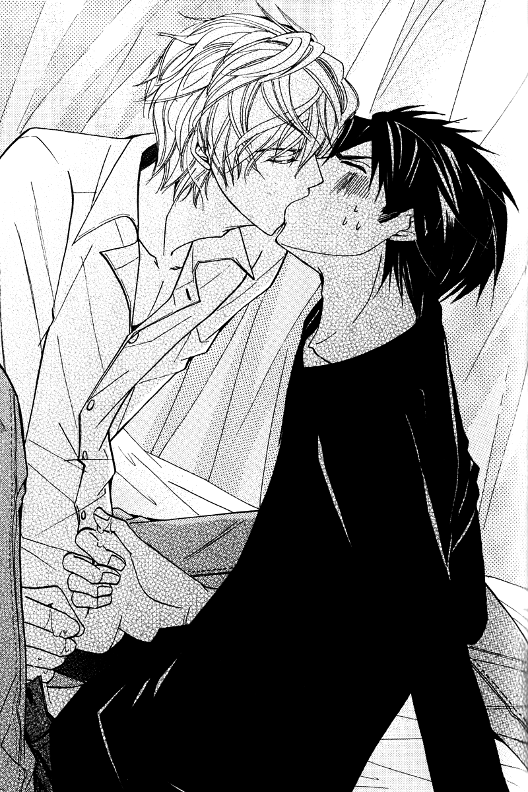
“Nnn….nn?!” Distracted by the kiss, Kirishima had started to drop his hand further down between Yokozawa’s legs, brushing around beneath him to ease a finger underneath. Shaking his head to break the kiss, Yokozawa hissed angrily, “Oi–hey. Where the hell do you think you’re touching…?!”
“Don’t stop stroking.”
“Listen to me, dammit–ah…guh…!” A finger pressed inside, tight and painful despite being greased with the baby oil. He let out a soft cry at the intrusion, then immediately grit his teeth. “Quit…that…!”
“You really don’t like it?”
“I don’t…like being touched there…!” It wasn’t…as if he’d never been touched there, but he couldn’t stand the idea of being so utterly open and defenseless beneath someone else.
“…Wait, don’t tell me this is–your first time?”
“…NO COMMENT.” He didn’t want Kirishima getting any ideas in his head about Yokozawa’s past–and even less so did he intend on dredging up Kirishima’s own himself. While it would be a lie to say he wasn’t at least curious, he knew full well the powerful force his jealousy could become.
“…Well, whatever. Your first time or not, doesn’t change how it’ll go.”
“Then don’t ask!”
“What? I thought I’d go gentle with you if it was your first time.”
“Hah, like hell you would.”
“With an attitude like that–are you saying you’d rather I teased you a bit more?”
“Tease–!” Kirishima pressed his finger deeper and forcibly spread the narrow passage. His fingers, usually so clumsy, now moved with unbelievable proficiency. When Yokozawa paused to consider how those fingers which couldn’t even properly peel an apple now had him at their mercy, it was almost too humiliating to bear.
“What, done bitching already?”
“Shut…the hell up…!” His breath caught in his throat as the fingers continued working inside him, and he could feel them slipping in and out, brushing against him. Every now and then, Kirishima would pause to reapply the oil and add another finger. “Haa…!”
At each stroke, he’d let out some new, obscene cry–and even if he’d wanted to plug his ears, his hands were otherwise occupied. Yet despite his best efforts to continue pumping Kirishima’s cock, he couldn’t keep his focus.
“That’s…enough.”
“What’d you say?”
“Don’t tell me your hearing’s going already, old man. I said get on with it.” At this rate, he was going to wind up climaxing first, without a doubt. If they were going to do this, it may as well happen while he was still too out of it to care.
“Then–couldn’t you at least say it a bit more sexily?”
“Do you wanna do it or not? Personally, I wouldn’t mind sticking it in you, myself.”
“I certainly don’t mind if you want to try that–but for today, let me do you. I want to cum inside you.” He whispered this in a low, husky voice, and Yokozawa’s ears went numb. It was impossible to tell what kind of moves Kirishima had up his sleeve.
Taking Yokozawa’s silence as consent, he withdrew his fingers and peeled away Yokozawa’s pants and underwear entirely. Yokozawa patiently bore the humiliation and allowed his legs to be spread without protest.
“Oh by the way, I’m out of condoms right now, but–you don’t mind, right?”
“What?! Of course I mind–ngh!” Kirishima didn’t wait to hear his reply, slowly pressing in and situating himself inside Yokozawa, who grit his teeth against the pain and discomfort of having his body forcibly invaded, being opened up as he was. “Guh…ngh, ah!”
An indescribable shudder ran up his spine as Kirishima pressed in deeper, leaving behind only a cramping pain and a feeling of being filled, inside and out. He could feel Kirishima’s cock within him pulsing with a thudding badump badump.
“…Are you all right?”
He glared up at Kirishima, heedless of the concerned expression he was favoring Yokozawa with. “Of course not. And–fuck, if you cum inside me I swear I’ll kill you…!”
“You’re not convincing anyone all teary-eyed like that.” Yokozawa felt the stiffness in his body shatter as Kirishima jerked against his hip with the full weight of his body. Everywhere Kirishima was touching him throbbed with a numbing tingle, and his sensitive skin cried out to be touched.
“I realize this is a rather tactless question, but…what was it like when you were with Takano?”
“…NO COMMENT,” he responded breathlessly, flat-out refusing to answer. That was one thing he definitely didn’t want Kirishima imagining.
“Not that it really matters to me. You both look like bottoms to me.”
“I’ll bet everyone looks like that to you.” If someone with as harsh a mien as Yokozawa could look cute to this guy, then surely anyone could.
“I’m talking about on the inside. Or, what–are you saying I’m such a sex magnet you don’t mind my fucking you even though I’m a guy?”
“That wasn’t a compliment!” he barked back at Kirishima’s banter. If he had enough left in him to be talking stupid shit like that, Yokozawa really wished he’d just get this over with.
“Seeing as it seems you’ve still got plenty of fight left in you, I won’t hold back then.”
“You haven’t been holding back since this start–ngh, ah!” Yokozawa’s body jerked, flinching as Kirishima pressed in deep and continued to thrust with teeth-shattering intensity, forcing a strangled cry from Yokozawa’s mouth. The cock roughly thrusting in and out rubbed and chafed his insides, and despite his best efforts to bite back his cries, groans seeped out from deep with his throat, perfectly timed with Kirishima’s rhythm.
“Hng…aah…!”
“Come on, louder.”
“Like…hell…!”
“Though the sight of you holding back turns me on just as much…” Kirishima chuckled gruffly and bent forward to lick the long strip of skin bared before him when Yokozawa threw his head back. A shiver traveled down his spine at the sensation of Kirishima’s tongue against his skin, and he felt himself clench tighter around Kirishima in response.

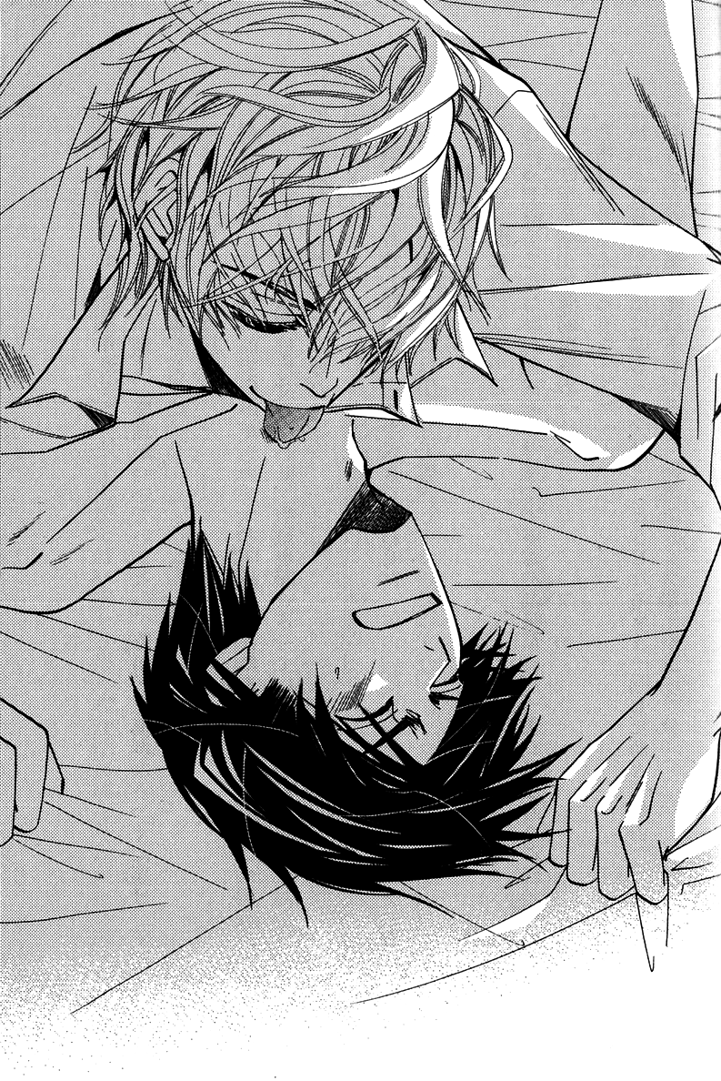
He convulsed around Kirishima with shivering jolts following each punishing thrust, and he worried his lip each time he felt himself being washed away by the pleasure being forcibly impressed upon him.
“Haa…ah…!” At the very least, he wanted to keep his pride intact–and so he kept a firm grip on his senses to keep himself from drowning in pleasure, but…he was nearly at his limit. The searing cock swollen with desire continued to bore into him, and his mind grew hazy through it all.
“Shit I think I’m gonna…” The rhythm of the thrusts grew even more violent, and his senses couldn’t keep up. The point where they were joined was slick and tight, but he could hardly even feel it anymore. “Ah…ah–ah…!!”
Kirishima thrust in deep, and Yokozawa felt his vision flicker and flash before him. In those few seconds, Yokozawa’s senses returned–and his body shook with a jerking tremble as he climaxed, clenching tightly around Kirishima still buried within him.
“…hngh…!” Kirishima gasped sharply and then shuddered violently. Yokozawa immediately knew from his expression and the feeling within him that he’d climaxed–after he’d outright warned him not to cum inside of him!
“…Kirishima-san, you…”
“Ah–sorry, sorry. I was a little late there…” The apology was nonchalant, his words lightly delivered–he didn’t look like he was ~sorry~ one bit.
Yokozawa glared up at him harshly. “You’d better be prepared to fucking take responsibility for that.”
“I will, I will! But–now that it’s a done deed, how about I take care of it after one more round?”
“What the…just fuck off and die!” He tried to paste on his angriest glare, but it didn’t seem to translate to Kirishima.
“I will, I will–but after one more round?”
“You–!” But his words were cut off as a pair of lips descended on his own, and he couldn’t bite out his complaints any further. No matter how he struggled, he was without a doubt at a disadvantage right now. Vowing in his heart that he’d get back at this guy later, he relaxed himself and just gave in.

When he stepped out of the shower, Yokozawa found Kirishima sipping a beer at the dining table.
“There’s one for you chilling in the fridge if you want it.”
“Didn’t I buy that?” It may have seemed like a benign comment to most onlookers, but given that it had come from someone Yokozawa knew full well didn’t even know the contents of his own fridge most of the time, it grated a bit.
“Well, guess I’ll hop in the shower too, then.”
“Hurry up.”
Yokozawa felt a sense of gloom sink over him when he recalled that they needed to think up an excuse for Hiyori to explain why they’d both showered in the middle of the day when it wasn’t even hot outside. He even felt judged by Sorata right now, and the cat couldn’t say anything. Kirishima finished off the last of his beer and stood–at which point Yokozawa asked, “That reminds me–what the hell were those ‘embarrassing pictures’ you were always going on about? Did you seriously even have anything?”
Yokozawa had half-forgotten, himself, but he now recalled that this had all started because he’d been practically blackmailed into hanging out with Kirishima to begin with. Now, he supposed it had just been another ruse to keep Yokozawa from getting suspicious over what Kirishima had been trying to do. Still, he did want to find out if such pictures actually existed or not.
“Oh, that. You wanna see?”
“You actually have some?!”
“I made sure to save them so I wouldn’t accidentally delete them or anything…ah, here we are! There.” After pressing a few buttons on his cell phone, Kirishima seemed to have found what he was looking for and turned the screen so Yokozawa could see as well.
There Yokozawa found several images of himself sleeping peacefully, with eyes red-rimmed either from drinking too much or perhaps from sobbing himself to sleep. It was a bit anti-climactic for Yokozawa, who’d been thoroughly convinced they’d been decidedly racier images, but after the sense of relief washed over him, it was quickly replaced with seething anger. “You–asshole! I can’t believe you threatened me with these kinds of pictures!”
“Hey, these are plenty embarrassing, don’t you think? Not even Hiyori would cry herself to sleep anymore!”
“You–!” But well, he had a point. He wouldn’t have hesitated one bit if he’d been asked which was more embarrassing–the apron shot or these ones.
“If you think it’s not embarrassing, then do you mind if I make it my wallpaper?”
“Of course I mind! Gimme that! I’m deleting these immediately!”
“Mmm, don’t wanna.”
“I’ll sue you for defamation!”
“Go ahead then; I’ll just get up on the stand and testify that I couldn’t help myself wanting to take pictures of my cute lover.”
“What the…!”
“…You’re adorable, blushing over something like this.”
“I’m–not–!” He flushed even further, still not completely used to being told things like that. He had no hope of ever winning against Kirishima’s utter lack of social mores. His only choice was to just avoid engaging him at all, it seemed.
“I’ll just have to keep saying things like that until you get used to it, I suppose.”
“Please don’t.” He shuddered at the mere thought–and yet, deep down, so long as it was Kirishima paying these compliments that didn’t seem to fit him at all…it wasn’t so terrible.
“Now don’t say that–my love is deep, you know. I’ll definitely make you happy.”
“Seriously?” He couldn’t help snorting at Kirishima’s bold display of confidence.
“Have I ever not been able to accomplish something once I’ve said I would?”
“…I don’t suppose so.”
This was Marukawa’s leading hit-maker, who brought to fruition everything he said he would despite being derided as being nothing more than a big-talker–if he said he’d do it, then there was no mistaking that he would.
While Yokozawa could hardly say he wasn’t worried in the least, this wasn’t going to be a relationship that made him want to cut himself down as before; there was no need to swagger and stiffen–they could let their feelings grow little by little.
“…Still, how are we supposed to face Hiyori now?” Once the sun started to set, she’d be on her way back from her friend’s place. While Yokozawa had no intention of telling her what had happened between them, he also didn’t trust himself to be able to meet her with a straight face either.
“Just the same as you always have.”
“Maybe you don’t mind it–but I’m not as ballsy as you are, you know!” For Yokozawa, it was less of an issue that he’d slept with a guy, and more of one that he’d slept with Kirishima. While she was close with Yokozawa, if she found out that he was in a romantic relationship with her father now, there was no way she wouldn’t be confused and concerned as his daughter.
“It’s fine–she’s my daughter after all! She doesn’t have a bigoted bone in her body!”
He colored at the unconcerned reply and snapped a hand out to grab Kirishima’s collar, jerking him forward. “Oi–you’d better not let her know about this, all right?” This wasn’t a matter of bigotry; while he understood that someday they’d need to discuss it with her, it didn’t have to be now.
Kirishima smiled as if scheming something. “Well I suppose that all depends on your attitude, then.”
“What the hell–are you trying to threaten me again?!”
“Nah–just playing with you a bit~” Despite the fact that he kept a straight face through the correction, this was hardly much better.
“I changed my mind–you can fuck off and die a hundred times over.” He shoved away the collar he’d grabbed, through with taking the guy seriously. Kirishima’s shoulders shook as he watched Yokozawa get riled up.
He really hoped he hadn’t made the wrong choice… Feeling a tinge of worry as he cast a sidelong glance at Kirishima, who seemed unable to stop himself from laughing, he released a long sigh.
~THE END~

